Robert Londe, master of Newgate School
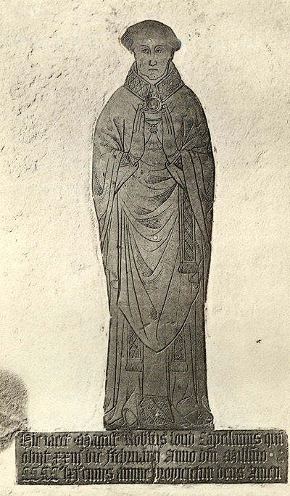
The brass of Robert Londe (d. 1462), master of Newgate School, Bristol, and one of the town’s later medieval Irish population, from his tomb in St Peter’s Church. This photograph was taken before the church and tomb were destroyed by bombing in 1940. He is depicted as a priest, in vestments. He is shown with the chalice which held the consecrated wine and above it is depicted the host, the consecrated wafer, both used during mass, or eucharist, when Catholics believe that the bread (wafer) and wine turn into the body and blood of Christ. His Latin inscription describes him as ‘Master Robert Londe, chaplain’ (magister Robertus Lond capellanus).

In 1430 Robert Londe had to buy a licence to remain in England when his fellow Irish were expelled by order of the king, Henry VI, and ten years later he was taxed as an alien, because of his Irish birth. He had lived in Bristol since at least 1419, and had attained the position of schoolmaster at Newgate by 1426; despite this, as far as royal officialdom was concerned, Robert was not a full subject of the king of England.

Robert first appears in the records as a chaplain in St Peter’s parish in 1419. The following year he became warden of St Michael’s, or Bradeston’s, Chantry in Winterbourne, just outside Bristol (a chantry was an institution designed to provide prayers for souls in Purgatory, supported by rents from property donated by the founder). St Michael’s was a relatively large chantry that had been founded seventy years earlier, and Robert had two chaplains under his supervision. He left in 1425, and was employed at Newgate by September 1426, when the Bristol merchant Thomas Bewflour left him a small bequest in his will. By 1449 he may have taken the degree of Master of Grammar at Oxford or Cambridge.

Such a degree would be evidence that Robert took his teaching seriously: most of the instruction given in schools such as Newgate would have been in Latin grammar (hence, ‘grammar schools’). Another indication of Robert’s dedication to the teaching of Latin is a manuscript book of 244 pages, now in Lincoln College, Oxford, which was almost certainly compiled for his use at Newgate. The first item in the book, a guide to grammatical rules, was copied by the scribe Thomas Short ‘at Bristol, above the New Gate’ on 8 May 1427; the second item, copied from the work of the Oxford Latin scholar John Leland, on the gender of nouns, was ‘written at Bristol’ on 20 May 1428. As well as Leland’s work, the compilation apparently includes material copied from grammar books used in schools at Wotton-under-Edge, Chippenham, and London.

The most fascinating part of the book is a set of translation exercises. These were probably used by Robert to provide English sentences which would then have been translated into Latin by his students. Exemplary Latin translations are also provided. Robert probably composed these himself, since some relate to Bristol:

‘To Bristol, the which is a port town, come more strangers than to Coventry, the which is not a port town, notwithstanding that both be equally good’
(‘To Brystow, the wyche ys an havyn towne, comyth moo strangerys than to Covyntre, the wych is no havyn towne, notwithstondyng that bothe bethe lyche good’)

‘Some handsome squire of Devonshire shall wed my daughter, the which goes to school upon the New Gate’
(‘Sum gay squyere of Davynschere schal wed my dowghter, the weche go to schole ap on the new yate’) – does this mean the daughter attended Robert’s school?

‘I can ride to Bath in a day and also far beyond if need be’
(‘Y kan ryde to Bathe in a day and als far beyond for nede’)

In addition to Latin grammar, Robert may have had a particular interest in canon (church) law, since a book on this subject was listed in an inventory of the possessions of St John the Baptist Church (Broad St) in 1469, described as ‘given by Master Robert, sometime schoolmaster of this town’. Among his students may have been William Worcestre, the famous antiquarian, who was born in Bristol in 1415 and who wrote a detailed description of the town in 1480. Robert’s brass gives his date of death as 23 February 1462.

Newgate school was housed in a chamber over the ‘New Gate’, built between the town wall and the castle wall, between Wind Street and Broadweir, on the edge of the parish of St Peter (the ruined church, bombed in the Blitz, stands nearby). From the middle of the fifteenth century Newgate became the site of Bristol prison, by which time the school had presumably closed down.

References
M. Dresser & P. Fleming, Bristol: Ethnic Minorities and the City, 1000-2001 (Phillimore/England’s Past for Everyone, 2007), pp. 22-4;
N. Orme, Education in the West of England, 1066-1548 (University of Exeter, 1976), pp. 38-40;
C. E. Boucher, ‘The Lond or Loud brass in St Peter’s Church, Bristol’, Transactions of the Bristol and Gloucestershire Archaeological Society, 30 (1907), pp. 265-72;
F. Neale (ed), William Worcestre: The Topography of Medieval Bristol (Bristol Record Society, 51, 2000).

copyright
All rights, including copyright ©, of the content of this document are owned or controlled by the University of London. For further information refer to http://www.englandspastforeveryone.org.uk/Info/Disclaimer

