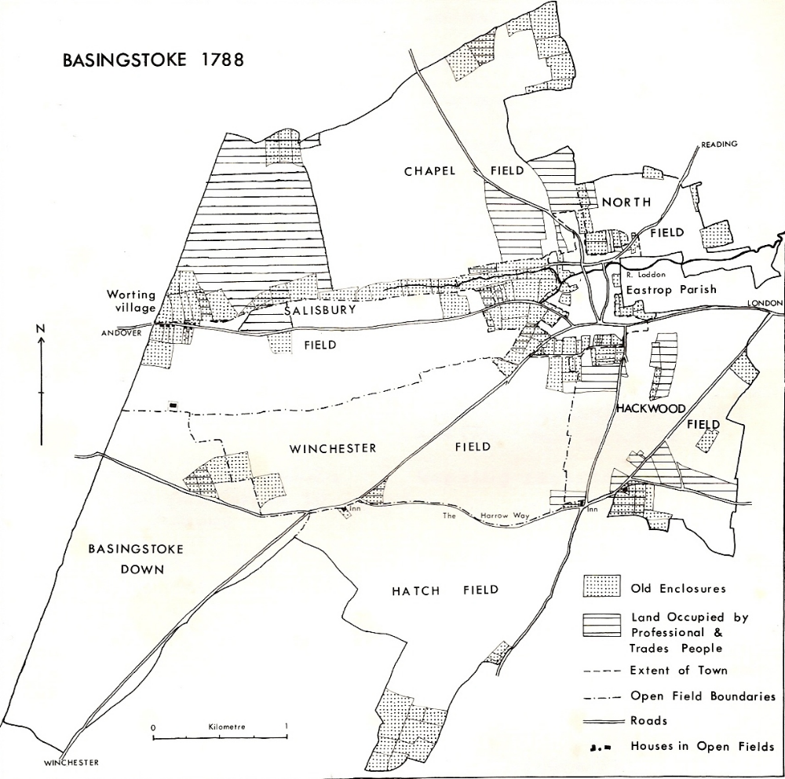
Figure 1 Basingstoke in 1788 Based on 1762 Godson map of Open Fields and 1788
Enclosure award. River Loddon, 6 open fields and the Down and old enclosures are shown

