The Mohuns of Cornwall
When, after the Norman Conquest, William de Mohun came from Moyon in western Normandy to Somerset he founded a dynasty. His family had their seat at Dunster in Somerset but they had many lands and manors elsewhere. William’s great great grandson was Reynold de Mohun who married Alice Briwere heir to her family’s large estates in Devon and Somerset. Their son Reynold spent little time at Dunster having many houses including Torre, Devon, where he died and he founded Newnham Abbey, Devon.

Reynold’s great grandson John II de Mohun was a soldier and a supporter of Thomas, earl of Lancaster. He and his wife Ada Tibetot had a large family to provide for. Two of the younger sons looked west including Lawrence of Tavistock, Devon and Reynold of Cornwall.

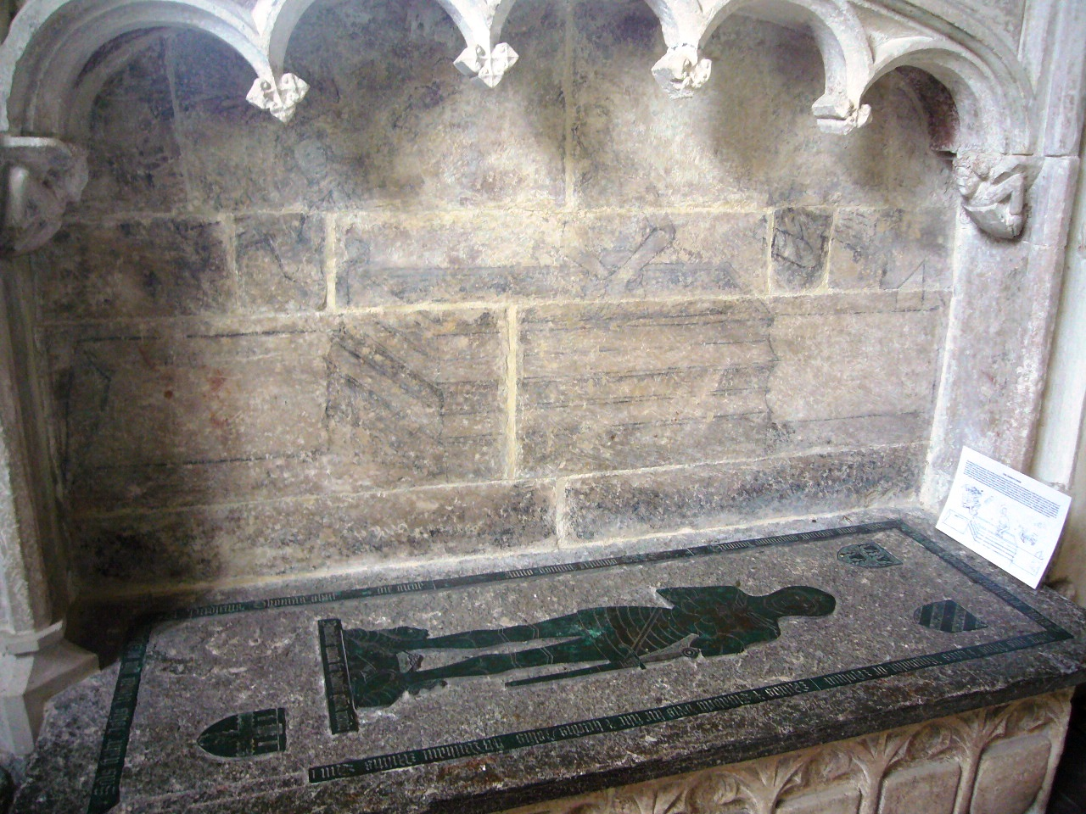
The younger Reynold married Elizabeth Fitzwilliam, heiress to the Hall estate at Bodinnick. The marriage was unhappy and Elizabeth tried to divorce Reynold and marry another man. However it was John de Mohun, her son by Reginald, who inherited Hall and was succeeded by his son Thomas (d. c.1400). One of them was probably responsible for building the chapel at Hall, now a ruin. Thomas’s memorial in Lanteglos church is unusual. The brass plate of him in armour is set on a chest under an arch, which is possibly much later and has a remarkable painting of the Resurrection on its back wall.

A descendant John de Mohun and his wife Anne died in an outbreak of ‘sweating sickness in 1508.
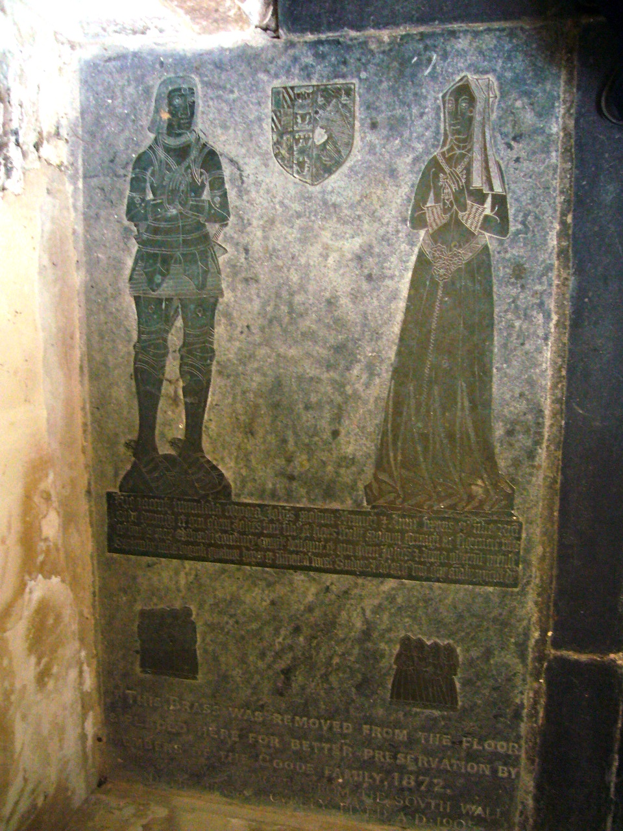

The family survived in Cornwall after they had died out at Dunster, several were sheriffs of Cornwall, and Sir William Mohun bought Boconnoc in 1579.

copyright
All rights, including copyright ©, of the content of this document are owned or controlled by the University of London. For further information refer to http://www.englandspastforeveryone.org.uk/Info/Disclaimer

