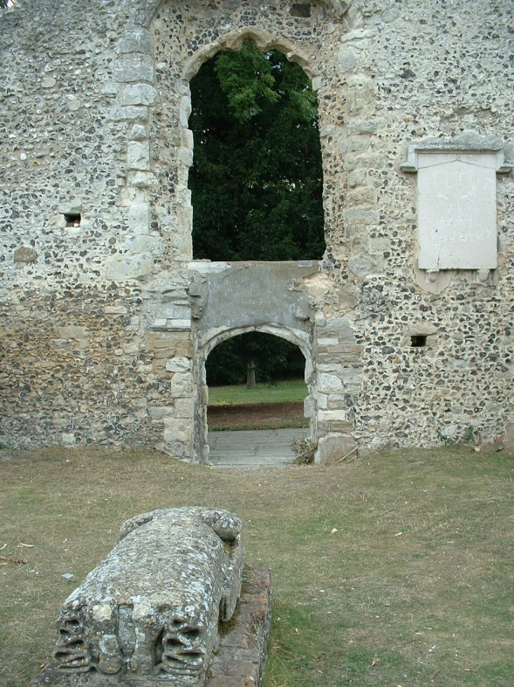
Now Grade II* Listed, the ruined Holy Ghost chapels tell a story of significant events in England’s history. During the reign of King John (1199-1216) there was a dispute between King and Pope (Innocent III) over who should be Archbishop of Canterbury. The Pope placed England under an Interdict, which meant that church services were suspended and the dead could not be buried in their churchyards. The townspeople of Basingstoke chose to bury their dead on the hillside north of the town. It also seems highly likely that the churchyard around St Michael’s parish church was unsuitable for many burials because of its low-lying position near the River Loddon. After the Interdict was lifted in 1214, burials continued and by 1244 a chapel with a tower existed, although the date when it was built is unknown. The chapel was cared for by the Guild or Fraternity of the Holy Ghost. In Henry VIII’s time a duty to educate was added to the Guild’s duties, at which time it was noted that it had been in existence ‘long before’ with a duty to collect payments for lights and prayers for the souls of the deceased.

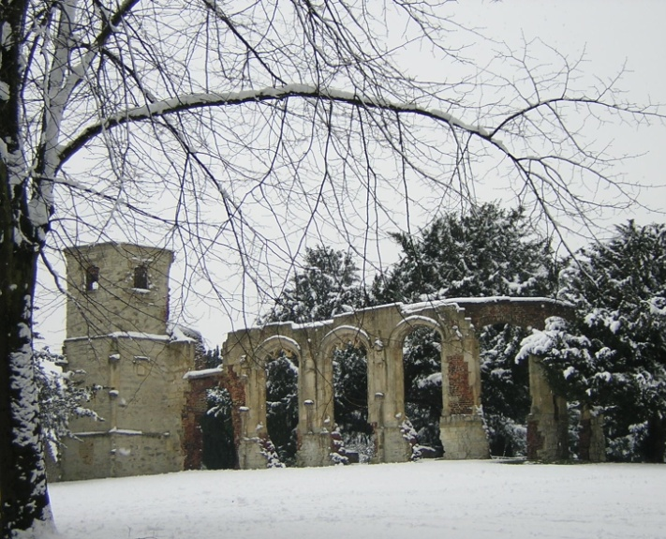

West end of 13th century chapel with 16th century tomb – possibly of a Warden of the Guild of the Holy Ghost.

In 1524, Lord Sandys (of The Vyne, Sherborne St John, and Mottisfont, Hampshire) extended the church, adding a substantial chapel, dedicated to the Holy Trinity, to serve as a burial place for himself and his family. He and his parents are buried here and it is his parents’ tombstones of black Antoing stone (sometimes called Tournai marble) which are laid on brick supports by the windows of the chapel.
Lord Sandys' Chapel of the Holy Trinity, 1624
Later members of the Sandys family were also buried here as is noted in the Churchwardens’ Accounts of St Michael’s for 1628-1630.

The chapel was renowned for its fine painted roof and high quality Flemish stained glass. The Reformation under Edward VI regarded the Fraternity as a suspect chantry chapel; it was ordered to be dissolved and items were removed and destroyed. When Catholic Mary Tudor came to the throne in 1553 the townspeople petitioned for the return of the Guild, which was done by royal charter of Philip and Mary dated 1556. This firmly established the provision of education for young men and boys in the town. A school room was built at the chapel’s west end probably around 1635. It served until 1855 and was known variously as the Holy Ghost School, The Free School, the Queen’s School or Queen Mary’s School. The school master was in Holy Orders and was often the Vicar of Basingstoke or of a nearby parish. Perhaps the most famous of these was Charles Butler, who became Master of the School in 1595 until he left to become Vicar of Wootton St Lawrence. In 1609 he published 'The Feminine Monarchie: A Treatise on Bees.’

A well-known local story associated with the cemetery or Liten as it was known, is that of Mrs Blunden who was notoriously buried alive in 1674. On 29th July 1674 the wife of wealthy maltster, William Blunden, sent her maid to get her a pain remedy from the apothecary. Presumably she took too much and became senseless and was, after proper tests, supposed dead. She was described as a ‘gross woman’. The weather was warm and it was decided to bury her quickly. The next day, schoolboys playing in the burial ground told their schoolmaster that they had heard noises coming from the recent burial. He is supposed to have taken no notice for a while, but on their insistence, was also convinced. The body was exhumed and said to be ‘most lamentably beaten’ and it was supposed that she had indeed, been buried alive. The story became embellished in a broadsheet from London which suggested that she had been re-buried – so buried twice while still alive! It also suggested that the town had been fined for the offence, but there seems to be no evidence for this.

During the Civil War (1642-1651) Col. Henry Sandys, 5th Baron Sandys, removed the stained glass windows for safe keeping to his homes at Mottisfont near Midhurst and especially to the chapel at The Vyne, Sherborne St John. The fortunes of the Sandys family were affected by Henry Sandys, a Royalist, losing his life at the battle of Cheriton in 1644. Subsequently The Vyne was sold to the Chute family in 1650 and Mottisfont, by descent, became the home of the Mill family. Sir Henry Mill (d. 1782) was rector of All Hallows Church, Woolbeding and made use of some of the glass there, which is still in situ today. Some of the pieces are set into a window in the Rex Whistler room at Mottisfont and pieces from The Vyne were given to St Michael’s, Basingstoke but were blown out by a bomb blast in 1941 so only fragments remain (see photo).

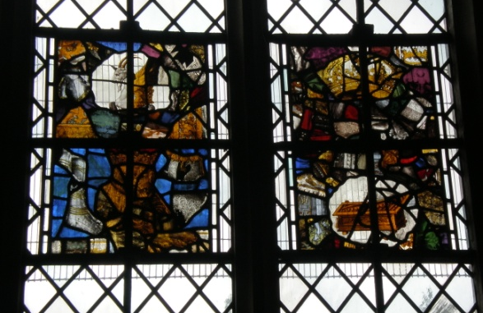
Glass in St Michael's – lower right is the hemp-breaker, one of the Sandys’ family emblems. Other hemp-breakers can be seen in The Oak Gallery at The Vyne and on the Holy Trinity Chapel and St George’s Chapel, Windsor.

Another small piece of glass was given to Canon Scholes for the Holy Ghost Roman Catholic Church in Sherborne Road, Basingstoke in 1903 and is inset into a window on the south side.

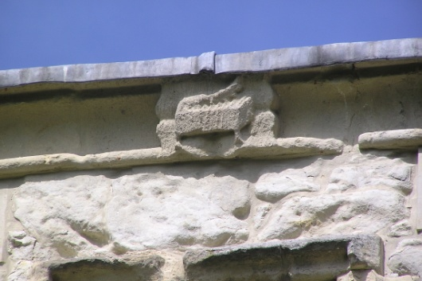
High on the parapet of the tower of Sandys’ chapel are various emblems: a winged goat, entwined initials of WM for William and his wife, Marjorie (or Margaret) and WS for William Sandys. The hemp-breaker emblem of the Sandys family arises from marriage to the Bray family when William married Margaret, niece of Sir Reginald Bray, a powerful statesman during the reign of Henry VII. Reginald Bray is buried in the Bray chapel in St George’s Chapel, Windsor, where many hemp-breakers can be seen. The emblem can also be seen in the Oak Gallery at The Vyne.

Hemp-breaker emblem on the Holy Trinity Chapel. Photo: Michael Rice

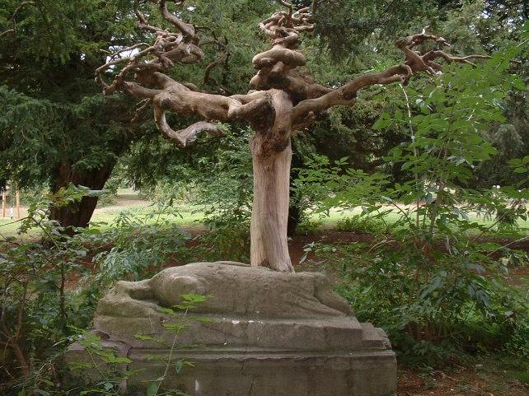
Lead from the chapel roof was removed during the Civil War, almost certainly by troops who were finishing off the long siege at Basing House, which finally fell in October 1645. Roofless and windowless, the chapels fell into disrepair.

William de Brayboeuf. A knight’s tomb
effigy, this would originally have been inside
the 13th century chapel

Circa 1817, two medieval tombs were ‘discovered.’ One was the tomb of a knight – Sir William de Brayboeuf, Lord of the Manor of Eastrop (d. 1284) and the other was of 16th century date. Although very weathered, it is possible to make out the shield and crossed legs of the knight’s effigy. The other early tomb may be of a warden of the Guild of the Holy Ghost – documentation notes the payment of ‘eight yards of frieze for the Schoolmaster’s gown, at 16d a yard’.

Another well-known commentator on the cemetery is Gilbert White, author of The Natural History and Antiquities of Selborne, (1789). White was a scholar with the sons of the Vicar, the Reverend Thomas Warton but evidently played in the burial ground. He describes in the Natural History how he and some others set a charge on the ruins, which went off later in the night, bringing down some of the masonry.

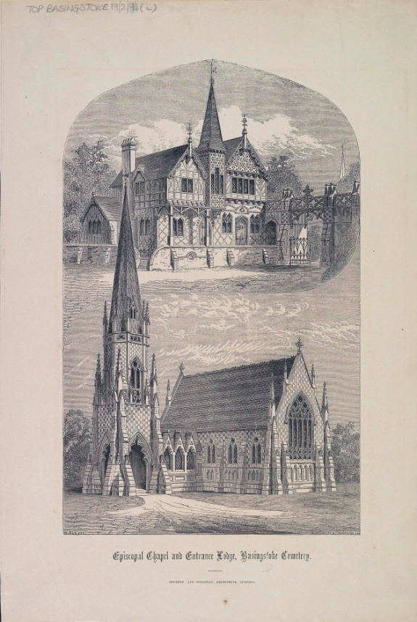
A Burial Board was set up in 1850 and the cemetery was enlarged. The Queen’s Grammar School moved to new premises in Worting Road (1855) and a more ‘Victorian’ cemetery was created. Yews were planted, the site was walled with brick and flint and a lodge in Victorian Gothic style and two mortuary chapels were erected in the cemetery, one for Episcopalians and the other for Non-Conformists. The chapels were demolished in the 1960s. The south eastern corner of the cemetery was reserved for Quaker burials on a piece of land given earlier by Henry Downs. Here are buried the Burberry, Wallis, and Steevens’ families, notable Basingstoke business people. The Cemetery Lodge is noted as the birthplace of John Arlott (1914-1991), cricket commentator, whose father was the cemetery keeper at the time.

This engraving shows one of the mortuary chapels, demolished in the 1960s and The Lodge, which survives at the Chapel Hill entrance.

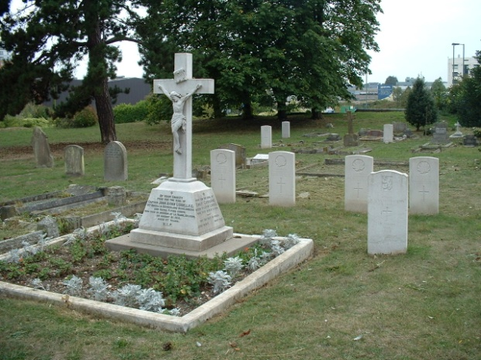
There are 21 Commonwealth War Graves headstones in the churchyard, all but one from the First World War, including that of Aidan John Liddell who received a posthumous Victoria Cross in 1915. Liddell’s citation read as follows:

‘For most conspicuous bravery and devotion to duty on 31st July, 1915. When on a flying reconnaissance over Ostend-Bruges-Ghent he was severely wounded (his right thigh being broken), which caused momentary unconsciousness, but by a great effort he recovered partial control after his machine had dropped nearly 3,000 feet, and notwithstanding his collapsed state succeeded, although continually fired at, in completing his course, and brought the aeroplane into our lines - half an hour after he had been wounded. The difficulties experienced by this officer in saving his machine, and the life of his observer, cannot be readily expressed, but as the control wheel and the throttle control were smashed, and also one of the under-carriage struts, it would seem incredible that he could have accomplished his task.’

Liddell's grave with other First World
War graves

Liddell came from a Catholic family and there is a window in the Holy Ghost Roman Catholic Church commemorating his Military Cross awarded for an earlier campaign. Some of the war graves here are of Canadians who were treated at Park Prewett – a Canadian Military Hospital in the First World War. There is also a Belgian war grave.

Debbie Reavell
2014

Baigent, A.F.J. and Millard, J.E., A History of the Ancient Town and Manor of Basingstoke (Basingstoke ,1889), 118.
Ibid, 514-515.
Hampshire Record Office. HRO 57A03. Letters patent of Philip and Mary restoring the Fraternity and some of its estates, 24 Feb 1557.
Baigent and Millard, 160.
Where he proposed that the hive had a ‘Queen’ bee rather than a ‘King’.
Mrs Blunden, A Gentlewoman Whose Life was Thrown Away by Ignorance or Haste (Willis Museum, Basingstoke).
Wayment H.G., The Stained Glass of the Chapel of the Vyne and the Chapel of the Holy Ghost, Basingstoke. Archaeologica CVII, (1982), 141-152. This article deals with the stylistic analysis of the glass. See also Jenkins J.M. and Simpson N.W., The Painted Glass of William, Lord Sandys (1470-1540) (Basingstoke).
‘Bray’ is a rebus on the French word ‘braie’, a hemp-breaker
Baigent and Millard, 139.
HRO TOP 19/2/94(L). Engraving of the Episcopal Chapel and entrance lodge, Basingstoke Cemetery Drawn by Sly B., engraved by Heaviside I.S. Poulton and Woodman, Architects, Reading.

