MOUNTBATTEN HOUSE – THE ORIGINAL BUILD

In 1975 Arup Associates were given the brief by Wiggins Teape with a budget of £7.5M to build a low cost, flexible office space to house 750 staff combining open areas, private office compartments and conference rooms so that part of it could be let separately if necessary.

Although the initial impression of the building is of random sections it actually lies symmetrically on a diagonal line.

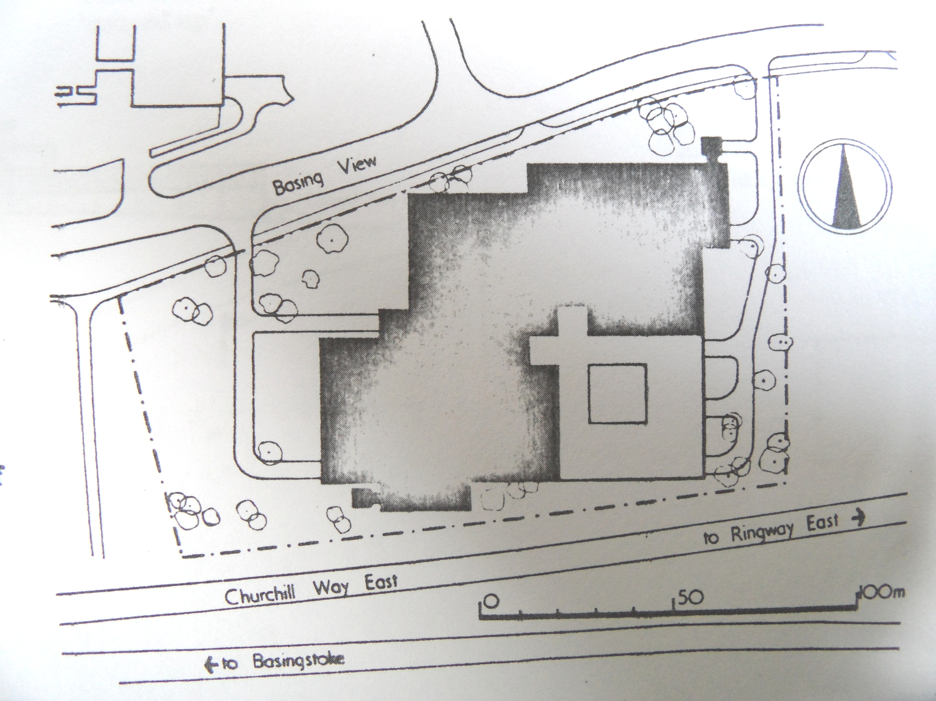

Plan view of Mountbatten House c.1976

Externally the building is clad in panels of anodized aluminium which changes in colour from bronze to grey according to the light. The brown tinted windows of each level overhang the garden terrace of the level below forming an arcaded walk.

The building is entered from the north where the double height boiler house can be seen behind plain glass. Vertically the lifts, stairs and washrooms are contained in two cores which suited the original brief requiring potential to sub let some of the space if necessary.

Internally the functional space is formed from an evenly spaced concrete grid with columns 7.5m. apart supporting what resembles pyramids with truncated tops. The cut off apexes provide a system for servicing ducts and contain the air conditioning, lighting and fire sprinklers which are accessible without disturbing the floor below. The ceilings are of textured concrete and give the opportunity to lose the traditional suspended ceiling and its claustrophobic feeling. Heating and cooling is controlled by induction units installed just inside the wall-to-ceiling glazing. The 7.5m bays provide a working space for 6-8 people and have been described as ‘sideless tents’. The open areas were deliberately made environmentally superior with views to the southern landscaped space while the executive, closed offices face north looking out onto neighbouring office blocks.

Car parks are enclosed in an underground space afforded by the sloping site. There is a kitchen, executive and visitor dining rooms and a restaurant able to convert into badminton and table tennis courts.

To reduce costs, Wiggins Teape brought their existing steel desks and cabinets from their London Gateway House premises. The architects of the Basingstoke site adapted these to fit into the new offices by covering them with cheap veneer panels.

All text taken from Aldous A. and Winter J., The Architect’s Jnl., (24 Aug 1977), unless otherwise stated.

