‘An Attractive Location and a Warm Welcome’: The Congregational Cause in the Parish of Ellisfield c1890-1949

Roger Ottewill

In a similar manner to the Congregational cause in the neighbouring parish of Farleigh Wallop that in Ellisfield started with meetings being held in a cottage. These appear to date from the early 1890s. Likewise the cause was supported by the members of London Street Congregational Church in Basingstoke. According to Kellys Directory for 1907 a Congregational Mission Room was erected in 1894.
During the early years of the twentieth century services were being held at 6.00 pm on Sundays and 7.00 pm on Thursdays. Interestingly, ‘a special’ and undoubtedly encouraging feature was ‘the attendance of so many young people, including young farm labourers.’ At that time, there was also a thriving Sunday school which was held ‘in a room in Pullen’s Cottage’. It would seem that ‘some of the children also attended Church Sunday School, so they had two Sunday School treats, both of [a] high standard.’ For women, there was a Mothers’ Sewing Class which met on alternate Friday afternoons.
Regular services were supplemented with gatherings for special events. For example, on Good Friday 1912, a tea, followed by a public meeting, was held ‘in a barn kindly leant by Mr Earwicker.’ There were musical contributions from the children and parents of Winslade Congregational Sunday School and short addresses by the Chairman, Mr Forder, and an ‘esteemed evangelist, Mr H. Williams.’ Later that year, ‘the most successful harvest thanksgiving service yet [was] held in the Mission Room’ with the observation being made that Ellisfield ‘stands badly in need of a chapel’.
This need was met in the following year, thanks to financial assistance from Miss Sarah Jane Wallis, who had been instrumental in building the chapel in Farleigh Wallop. As reported in the London Street church magazine:

A new chapel has been erected at Ellisfield by Miss S.J Wallis, in connection with our services held in that village. We have seen the building and it is an exceedingly suitable one in every way, and it looks well. The building is completed but the friends at Ellisfield are busy with the harvest at present so that it is thought well that the Opening Services should be combined with the Harvest Thanksgiving Service on Thursday, September 11th. We ask our friends in town to make a special note of this date that they might be present upon that occasion. We should like to see a good number go out from London Street.

The chapel was duly opened in the autumn, as recorded in the Hants and Berks Gazette:

On Thursday in last week took place the formal opening of a new Congregational Chapel which has been erected in this village by Miss S.J. Wallis, who has been interested in Ellisfield for many years. Hitherto services have been held in a cottage, but the accommodation being insufficient Miss Wallis has provided a wooden building capable of accommodating about a hundred persons. By means of subscriptions the members of the congregation have furnished the building with seats and with an American organ, and gifts presented by various friends include a Bible for the reading desk and a lamp. The opening ceremony was attended by numerous friends from Basingstoke, Farleigh, Winslade and Cliddesden, who with the villagers of Ellisfield made up a company of nearly a hundred. They assembled in front of the building, and after expressing the pleasure it gave her to take this part in the religious life of Ellisfield, Miss Wallis opened the door and the people entered the chapel, when a short dedicatory service was conducted by Mr. Gage of Basingstoke. Afterwards the assembly partook of tea in the meadow, and this was followed by a meeting in the chapel …

In this report there is no indication of the location of the chapel. However, on an ordnance survey map dating from the 1920s it is shown as being situated on a road, known as Green Lane, nearly opposite Hill Farm (see Fig. 1).
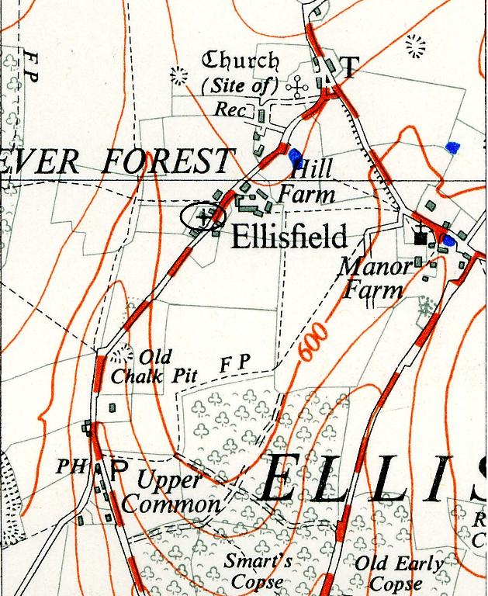

Fig. 1: Part of Ellisfield Parish.
+ Indicates approximate location of Congregational Chapel

During the 1920s and 1930s the chapel appears to have been well used and in 1931 it acquired the organ from Winslade when that chapel was closed. Due to its attractive location and the warm welcome they received, Ellisfield was also a popular destination for Congregationalists from Basingstoke. For example, on Good Friday 1926 ‘a charabanc party went from Worting and May Street (two Congregational chapels in and near to the town) … [and] a splendid tea was provided [after which] most of the party went to the woods to gather primroses and returned to the Chapel for an Entertainment given by the Worting Choir …’ While in July 1937 it was reported that: ’Visitor’s Sunday was a great encouragement to the folk who so nobly and faithfully stand by at our furthest outpost. Thank you London Street friends for your help with motor, music and melody. And May Street Young People … please accept our best thanks for your presence and your singing.’ One village historian suggests that by now ‘the chapel would ring out with hymns and “Alleluias” only once a month on a Sunday, because a preacher from afar had to make his way somehow to Ellisfield, very often having to walk miles or cycle.’ The London Street preachers’ rotas, however, indicate that Ellisfield Congregationalists continued to enjoy regular Sunday services.
Moreover, notwithstanding the difficulties associated with its relatively remote location, services carried on throughout the Second World War, being held at 3.00, during the autumn and winter months, and 6.00, during the spring and summer months. Closer relations were also forged with the Anglican Parish Church of St Martin’s. In 1943, a united harvest festival was held in the chapel with the service being conducted by the Congregational minister from London Street, Rev. Wilfrid Salmon, while the preacher was the Rector of Ellisfield, Rev. Angus R.H. Mackay. ‘On the previous Sunday evening the chapel was closed, and the worshippers joined in the Harvest service at the Parish Church.’ The significance of this collaboration was not lost on the local newspaper. In a full report it was described as:

unique in the history of the Congregational Church in Ellisfield … A real sense of Christian unity pervaded the whole of the … proceedings … and it is hoped by one and all that further efforts of Christian fellowship may be made possible upon suitable occasions in the future, other than harvest festivals only.

A few weeks later the chapel was closed with the congregation attending the Parish Church for the annual Remembrance Day Service.
Once the War was over the situation appeared to get back to normal, with services continuing to be held each Sunday and some of the most appreciated being those led by members of the London Street Youth Fellowship. However, declining congregations meant that in the autumn of 1949 the London Street deacons reluctantly decided to recommend its closure. Fittingly for such a rural setting, the last service was the harvest festival celebration in October 1949. In keeping with the previously mentioned spirit of Christian unity, a letter was written by the deacons to the Rector asking him ‘to contact the friends formerly attending at Ellisfield.’ Presumably this was to enable him to ascertain and respond appropriately to their spiritual needs.
Following the chapel’s closure, the seats and organ were removed and sold along with the building. It is not clear who bought the premises or to what use, if any, they were put during the 1950s, but the village web site records that in the 1960s, the chapel, ‘for many years a well attended, thriving centre was demolished and rebuilt as Fox Hill House’. Unfortunately, it does not appear that images of the chapel, if there were any, have survived.

In the Preachers’ Meeting Minute Book, 1891-1925, held in the London Street URC Archive, it is noted that a Sunday School commenced in a cottage in April 1894. The same source indicates that Mothers’ Meetings were also started.
Kellys Directory for Hampshire and the Isle of Wight, 1907, 165. The location of the Mission Hall is not known. In later editions of Kellys Directory the year has been changed to 1914. Presumably the new date relates to the erection of the chapel. As will be seen, this was actually built and opened in 1913. In another source, the phrase “Mission Cottage” rather than “Mission Hall” is used, Basingstoke and District Congregational Magazine, vol 5, New series, no.1, January 1912, 4.
Basingstoke and District Congregational Magazine, vol.5, New Series, no.1, January 1912, 4.
Marian and Hugh Sims-Williams, A History of Ellisfield, Authors, 1984, 26.
Hants and Berks Gazette, April 13 1912.
Hants and Berks Gazette, October 5, 1912.
Basingstoke and District Congregational Magazine, vol.6, New Series, no.9, September 1913.
Hants and Berks Gazette, September 27, 1913.
Roger Ottewill, “ ‘A Perfect Little Paradise’: A History of Winslade Congregational Chapel 1888-1935”, Hampshire Field Club Newsletter, no.56, Autumn 2011, 5.
Basingstoke & North Hants Congregational Magazine, vol.19, New Series, no.5, May 1926, 7. Each year, the Good Friday celebrations at Ellisfield served as an occasion for attracting visitors from Basingstoke and elsewhere. Harvest thanksgiving services were also well patronised.
Basingstoke & North Hants Congregational Magazine, vol. 30 New Series no.7, July 1937, 7.
Bea Hawkes, A Walk round old Ellisfield and Farleigh Wallop, Author, 1986, unpaginated.
Basingstoke & North Hants Congregational Magazine, vol.36, New Series, no.11, November 1943, 5.
Hants and Berks Gazette, October 8, 1943.
London Street Congregational Church Minutes of Deacons’ Meetings, 1945-56, 137, London Street URC Archive.
London Street Congregational Church Minutes of Deacons’ Meetings, 1945-56, 141, London Street URC Archive.
http://www.basingstoke.gov.uk/content/page/36505/Ellisfield%20-%20December%202002.pdf, accessed 3 May 2105.

