Congregationalism in Old Basing: Pyotts Hill Chapel c.1868-1943

Roger Ottewill

During the nineteenth and early twentieth centuries, London Street Congregational Church in Basingstoke was instrumental in what today would be called ‘planting’ congregations in a number of the surrounding parishes. One of these was Old Basing. Once established, the Church in Basingstoke exercised pastoral oversight assisting with the provision of preachers and sometimes finance. Such an arrangement reflected the belief of Rev. Alexander McKennal in:

… the primitive Episcopal ideal, according to which a strong central community with its minister may take over the “oversight” of several smaller communities around it – each relatively independent – and may with those constitute one church.

Although none of the surviving records indicate exactly when the Congregational cause in Old Basing was instituted, it was already in existence by the time of the 1851 Census of Religious Worship. In the census return, which was completed by London Street’s minister, Rev. Alfred Johnson, it was recorded that the Independents (Congregationalists) of the parish worshipped at Cottage House, Basing. This was described as a ‘Dwelling House’, which was ‘not used exclusively for worship’. Fifty were present at the afternoon service on the day of the census.
Some years after the census, a permanent place of worship was constructed, but the records are unclear as to the year in which this took place. White’s Directory of Hampshire records that: ‘The Independents have a chapel, which was erected at Pyotts Hill [a district within Old Basing] in 1868, at a cost of £200, raised by subscription; it will accommodate 100 persons.’ While in the records of the Hampshire Congregational Union the year given for the establishment of the cause is 1872. A further source of confusion is that, Gordon Timmins, in his guide to Old Basing and reproducing information from the Hampshire Treasures Survey, states the chapel was built, at a cost of £200, in 1886. Since the compilers of the Hampshire Treasures Survey indicate that their source was White’s Directory it would seem that the last two figures of the year were reversed and nobody spotted the error!
Whatever the exact date for its construction, the location of the chapel is clearly shown on Ordnance Survey maps from the late nineteenth century (see Fig. 1).

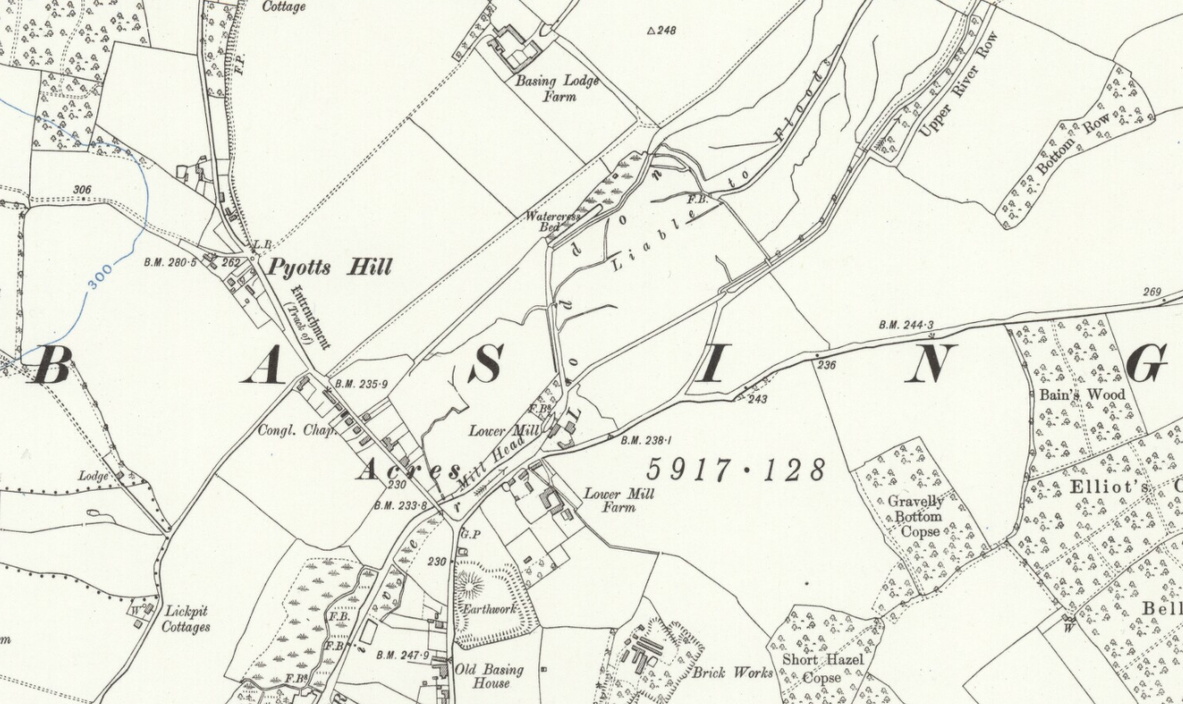

Fig 1: Location of Pyotts Hill Congregational Chapel

Like many other rural chapels it was a simple building, with no embellishments. It can just about be seen in the photo of Pyotts Hill which constitutes Fig. 2.

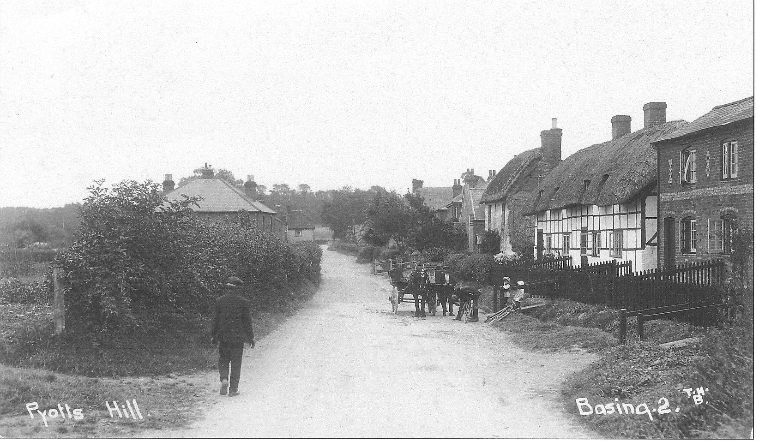

Fig 2: Pyotts Hill Congregational Chapel

In 1908, when the London Street Church magazine was re-launched, the situation at Pyotts Hill was summarised as follows:

Good congregations and an all-alive appearance characterise our work in this village. There is a Band of Hope, a flourishing [Sunday] School, afternoon and evening services on Sundays, and a midweek preaching service. The Choir journeyed to Tadley and gave a Service of Song which was much appreciated.

Such buoyancy meant that the premises needed to be kept in good repair.
In 1912 they were renovated, thereby presenting ‘a very pleasing and comfortable appearance.’ Since much of work was undertaken on a voluntary basis by ‘friends’ of the chapel, it was, in the words of the London Street Church magazine, ‘a splendid testimony to their devotion to this little Church.’ Later, in 1914, the chapel premises were extended. As reported:

August Bank Holiday was a red letter day in the history of Pyott’s Hill chapel. For a long time past the present building has been found insufficient, and an additional room for small meetings and for the work amongst young men has been erected … The proceedings commenced with a short dedicatory service and formal opening of the new room. This was followed by tea in the meadow…

Notwithstanding the inclement weather over 200 attended, with the Mortimer and Silchester united brass bands helping to entertain them.
During the inter-War period the rhythm of church life remained relatively undisturbed, with regular Sunday services and special events, such as New Year parties for the children; celebrations to mark the anniversary of the Sunday school and services of song. There were also fetes and teas for adults. Even as late as 1937 there are references in the London Street Church magazine to the revival of Women’s Own and the considerable interest in the Sunday School and a newly established Children’s Hour. However, perhaps indicative of the challenges to come, reference was also made to the lack of funds preventing the Sunday school scholars having their usual summer outing.
Initially the outbreak of War did not adversely affect the situation beyond making it more difficult for preachers to get to the chapel due to petrol shortages. Nonetheless, a service was held every Sunday until the winter of 1941 when it was decided to suspend services for three months, a sign that all was not well. That said, following their suspension services were resumed with a statement being made that there was no intention of permanent closure. However, by mid-1943 it was clear that with dwindling numbers this was to be the ultimate fate of the chapel. Accordingly, in the words of Rev. Wilfrid Salmon, London Street’s minister:

To our great regret, circumstances have obliged us to close Pyotts Hill chapel. Opened 71 years ago, it has had a long career of usefulness. For more than half a century it was well supported, and maintained a vigorous Sunday School. Its influence extended well beyond the boundaries of the village. Of late years, however, congregations have dwindled, and the Sunday School has ceased to exist. It has become apparent that the Methodist Church in the centre of the village is in a better position to meet Free Church needs. The facts of the situation had to be faced sooner or later … The closing service was held on 26th September [1943].

Reference was also made to contributions of ‘Mrs King, who for so long was the centre and focus of chapel affairs’ and Mr E.G. Leavey, the organist: ‘Without his valuable and talented assistance the chapel might have been closed much sooner.’
It is interesting that in Old Basing the spiritual needs of the remaining chapel adherents were seen as being most appropriately met by the Methodist Church. As Anne Pitcher records most of Congregationalists ‘joined the worship at the Methodist Chapel in the Street.’ The Congregational chapel building was subsequently used as a warehouse and during the mid-1950s converted into residential accommodation, which continues to be the position in 2015.

Frederick Powicke, A History of the Cheshire County Union of Congregational Churches (Manchester, 1907), 92, quoted in Gerald Rimmington, “Congregationalism in Rural Leicestershire,” 97. Mackennal was the distinguished minister of Gallowtree Gate Congregational Church in Leicester.
John A.Vickers (ed), The Religious Census of Hampshire 1851 (Winchester: Hampshire County Council, 1993), 180.
William White, History, Gazetteer and Directory of Hampshire (Sheffield: William White, 1878), 128.
Annual Reports of the HCU, Hampshire Record Office Ref: 127M94/62/…
Gordon Timmins, Old Basing: A village history (G. Timmins, 2006), unpaginated. See also Hampshire Treasures Survey: Vol. 2 Basingstoke and Deane (Winchester: Hampshire County Council, 1979), 21.
Basingstoke Congregational Magazine Vol. 1 (New Series), No.1 (January 1908), unpaginated.
Basingstoke Congregational Magazine Vol. 5 (New Series), No.7 (July 1912), 4.
Hants and Berks Gazette, August 8, 1914.
Basingstoke Congregational Magazine Vol.30 (New Series), No.4 (April 1937), 9.
Basingstoke Congregational Magazine Vol.30 (New Series), No.12 (December 1937), 9.
Basingstoke Congregational Magazine Vol.30 (New Series), No.7 (July 1937), 7.
Basingstoke Congregational Magazine Vol.36 (New Series), No.10 (October 1943), 1. In referring to the chapel being opened 71 years earlier, the minister was using the year shown in the Hampshire Congregational Union records as the basis of his calculation.
Anne Pitcher, Old Basing (Author, 1978), 75
Hampshire Treasures Survey: Vol. 2 Basingstoke and Deane (Winchester: Hampshire County Council, 1979), 21.

