COAL SHIPMENTS FROM THE WEAR, 1606-1720
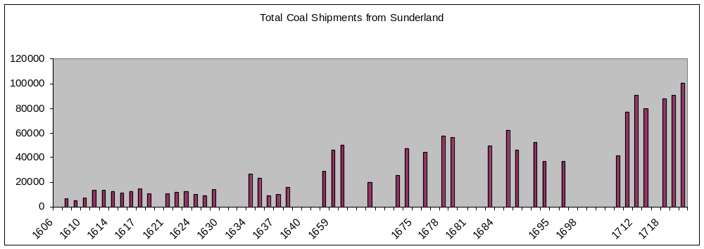

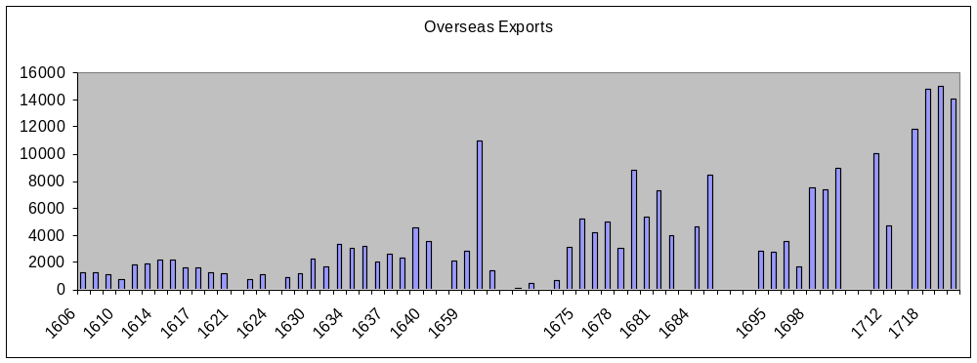

Sources: Sources: Hatcher 1993, 493-5, is preferred to Dietz 1986, 291, for 1606-1700; supplemented by Dietz; supplemented for 1608, 1610, 1623 and 1630-1 by E Sussex RO, GLY/ 387, /447-58, /478-96, and for 1635-8 by W Yorks RO, Leeds, 100/PO/6/VI/4; Dietz is used, 1703-50.

Quantities are given in chaldrons. Conversions from tons to chaldrons have assumed 53 cwt (2.65 tons) per chaldron, which may not be accurate for the 17th century: see Dietz 1986, 282-3.

References: J. Hatcher, History of the British Coal Industry, i. Before 1700: Towards the Age of Coal (1993)
B. Dietz, ‘The north-east coal trade, 1550-1750: measures, markets and the metropolis’, Northern Hist., xxii (1986), 282-3.

