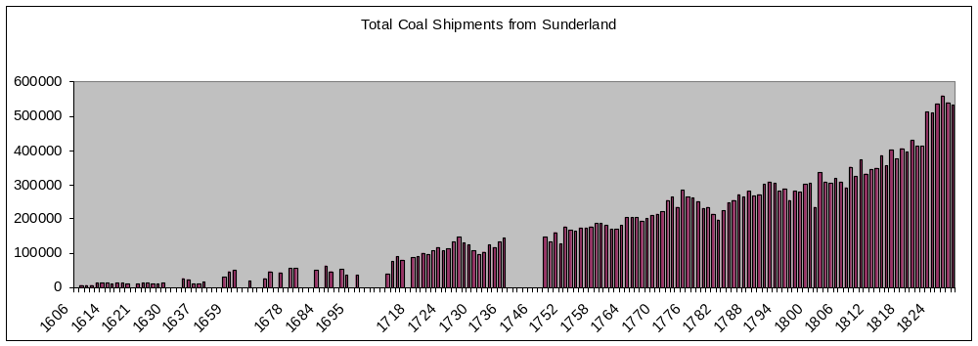

Sources: Hatcher 1993, 493-5, is preferred to Dietz 1986, 291, for 1606-1700; supplemented by Dietz; supplemented for 1608, 1610, 1623 and 1630-1 by E Sussex RO, GLY/ 387, /447-58, /478-96, and for 1635-8 by W Yorks RO, Leeds, 100/PO/6/VI/4; Dietz is used, 1703-50, supplemented 1722-39 by Northumbs RO, 3410/GA/2, p. 68, for 1721-2, 1732-3 and 1736 by Miller 1978 based largely on River Wear Commission figures which are in general lower than rival estimates, and for overseas exports 1717-23 by TNA, T 1/332/30; TNA, T 1/332/31 for overseas exports 1745-7; Garbutt 1819, 394-5, chart 1749-91, derives from Holmes; Northumbs RO, 3410/East/4, p. 33, 1791-1812, derives from Surtees, I pt. 2, 265, though see Durham Chapter Lib., Sharp 2, facing p. 265, and for coal exports 1786-9, Northumbs RO, 3410/Wat/1/17; Northumbs RO, 3410/Bud/54/45, 1822-7; Durham Chapter Lib., Sharp 2, facing p. 265, 1819-21, 1828.

Coal is measured in chaldrons on these charts. Conversions from tons to chaldrons have assumed 53 cwt (2.65 tons) per chaldron, which may not be accurate for the 17th century: see Dietz 1986, 282-3.

