Selected Photographs of keigwins

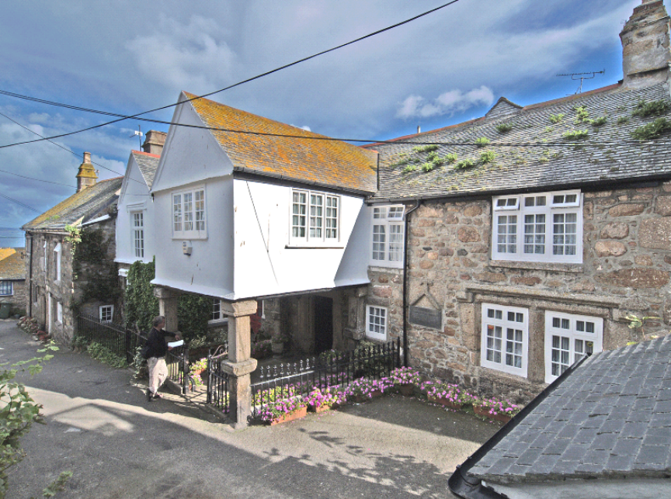

- Keigwin with Little Keigwin and the Old Standard far left

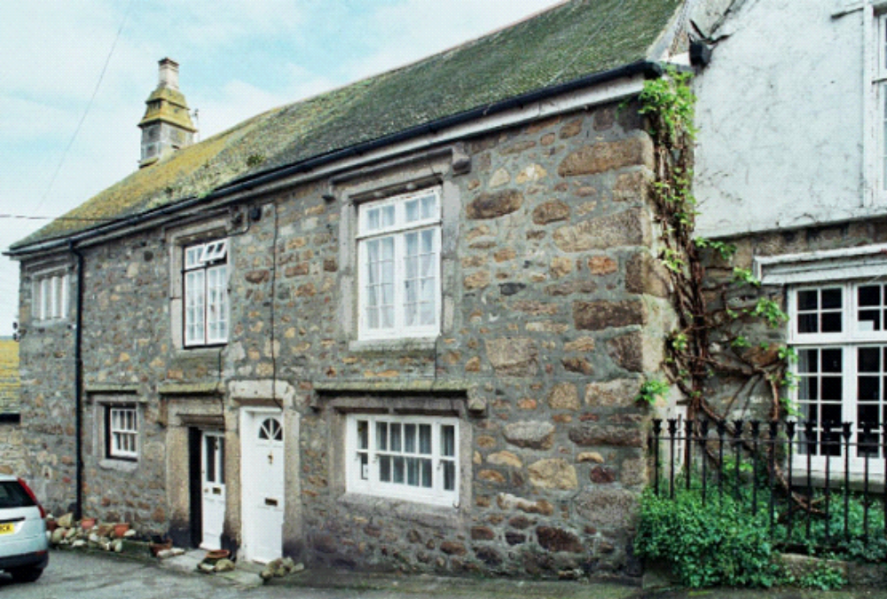

2. The Old Standard

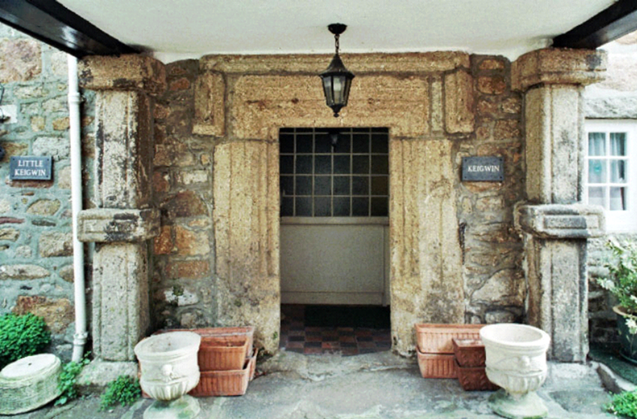

3. Keigwin: moulded granite front doorway and flanking columns of late porch

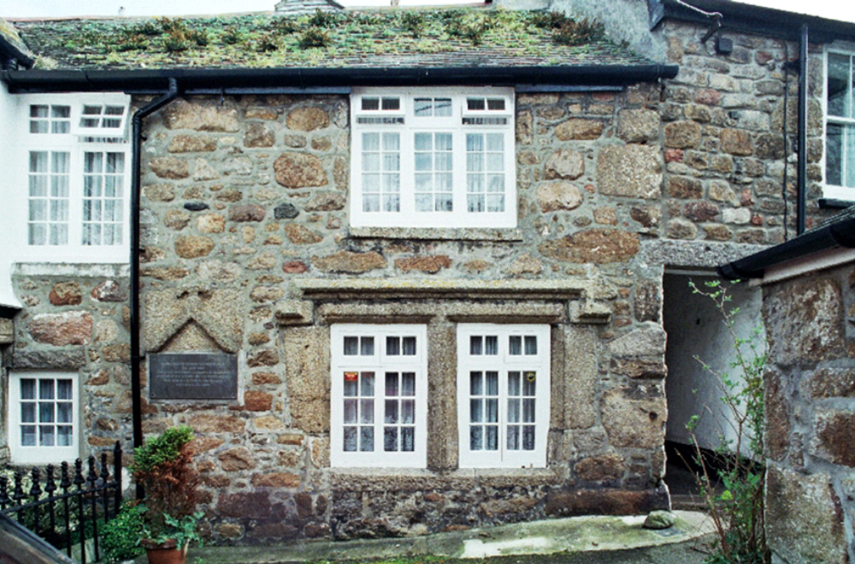

4. Keigwin: restored hall window and reset gable coping of former lateral stack

