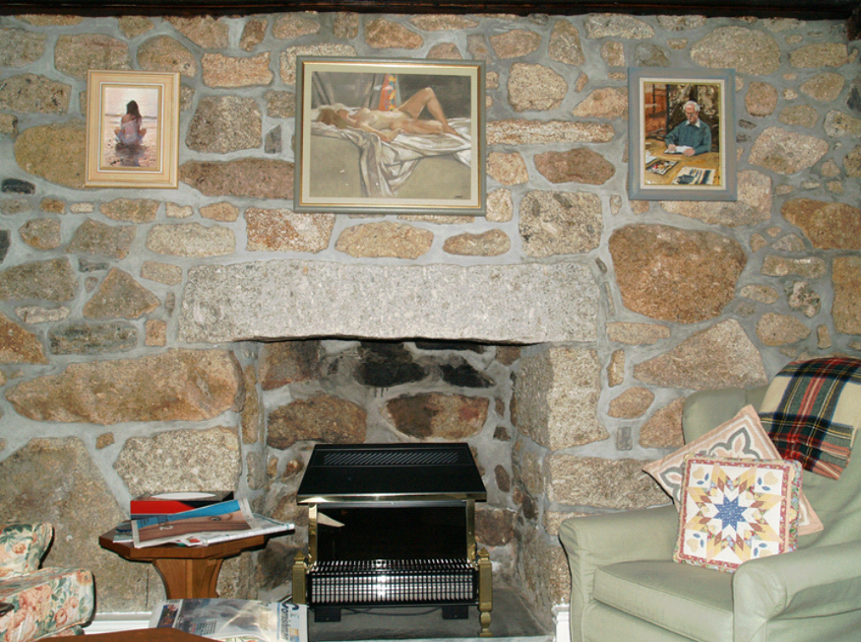

13. Keigwin: remodelled inserted fireplace to west end of hall

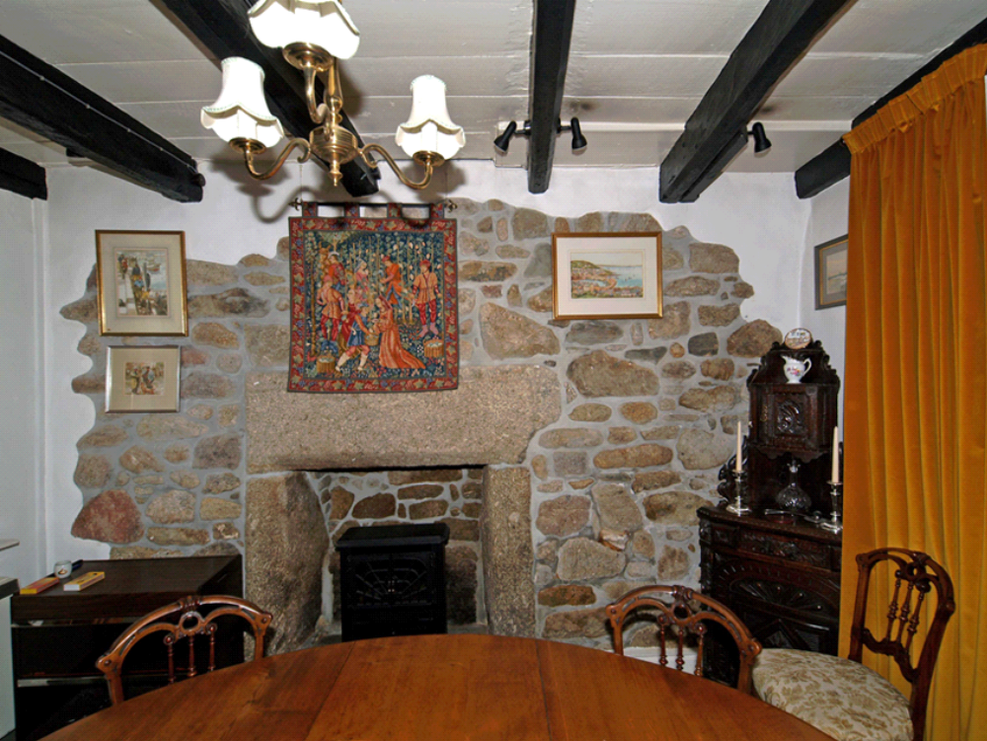

14. Keigwin: original parlour fireplace and ceiling with original chamfered joists
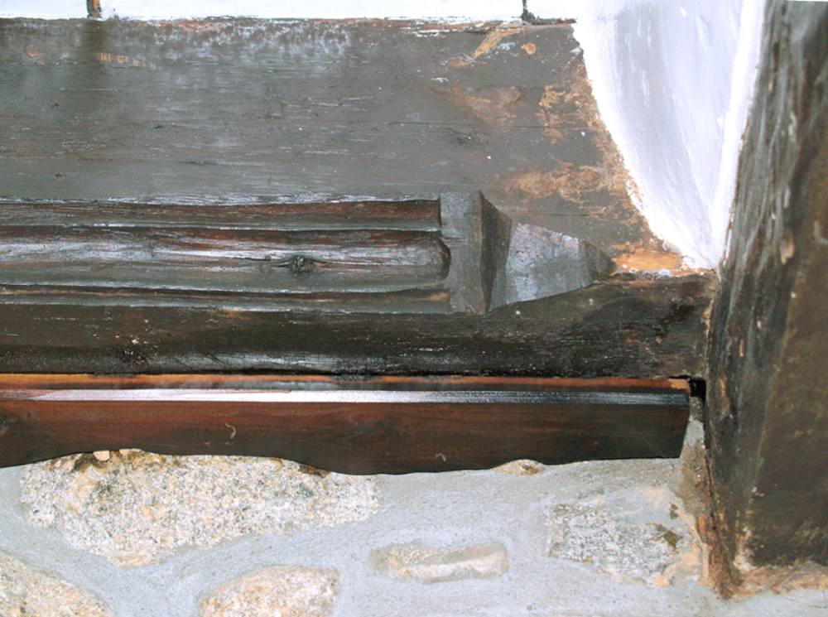

15. Keigwin: hall ceiling detail with moulded joist and stop

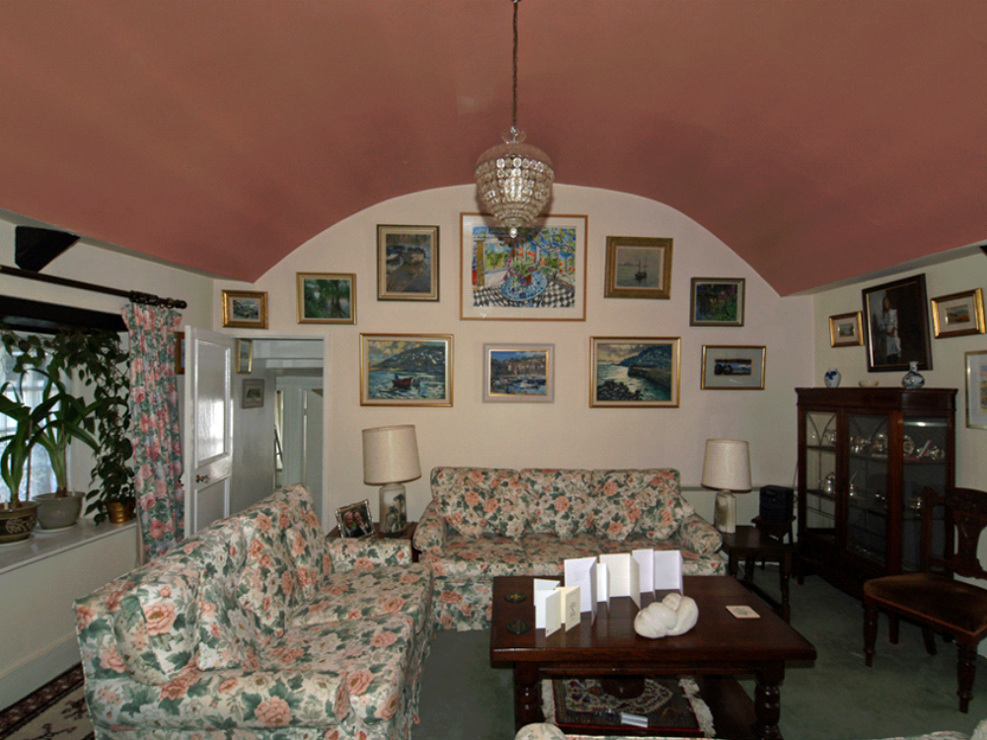

16. Keigwin: chamber over parlour with plaster barrel ceiling and 2-panel door

