PERCY BOND HOUFTON
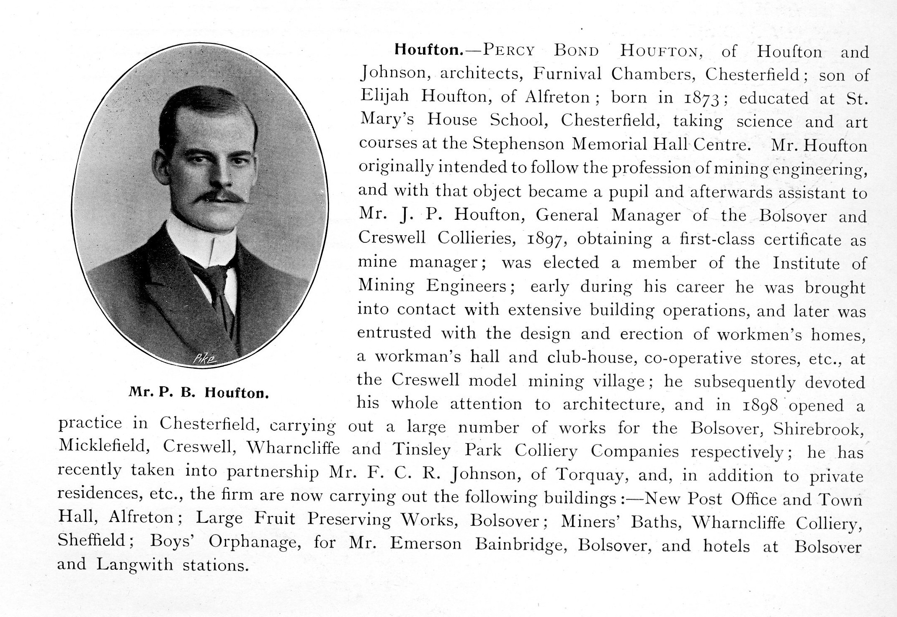
The article above is from Nottinghamshire and Derbyshire at the Opening of the Twentieth Century: Contemporary Biographies, edited by W.T. Pike, published in 1901. Though it is not entirely clear from this biography, or from that of John Plowright Houfton in the same publication, they were cousins.

The Derbyshire Times obituary (22 May, 1926 edition) describes P.B. Houfton’s life, through which we are able to find out much more about him.

He had a long-standing interest in model colliery villages. Whilst Bolsover Model Village had been built by a Nottinghamshire company, P.B. Houfton is named as the architect of Creswell Model Village and the Institute there.

His success at Creswell resulted in Houfton being given charge of the south Yorkshire village of Brodsworth. Here he ensured, according to the Derbyshire Times, ‘ample space between the houses, good playing grounds and institute and amenities hereto unheard of in colliery villages’.

He was next involved with the so-called ‘White City’ at Rainworth, near Mansfield. At the time of his death Houfton was in charge of new villages at Rainworth and Clipstone. Here again were playing grounds, institute, etc.

Other major buildings Houfton was also responsible for included the original Chesterfield Technical College block, on Infirmary Road in that town and the former Midland Bank, Chesterfield.

Houfton, in conjunction with Derbyshire County Council’s architect G. H. Widdows devised the so-called ‘open-air system’ for school architecture. Several schools were built to this plan.

Amongst his many works, Houfton was also responsible for the design and layout of housing estates in Chesterfield (at Boythorpe, Highfield, Derby Road and Tapton (which was not built)), Edwinstowe, Ashbourne, Clay Cross and two in South Wales. Houfton was consulting architect to Chesterfield Rural District Council. He had also designed a set of plans for the Derbyshire Miners’ Convalescent Home at Skegness. Before his death, one of his more recent works had been offices for the Staveley Coal and Iron Company.

On his death, aged 51, Houfton was a fellow of the Royal Institute of British Architects. He lived at Brookside, Chesterfield.

