Miles Astman Wood FRCS. MRCS, LSA

Miles Astman Wood was born at Newent in Gloucestershire about 1807. He trained at Guy’s Hospital, London, and for a short time in Paris under Laennec, the inventor of the stethoscope. As well as his medical studies, he was a scholar of Latin and French. In 1830 he qualified as a Member of the Royal College of Surgeons and a Licentiate of the Society of Apothecaries. He first appears in Ledbury in 1838, listed as a surgeon in New Street. Directories of 1842 and 1851 listed him as a surgeon at the Dispensary in New Street. In 1861, when Ledbury was full of workers building the railway line from Hereford to Worcester, he was appointed surgeon to the railway company. The Jakeman & Carver Directory of 1890 listed him and the dispensary in New Street. He was still in practice in 1891, at the age of 84, though with the assistance of his son Miles Astman Wood and B. Frederick Rainsford from Galway, who lived with the family, as had earlier assistants. He died on 28 July 1898, aged 91.

Miles Astman Wood married Anne, the daughter of Thomas Webb, JP, the Ledbury banker. She had been born in Ledbury about 1811 and died on July 25 1872. They had seven children, four sons and three daughters: Myra (bapt. 20 April 1840), John Henry (bapt. 14 May 1841), Miles Astman (born c. 1843), Elliott (born c. 1844), Constance (born c. 1846), Elizabeth (born c. 1848) and Charles Knight (born c. 1852). The family lived at Orchardleigh, New Street, and featured in all the census records from 1841-1901. A professional assistant was employed in 1851 and 1861, but by 1871, Miles Jnr was recorded as a registered general practitioner living with his father. In1891, Miles Snr, now 84 years of age, again employed a professional assistant. Two of the sons, John Henry and Miles Astman, became doctors like their father. Elliott was a soldier, rising to become Major-General Sir Elliott Wood, K.C.B. Charles or ‘Charlie’ also joined the Royal Engineers and became a Lieutenant Colonel. Of the daughters, Constance remained with her brother Miles until 1901 – neither of them married.

The household of the Wood family was supported by a considerable domestic staff, who lived in. Was it a matter of professional discretion that most of the servants came from outside of Ledbury? A cook was recorded throughout the period, though only in 1871 and 1881 was she the same person, Elizabeth Hill. A housekeeper featured in 1861, the only year when no housemaid was listed. In 1851, when the children’s ages ranged from 3 to 11, both a nurse and a governess were employed. Whether the servant described variously as a page or footman, was purely for family service or concerned with the doctor’s profession is not clear. Until 1881, the adjacent property was occupied by a groom, James Williams, whose eldest son worked as stable boy. It is possible that these were also part of the family’s workforce.

The status of the family is confirmed by the memorial plaque on the north wall of the Parish Church which bears the motto ‘virtus et fortitudo’ and records that Ann Wood was the daughter of Thomas Webb JP and Deputy Lieutenant. Ann and Miles Astman, their children, gave the church a carillon of seven hymn tunes in memory of their parents. This carillon still plays each day, honouring the family that had contributed to the medical welfare of Ledbury’s inhabitants for at least seventy years.
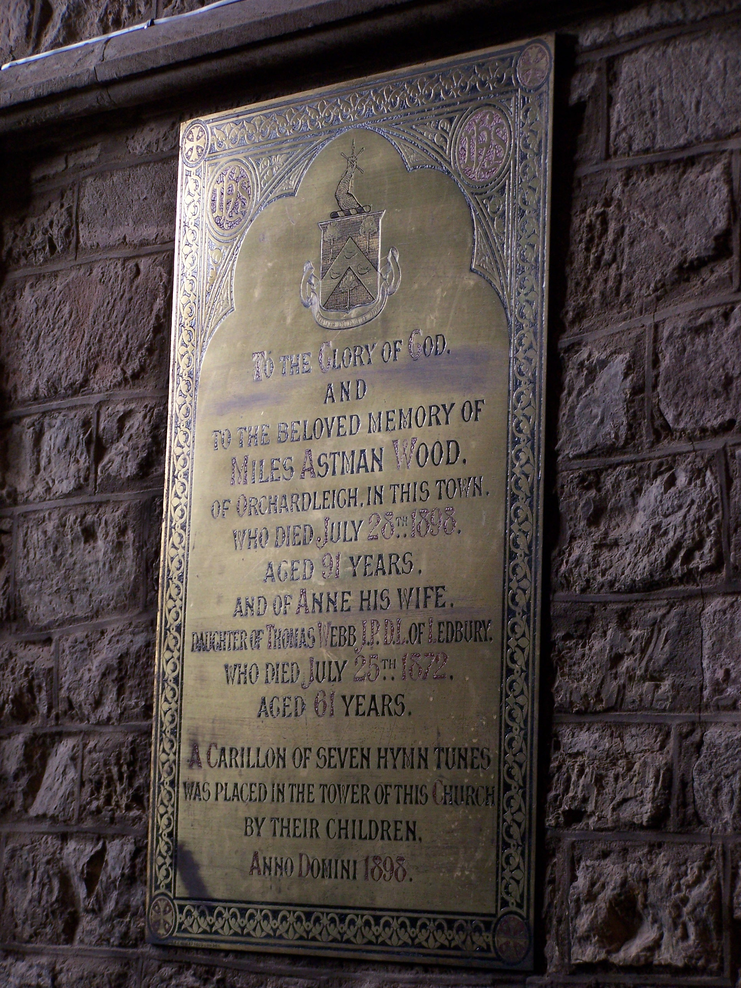
© Lowe

TO THE GLORY OF GOD
AND
TO THE BELOVED MEMORY OF
MILES ASTMAN WOOD
OF ORCHARDLEIGH, IN THIS TOWN.
WHO DIED JULY 28TH 1898
AGED 91 YEARS.
AND OF ANNE HIS WIFE,
DAUGHTER OF THOMAS WEBB J.P. D.L. OF LEDBURY,
WHO DIED JULY 25TH 1872.
AGED 61 YEARS.
A CARILLON OF SEVEN HYMN TUNES
WAS PLACED IN THE TOWER OF THIS CHURCH
BY THEIR CHILDREN,
ANNO DOMINI 1898.

John Henry Wood trained at King’s College Hospital, London, and became a Fellow of the Royal College of Surgeons. He was a general practitioner in Tarrington, only a few miles from Ledbury. Although he did not marry, his brothers and sisters regularly visited him, enjoying tennis parties and family gatherings. With his brother Elliott he made canoe trips down the river Wye. However, his real passion was natural history, of which he developed a very broad knowledge. He became internationally renowned for his study of tiny moths (microlepidoptera). Two European butterflies are named after him. He published 45 scientific papers on the tiny moths and on flies (Diptera) and his collections of both are at the British Museum. He published four articles in the Woolhope Club Transactions. His very readable diary, 1891-1894 is now in the Hereford City Library.

Miles Astman Wood also trained at King’s College Hospital, London, and was registered Fellow of the Royal College of Surgeons by at least 1871. In 1890, Miles Astman Jnr. LRCP & FRCS, was also Medical Officer to Ledbury District and to the Union Workhouse.

Sir Elliott Wood (1844-1931), Major-General, KCB

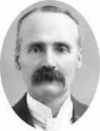

Sir Elliott Wood, courtesy of the Royal Engineers Museum

Elliott joined the Royal Engineers and served in the Sudan and in South Africa. He led the 17th company from Cairo to take part in the Suakin Expedition in 1895. He was responsible for laying a railway line from Mafeking (check) to Berber. He is credited with having devised the use of blockhouses (small forts) during this campaign. They were used much more extensively in the Anglo-Boer War 1899-1902 in South Africa. Elliott was the Chief Engineer during this time. He retired to Holmer Court in Herefordshire and wrote his memoirs, Life and Adventures in Peace and War in 1924.

Charles Knight Wood (1852-?)
He was born about 1852, and appears to have been named after his uncle Charles Knight Webb. By 1901 Charles Knight Wood was aged 49 and a Lieutenant Colonel in the Royal Engineers. He and his wife Lilian were living at R.E. House in St. Paul’s parish, Sheerness, Kent. With them were their sons Miles Astman, aged 13, and Charles, aged 9.

This article is based upon the research notes of:
Dr. Henry Connor
Dr Basil Miles,
Liz Wreford, EPE volunteer
Ann Ralph, EPE volunteer

Elliott Wood (1844-1931) Correspondence and papers 1869-1924, Royal Engineers Museum, 9301.15.1-121, Correspondence with Sir Reginald Wingate 1895-1900, Durham University Library Archives and Special collections, Wingate Papers
1881 Census records show him, aged 39, GP, MB London, MRCS London, living a s a lodger at the Willows (Post Office), Tarrington, with Silas Wood, 63, his wife Susannah, aged 62, and their daughter Susan, aged 32. He was at the same address in 1891 and 1901.
Transactions of the Woolhope Naturalists Field Club: ‘On clear-wing sphinges’, 1876, 199-202; ‘The Nepticulae of the Woolhope district’, 1891, 257-264; ‘Additions to the list of Herefordshire lepidotera since 1892’, 1899, 186-189; ‘The diptera of Herefordshire – the Platypezidae, Pipunculidae, and Syrphidae’, 1903, 363-375.

