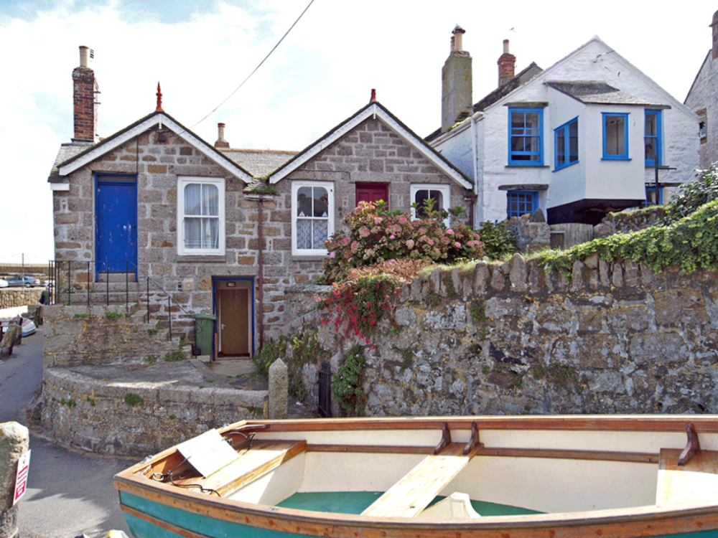
43. Context: 18th century houses remodelled c1900 east of the Old Standard

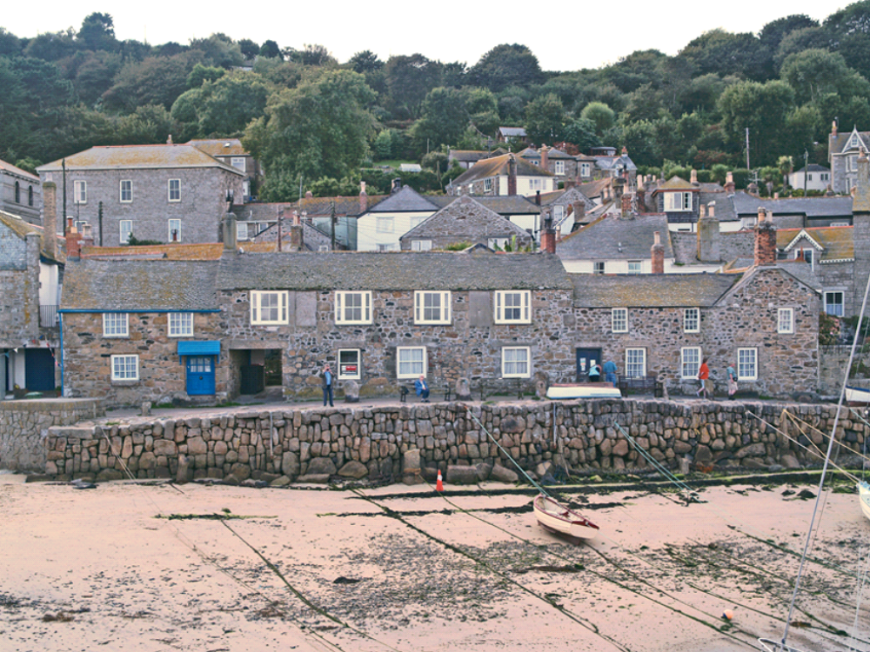
44. Context: the Wharf: 18th century row of cottages, the central part rebuilt in the 19th century

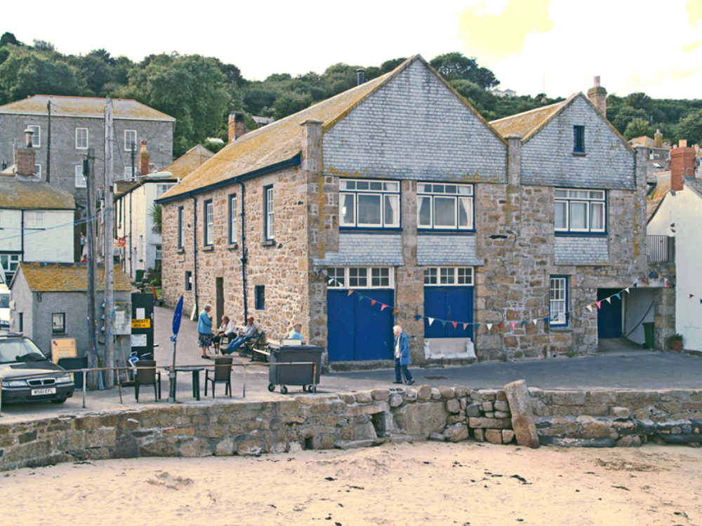

45. Context: south-east corner of block of buildings relating to Keigwins and the Old Standard

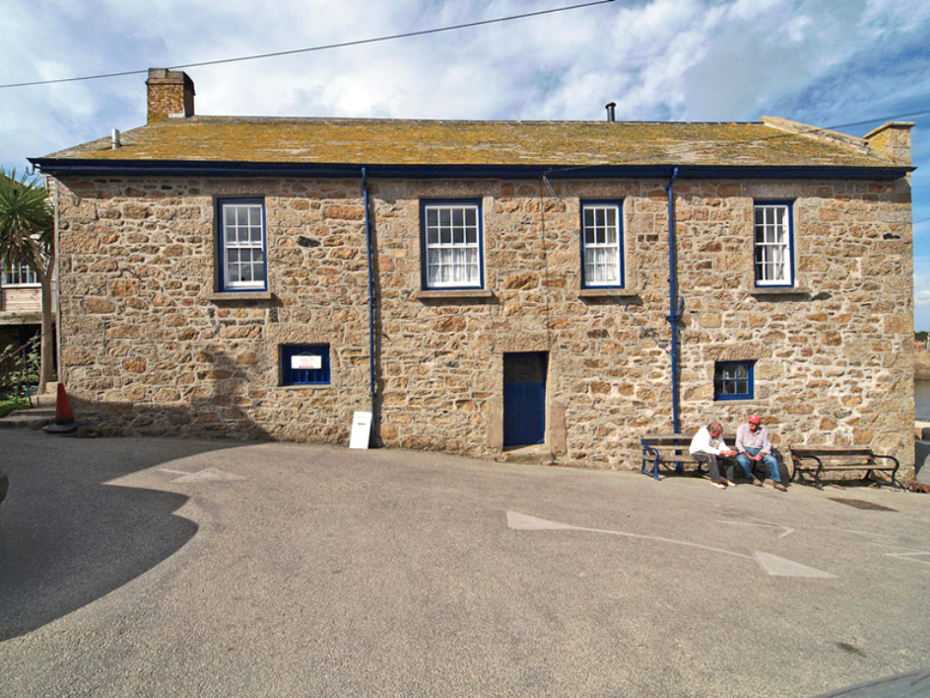
46. Context: south end of former fish-processing buildings south of Old Standard

