completed parish survey questionnaire for mylor.

Date of Completion
31st October 2006

Name of Volunteer
Felicity Collins

Grid Reference
OS Explorer 105 820 353

Status (In use/redundant – open/closed)
Church of England – in use – normally open

Guide Book/sheet/tablet?
Concertine Leaflet Guide to the Parish Church of St Mylor. Price 50p. Olivia Stationery, Camborne.
Hand boards in French, German, Spanish and Dutch.

Stained Glass Windows
None known to be prior 1559

Bench Ends
- Two identical bench ends joined to the screen at right angles and forming part of the choir stalls north and south.
Each has: two plain shields set horizontally on two cusped tracery panels, above which are four smaller, semi-circular beaded tracery panels. A band of intertwined foliage across the base and a twisted pattern among the top.
- Some parts of a Medieval Rood Screen reformed in its original position. 4 panels with undulating foliage. Some of the colouring remains red and black.
Above the panels an inscription:
IARYS IONAI JESW CREST
Possibly the old Cornish words meaning “The grace of our Lord Jesus Christ”. Alternatively it may be “Mary, John, Jesus Christ” referring to the original Rood.

Please see sketch of bench end drawn by a volunteer, Joan West, below
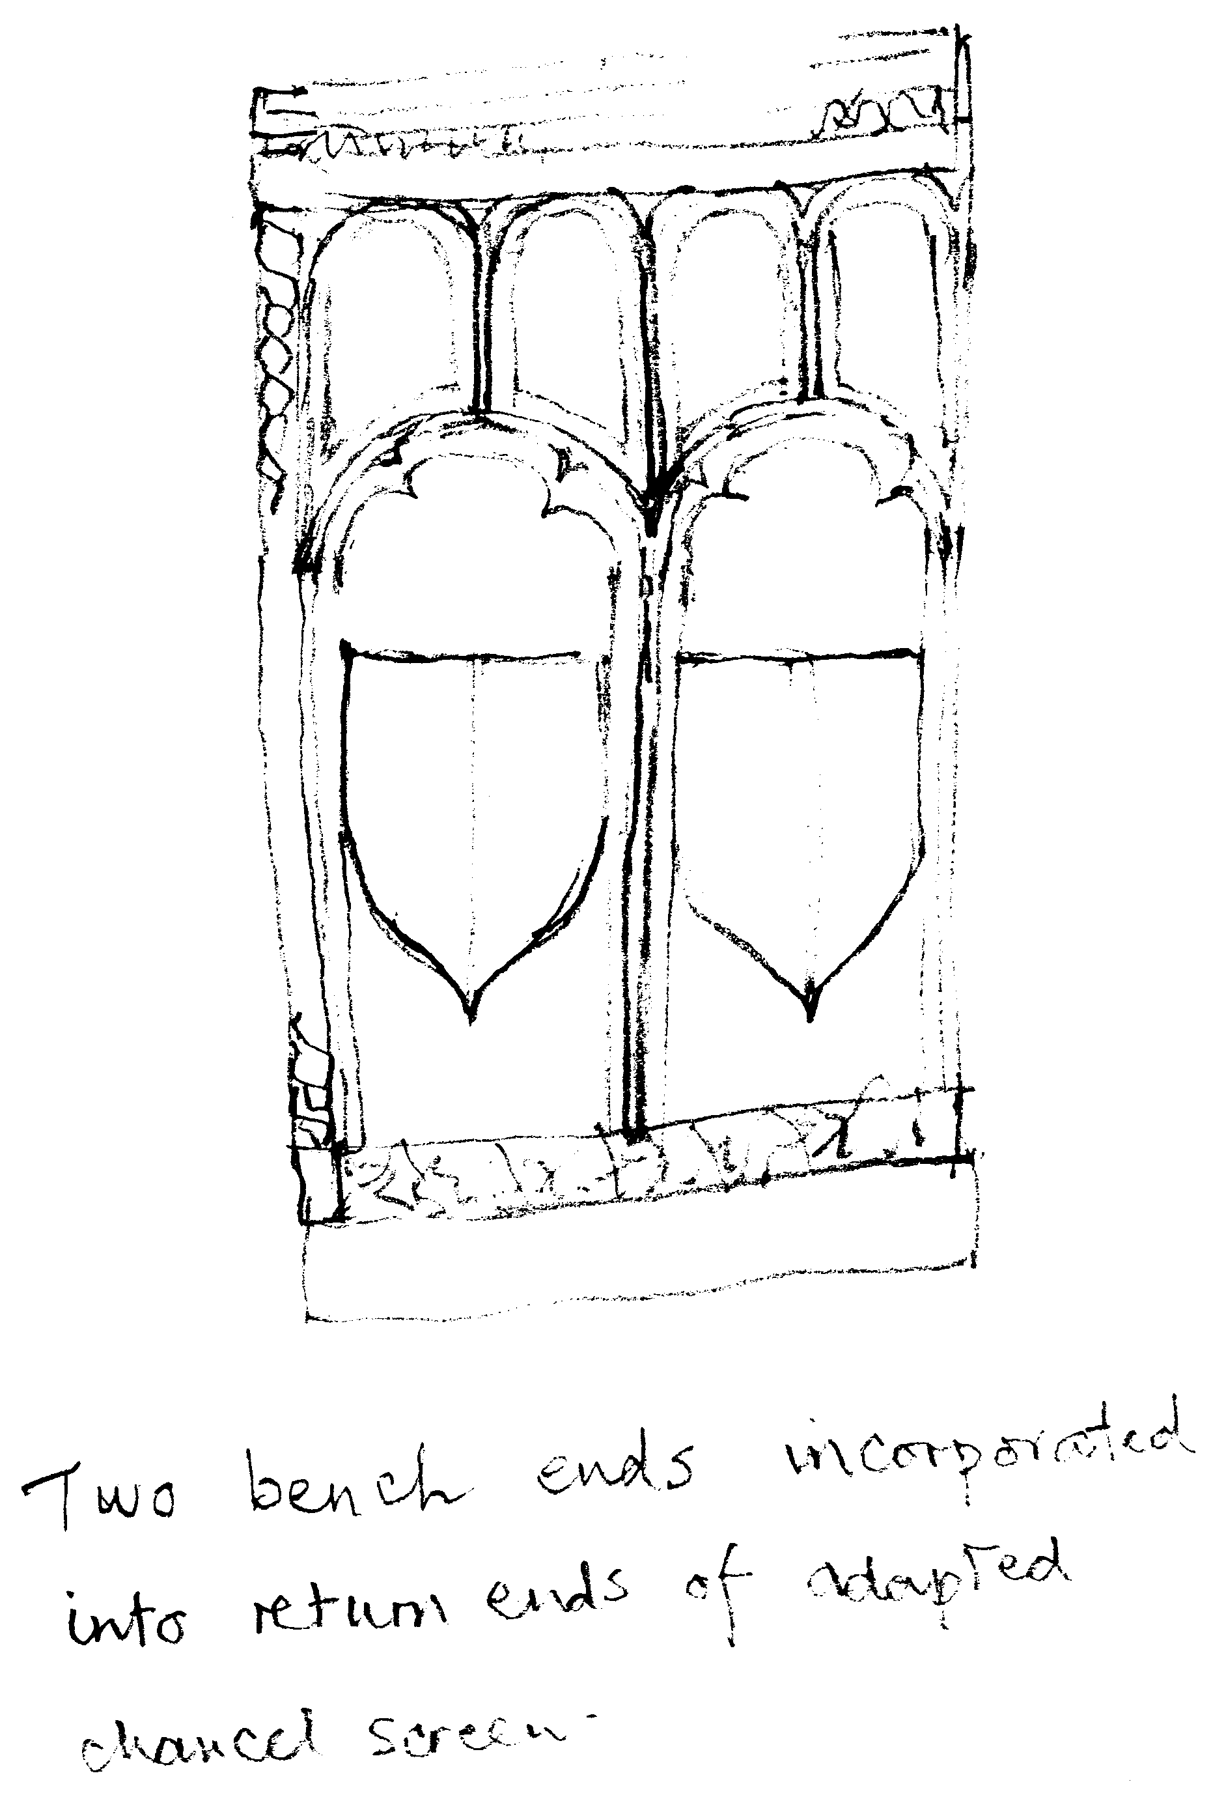

Chapels
None known

Holy Wells
None Known. A modern well at St Mylor Church has been created from one of the many spring in the churchyard.

Crosses
No.1
Name: The Cross of St Mylor
Location: OS Explorer 105 820 353
Nature of Location: Outside St Mylor Church to east of the south porch.
Surviving Remains: Stone Monolith of granite 17’6” in length, of which 7’ is buried in the ground. Thought to be the tallest in Cornwall. The cross on the head incised to supercede the disc. Unique pattern of 3 concentric circles below the neck. Reinstated in present position c.1870, having been used as a flying buttress to the church.

No.2
Name: The Flushing Cross
Location: OS Explorer
Nature of Location: St Peter’s Church, Flushing, in front garden.
Surviving Remains: Head of the Cross, which once stood high on the hill above the village on the stone is an incised figure in a tunic surrounded by a circle. The skirt of the tunic is now beneath the soil. A Latin cross is on the back of the stone. Thought to have been a Wayside Cross placed on the route from the Manor of Restronguet to Arwennick (Falmouth).

Wall paintings
None

Other Objects
- High backed wooden chair with arms in St Mylor Church. Date of chair unknown. By hearsay may have come from Glasney College, Penryn. Made of Bog oak and crudely constructed with carvings of the Magi and of the Tudor Rose.
- Also in St Mylor Church: Fine oak carved pulpit, exact date unknown, reported to be early Elizabethan.
- Stone pillar priscina in St Mylor Church, near altar.

Other Religious Sites
Cregoes 4 fields to the south of St Mylor Church and on Trefusis land at the top of the hill. The name of the fields means the barrows or burial places and is thought maybe the position of old Mylor Churchtown. The field names are: Lower Cregoes, Middle Cregoes, Higher Yonder Cregoes and Higher and Lower Homer Cregoes comprising around 54 acres.
Location: Explorer OS 105 821 345

Parc-an-Grouse Field of the Cross – and part of Restronguet Barton. A Cornish cross onr Menhir may have existed here.
Location: Explorer OS 105 812 363

Restronguet Manor thought to have its own chapel in the Middle Ages – Location unknown.

(Another small field nearly adjacent to Parc-an-Grouse is named Church Close on the Tithe Map of 1839 but not known by this name today).

Books of Reference, Articles or others sources referred to
Hugh P Olivery MRCS Notes on the Parish of Mylor Cornwall Publisher: Barnicott, Pearce, Athenaeum Press 1907 (now out of print and unavailable).
Revd J C James St Mylor’s Church – Brief History Published by Mylor History Group 2004 reprinted 2006.
U.M. Redwood Guide to Flushing St Peter’s P.C.C. reprinted 2000.
Inside Churches – a guide to Church Furnishing. Revised by NADFAS 1993 -= based on original edition by Patricia Dirsztay.
Nicholaus Pevsner Buildings of England Reprint 1977. Penguin Books Harmondsworth, Middlesex.
Tithe Map of Mylor Parish 1839 Cornwall County Record Office.

Personal comment

