CAROLINE CAREY WIFE OF FRANCIS Dickinson

Caroline Carey was the daughter of Major General Thomas Carey and his first wife Caroline Smith of Woodhall Park, Hertfordshire who died in 1816 following her daughter’s birth. In 1835 the young Caroline married Francis Dickinson of Kingweston, a gentleman antiquarian in the high Anglican tradition who owned virtually the whole parish. They spent some of their time at Kingweston House by then surrounded by maturing plantations, avenues and parkland.
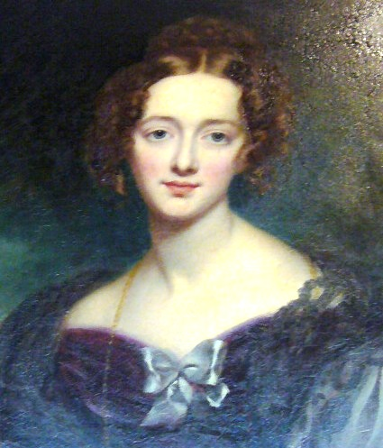

Caroline and Francis had seven daughters and six sons, one of whom Henry died an infant. Only two of her sons and two of her daughters married. Her son Carey was ordained but died in his twenties and her daughter Gertrude and Philippa had also died young. When Caroline made her will on 24 November 1888 she was anxious to provide for her unmarried daughters. She appointed her eldest daughter Sophia and her second son Reginald as executors. She gave Sophia most of her books, her pictures and the jewellery in her dressing case or elsewhere, except the diamonds given to Francis by Maria Pinney that were family heirlooms, to be divided between her and her unmarried sisters as she saw fit. The rest of her property she left to her husband Francis for life. After Francis’s death Reginald was to have the books in St George’s Square London that had been her stepmother’s. She gave her piano to her daughter Frances and her £470 Great Indian Peninsula Railway stock to her daughter Lucy, a young widow who had that May married the Revd Iltyd Rosser. Caroline left her plate with the swan crest between her daughters who should be unmarried at Francis’s death. She confirmed an estate settlement made in 1887 and gave the residue of her estate after her husband’s death to her daughters Sophia, Frances and Edith if they were then unmarried. The will was witnessed by the Revd George Horner and Maurice Horner, JP.
Her other children were presumably well provided for. Her eldest son William would inherit the Kingweston estate and already had children of his own as did Arthur who had married Alice daughter of Augustus Woodforde of Ansford. Of all her children it was the sixth daughter Mary who had made the best marriage. She married Thomas Charles Agar-Robartes, later 6th Viscount Clifden, son of Thomas James Agar-Robartes, 1st Baron Robartes of Lanhydrock, Cornwall on 24 April 1878 at St. Peter's Church, Eaton Square, London. Mary (died 19 January 1921 at Lanhydrock House) inherited her mother’s fecundity giving birth to ten children of whom one died an infant.

copyright
All rights, including copyright ©, of the content of this document are owned or controlled by the University of London. For further information refer to http://www.englandspastforeveryone.org.uk/Info/Disclaimer

SHC, DD/DN 400.

