THE MOTE HALL
The name Moot or Mote Hall comes from an Anglo-Saxon word for meeting or court. Records of meetings of the Court of the Hundred of Basingstoke and the Court of Frankpledge from 1386 are held at the Hampshire Record Office. Selections below are from transcripts by Baigent & Millard.

The Mote Hall stood in the Market Place until it was destroyed in the great fire of 1656. As Court rolls of 1514 and 1520 mention shops under the stair, it was probably similar to the Titchfield Market Hall at the Weald and Downland Open Air Museum, Singleton – the ‘shops’ being temporary stalls that could be folded away at night.

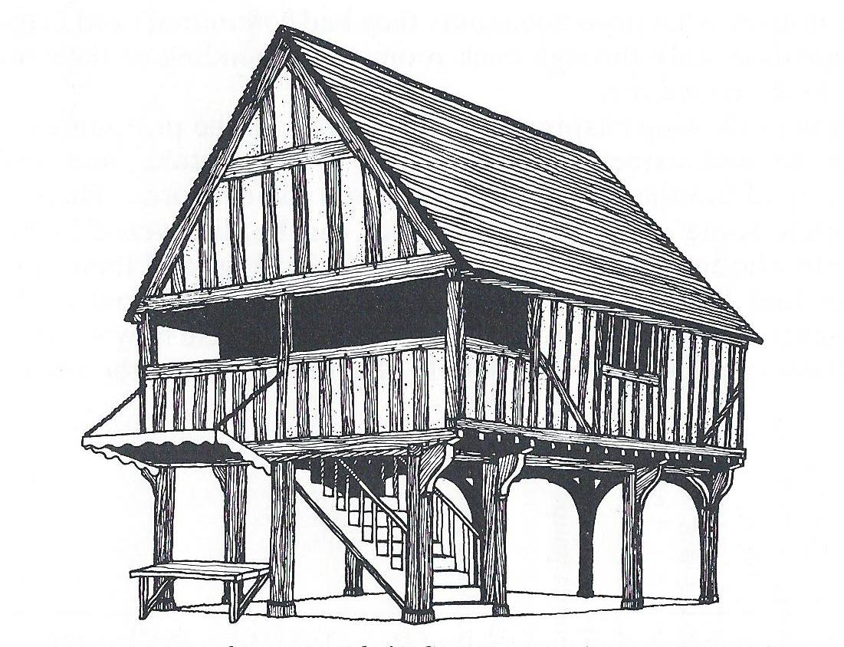
Drawing by Andy Bardell from Voices of Basingstoke 1400-1600 by Anne Hawker

By 1511 the building needed repair: ‘It is ordered by the assent of the twelve jurors that the bailiffs are to build the walls of Le Motehall, against the feast of Pentecost, and they shall take as much as is necessary to build the said walls from the 13s 4d due to the bailiffs from the tithingmen.’ (10th May 1511) And again in 1549: ‘Also they present that the common hall, called le Mote hall, is in decay and ruinous and the rain comes in because it is not well covered with tiles; therefore it is ordered, that the bailiffs amend and sufficiently repair it before the feast of Christmas next, under a penalty of 20s to be levied by the constables and churchwardens and to be spent by them in repairing the roadways.’ (16th November 1549) On 9 Sept 1550 Thomas Canner, son of John Canner formerly of Basingstoke, deceased, granted ‘to Anne Dynett of Basingstoke, widow ... a messuage with cellar in the market place next to the common hall of the town’. Unfortunately there are no more details.

In 1579 some of the most important men of the town did their bit to make improvements: ‘On this day Robert Walker and Robert Stocker the late bailiffs; William Crome, John Greeneway, mercer, John Greene, Henry Hopkins, Roger Reve, John Clarke, Rowland Hollowaye and James Cowslade gave 12d each towards the reparation of the court house (domo praetorii) called le Mote Hall; and the present bailiffs, Clement Southe and Anthony Smithe, have a precept ordering them to repair the tiling and wall of the said house before the next Court Leet under a penalty of 40s to the use of the poor, and whoever neglects to pay to the bailiffs their subscription is to forfeit 6s 8d to the use of the poor.’ (18th November 1579)

It wasn’t only the people of the immediate vicinity who had to come to the courts. Tithing men had to come to pay their ‘cert money’ for Chineham, Cliddesden, Eastrop, Hatch, Kempshott, Nately Scures, Somershill, Steventon, Tunworth, Winslade and Woodgarston. They also had to say that all things were well or to report any misdemeanours: anyone who had broken the rules on the sale of bread or beer, overcharged for services, obstructed roads or streams, ‘unjustly drawn blood’, been ‘a common scold’, failed to clear overflowing gutters or ditches, stolen a horse, a gown, ploughing equipment or other ‘chattels’. Even neighbouring lords were fined, as was John Wallop, Esquire, of Farleigh, who ‘entered upon the common pasture of Basingstoke, called le Downe, with his servants, and ... covered a great part of the same pasture with thorns and thistles cut down and placed there, so that the animals of the aforesaid men and tenants of Basingstoke could not enter upon nor have pasture there for a long time, to their great damage’.

Hampshire Record Office (HRO) 148M71/2/1076
F J Baigent & J E Millard A History of the Manor and Town of Basingstoke, C.J. Jacob, 1889
Baigent & Millard op cit, p 316
Baigent & Millard op cit, p 339
HRO 23M58/246
Baigent & Millard op cit, p 347
Examples are given in Anne Hawker, Voices of Basingstoke 1400-1600 Basingstoke Archaeological & Historical Society 1983
Baigent & Millard op cit, p 292

