Church illustrations

English lettering dating from circa 1340.

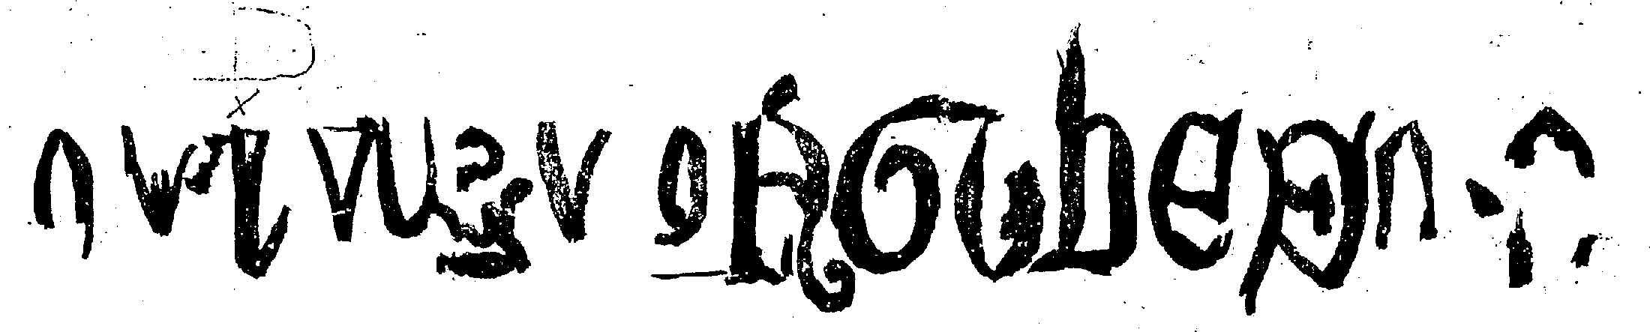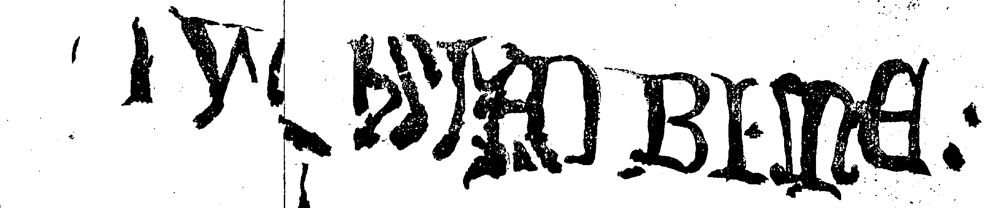

A tracing of the lettering made circa 1900
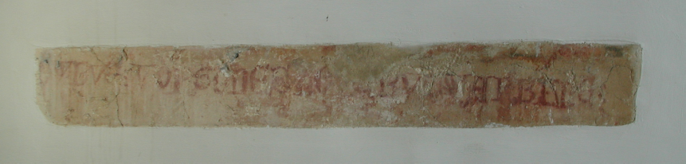

---BV-:VOR-GUDES-----------V---WAR-BI-ME

The letters that it has been possible to decipher

