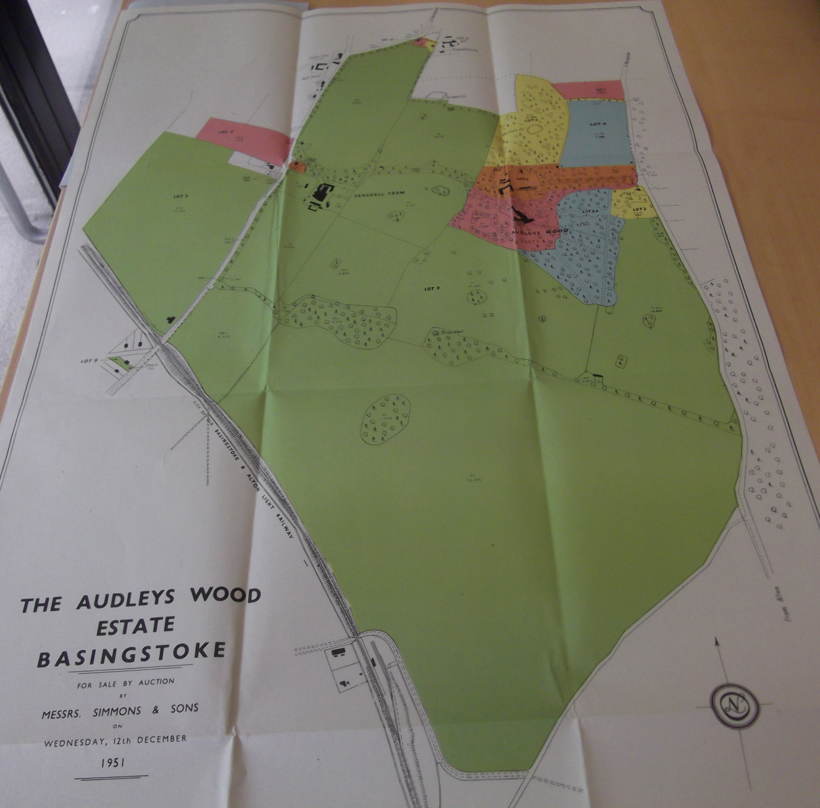
Plan of Audleys Wood Estate in sale catalogue, 1951.

