The Buckskin Farm Burglary and the Epsom Murder
Buckskin Farm was ‘a lonely situation, at least a mile from any other residence’. William Crockford lived there with John Duckett, his carter, and Joseph Pound, his 14 year-old farm servant. Mr Crockford was a wealthy man, and was thought to keep large amounts of cash in his house.
On the night of the 17th April 1832, four men tried to break into the house, but they could not get in as the windows were securely barred, so they had to find a different way of gaining entry. They came up with the idea of opening the farm gate and driving the cows into the garden.
This had the desired effect. Shortly after midnight, the noise of the cows woke Mr Crockford. He looked out of his window, and, by the light of the moon, saw the cows trampling all over his garden. Assuming that Joseph Pound had not shut the gate properly, he woke him up and told him to drive the cows back and shut the gate. Joseph went down, and as soon as he opened the back door, the four men rushed in. One grabbed Joseph, and the other three ran upstairs.
Hearing the footsteps on the stairs, Mr Crockford woke John Duckett and gave him a gun, while he prepared his pistol but it was too late. John Duckett managed to fire his gun, but with no apparent effect. One of the men struck him down with a heavy crowbar. The mark of one of the blows was still on his head two years later.
William Crockford was still preparing his pistol when one of the men seized him before he had a chance to fire. While he was struggling with that man, the man who had put John Duckett out of action struck him on the head with the crowbar, and continued hitting him, smashing his right hand so that he lost one of his fingers.
The robbers demanded that Mr Crockford tell them where his money was. To avoid further injury he showed them a wooden chest. The robbers broke open the chest. Inside was a smaller chest in which were some old parchments and a canvas bag containing £205 in sovereigns, £30 in Bank of England notes, and a promissory note for £200. The robbers took the chest, three gold rings, some silver items, and a horse pistol and went off in the direction of Hatch Warren Farm, where the empty chest was found the following day.
On the 19th of April, Messrs Cole, Lamb and Brooks, Basingstoke solicitors, issued a notice offering a reward of £50 for information that would convict at least three of the four villains. The notice also offered the reward to an accomplice who gave such information.
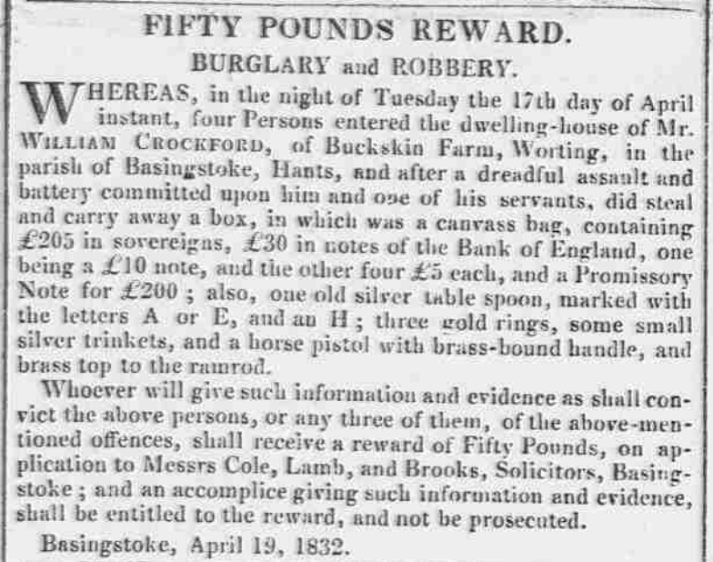

Shortly after, three men from Cliddesden: James Dibley, Charles Dibley, and William Ledger, were charged with the robbery, and sent to Winchester gaol to await trial.
About five weeks after the robbery, Charles Silver, who had worked for Mr Crockford about five years’ previously, applied for the reward. He said that he and John Young, John Blay, and Daniel Higgins, who were known to be ‘a desperate gang of freebooters who have long infested the upper part of Hampshire and Surrey’, had robbed William Crockford. He told John Renouf, the Basingstoke constable, that, after the robbery, they walked to Farnham and on the way there they buried the parchments in a mound of earth. Charles Silver retraced his steps with John Renouf, and they found the parchments near Greywell.
The hunt was now on for Silver’s accomplices. There was no sign of John Young, but the constables managed to catch John Blay and Daniel Higgins. However, when John Renouf was escorting him to Basingstoke, Higgins managed to escape near Virginia Water, despite wearing handcuffs.
John Blay’s trial took place at the Hampshire Summer Assizes in Winchester on the 17th July 1832. Charles Silver told the court that John Young had asked him where they should find a lone house in the country where there was any money. He suggested Buckskin Farm as he knew William Crockford was a wealthy man. Henry Bulpett testified that he was in Basingstoke gaol when John Blay was committed. Blay asked him if a man by the name of Silver was there, and whether he had turned King’s Evidence. Bulpett told him he had, to which Blay replied, ‘I am very sorry for it, as I intended to turn King’s Evidence myself’.
The judge summed up the case by saying that, as the men did not break into the house, but entered by an open door, Blay could not be convicted of a capital offence. Instead, if convicted, he must be transported for life, as by a recent Act of Parliament no discretion was left to the court to give a more lenient sentence. The jury without hesitation found John Blay guilty, and he was sentenced accordingly.
At the same court, the prosecution offered no charge against the two Dibleys and William Ledger for the Buckskin Farm burglary.
The Epsom Murder
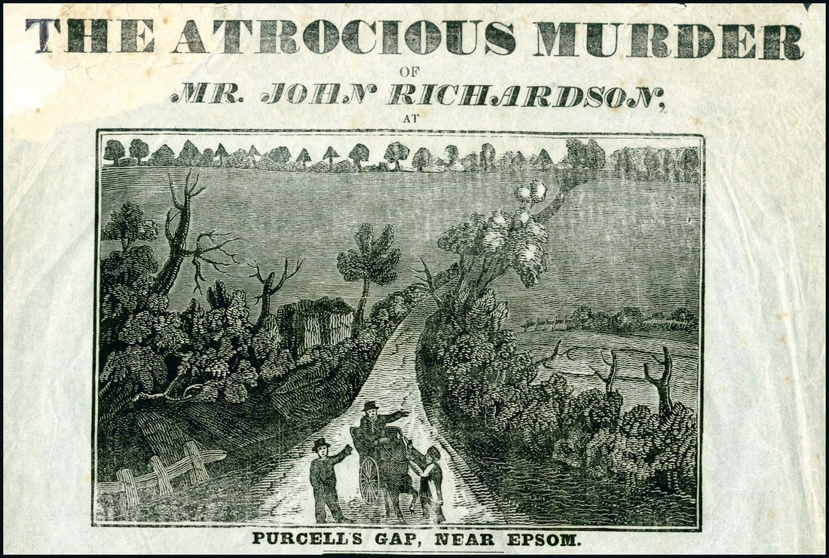

On Wednesday, 26th February 1834, John Richardson, steward to John Perkins of Bletchingly, attended Epsom Corn Market. During the course of the day, he received from a Mr Stokes of Ewell £20 in Bank of England notes, three sovereigns and three shillings.
At about six o’clock that evening, John Richardson set off in his gig for Bletchingly. About half a mile from the Grand Racing Stand, the narrow lane, along which he was travelling went through a deep hollow, known as Purcell’s Gap. The seclusion of the spot, a long way from the nearest habitation, and the slow, steep climb out of the hollow, made it the ideal place for a robbery.
As Mr Richardson was nearing the top of the hill, two men sprang out of the darkness. One seized hold of the horse’s head, whilst the other came up to the side of the gig and demanded his money. Mr Richardson, who always travelled with loaded pistols in case of robbery, replied to the demand by firing one of his pistols, but missed. One of the robbers returned fire. The ball grazed Mr Richardson’s right arm, entered his chest, perforated his lungs, and lodged against the bone of the right shoulder.
Mr West, the carrier between London, Ewell and Banstead, was approaching the spot at the time. He heard the two shots. As he got closer, he saw two men crouching over a person lying on the ground. The men ran off as he approached, and he heard a faint cry of, ‘Lord have mercy upon me’, from the man on the ground. As West tried to raise the man up, ‘the deceased … heaved a deep sigh, and immediately expired’. West placed the dead body in his cart and took it to the Surrey Yeoman Inn at Banstead.
The murder caused a great sensation for miles around. A total of £300 was offered for the capture of the person who fired the fatal shot. During the next few months, some 30 individuals were charged with the murder, but all managed to prove their innocence. Accounts of the murder and the very many arrests and acquittals that followed filled many newspaper column inches, and gave rise to at least one broadside, The Atrocious Murder of Mr John Richardson at Purcell’s Gap, Near Epsom, which included this glorious verse:
T’was near the town of Epsom – oh dreadful to relate!
A murder was committed, which I to you now state.
Unfort’nate Mr Richardson, as riding all alone,
Was by blood-thirsty villains most barbarously slain.
Undaunted did this brave man fire, when him they did stop,
But at that very instant he was killed by a fatal shot!
They next ransacked his pockets, and took both notes and gold,
Then left him welt’ring in his blood, quite lifeless and cold.
When presently, West the carrier, drove up with all speed,
But, alas! Not in time to prevent the fatal deed.
West took him off the ground, while reeking in his gore,
And to the Surrey Yeoman Inn, mournfully he bore.
The sad news flew like lightening the country all around,
And two hundred pounds offer’d, if the villains were found;
Likewise the good King’s pardon, and one hundred pounds more
To any who could tell, except the actual murderer.
But, oh! What grief and misery awaits his dearest wife!
When she heard the fearful news, it nearly cost her life.
She clasp’d her orphan children, and press’d them to her heart,
And kneeling pray’d to Heav’n, its blessings to impart.
Let’s hope the cruel actors of this most horrid deed,
May be brought to the bar of Justice there for to plead,
And meet the fatal punishment they richly deserve,
As a warning to all who from the paths of virtue swerve.

The Buckskin Farm burglary – the final outcome
On the 31st May 1834, the Egham police captured John Young in Buckinghamshire. Young offered ‘a most desperate resistance’, but was taken to Basingstoke goal chained and pinioned.
A few days later, John Renouf captured Daniel Higgins near Brentford, where he was working in a brickfield. Some 20 or 30 of his fellow workmen attempted to rescue Higgins, but, with the help of his assistants, Renouf brought off his prisoner, and carried him to Basingstoke where he was safely lodged with Young. John Pearse, another Basingstoke constable, went off in search of Charles Silver.
On Monday, 16th June, John Renouf and his assistants escorted Young and Higgins to Winchester goal to await trial, along with Charles Silver, for want of bail, to give evidence against them.
Young and Higgins appeared before Mr Justice Patteson at Hampshire Assizes on the 14th July 1834. William Crockford told the court that, as the men came up the stairs they shouted, ‘Damn your eyes, we’ll murder you all’. He said:
‘They beat me severely with an iron bar and sticks, my finger was cut off with a stroke of the iron bar. One of them said, “Damn your eyes, let us have your money, or we’ll murder you!” Higgins said, “We don’t want to hurt you if you let us have your money.”’
Charles Silver testified that, about a fortnight after he suggested to John Young that his old employer’s house would be good place to rob, he met Young near Virginia Water. Young had brought along John Blay and Daniel Higgins. The four of them made their way to Basingstoke and reached the farm around midnight. He said that Young hit Crockford and Duckett across the head with an iron bar.
George Perkins, constable at Egham, told the court that, shortly after the Buckskin Farm burglary,
‘I saw Young at the Pack-horse at Egham. He said to me, “Perkins, how are you?” He told me an uncle had died, and left him a good property. He was dressed on a new suit of clothes. He asked me to drink, and when he paid he pulled out a handful of sovereigns. I did not see him till the 31st of May last, when I apprehended him in Buckinghamshire. He then said to me, “Is this for Epsom?” I told him no, it was for the robbery; it never struck me then about the murder at Epsom. I brought him to Basingstoke pinioned. He threatened my life.’
Another witness, an undertaker from Egham named Andrews, said,
‘Young came to me on the 18th of April 1832, and gave orders for a coffin for his child. I told him it was an expensive order, when he pulled out of his pocket 13 or 14 sovereigns. In two or three days I saw him with a new suit of clothes; he then showed me 20 or 30 sovereigns in addition to the 13 or 14. He said an uncle had died in America and left him a guinea a day.’
After the witnesses had finished their testimony, and Mr Justice Patteson was about to sum up, Young interrupted:
‘It is no use to deny it; but the innocent should not suffer. I was at the robbery. When Duckett fired the pistol he blew off the top of my finger. I took it out of his hand, and knocked him down with the iron bar, and then struck Crockford with it on the head, and said, Damn you, I’ll kill you; and I wish I had.’
After the summing up, the jury without hesitation found both men guilty, upon which Young exclaimed, ‘I wish I had killed the old bugger. If I had murdered him he would not be able to give evidence here today’.
The judge said, ‘You will not provoke me to pass sentence on you now; I will rest on my pillow first; but most probably you will be hanged.’
Young continued, ‘I wish I had killed the old bugger, as I did the other bugger at Epsom.”
The following morning, Young and Higgins were placed at the bar. Justice Patteson put on the black cap and said that they were both found guilty of burglary, committed under circumstances of great cruelty, for which the punishment was death. However, he said he could draw a distinction between the two prisoners. Higgins did not use any violence. On the contrary, he told Mr Crockford that if he showed them where his money was they had no wish to hurt him. He therefore directed that sentence of death should be recorded against Higgins, but his life should be spared on condition of his being transported for the rest of his natural life. To which Daniel Higgins replied with much relief, ‘Thank you, my Lord. Thank you, my lord.’
With regard to John Young, the Judge said that it was evident that he struck the old man with the iron bar on the head and broke off his finger, and that he went there with a determination to use any violence that was necessary to possess himself of the money. There were no mitigating circumstances, and he would be left for execution in ten days’ time. ‘Thank you, my Lord’, Young replied, ‘I did not know I had so long to live.’ The Judge exhorted him to repent, but Young laughed at him.
During the time the Judge was addressing him, Young was making faces and laughing. After the Judge told him the sentence was that he would be fed on bread and water, ‘till the morning of your execution; and that you then be led to the place of execution and hung by the neck till you are dead; and may the Lord have mercy on your soul,’ Young went out of court dancing.
John Young was executed on the morning of the 2nd of August 1834. On being placed under the beam, he said,
‘I would rather be cut to pieces on this scaffold, than split on my accomplices. I have made no confession, nor will I, and I advise all who may be concerned in robberies to keep their own counsel, and have no women concerned with them.’
The drop then fell, and, from the extreme length of the rope, he died almost instantly.
John Young was 25, and lived at Egham with his wife and two children. Although there was no further confession, contemporary opinion was that, taking account of the first words he said when he was apprehended, and his remarks in court, he was guilty of the Epsom murder. But it was for the Buckskin Farm burglary that he was hanged.
Bob Clarke, September 2014
Sources:
Berkshire Chronicle, April 21, 1832
Reading Mercury, April 23, 1832
Berkshire Chronicle, April 28, 1832
Berkshire Chronicle, June 2, 1832
Hampshire Advertiser, July 21, 1832
Morning Chronicle, February 28, 1834
Berkshire Chronicle, June 4, 1834
Berkshire Chronicle, June 21, 1834
Berkshire Chronicle, July 19, 1834
Hampshire Advertiser, July 19, 1834
Reading Mercury, July 21, 1834
Hampshire Advertiser, August 2, 1834.

