A ‘Pretty Little Building’: Farleigh Congregational Chapel 1906-1927

Roger Ottewill

It would appear that the Congregational cause in the parish of Farleigh Wallop commenced in 1900. This is the year given in the records of the Hampshire Congregational Union [HCU]. Initially services were held in the homes of members. Some idea of how this kind of ‘country’ work developed can be gained from the following newspaper report of the opening of the chapel at Farleigh in 1906:

Hitherto the Congregationalists at Farleigh have not been favoured with a sanctuary in which to conduct their religious services, but nevertheless the work has been spreading under the ministry of members from the parent church at Basingstoke. The services first took the form of cottage meetings, then in the course of time, as members increased, the services were conducted at the farm, by kind permission of Mr Cole. Therefore it is not to be wondered that the erection of a chapel should have been awaited with much anxiety.

The chapel was situated at Foxhall ‘on the main road between Farleigh Hill and Nutley‘ and was therefore some distance from the main settlement (see Fig. 1).

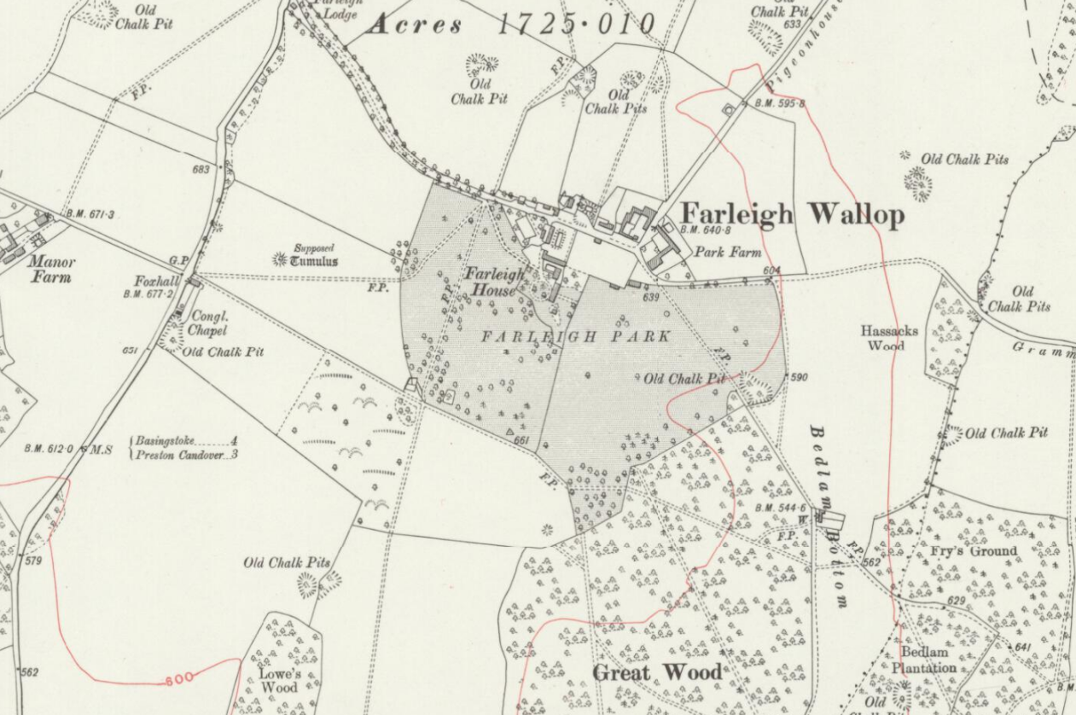
Fig.1. Ordnance Survey map of 1910 showing the location of the chapel

As indicated in the previously mentioned newspaper report:

Through the kindness of the Earl of Portsmouth the necessary land was granted a 999 years’ lease at a nominal rent, the site abutting on the left hand side of the main road. The building has been erected by Messrs. Mussellwhite and Sapp, of Basingstoke. It is of corrugated iron, with a patent felt roof, for which is claimed the advantage of keeping the building cool in hot weather. At the rear end is a shed for cycles etc., which will be appreciated by preachers and visitors from distant churches. The interior is matchboarded, and the chapel will accommodate nearly one hundred people. The light is supplied by large hanging lamps in the centre and wall lamps at the side. The reading desk stands on a raised platform at the end, while the music is supplied by a fine American organ, presented by the Christian Endeavour Society of the London-street Church at Basingstoke. On the desk rested a Bible and hymn book (“Sacred Songs and Solos”) presented by the Rev A.C. and Mrs Tarbolton respectively. The Bible bore the following on the fly-leaf: “Presented for use in Farleigh Chapel by the pastor of the parent church, in the hope and prayer that the Word of God may have free course and be glorified whenever the Book is opened for its proclamation – A Capes Tarbolton – 6th Sept 1906.” In the Hymn Book was written: “May Jesus Christ be praised.” Presented for the use of Farleigh Chapel, with all good wishes, on the opening day by Mrs Tarbolton. – 6th Sept 1906.

The references to the opening ceremony also make interesting reading:

The opening ceremony took place on Thursday afternoon, when the doors were unlocked by the Mayoress of Basingstoke (Miss S J Wallis), who has taken a deep interest in the work, and has generously borne half the cost of the building. By half-past four quite a large number of people had assembled, several friends coming from Basingstoke – some in conveyances, others on cycles and a few who preferred to foot it.
The Rev. A. Capes Tarbolton … conducted the service, and, having read the dedicatory service and offered the dedicatory prayer, read a telegram from Miss Annie Smith congratulating the people of Farleigh on their new edifice and wishing them success. In calling upon Miss Wallis to open the doors, Mr. Tarbolton said he did so with great pleasure for three reasons: firstly, because Miss Wallis had taken such a heartfelt interest in this good work in the cottage and farm meetings; secondly, because half the cost of erection had been generously borne by her; and thirdly, because she occupied the honoured position of Mayoress of Basingstoke, upon which they most heartily congratulated her.
Standing in the porch entrance previous to unlocking the doors the Mayoress said: It is very nice to be playing the part of Mayoress when asked to do such a deed as that which I am about to perform. But as well as the pleasantness of the occasion I feel it to be a solemn one too – the opening of this pretty little building, which we dedicate to the service of God. ‘Although it is our joy and safety to know that God is everywhere, yet may we not believe that in a special manner He is with us when we gather together to worship Him in any place set apart for that sacred object? And for this reason may those who will come here week by week find verification of the promise of Jesus Christ “There am I in the midst.” To you in particular who live in Farleigh another opportunity is placed in your way; another open door for you to enter in and hear what God the Lord has to say to you through one and another of His servants. How comparatively easy it is now for those who live in villages as well as in towns to hear the Gospel of the grace of God. Surely, very few, if any, in England can say, “No one ever told me” – which was the reply of the dying gypsy boy to someone who whispered in his ear the sixteenth verse of John III. What a difference there is between our rural England, with her churches and chapels dotted about, at longer or shorter distances, and parishes in heathen lands, where one missionary has more land to cover and more souls to tell the way to heaven to than hundreds have in our favoured land. May this simple building serve our day and generation, and may many learn spiritual lessons within it to prepare them for the time when shall be the word spoken: “I saw no temple therein.” Miss Wallis then unlocked the doors and duly declared the building open. The friends followed her into the building, which was soon filled, and by way of opening, “All hail the power of Jesu’s name, “to the tune “Diadem,” was heartily sung. Having read Psalm CXXII the Rev. A.C. Tarbolton offered prayer and concluded the service. Miss Sapp presided at the organ.

As usual on these occasions the more formal and spiritual part of the proceedings was followed by refreshments:

A social cup of tea was then partaken of, two sittings being necessary to accommodate the large number present. The weather being sultry and the roads dusty, it proved indeed “the cup that cheers” to those friends who had cycled or walked from Basingstoke. The wants of all were well attended to by a host of willing friends, including Miss Wallis.

However, this did not mark the end of official opening. In the evening a public meeting was also held:

The chapel was again completely filled in the evening for the public meeting, when the Mayor of Basingstoke (Mr. R.S. Wallis) presided. His worship expressed his pleasure at being able to be with them on that occasion, and at seeing so many present, and he was glad to have this opportunity of showing his sympathy with the work.
After prayer by Mr. A Beasley, the Rev. A. Capes Tarbolton gave an address. He said he was exceedingly pleased to see such a large gathering present, and although they could scarcely expect to get so many at their future services, he trusted the numbers would be good, and that the villagers would use every endeavour to get there as often as they could. It was only a small building, but it was well sometimes to compare the small with the great. He had thought of Solomon’s temple as compared with their little chapel. Although there were no glittering jewels or outward adornments, yet the spiritual life and glory of their services might exceed that of Solomon’s temple. Solomon recognised the advantages of music, and so did they today, and they had a splendid organ given them by the Christian Endeavourers of London-street church. And as they read of the sacrifices and offerings made at the temple, so they were reminded of the various offerings from so many kind friends in connection with this building. And it must likewise be a building of thanksgiving and praise, and what was most essential of all, it must be a house of prayer. He trusted that they would pray for the prosperity of this little chapel, and no matter who the preacher might be, let them come expecting to hear a message from God.
Mr. G. Gage, the Church Secretary, said he had been pleased to note the many who had helped to build this chapel, and now it was finished he hoped there would be many to maintain it. He did not mean altogether financially, but more particularly the inner life of the Church. Although they could not always have their friends from Basingstoke with them he urged them to do their utmost to attend whenever they possibly could, remembering that in the parent Church they had many who were deeply interested in this place, and were anxious for its future development. In their financial support he would ask them to remember Christ watching the treasury box at the gate of the temple. It was not what was given, but how it was given which placed the value on the offering.
At this stage of the meeting the Mayor asked to be excused, as he had a meeting to attend at Basingstoke, but before leaving, he was accorded a hearty vote of thanks for his presence and sympathy with the work.
Mr. G. Fellows, the Church Evangelist then gave a short address, and Mr. Joseph Cane also spoke briefly. Mr. Fellows mentioned that Mrs. Taplin had by means of a collecting book raised £3 11s 3d, and the proceeds of the day’s services amounted to £5 1s. His Worship the Mayor gave 10s, and a postal order for 10s had also been received from Miss Smith. Miss Wallis kindly gave several tea things, and a table cover was also presented by Mr. Jackson. To all of these hearty votes of thanks were given. We understand there is no debt on the building.
Mr. Jukes proposed a vote of thanks to all those kind friends who had assisted at the tea, and this was seconded by Mr. Cane, junr. The meeting was then closed with prayer. Mr. A.G. Wood ably filled the role of organist, and the singing was bright and hearty.
Mr Fellows will be the preacher for Sunday, the service to commence at 6 o’clock.

The length and detail of this report from a secular newspaper is indicative of the interest that was still being taken in religious affairs at this time. Its content also illustrates the high expectations surrounding Farleigh Congregational Chapel. The evidence suggests that for a short while these were met.
For example, some idea of the effective work and witness of the Chapel in its early years can be gained from this brief report which was published in the London Street Church magazine of January 1908:
Farleigh. – Services are held here every Sunday evening at 6 o’clock. A good attendance is usual and the services are of an inspiring nature. We also have a Sunday School, which has been successful from the beginning and still continues to prosper. Mother’s Meetings are held on alternate Thursday afternoons, and the management of this work is in the hands of the Misses Smith.

From time to time visits were made by members of London Street and in January 1910 ‘the Boy’s String Band, who always seem to be much appreciated, was present and assisted in the musical part of the Service’.
However, after this promising start, it was not long before the cause was struggling. Like many rural chapels the removal of families who had played a crucial role in its activities was a major cause for concern. Thus, in January 1912, the report for the preceding year makes reference to such difficulties. ‘Two or three large families connected with us have recently left the neighbourhood, greatly reducing the [Sunday] school.’ At some point the Sunday school closed, since in 1914 it was reported that: ‘Two or three families having recently come to Farleigh render opportune the formation of a Sunday School there, but as there is no one on the spot to conduct it, we shall be pleased if someone will kindly volunteer to do so. We believe that the formation of a Sunday School will do much to strengthen this weak cause.’
The phrase ‘weak cause’ clearly indicates its vulnerability. In view of this, it is not surprising that HCU records indicate that the Chapel was ‘temporarily closed’ between 1918 and 1920. However, it would appear to have reopened in 1921. Moreover, during the first half of the 1920s, reports of well attended Harvest services appeared in the London Street Magazine for 1924 and 1925. The report for 1924 reads:

The Harvest Thanksgiving service at Farleigh on Sunday evening, September 21st was attended by a good congregation who very much enjoyed and greatly appreciated the service of Mr Carter of Odiham. On the Tuesday evening following a public meeting was held, when a charabanc load from May Street [Mission Hall in Basingstoke] and a good number of Farleigh friends completely filled he building. The pastor, Mr Jefferson, conducted the Service and afterwards the flowers, fruit, vegetables etc were sold.,

During this period, as indicated in the minutes of London Street deacons’ meetings, the roof of the chapel was repaired and it was equipped with a stove. Thus, it is clear that efforts were still being made to keep the Chapel going. That said, in the longer term, they proved to be unsuccessful and at the London Street deacons’ meeting on the 6th May 1927 it was resolved ‘to abandon the work at Farleigh.’ Consequently, the chapel was closed permanently just over 20 years after it had been opened with such high expectations in 1906. This must have been a considerable disappointment to those who had been present on that occasion and indeed contributed to its construction.
It is not entirely clear what happened to the chapel building. One proposal was to move it to Ellisfield, but this was deemed to be either too impractical or too expensive. Another was to sell it and an advertisement duly appeared in the Hants and Berks Gazette. However, this does not appear to have produced any purchasers since the deacons then entered into negotiations with the Portsmouth Estate for its purchase. Whatever its fate, today there is little evidence of a chapel ever having been on the site which is now covered with trees (see Fig. 2).

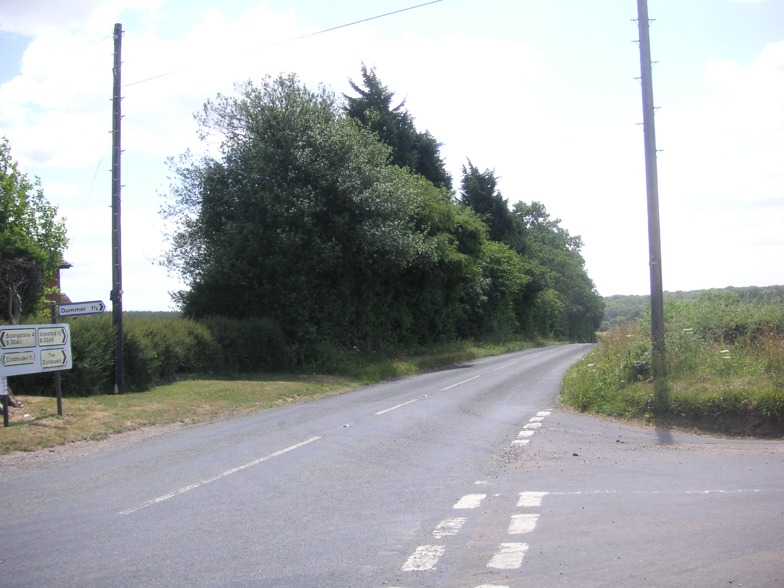
Fig.2. The site of the Chapel in 2012

See, for example, the Report of the HCU for 1901. HRO Ref: 127M94/62/46.
This was London Street Congregational Church.
London Street Congregational Church Minutes of Deacons’ Meetings, March 1905. The main road is now the B3046.
Although an Anglican, the Earl of Portsmouth was a great supporter of Nonconformity. He also provided the land for the Congregational chapel at Winslade.
Mussellwhite and Sapp were leading members of London Street Congregational Church in Basingstoke.
A(lfred) C(apes) Tarbolton was the minister of London Street Congregational Church.
S(arah) J(ane) Wallis was a member of one of Basingstoke’s leading families and was also instrumental in securing the erection of the Congregational Chapel at Ellisfield in 1913.
Nothing is known about Miss Annie Smith.
It was quite an accolade for the Congregationalists of Farleigh to have the Mayor of Basingstoke attend the opening of their chapel.
Gage was Secretary of London Street Congregational Church.
George Fellows was attached to London Street. In addition to Farleigh he had responsibility for the causes at Ellisfield, Mapledurwell, Pyotts Hill, Winslade and Worting,
Because of his other commitments, Mr Fellows, led the services and preached at Farleigh on relatively few occasions. On other occasions lay preachers exercised these responsibilities on a rota basis.
Hants and Berks Gazette, September 8, 1906.
Basingstoke Congregational Magazine, vol.1 New Series, no.1, January 1908, unpaginated.
Basingstoke & District Congregational Magazine, vol.3 New Series, no.3, March 1910, unpaginated.
Basingstoke & District Congregational Magazine, vol.5 New Series, no.1, January 1912, p.4.
Basingstoke & District Congregational Magazine, vol.7 New Series, no.6, June 1914, p.3.
HRO Ref: 127M94/62/62-64.
John Jefferson was the evangelist based at London Street from 1922 to 1927.
Basingstoke & North Hants Congregational Magazine, vol.17 New Series, no.10, October 1924.

