‘A Perfect Little Paradise’: A History of Winslade Congregational Chapel 1888-1935
Roger Ottewill

Introduction

Some of the most poignant reminders of the vitality of rural Nonconformity in years gone by are the buildings which served as places of worship, sometimes in unexpected locations. Many are modest chapels which were built in the nineteenth and early twentieth centuries to serve the needs of those who cherished a form of worship that was plain and simple and non-liturgical. In other words, they eschewed the formality and ritual associated with Anglicanism.
In parts of rural Hampshire, the Congregationalists were zealous chapel builders. A few of their chapels, such as those at Braishfield and Burton Green, continue to this day to serve their original purpose. Most, however, have either been demolished or converted to other uses, such as private residences or offices. A building which survives but has long since ceased to be a place of worship is the Congregational chapel that served the small village of Winslade, situated on the road between Basingstoke and Alton. With a population of only 59 in 1901 it is surprising that it had its own Nonconformist chapel as well as an Anglican church. The origins, construction and contribution of the chapel to the religious life of the area in which it was located are the subjects of this short article.

Origins and Location

As in other Hampshire villages, the Congregational ‘cause’ in Winslade began a few years before the construction of the chapel in 1888, with meetings initially being held in a cottage. These were facilitated by an evangelist attached to London Street Congregational Church in Basingstoke. As the numbers attending every Sunday, ‘to hear His Word and to make trial of His Grace,’ increased so it became necessary to look for larger and, ideally, purpose built premises. Thanks to the generosity of two benefactors a chapel was eventually built. One of these was the Fifth Earl of Portsmouth, the largest landowner in the neighbourhood and indeed Hampshire, who donated the land. Towards the end of his life, the Earl spent most of his time in Devon, where he had one of his homes, leaving ‘the management of the fertile farms … [in Hampshire] to his eldest son, Lord Lymington,’ who inherited the peerage on the death of his father in October 1891. He seems to have been more religiously inclined than his father and, although an Anglican, he was very sympathetic towards Nonconformity and the Protestant cause more generally. For example, in 1903 he opened the Grand “Reformation Times” bazaar, organised by London Street, with a ‘stirring’ opening address in which he stressed that this was ‘a time when all those who valued the principles of the Reformation and the Protestant faith should stand together’ in opposing the Government’s Education Act.
The other benefactor was Thomas Maton Kingdon, who paid for the building and its furnishings. Kingdon ran a flourishing ironmongery business in Basingstoke. He was a member of the borough council and serving has first term as mayor when the chapel was opened. Moreover, he was a leading Congregationalist, being a deacon of London Street. At his memorial service and funeral in 1901 the pastor, Alfred Capes Tarbolton, paid the following tribute to him:

He was conspicuous for strength and firmness of conviction, and for courage in avowing and maintaining what he thought. In politics, municipal matters, questions of temperance and religion, questions of civil and religious liberty he had a clear vision of the value of principles, and a tenacious hold on those he felt to be true. Not from narrowness, for he had a broad and judicial mind and singularly acute and sober judgment. But truth once seen he held through good report and ill.

Although this might suggest a somewhat stern and unbending Victorian personality, the pastor went on to indicate that it was, in fact, tempered by ‘considerations of the difficulties of others’; a mellowness ‘as his life drew to a close’; and surprisingly perhaps a ‘tenderness almost feminine’.
In deciding on the location of the chapel various sites were considered by Kingdon and Lord Portsmouth’s steward. An initial choice had to be abandoned because access depended on the consent of Lord Bolton and it appears that this was unlikely to be forthcoming. Eventually, the chapel, or ‘little Bethel’ as it was termed in the Hants and Berks Gazette’s report of its opening, was built ‘near to the foot of the hill leading towards Herriard and … [was] approached by a lane called the Ellisfield Lane.’ The exact spot was ‘known to the people of the parish as Westfield.’ However, concern was expressed that, at first sight, the location ‘would seem to be a very unfavourable one for the purpose, as it … [was] not in the centre of the village and … [was] approached by a lane which in the winter time … [would] probably be very dark and muddy.’ Nevertheless, assurances were given that:

the site was really a most convenient one, being only a few minutes walk from the centre of the village … and close to the point where converge several paths leading to Herriard and Ellisfield, the interests of the people residing in these two places having been taken into consideration as well as the interests of the Winslade folk.

Notwithstanding its remoteness or perhaps because of it, Kingdon considered the location to be ‘a perfect little paradise.’
The chapel itself was described as ‘a neat brick and slate building, with a porch’. Inside there was a rostrum and wooden forms with backs capable of seating 80 worshippers. Music was provided by a harmonium donated by Walter Wadmore, another member of London Street and of the borough council. There was also a copper which, as it was put in the newspaper report, would ‘come in handy at tea fights.’ This domestic touch echoes Everitt’s observation that since the origins of many Nonconformist causes in rural areas lay in ‘cottage meetings,’ as was the case in Winslade, they lent ‘from the outset a certain domesticity to the Dissenting chapel …’
The site was surrounded by an iron fence and somewhat optimistically perhaps it was large enough to be able to accommodate additions should they become necessary. Appropriately at the front of the building there was stone bearing the inscription: ‘Erected by T.M. Kingdon. J.P., Mayor of Basingstoke.’ Much was made of the office held by Kingdon at the time and it was initially dubbed ‘The Mayor’s Chapel.’

Opening

The chapel was formally opened on Monday 25th October 1888. The proceedings began with a service in the afternoon, which more than 100 people attended. Sankey’s hymns were heartily sung, prayers were offered, lessons were read and a sermon based on the text ‘I was glad when they said unto me – Let us go into the House of the Lord’ was preached by Alfred Tarbolton. During the course of the sermon, the preacher emphasised the different places where God could be worshipped. Referring directly to the chapel he commented, in somewhat poetic language, that:

This little building did not indeed make a great show, like the cathedral with its towers, yet situated in the midst of a charming landscape, and with the afternoon sun lighting up its rosy front, it was not without beauty, and they thanked God for it.

He went on to express the hope that within the chapel ‘many a heart might be born again.’
The service was followed by a tea. As recorded:

While the ladies were … engaged [in preparing the tea], assisted by a few handy gentlemen, the main company strolled along the green paths in the copses hard by, to spy out the remnants of the nuts on the bushes.

After tea, there was more singing and what was in essence a public meeting with strong religious overtones. During the meeting, Kingdon gave details of the sequence of events that had led to the erection of the chapel and challenged those living in ‘Winslade, Herriard, Ellisfield and the district around’ to use the building effectively as a place of ‘spiritual welfare.’ The next speaker was Sydney Watson, the village evangelist with responsibility for the cause at Winslade. He based his ‘cheerful address on what he called the Ps of the matter’, people, place, pulpit and preachers. After confirming that ‘the foundation truth … declared here would be salvation through Jesus Christ’, he observed, perhaps with tongue in cheek, that ‘if they didn’t like the preacher one Sunday, if they came the next they would hear somebody else’. Lastly, Tarbolton spoke again and gave what was described as an ‘inspiring address’ in which he commented on the fact that unusually the chapel was free of debt from the outset and consequently there was no need for a collection to be taken. As was the norm on such occasions the proceedings closed with a benediction.

The Coming of the Railway

For the first ten years of its existence little of import happened to disturb the ‘perfect little paradise’. However, all this was to change with the building of the Basingstoke and Alton light railway between 1898 and 1901. More specifically, the nature of the chapels’ location was profoundly altered by the construction of a substantial embankment, with a bridge over Ellisfield Lane (Fig. 1).

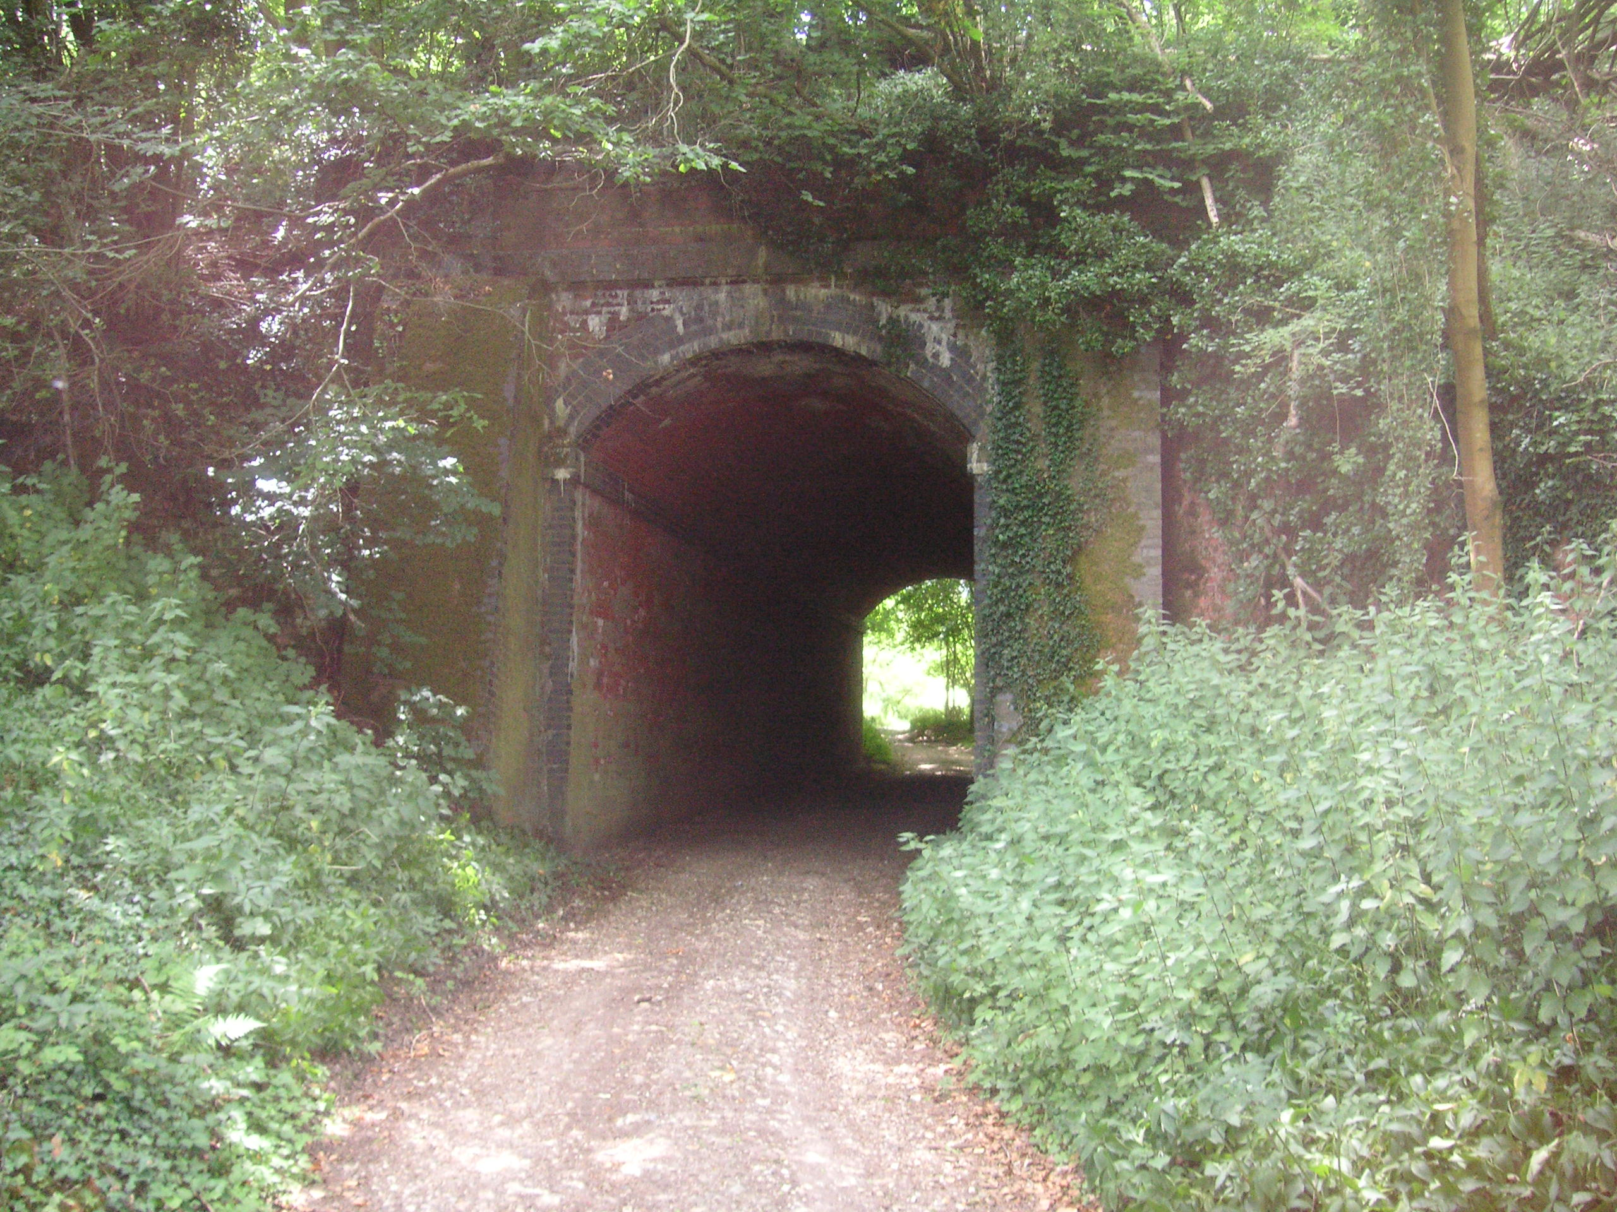
Fig.1. Railway embankment and bridge over Ellisfield lane
As it is put in a history of the line:

The embankment continued to increase in height and passed over Winslade Bridge which allowed a lane to pass underneath. From the vantage point it was possible to see the village cottages to the left as well as the small Congregational Chapel hard by the railway to the right (Fig. 2).

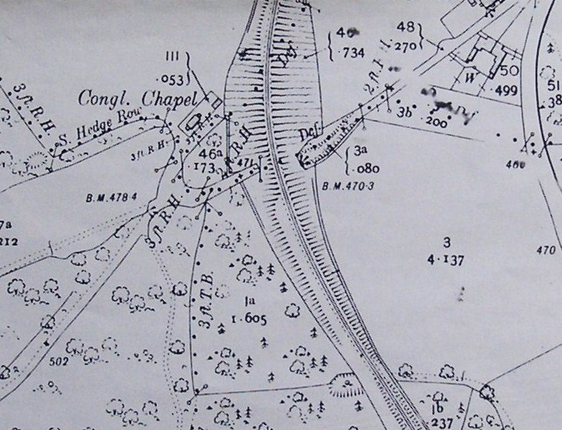
Fig.2. Ordnance Survey map of 1910 showing the location of the chapel in relation to the railway embankment

However, nothing daunted, the worshippers saw this as an evangelistic opportunity and as it was put in the chapel’s report for 1899: ‘During the summer a series of open-air meetings were held outside the dwellings of the navvies employed upon the new line.’ It is not recorded whether this had any lasting effect on those who were involved in constructing the embankment.
In the chapel’s report for 1905 reference was made to ‘the difficulties arising from the position of the chapel since the making of the new railway.’ Clearly, the presence of the embankment added to the chapel’s isolation and gave the appearance of it being more cut off from the village than had originally been the case. Nonetheless, this difficulty as well as the ‘scanty population’ were ‘bravely met’ and ‘a good work was being carried on.’
This good work was reflected in the following report which appeared in the London Street church magazine of January 1908:
Winslade We hold services at this place twice on Sundays, morning and evening. The morning services are usually well attended, considering how remote the church is from any population. The local preachers always get a hearty welcome from the Winslade friends, and no doubt they find the little sanctuary on the fringe of the wood to be a veritable means of grace.
Although numbers remained small and the cause suffered from time to time through the loss of key people, in the years leading up to the First World War services continued to be held on a weekly basis. Moreover, for the year 1911, it was being reported that ‘the services held on Sunday and Fridays evenings … [were] really well attended, especially by young people.’ In addition, there was a Sunday school with 18 children which met on Sunday afternoons. Later, a Band of Hope branch was formed.
In view of its idyllic setting and notwithstanding the railway embankment the chapel was also a favourite place of worship for Congregationalists from further afield. For example, in the spring of 1913:

A delightful time was spent at Winslade on Easter-Monday, by friends from Basingstoke, Worting, Ellisfield and Herriard. An excellent tea was provided, which was appreciated, especially by those who had walked long distances. After tea the friends took a pleasant walk in the wood near by which was rendered inviting by spring flowers. At almost 6.30 the friends returned to the evening service. The little Chapel was packed. The Chairman, Mr E. Jewell, having explained that the service was to take the form of a Service of Song entitled “The River Singers” immediately preceded; The Connective Readings were given by Mr Best. The service was a very interesting and enjoyable one …

At this time, like many of the rural causes, Winslade was dependent for its survival on the support it received from its ‘mother church.’ In short, London Street provided the manpower and some of the money to keep in going. However, it was also reliant on stalwarts from the local area such as Mr and Mrs Godwin who lived in Winslade village and Mr and Mrs Best from Tunworth. In 1901, James and Rhoda Godwin were aged 56 and 55 respectively. In the census returns James’s occupation was described as that of ‘woodman (est)’ and, their daughter Florence who lived with them, as ‘mother’s help’. Mr Godwin not only led services but also made the arrangements for visiting lay preachers. Not surprisingly, the Godwin’s decision to leave Winslade in 1911 caused ‘anxiety.’ Charles Best was a farmer and lived with his wife at Manor Farm. They served as Sunday school superintendent and organist respectively. On Boxing Day 1912 it is recorded that ‘the Sunday School children spent a delightful time at Manor Farm … An excellent tea was provided after which they thoroughly enjoyed games and singing until about 8 p.m.’ The Best’s contribution to the life of the Chapel was given formal recognition in December 1912 when they were presented with ‘a handsome silver teapot and walking stick … as a token of appreciation from the members of the congregation and friends from Basingstoke.’

Demise

During the First World War and the 1920s the chapel continued to serve as a source of spiritual sustenance for a small but declining band of committed worshippers, with a loyal cohort of lay preachers from Basingstoke and elsewhere leading the services. From time to time the numbers attending these and special events, such as entertainments, teas and picnics, were supplemented with visitors who continued to be attracted by the chapel’s picturesque location. These included friends from Ellisfield, Farleigh and Herriard; the Basingstoke Primitive Methodist brass band; the Worting Choir; and a ‘charabanc load of people’ from the May Street Chapel in Basingstoke. In 1926, 24 members of the Christian Endeavour Society for young people, which was attached to London Street, conducted the harvest festival service and ‘greatly cheered and helped the few who regularly gather[ed] there for worship.’
Moreover, during this period improvements were made to chapel. In early 1923 hanging lamps were provided to enable evening meetings to be held and in late 1923 crockery was donated to assist with the catering arrangements. In 1924 the men of the chapel carried out renovation works and redecorated the building, with a formal re-opening being held in June.
Notwithstanding these efforts, by 1929 concern was being expressed over the continued viability of such chapels. This was evident in the following appeal which appeared in the London Street church magazine:

With increasing travelling facilities, how easy it is to leave “the Village Chapel!” This is a difficulty we must face up to. Your own Village needs YOU! Christ makes His demand upon your service THERE! I am really appealing for regular attendance and support of that little cause to which you would ordinarily go. REGULARITY means SUCCESS. Of that I am sure and will help to bring God’s Blessing upon our work during 1929 in increasing measure.

For Winslade, however, such exhortation was of little avail and in the summer of 1930 the deacons of London Street, in facing up to the reality of the situation, decided to close the chapel during the winter months. Following this decision, the chapel never reopened. From the surviving records it is difficult to establish when the final service was held. It may have been in late August 1930 or the first Sunday in October, which had been scheduled for harvest festival. Not surprisingly, perhaps, its closure was less well documented than its opening had been.
Having decided not to continue using the building as a place of worship the deacons were faced with determining is ultimate fate. In 1931, it was proposed ‘to remove the chapel building at Winslade to the recently purchased building site at Worting’, where the cause remained buoyant. This suggestion, however, clearly proved to be impractical. Later that year, the deacons ‘agreed that the [Winslade] organ be transferred to Ellisfield and the furniture be removed.’ Rather amusingly, at the same time it was reported that ‘complaints had been received that … [the] organ … [was] causing disturbances in the wireless in houses near the church.’ Presumably the problem disappeared with the removal of the organ. The deacons then received an offer to purchase the premises from Mr Fosbury, who wanted to convert them into a dwelling house. This was declined since such usage was prohibited by the lease.
For the next four years little seems to have happened. In 1935 the deacons approached the agent for Viscount Lymington, with a view to selling the building to the Portsmouth Estate. After a certain amount of haggling over the sum to be paid, a figure of £35 was agreed. Needless to say, for Lord Lymington this was somewhat higher than he felt the land and building justified while the deacons of London Street ‘felt the offer might have been a shade larger’. In the correspondence the future use of the building was described as that of an ‘occasional winter cattle food store’.
Over the years it has been used as a storage facility by various farmers. Because of its isolated position it is vulnerable to vandalism and recently it has had to be re-roofed and the windows boarded up (Fig. 3). Nonetheless, it retains many of its original features and looks much as it did when the area in which was located was eulogised as ‘a perfect little paradise’.

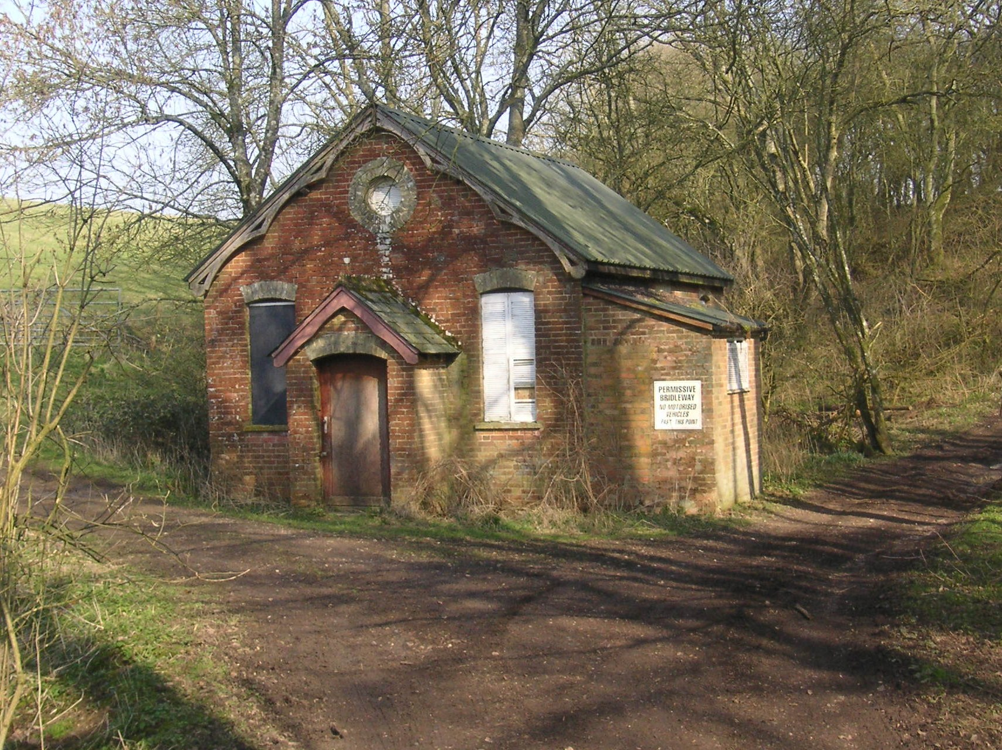
Fig.3. Chapel building in 2011

Acknowledgements

I should like to express my thanks to Bob Applin for first alerting me to the remote location of Winslade Congregational Chapel and to Jean Holton the archivist of London Street United Reformed Church for her great assistance in making available many of the primary sources on which this article is based.

Article published in the Hampshire Field Club Newsletter, No.56, Autumn 2011, 3-6.

For example, the chapel at Mapledurwell is now a private residence and the one at Cheriton, architects’ offices.
The equivalent figures for 1891 and 1911 were 114 and 87 respectively.
Apart from Winslade, at one stage London Street also served as the mother church for the causes at Cuffaude, Ellisfield, Farleigh, Mapledurwell, Pyotts Hill, Round Town and Worting.
Hants and Berks Gazette, October 30, 1888.
Hampshire Advertiser, October 10, 1891.
Hants and Berks Gazette, March 7, 1903.
Hants and Berks Gazette, November 3, 1901.
Hants and Berks Gazette, October 30, 1888.
At the time ‘tea fight’ was a humorous expression for a tea party or tea meeting. It is has an affinity with the term ‘bun-fight’
Alan Everitt, The Pattern of Rural Dissent: the Nineteenth Century (Leicester: Leicester University Press, 1972), p. 64.
Psalm 122, v 1.
Hants and Berks Gazette, October 30, 1888.
Hants and Berks Gazette, October 30, 1888.
Hants and Berks Gazette, October 30, 1888.
Martin Dean, Kevin Robertson and Roger Simmonds, The Basingstoke and Alton Light Railway (Crowcombe: Crusader Press, 1998), p. 31.
London Street Church Manual for 1899.
London Street Church Manual for 1905.
Basingstoke Congregational Magazine, Vol 1 New series (1), January 1908, unpaginated.
Basingstoke & District Congregational Magazine, Vol 5 New series (1), January 1912, p. 4
The Band of Hope was the leading temperance organisation for children and young people.
Basingstoke & District Congregational Magazine, Vol 6 New series (4), April 1913, p. 5
Basingstoke & District Congregational Magazine, Vol 5 New series (1), January 1912, p. 4.
Basingstoke & District Congregational Magazine, Vol 6 New series (2), February 1913, p. 5.
Basingstoke & District Congregational Magazine, Vol 6 New series (1), January 1913, p. 5
Basingstoke & North Hants Congregational Magazine, Vol 19 New Series (10), October 1926, p. 7.
Congregational Magazine for Basingstoke Group Church & Fleet, Vol 23 New Series (1), January 1929, pp. 9-11.
London Street Deacons Minute Book 1930-1945, April 27, 1931.
London Street Deacons Minute Book 1930-1945, July 28, 1931.
Correspondence file relating to the purchase by Lord Lymington of Winslade Chapel, Hampshire Record Office Ref 15M84/E6/4/23

