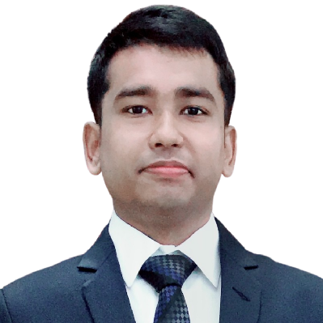

Professional development completed in IT Management in Japanese.

Computer Engineering Fundamentals, Wireless Communications & Networking, Computational Algorithms, Natural Language Processing, Internet-of-Things Devices, Data Protection & Security, Software and Hardware Engineering.

**Diploma in Computer Science & Engineering Technology (2018)**

CCN Polytechnic Institute. (4 years Technical School)  
Chowdhury Estate, CCN Road, Kotbari, Comilla,Bangladesh.

Android(XML, Material You, getWidget, Compose UI, SwiftUI)

Slack, Zoom, Github pages, Backlog, other social webs.

HTML/CSS,Coding(kotlin,JavaScript,NuxtJS,NodeJS,PHP(Laravel),JQuery,Python(flask)), FrameWorks(Flutter,Jetpack Compose), Responsive Design, Testing/Debuging, Brawser Tools, Automation Tools(Selenium), Docker etc

Kotlin, Java, Android Studio(phones,tablets), Kotlin Multiplatform, Git(Github/GitLab,Backlog), Jetpack Compose,Flutter, Materal3 Design, AndroidX, View/Data Binding, Google Play Service, Firebase(App distribution, Analytics, Crashlytics,Push messaging, Dynamic links,Auth,Database,App indexing), Google Play Console, Google Analytics, Google ArCore SDK, Camera Services, SceneView, Rest Full services, OkHttp, Json, Fuel, Coil, Github workflows/actions, Swift(reading), Gradle and C#

Developed team communications and information for meetings.

**US Software Limited (2018)**

Internship-Programmer,Dhaka

**Qualia Systems(2022〜)**

Full-Time(System Engineer-Android), Tokyo, Japan

**IT Specialist & Business Management(2022)**

Japan International Institute of Cybernatics(4-chōme-2-1 Shinmatsudo Matsudo,Chiba,Japan)

Japanese

Hindi

English

**EDUCATION**

Working on various Mobile Application like(Daily Report Management-Japanese) and (an accident car shooting application and file-sharing/Communication service with augmented reality environment).

Collected expertise in Android and web application development with local and foreign engineers.

**Qualia Systems(2021-22)**

Internship-System Engineer(Android), Tokyo, Japan

**MY SKILLS**

Monitored organization’s networks for security breaches and investigated violations.Prepared reports which documented security breaches and extent of damage caused by breaches.Conducted penetration testing and located vulnerabilities in systems before they could be exploited.

Internship in Cyber Security,Dhaka

A fast-learning developer pursuing a challenging position at an exciting company to leverage my skills and experience. A self motivated achiever with an ability to plan and execute. I’m very passionate about learning new technologies.

**ABOUT ME**



Mobile Application Developer

HRIDOY CHANDRA DAS

**EXPERIENCE**

hridoycseboy@gmail.com

linkedin.com/in/ihridoydas

**HOBBIES**

Reading

Cricket

Music

Coding

Bangla

**LANGUAGES**

07040762636