Instruction. Please always mark the answer with a cross.

1. If you see this feedback option:

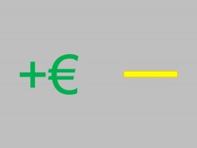

The card says you can win money.

The card says you can lose money.

1. If you see this feedback option:

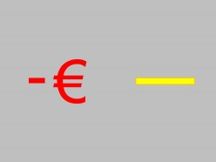

The card says you can win money.

The card says you can lose money.

1. If you decide to press the button, which of the two statements is correct?

I have to press the button when I see the map.

I have to press the button when I see the circle.

1. If I choose the correct answer, I always get the correct feedback:

The statement is correct.

The statement is false.