Cortex-data (script 01)
A=anodal
B=sham

Accuracy as function of pair and stimulation condition
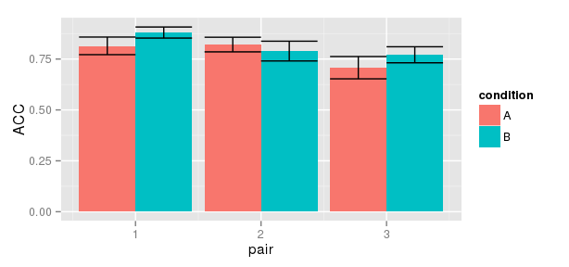
repeated measures, so more informative to look at means of differences (error bars are confidence limits)
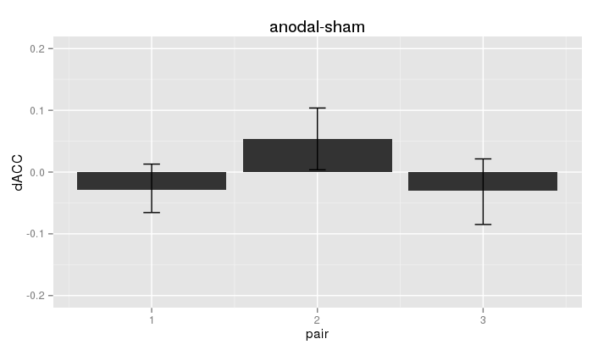

Logistic regression (we did not include this but should have):

Formula: ACC ~ scale(trial) + as.numeric(pair) + condition + (1 | subj)

Fixed effects:
Estimate Std. Error z value Pr(>|z|)
(Intercept) 2.33403 0.24722 9.441 < 2e-16 ***
scale(trial) 0.35311 0.02565 13.767 < 2e-16 ***
as.numeric(pair) -0.39035 0.03131 -12.468 < 2e-16 ***
conditionB 0.23278 0.05044 4.615 3.93e-06 ***

all the usual suspects: later trials are more accurate (learning), higher pair number associated with lower accuracy (difficulty).
In addition, sham has a positive effect (i.e., anodal performs worse).
Here an illustrative plot with data from two random subjects and model fit:

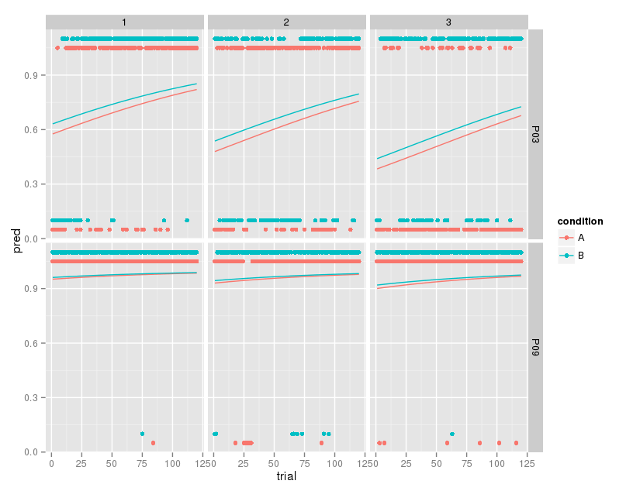
Reaction times do not appear to be influenced by stimulation (at least not the mean):

Formula: (RT) ~ scale(trial) + as.numeric(pair) + condition + (1 | subj)
Fixed effects:
Estimate Std. Error df t value Pr(>|t|)
(Intercept) 773.225 38.655 16.000 20.003 1.53e-12 ***
scale(trial) -69.966 2.039 11380.000 -34.322 < 2e-16 ***
as.numeric(pair) 20.705 2.496 11380.000 8.295 < 2e-16 ***
conditionB -1.711 4.077 11380.000 -0.420 0.675
but effect of learning and difficulty still there.

Possible that anodal stimulation results in more variable Rts, though:
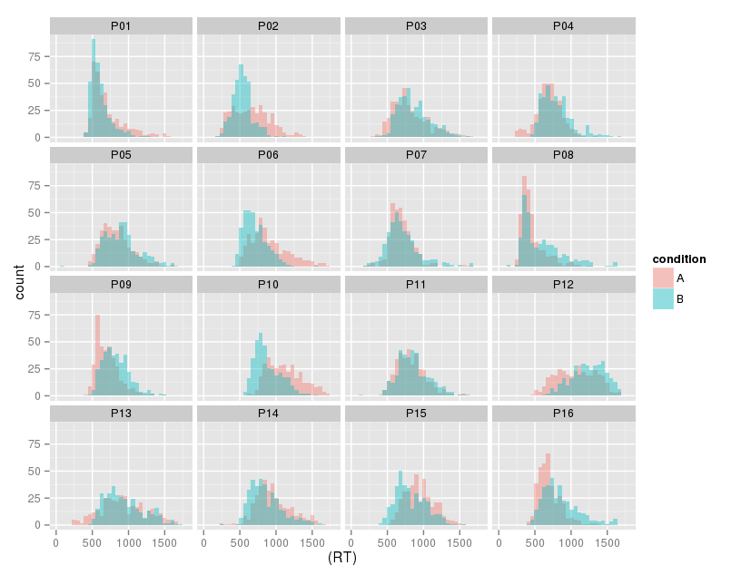
RTs per pair

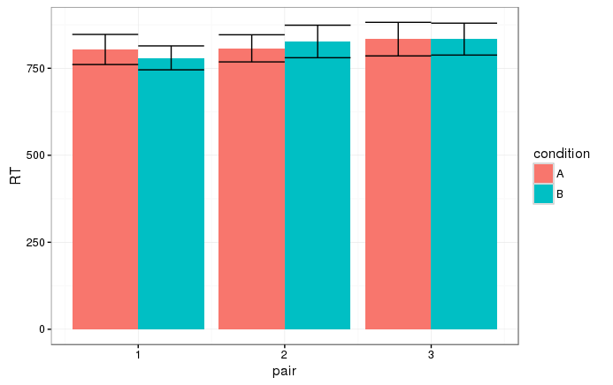
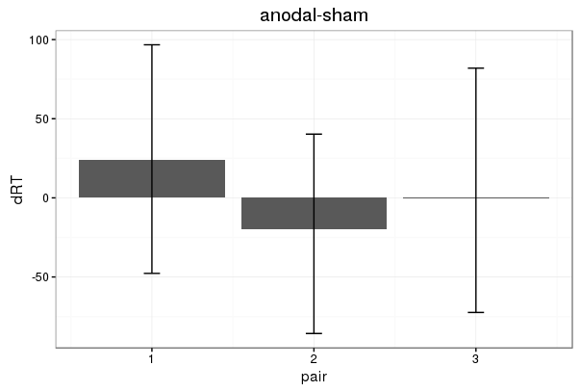
Formula: (RT) ~ scale(trial) + as.factor(pair) * condition + (1 | subj)
Fixed effects:
Estimate Std. Error df t value Pr(>|t|)
(Intercept) 803.842 38.555 15.000 20.849 1.01e-12 ***
scale(trial) -69.977 2.037 11364.000 -34.352 < 2e-16 ***
as.factor(pair)2 3.187 7.061 11364.000 0.451 0.651731
as.factor(pair)3 29.260 7.060 11364.000 4.144 3.43e-05 ***
conditionB -24.154 7.056 11364.000 -3.423 0.000621 ***
as.factor(pair)2:conditionB 43.166 9.980 11364.000 4.325 1.54e-05 ***
as.factor(pair)3:conditionB 24.200 9.977 11364.000 2.425 0.015305 *

Interestingly, pair 2 is positively influenced by tDCS both in terms of ACC (more) and RT (faster) while the other pairs are impaired (hence the main effect).

P(stay|win) and p(stay|lose)
this reproduces table 2 from the paper (mean+SEM):
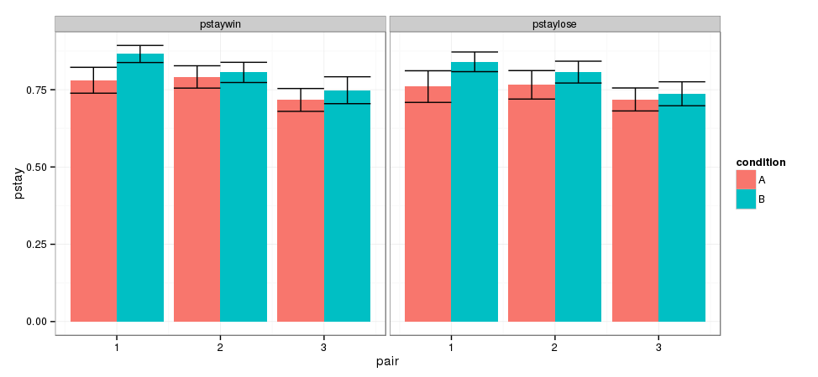
and the corresponding plot of differences (confidence limits), anodal-sham
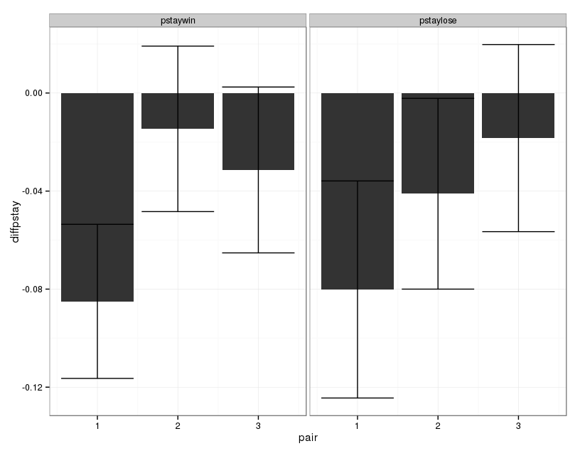
Transfer phase
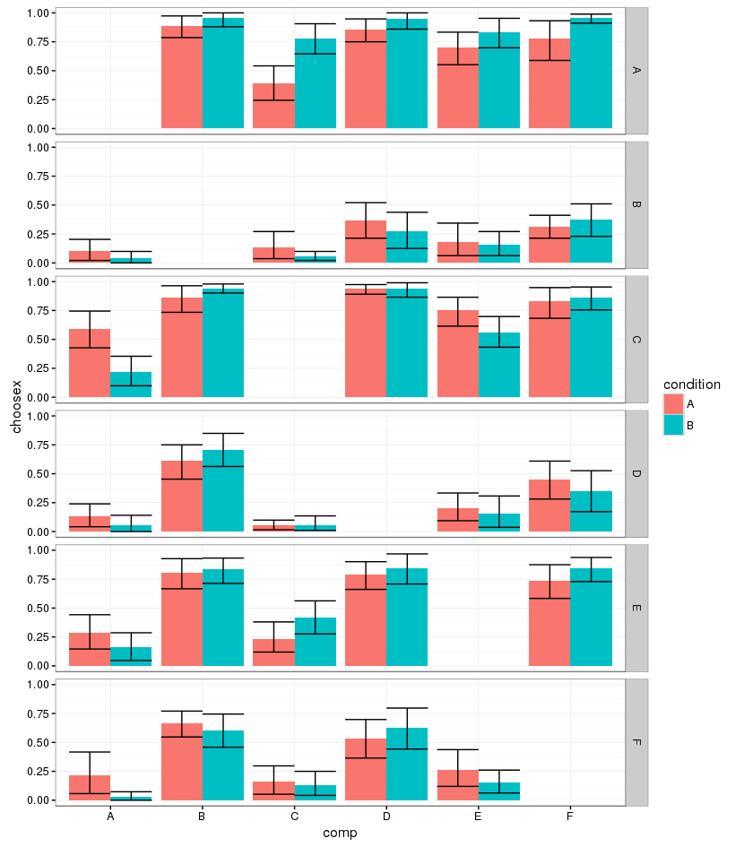

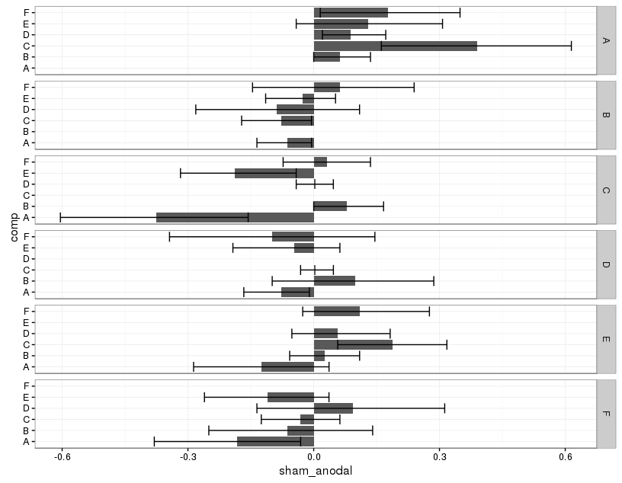

Optimal Parameters (05)
rescaled to 1
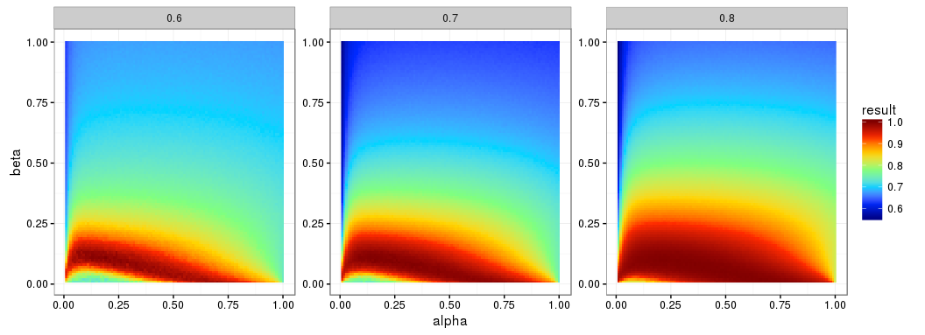
real mean ACC
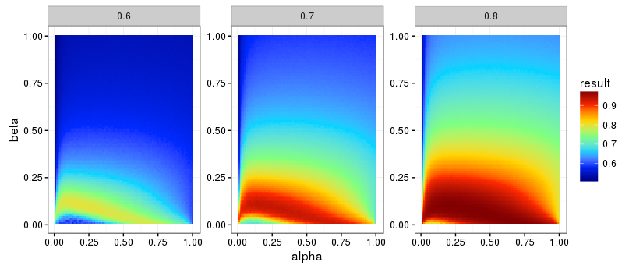
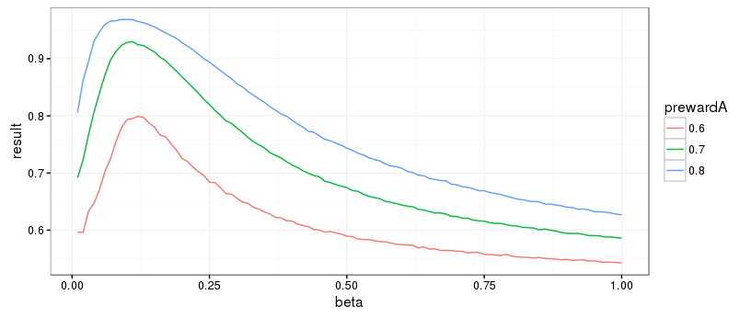
at alpha=0.1
for several slices of alpha, mean ACC per reward prob plus maximum beta value (diamond)

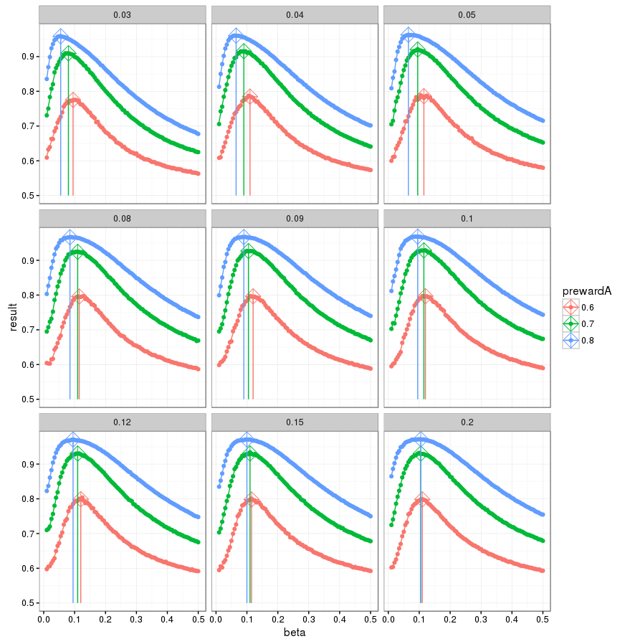

Looking at median ACC instead of mean ACC: something is weird. Need to look at ACC distribution?
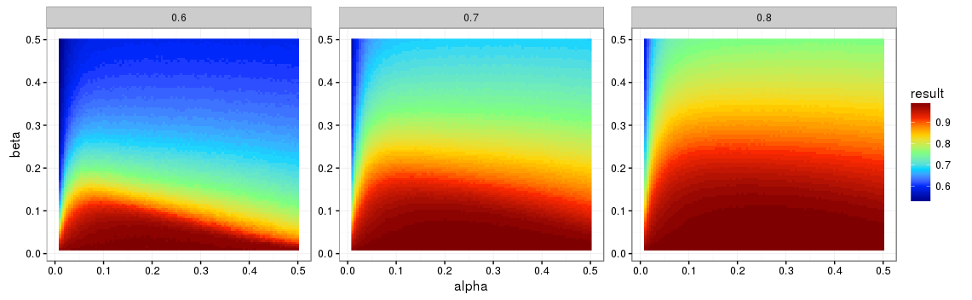
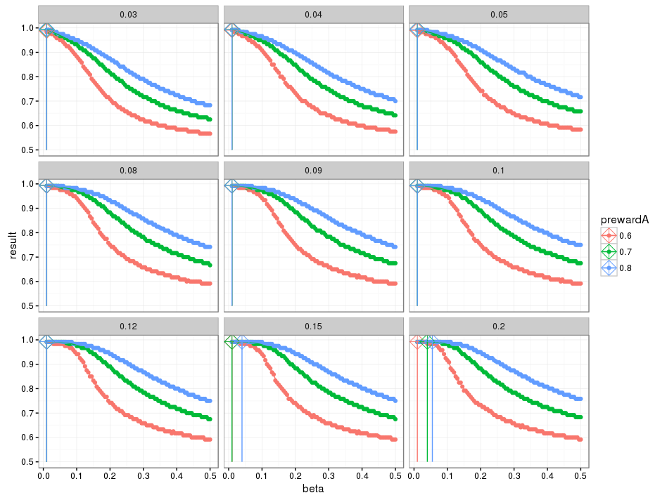
Qlearning alpha/beta model Q0=0 (02)
summary for group alpha/beta (surprisingly low wrt placebo study using the same task…?); anodal
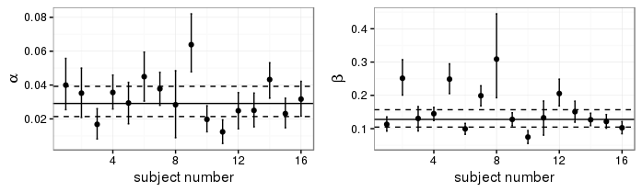
Final Q-values per subj/condition
