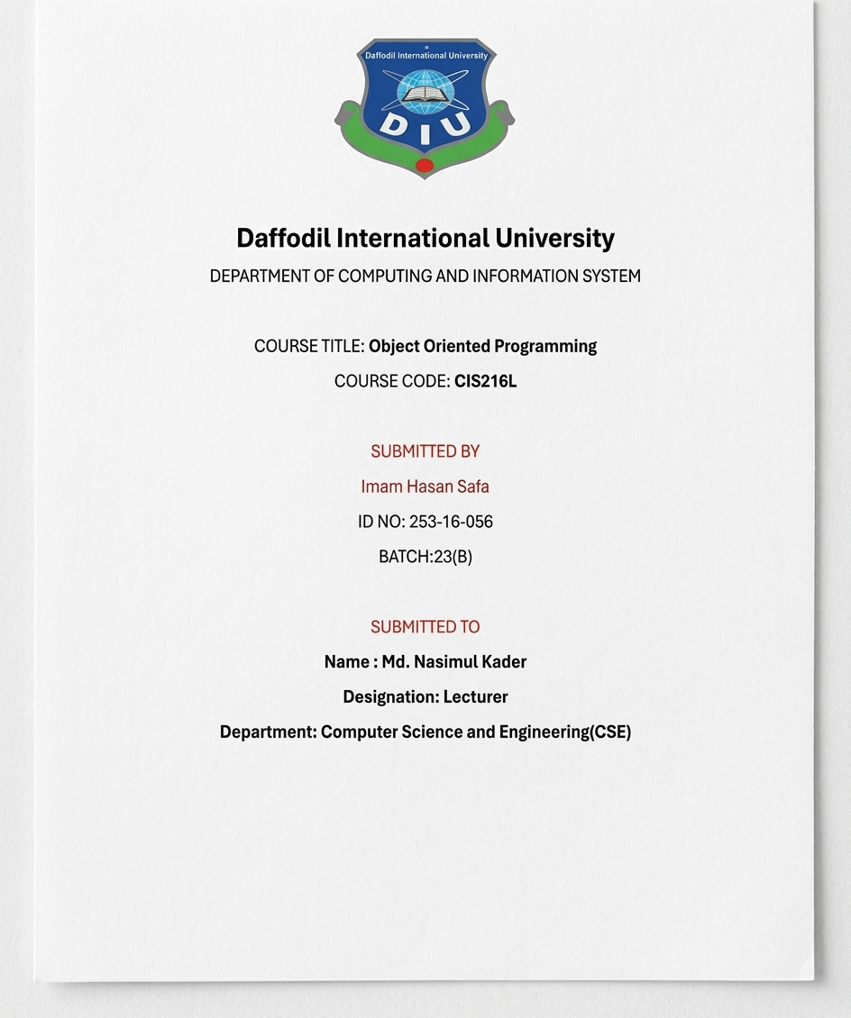
Github : https://github.com/ihsafa20062004-netizen/OOP/edit/main/JAVA
CODE:
public class Hello{

public static void main(String[] args) {

System.out.println("Hello World");

}

}
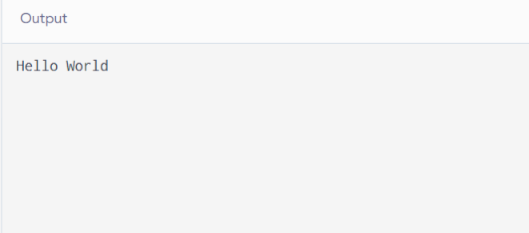

public class Daffodil{
public static void main(String[] args) {
{
System.out.println("This is inside the block.");
}
System.out.println("This is outside the block.");

}
}
