Bahrain

2020

Easy Linux for Beginners

Step by step guide to learn Linux

Noman ul Haq

Noman ul Haq Documentation on Linux

Table of Contents

Introduction 1

What is an Operating System? 1

Detect hardware 1

Manage processes 1

Manage memory 1

Initiate user interfaces 1

Establish file systems 1

Manage access and user authentication 1

Provide a platform for administrative use 1

Start-up services 1

What is Linux? 2

Supports clustering 2

Runs virtualization 2

Cloud Computing 2

Options for Storage 2

History of Linux 2

Linux as Compared to other Operating Systems 3

# Introduction

## What is an Operating System?

A computer, complete with all its parts – the CPU, mouse, monitor, and keyboard – will not work without a central program that will piece it all together. In order to use a PC, you need a piece of software inside which will take care of making the hardware work for you. A special kind of software which is between the hardware of the PC, and the programs that you want to use and work with. This piece of software is the Operating System, or more easily referred to as just an OS.

In short, an operating system is the software that brings together a computer’s hardware and the different programs that you want to install on it. Without it, when you booted up your PC, you would not get anything on the monitor, and neither mouse nor keyboard will work. You would be unable to watch videos, listen to music, edit photos, or to simply write a note.

With that said, an operating system is responsible for doing the following tasks:

Detect hardware– An OS is responsible for validating the components of a computer during boot up (hard drive, CPU, network cards, mouse, etc.) and loading the corresponding drivers and modules for the hardware to properly run.

Manage processes– Similar to the way our mind works, several processes or applications are running on a computer at the same time. It is the OS that is responsible for allocating CPU resources and sharing it among the processes. The OS also provides the user the option to start, stop, or restart a process.

Manage memory– Each application needs a specific amount of RAM and swap memory to function. The OS is responsible for assigning memory allocations, and for handling memory requests.

Initiate user interfaces- An OS offers users ways to access the system either via a command line or a graphical user interface (GUI)

Establish file systems– The OS handles the management of files (access, directories, and structure), including the access to the file system.

Manage access and user authentication– An OS allows for creating user accounts with different permissions for access to files and processes.

Provide a platform for administrative use– A computer’s OS provides a platform for the administrator to add users, allocate disk space, install software, and to perform activities to manage the computer.

Start-up services– The OS manages several processes running in the background known as ***daemon processes***.

## What is Linux?

Linux is an operating system, similar to the examples mentioned in the previous section, and is often described as Unix-like.

The stark difference between Linux and other operating systems lies in the fact that Linux is an open-source operating system. This means that Linux is continuously developed collaboratively. Unlike Windows and OS X which are both tied to the respective companies (Windows and Apple), not one company owns Linux’ development and support. Builder Linux is a shared vision, with different companies sharing research, development, and the associated costs. This open source cooperation among companies and developers has led to making Linux one of the best ecosystems for use from small digital wristwatches to servers and supercomputers. Based on statistics, there are at least 100 companies and more than 1000 developers who work together for every kernel release.

Linux is composed of a *kernel*, the core control software, plus plenty of libraries and utilities that provide different features. Linux is available through many *distributions*. These are what we can call Linux flavours. Distributions are groups of specific kernels and programs. The most popular ones include Arch, SUSE, Ubuntu, and Red Hat.

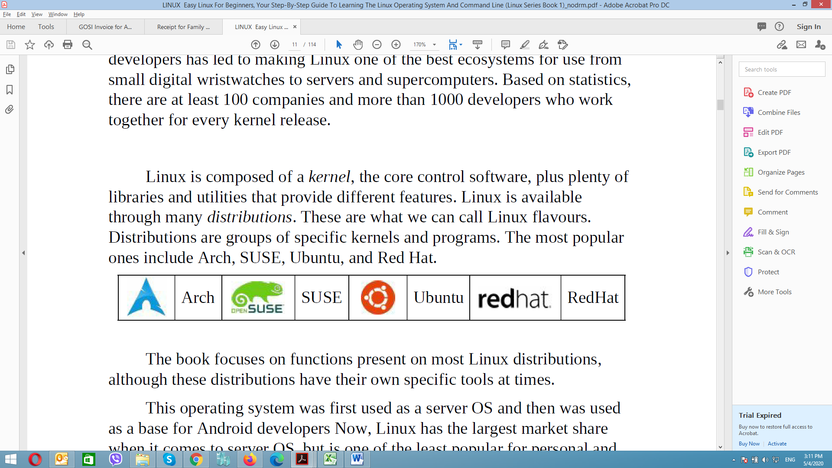

In addition to the tasks performed by an operating system, Linux has the following characteristics:

Supports clustering– Multiple Linux systems can be configured to appear as one system from the outside. Service can be configured among clusters and still offer a seamless user experience.

Runs virtualization– Virtualization allows one computer to appear as several computers to users. Linux can be configured as a virtualization host – where you could run other OS such as Windows, Mac OS, or other Linux systems. All the virtualized systems appear as separate systems to the outside world.

Cloud Computing– Linux can handle complex, large-scale virtualization needs – including virtual networks, networked storage, and virtual guests.

Options for Storage– Data need not always be stored in your computer’s hard disk. Linux offers different local and networked storage options such as Fiber Channel and iSCSI.

## History of Linux

Linus Benedict Torvalds, a student from Finland, created Linux in 1991 using C and assembly language. Linux was developed as a free, open source, open license operating system, which enables developers around the world to study and modify the OS. Since the release of the initial source code in 1991, it has grown now to more than 18 million lines of code under GNU General Public License.

Initially, Torvalds named the operating system he invented as Freax, a combination of the words “free”, “freak”, and “x”. He uploaded his files to an FTP server where his colleague, Ari Lemmke, was the FTP server administrator. Lemmke thought *Freax* was not a good sounding name so he renamed the folder to *Linux* without telling Torvalds. Later on, Torvalds approved the name change.

In 1992, Linux was licensed under GNU GPL and the first Linux distributions (also called *distro*) were created – Boot-root, MCC Interim Linux, Softlanding Linux System (SLS), and Yggdrasil Linux where one of the first few released in the same year. Several distributions have been created over time: Slackware - the oldest existing distro, Debian - the largest community distribution, and commercial distributions Red Hat and SUSE.

In recent years, Linux has seen more developments. The server market revenue of Linux has already exceeded that of Unix. The Linux-based mobile OS Android has gained 75% of the market share. In 2015, Linux Kernel Version 4.0 was released.

Through collaborative works, Linux is now one of the most powerful operating systems. Data shows that 98.8% of the world’s fastest systems use the Linux kernel. Isn’t it comforting to know that you are using the same OS as these supercomputers?

### Linux as Compared to other Operating Systems

Now, let’s get to the important question: Is Linux better than the others? Let’s compare Linux with other well-known operating systems.

#### Cost

If you obtained Windows legally, you would have paid more than $100 or even more for the Pro version. Linux, on the other hand, is free of charge. For Linux commercial distributions, companies sell services such as support and documentation, but the OS itself comes for free.

#### Viruses

Linux hardly gets any viruses. Since most PCs run on Windows, attackers target Windows OS. The open-source policy of Linux is key. With many developers working on Linux, there are more eyes focused on seeing security flaws. There’s plenty of help too, if ever a real Linux virus comes around. Proprietary operating systems are tied with the number of employed engineers and resources they have. With Linux, any developer from around the world can simply download the source code and help out with finding and solving flaws.

#### System Stability

As mentioned in the previous section, Linux is used in servers and supercomputers. Large-scale systems can go on for years without restarting the server. The time when a proper restart is performed is during kernel upgrades – even upgrades for software running on aLinux server only perform a service restart and not a node restart.

Compare that to the number of times you’ve experienced losing data because the program crashed or the time when you plugged in a device and you saw the “Blue Screen of Death” in Windows. I am not saying that you will not turn off your computer when running on Linux, but the option is there, if you wish to do so.

#### Installation

When you install Linux (any of its flavours – Ubuntu, Fedora, etc.), you get all the stuff that you need text editor, spreadsheet, presentation program, photo editor, web browser, movie player, PDF reader, and the like. As compared to Windows and other OS, once you have the OS set-up, you will have to install all the other software that you need one-by-one.

This also holds true for hardware drivers too. In Windows, you would have to install the drivers first. Drivers usually come in CDs when you purchase hardware. Now, think about the time when you would need to install the driver and you couldn’t find the CD for it? You would have to go to the manufacturer’s website to download the specific driver. In Linux, drivers are included in the Linux Kernel installation – you get to save time and it’s a lot more convenient.

#### Support

Linux has a large community online where new users can get information, read FAQs, and ask questions if there are programs or features that you think are not working right. The great thing about open-source is that with plenty of people involved in the OS, there are an unlimited number of resources that you can use and learn from. All these come for free too!

These are some of the reasons why Linux is a better OS compared to others. However, do note that Linux uses open-source software, so if you are concerned about any of the items listed below, then you should stick to Windows or your current OS:

* You need to work using proprietary software. If you absolutely cannot find an open source program that will match the proprietary software that you need, keep your current OS.
* You are a serious gamer. The majority of games are only made compatible with Windows.
* Hardware is not yet supported in Linux. Very new hardware like those released only in the few months prior might not yet be supported in Linux. Hardware vendors usually release drivers only for Windows and Mac since these are the most popular.

Most individuals with Linux installed do away with these issues by what is called *dual-booting*. This is the option of installing both Windows and Linux on your device so you can choose either of the OS depending on your needs.

# Commands

|  |  |
| --- | --- |
| **Command line** | **Descriptions** |
| Cd / | It takes us root directory |
| Ls | List / all available data within directory |
| Cd home | To reach home directory |
| Cd .. | Back step |
| Mkdir | Make directory |
| touch test.txt | To create new file |
| vi test.txt | To open file in vi file editor   * To write we have to go to insert mode and we need to type i * To exit from insert mode we press esc button * To save we type shift + : * Then I write wq (w = write q = quite) |
| cat | To print content in the file |
| cp | To copy file from one destination to another destination   * Cp test.txt /home/noman/foldername |
| mv | To move file from one destination to another   * mv test.txt /home/noman/anotherfoldername |
| rm | To remove any file   * rm test.txt /home/noman/anotherfoldername |
| man | To check option description of another command   * man mkdir * man ls * man touch |
| Find | For searching any file   * find /home/noman/foldername/ “test.txt” * find /home/noman/foldername/ “*.txt” * find /home/noman/foldername/ -name “app.txt” |
| Uname | Written name of operating system |
| Uname –a | Display detail system and operating system |
| Uname –p | Display processor information |
| Lscpu | Display system information like # of cpu, ram etc. |
| Df | Display disk space   * df –h (diplay human readable form) |
| Du | Display how many files available in directory with space in specified directory |
| Du –s | Total size of directory |
| Du –s -h | Total size of directory (human readable form) |
| Date | To written date |
| Cal | To display calendar |
| w | Ho is online |
| Apt-get | To install any package   * apt-get install python |
| Apt-cache | Sudo apt-cache search python |
| Info | Information on command |
| Type | Show the Location of key command file   * type man * type mkdir |
| Bg | To check any background services |
| Free | To check how much memory is available and free |
| Ps | To show all running processes |
| Kill | To kill any process   * kill 2985 |
| Nice | To run the program with low priority |
| Top | To check cpu processes user, memory utilization by each process |
| Su - | To switch user |
| Shutdown | To shutdown the system |
| Sudo su | To enter into root user |
| Sudo | Install any package from normal user without entering into root user   * sudo get-apt install python |
| Ctrl+a | Start of command |
| Ctrl+e | End of command |
| Pwd | Show current directory (path working directory) |
| Scripting | Touch simple.sh  Vi simple.sh  #!/bin/bash  Echo my first name is : $1  Echo my last name is : $2  **To execute:** ./simple.sh Noman Haq  Permission denied error  Chmod 777 simple.sh  **To execute:** ./simple.sh Noman Haq |
| Permissions | 0 = no permission  1 = executable permission  2 = write permission  4 = read permission |
| Ls –l | To check the permission on current directory |
| Permission class | There are 3 permission classes 1. Owner 2. Group 3. Other users |
| Chmod | To assign or rollback permission  Chmod 777 simple.sh (7 = for all e,w,r permission) |
| Uptime | To check since how long my system turned on uptime is the command that shows the duration that the computer has been up. In this case, the computer has been up for the last 29 days, or almost1 month. |
| Uname | Show name of operating name |
| Uname -srv | To check relase and version |
| Cd ~ | To go to the system root directory |
| Cd / | To go to the user root directory |
| Hostname | Show hostname |
| Hostname –i | To show ip address |
| Date | Show current date and time |
| Cal | To show calendar |
| W | To see which user is online at the moment |
| Lscpu | System Architecture information |
| Cat /proc/cpuinfo | To print all cpu related information |
| Df | To see disk space information |
| Df –h | To see disk space information (human readable form) |
| Sudo Apt remove package name | To remove any package from the system |
| Alias | To give short name on any command.  Alias myfile =”touch myfile.txt” |
| Unalias | To remove our custom command |
| To create new user | Cd /  Cd home |
| Useradd | To create new user  Sudo useradd Arahman –m |
| Passwd | To set password  Sudo passwd Arahman |
| Userdel | To remove any user  Sudo userdel Arahman –r |
| Info | Info ls  To get information on any command |
| Whatis | To get short description on any command  Whatis ls |
| Whereis | To show Command line location |
| Which | To show path variable |
| Bg | To see backgroung processes |
| Free | To see free spaces in memory |
| Ps | To see which processes are up and running |
| Kill | To kill any running process  Kill (PID)  Kill 5465 |
| Top | To check to up and running processes |
| Reboot | To reboot the system |
| Shutdown | To shutdown the system |
| Nice | To display all low priority program |
|  |  |