course · document type
Document title goes here
A one-sentence lead that says what this document is for and who should read it.
part 1 · category a

First section
A lead paragraph in the larger grey face, opening the section.
Body text sits here. Lorem ipsum dolor sit amet, consectetur adipiscing elit, sed do eiusmod tempor incididunt ut labore et dolore magna aliqua. Ut enim ad minim veniam, quis nostrud exercitation ullamco laboris nisi ut aliquip ex ea commodo consequat.

A subsection
Placeholder paragraph with a displayed equation, which in Word is set as text; maths-heavy material stays LaTeX-first. Emphasis is italic.
∇f(x) = (A + Aᵀ) x (1)
- First bullet point.
- Second bullet point.
42  Caption for the first figure, saying what was counted and on which date. | 7.5  Caption for the second figure. | 100%  Caption for the third figure.

what this does not mean | A callout holds the objection a careful reader would raise, stated before they have to. Placeholder text.
A single pull-quote claim, set large between two rules.
attribution label
Figures read on 21 September 2026 from the build log, with the command that produced them.

How the pieces connect
figure 1 node-and-arrow flow
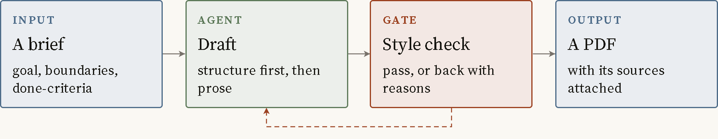
A failed gate returns to the draft step, twice, then to a person.
Slate boxes are inputs and outputs. Sage boxes are work an agent does. Rust boxes are deterministic checks that pass or fail.
table 1 what the three node kinds mean
kind | how it is drawn | use it for
hsnode | Slate rule, slate-tint fill | An input or an output
hswork | Sage rule, sage-tint fill | Work an agent does
hsgate | Accent rule, accent-tint fill | A check that passes or fails
listing 1 placeholder code
def placeholder(x):
return x * 2
A listing shows output as it came back, trimmed but not edited.
plate name 1600 × 900, 21 september passed
A plate caption says what the image is evidence of. In Word the plate image goes in a Figure paragraph above the spec line.

Sources
- Author, Title of the first source, Publisher, Year.
- Author, Title of the second source. https://example.com/source

