eyebrow · september 2026

Document title
A one-sentence lead that says what this document is for.
The opening paragraph is the only general one. It says what the thing is and why a reader should care, before any number or mechanism appears.
A second paragraph can set up the figure below. Nothing is illustrated twice: if the diagram carries it, the prose does not repeat it.
figure 1 node-and-arrow flow
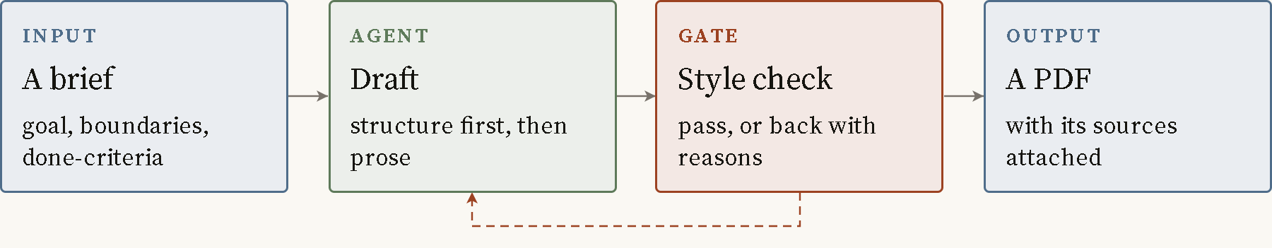
A failed gate returns to the draft step, twice, then to a person.
Slate boxes are inputs and outputs. Sage boxes are work an agent does. Rust boxes are deterministic checks that pass or fail.
Figure 1 from core/docs/DESIGN.md, read 21 September 2026.

Measured results
A stat row carries two to four measured figures, each with what was measured and when.
42  Caption for the first figure, saying what was counted and on which date. | 7.5  Caption for the second figure. | 100%  Caption for the third figure.
A single pull-quote claim, set large between two rules.
attribution label

what this does not mean | A callout holds the objection a careful reader would raise, stated before they have to. Placeholder text.
Figures read on 21 September 2026 from the build log.

Sources
- Author, Title of the first source, Publisher, Year.
- Author, Title of the second source. https://example.com/source

