Ideation Phase Empathize & Discover
Date | 28 September 2026
Team ID | SWTID-2026-9038
Project Name | Script-Controlled ACL – Restrict Record Access Based on Field Value
Maximum Marks | 4 Marks

Team Leader: K. Kumutha | Members: R. Siva Dharshini, S. Vayshavi, M. Jasmin

Empathy Map Canvas:
An empathy map is a simple, easy-to-digest visual that captures knowledge about a user's behaviours and attitudes.
It is a useful tool to helps teams better understand their users. Creating an effective solution requires understanding the true problem and the person who is experiencing it. The exercise of creating the map helps participants consider things from the user's perspective along with his or her goals and challenges.

Example:
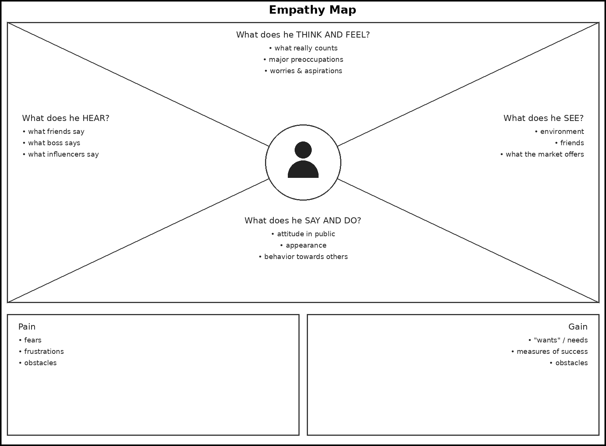
Reference: https://www.mural.co/templates/empathy-map-canvas

Example: Script-Controlled ACL – Restrict Record Access Based on Field Value
