Enhancing Network Intrusion Detection: Impact of Data Cleaning and Feature Selection on the CIC-IDS2017 Dataset
Author: İhsan Dalkıran
Email: ihsandalkiran@posta.mu.edu.tr/ihsndlkrn@gmail.com

Abstract
This study aims to improve the performance of machine learning-based Network Intrusion Detection Systems (NIDS). Structural issues within the widely used CIC-IDS2017 dataset, such as packet duplication and mislabeling, can lead to overfitting in machine learning models [1]. In this project, these flaws were addressed through data cleaning and preprocessing, followed by dimensionality reduction using feature selection techniques. A Random Forest algorithm was trained on the cleaned and optimized dataset. The results demonstrate the critical importance of data quality and proper feature selection in improving the reliability and robustness of NIDS models.
1. Introduction
Problem Definition
The rapid growth of network traffic has made cyberattack detection increasingly complex. Machine learning (ML) provides a powerful approach for automating this process; however, the effectiveness of ML models heavily depends on the quality of the training dataset, particularly datasets such as CIC-IDS2017 [1].
Motivation
High dimensionality and class imbalance in the original dataset can negatively affect detection models by introducing noise and bias into the learning process [2].
Objective
The primary objective of this project is to eliminate known noise within the dataset, select the most significant network traffic features, and provide a Proof of Concept (PoC) for an autonomous defense system.
2. Fundamentals
- Network Intrusion Detection Systems (NIDS): Systems designed to monitor network traffic and detect anomalous or malicious activities.
- CIC-IDS2017 Dataset: A benchmark intrusion detection dataset containing 15 traffic classes (benign and multiple attack categories) with more than 80 network flow features [1].
- Feature Selection: Techniques such as Information Gain are used to reduce dataset dimensionality by identifying the most informative features, thereby improving model efficiency and reducing confusion [2].
- Random Forest: An ensemble learning algorithm based on decision trees that performs effectively on multi-class and imbalanced datasets.

3. Related Works
Numerous studies have focused on dimensionality reduction and imbalanced datasets in the field of network intrusion detection. Kurniabudi et al. applied Information Gain-based feature selection on the CIC-IDS2017 dataset and reduced the original 78 features to the most significant 22–28 features. Using Random Forest classification, they achieved accuracy rates of up to 99.8% [2]. However, their study utilized the original version of the dataset without addressing its structural flaws.
In contrast, a more recent study conducted by Lanvin et al. demonstrated that the CIC-IDS2017 dataset contains several imperfections, including incorrectly ordered packets within pcap files, approximately 4.5% duplicated packets, and mislabeled Port Scan attacks [1]. Their findings showed that these data quality issues artificially inflate model performance and contribute to overfitting. After cleaning the dataset, they observed reductions of up to 20% in recall scores for classical machine learning models [1].
Contribution of This Study
This project combines these two perspectives from the literature. The modeling architecture inspired by the referenced GitHub repository and the feature selection strategy proposed by Kurniabudi et al. [2] were applied to the cleaned dataset suggested by Lanvin et al. [1], aiming to build a more realistic and reliable intrusion detection system.
4. System Proposal (Materials and Methods)
- Data Preprocessing: Cleaning NaN, Infinity, and duplicated values from the dataset.
- Feature Selection: Identifying critical network traffic features using Information Gain and manual feature analysis techniques.
- Model Training: Training a Random Forest classifier using the Scikit-Learn framework with a 70% training and 30% testing split.
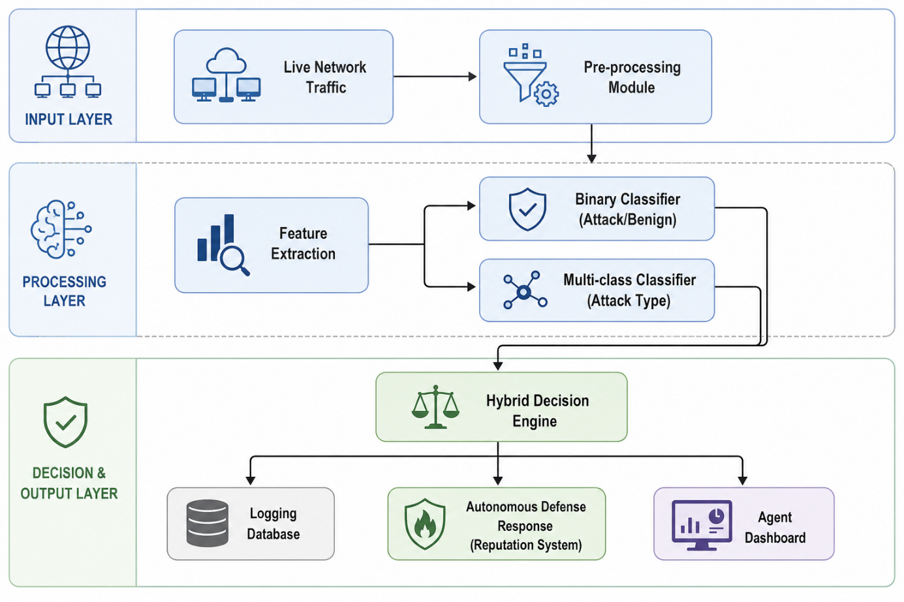
Figure 1Proposed Autonomous Defense Agent Architecture. This diagram illustrates the bidirectional flow of the defense agent, from real-time packet capture to the hybrid decision engine and autonomous response mechanism.
5. Implementation
This section explains the development process of the proposed Proof of Concept (PoC), the technologies used, and the evolution of the machine learning pipeline over time. The project was developed in Python using the pandas and numpy libraries for data manipulation, Scikit-Learn for machine learning processes, and imblearn for handling imbalanced datasets. The implementation process was carried out in three major stages based on the reference GitHub architecture and the cleaned dataset proposed by Lanvin et al. [1].
5.1 Evolution of the Machine Learning Pipeline
The intrusion detection system developed in this project evolved iteratively to overcome structural challenges in the dataset, including high dimensionality and severe class imbalance.
Stage 1: Exploratory Pipeline and Automatic Feature Selection
In the first stage, the objective was to reduce noise and dimensionality within the raw dataset containing more than 80 features.
- A data-driven approach was adopted, where the feature_importances_ property of the Random Forest algorithm was used to identify the 15 most significant features.
- Features with high Pearson correlation values were detected, and less important correlated features were removed to reduce overfitting risk.
- Data scaling was performed using RobustScaler, while NaN and infinite values were cleaned.
Stage 2: Data Leakage Prevention and Multi-Class Classification
In the second stage, the system evolved from a binary classifier (“Attack vs. Normal”) into a multi-class architecture capable of classifying different attack categories such as DoS, DDoS, PortScan, and BruteForce.
Key engineering decisions included:
- Preventing Data Leakage: SMOTE (Synthetic Minority Oversampling Technique) was applied only to the training dataset rather than the entire dataset. This prevented synthetic samples from leaking into the test data and ensured a more realistic evaluation environment.
- Overfitting Control: Model stability was evaluated using Stratified 5-Fold Cross Validation, minimizing differences between training and testing F1-scores.
Stage 3: Final Autonomous Defense Agent (Production Pipeline)
In the final stage, the system was optimized for real-time deployment in live network environments.
- Manual Feature Selection: Instead of automatic feature selection, six manually selected critical features (such as Flow IAT Mean and Flow IAT Std), aligned with the findings of Kurniabudi et al. [2], were integrated into the pipeline to improve decision-making speed.
- Hybrid Sampling: The excessively large BENIGN class was reduced using RandomUnderSampler to prevent CPU bottlenecks, while minority classes such as Infiltration and Heartbleed were balanced using SMOTE.
5.2 Label Corrections and Data Standardization
During preprocessing, several structural issues within the CIC-IDS2017 dataset were corrected. Windows-1252 encoding errors were cleaned, and SMOTE was used to address the class imbalance problem.
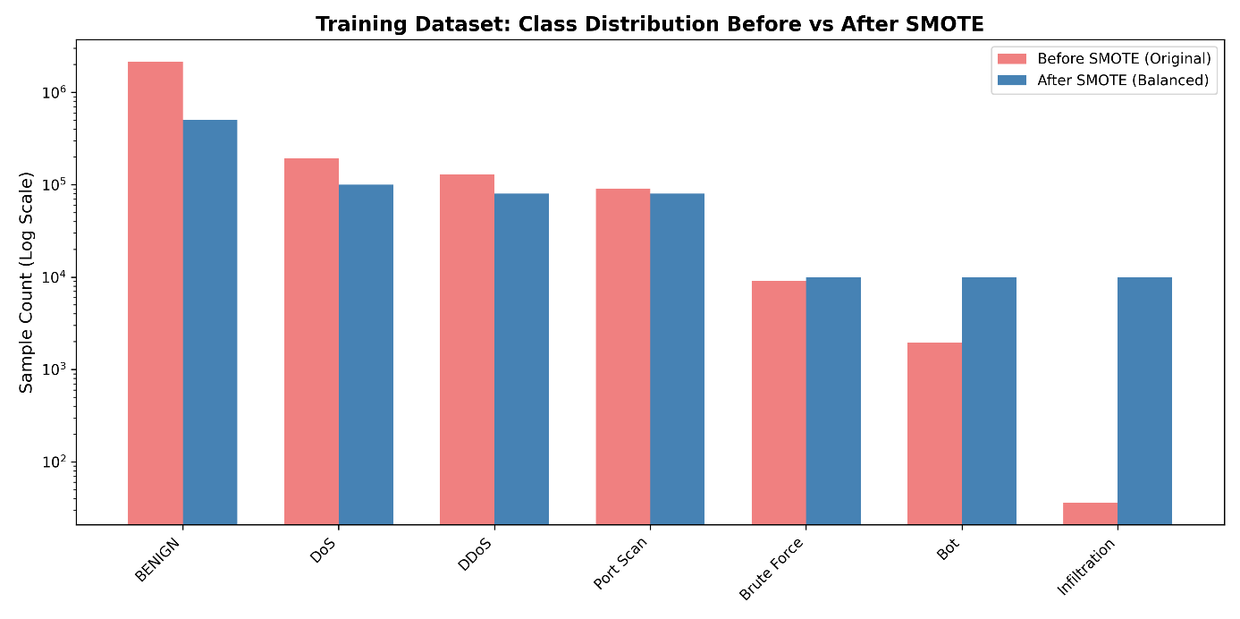
Image 1 SMOTE Distribution

5.3 Usage of Generative AI
In accordance with project requirements, Generative AI tools (e.g., ChatGPT and Gemini) were utilized only as development assistants during specific stages of the project.
AI assistance was limited to the following tasks:
- Debugging complex pandas indexing and data manipulation errors.
- Optimizing SMOTE and pipeline integration processes using the imblearn framework.
- Supporting the interpretation of anomalies within network traffic data (e.g., the role of IAT Mean values in DoS attack behavior).
- Writing formatting scripts for cleaner visualization of correlation matrices and confusion matrices in the terminal.
6. Results and Discussion
6.1 Feature Importance Analysis
The six most influential features used by the model are presented in Image 2: Feature Importance. Consistent with the findings of Kurniabudi et al. [2], Packet Length Variance and Init_Win_bytes_forward were identified as the most discriminative features.
Using only these optimized six features instead of the full dataset significantly improved decision-making speed and minimized latency during real-time traffic analysis.
6.2 Multi-Class Classification Performance
The detection performance of the model across seven attack categories and benign traffic is shown in Image 3: Multi-Class Confusion Matrix.
The confusion matrix demonstrates the following:
- Benign Traffic: Achieved a very high detection accuracy of 99.70%.
- Minority Classes: Despite containing only 36 samples, the “Infiltration” class achieved 99.81% accuracy, while Bot attacks achieved 98.67%.
- DoS and DDoS Attacks: Volumetric attacks were detected separately with accuracies of 99.69% and 99.89%, respectively.
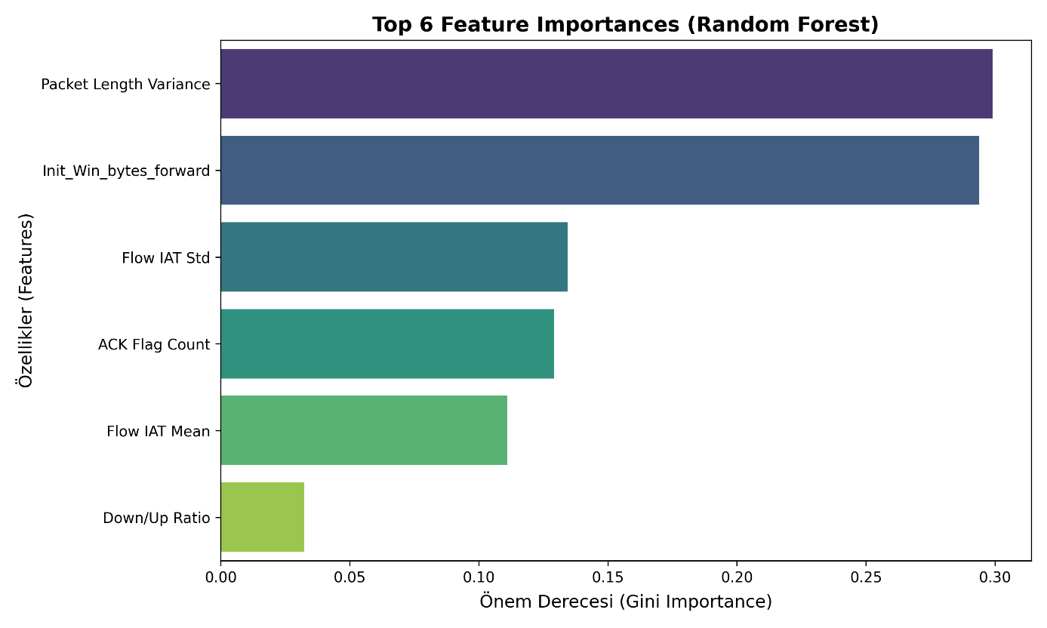
Image 2 Feature Importance
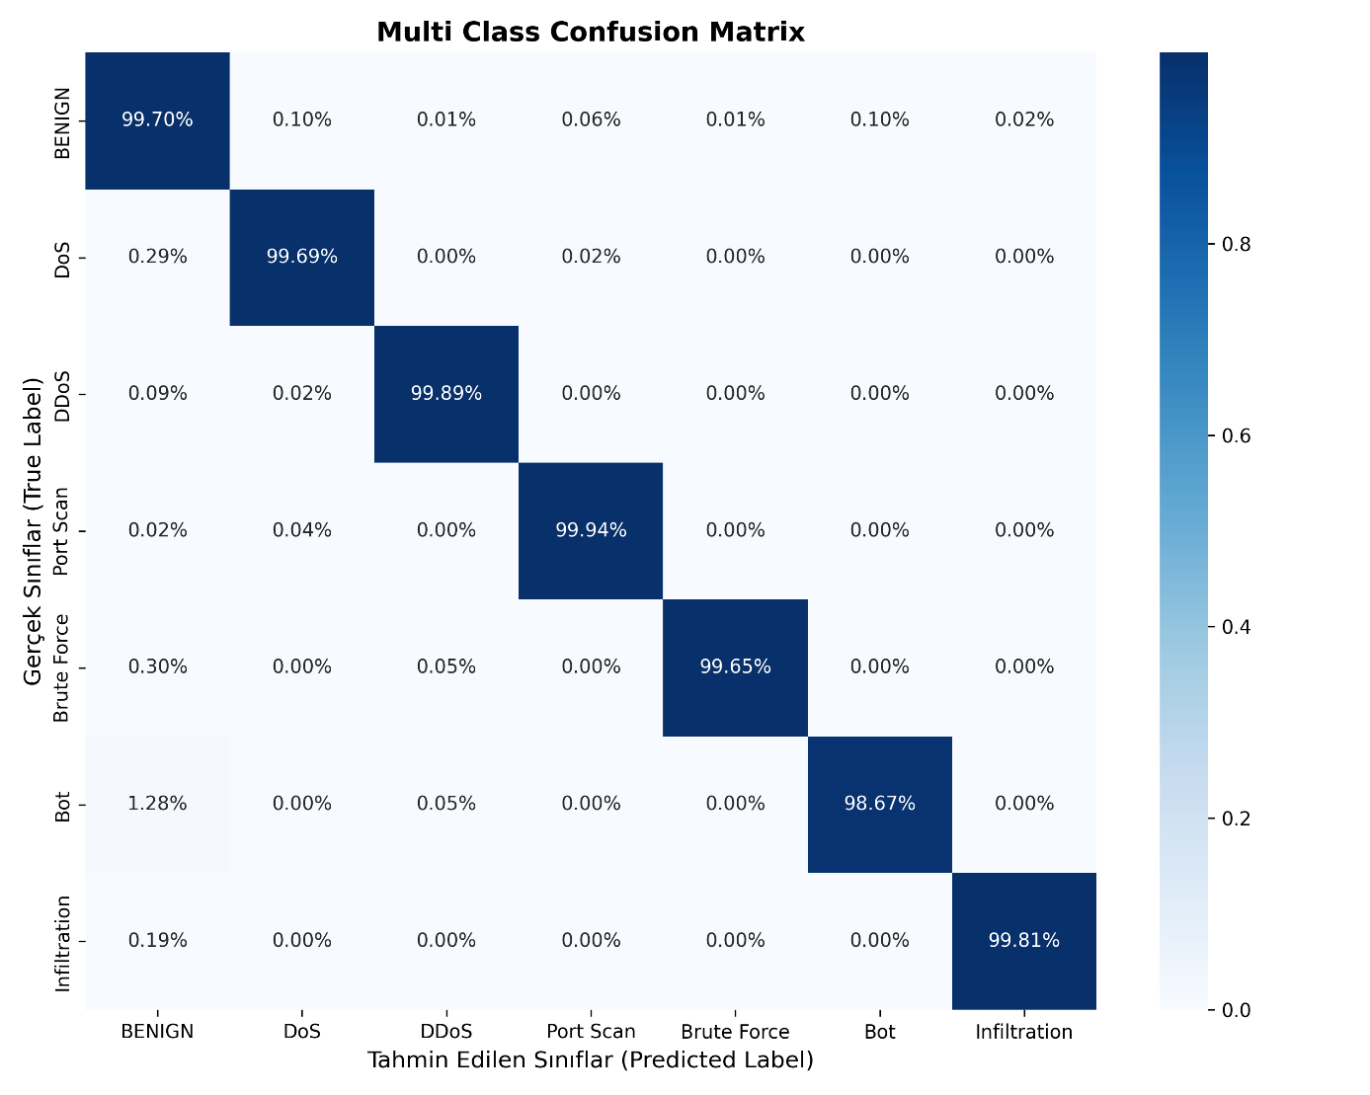
Image 3 Multi Class Confusion Matrix
6.3 System Limitations and Real-World Testing
Although the model achieved over 99.8% accuracy on the test dataset, real-time network experiments conducted using agent_daemon.py and Scapy revealed difficulties in distinguishing between real-world traffic and attack traffic.
Two major issues were identified:
- Feature Extraction Mismatch:
The model was trained using static flow summaries generated by CICFlowMeter after complete TCP session termination. However, the live defense agent makes rapid decisions based only on the first 10 observed packets. This window difference caused mathematical inconsistencies between training and real-time features.
- Concept Drift:
The CIC-IDS2017 dataset was generated in a controlled laboratory environment. During real-world testing, modern CDN servers exhibited long Keep-Alive waiting periods, resulting in high Flow IAT Mean values. The model incorrectly associated these behaviors with Slowloris-style DoS attacks, leading to confusion.
These findings demonstrate that high accuracy scores obtained on closed benchmark datasets do not necessarily translate into real-world success. They also highlight the necessity of retraining models using streaming network data and real-time traffic statistics.
7. Conclusion
Experimental results showed that cleaned data and optimized feature selection enabled the model to achieve offline accuracy rates exceeding 99.5%. However, real-time testing on the developed autonomous defense agent exposed significant data drift problems between laboratory environments and real-world traffic conditions.
Although the model achieved excellent performance during offline evaluation, it struggled with asymmetric real-time network flows. This study demonstrates that machine learning-based NIDS systems depend not only on data quality and feature engineering, but also on strict consistency between training-time and deployment-time feature extraction processes.
Future work will focus on improving real-time detection performance by training the model directly on time-window-based packet sequences generated by Scapy instead of CICFlowMeter summaries. This approach aims to develop a fully autonomous system capable of adapting to the dynamic nature of real-world network traffic rather than memorizing patterns from static datasets.
References
[1] M. Lanvin, P. F. Gimenez, Y. Han, F. Majorczyk, L. Mé, and É. Totel, “Errors in the CICIDS2017 dataset and the significant differences in detection performances it makes,” 17th International Conference on Risks and Security of Internet and Systems (CRiSIS), pp. 18–33, 2022.
[2] Kurniabudi, D. Stiawan, Darmawijoyo, M. Y. bin Idris, B. Kerim, and R. Budiarto, “Important Features of CICIDS-2017 Dataset For Anomaly Detection in High Dimension and Imbalanced Class Dataset,” Indonesian Journal of Electrical Engineering and Informatics (IJEEI), vol. 9, no. 2, pp. 498–511, 2021.

