Devops Challenge user guide

1. Fork this repository to your own repository.
https://github.com/ihsanizwer/devops-challenge-dotnet.git
2. Go to dev.azure.com, login and select on creating build pipelines. From here, choose build from gihub repositories and select the repo.
3. Configure the artifact directory. (Last task in the build pipeline). So that the artifacts are saved where you wanted them to be saved. Please note that static code analysis has been setup. Once you build the solution, can go to the logs to view the recommendations from them.
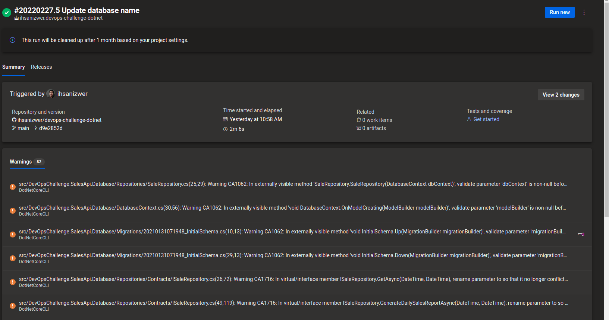
4. Please note that sometimes the build may fail simply restart and it will work. This is a known issue. Simply just rerun it again.
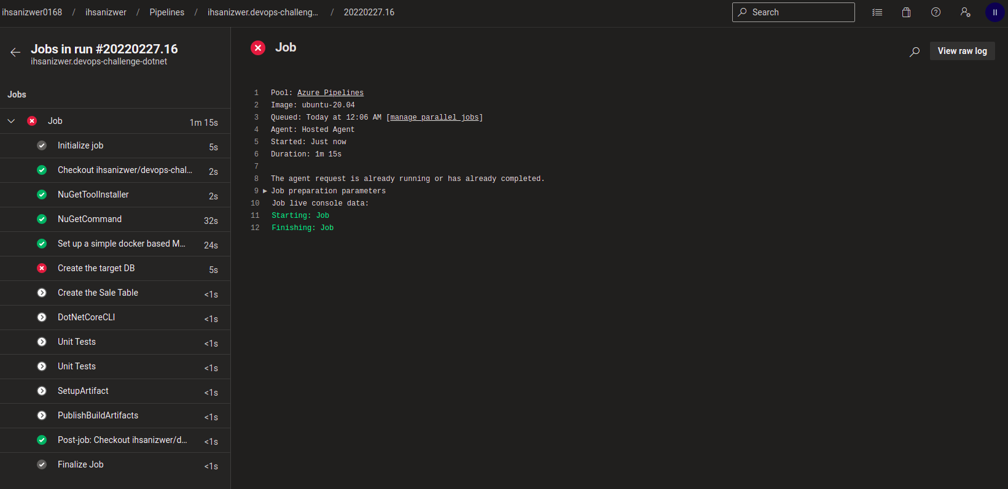
5. Now it is time to configure the deployment pipeline. You can setup terraform as per the image below. Service Principal will be used for connections from the terrasform to the infrastructure. Don’t forget to set the release agent to be Linux as well.

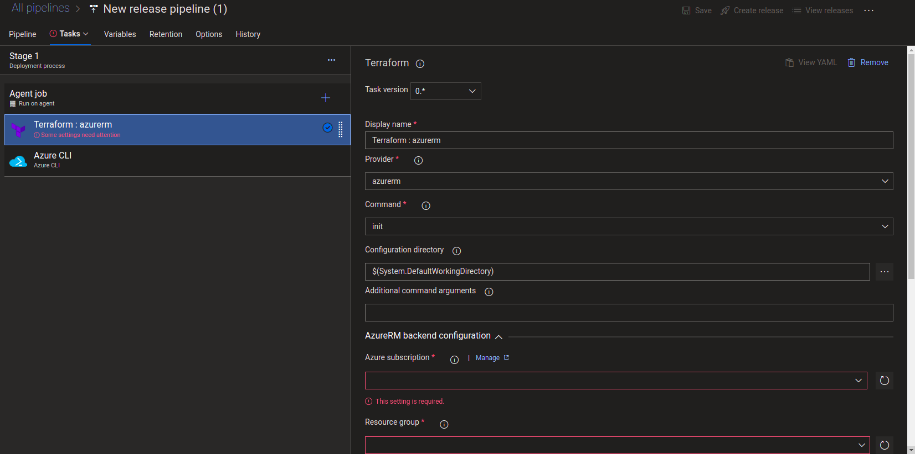
Suppose you want to run the infrastructure, you can use the terraform file. Here, be sure to set the correct subscription. Here you will need to give resource group, Azure subscription, place to save your statefile etc. However, if you just want it to work, simply use az cli to authenticate and deploy.
If you are setting up the terraform via azure devops, then you will need the below commands as azure cli(powershell) commands to get the details of the IP automatically.

$pip = Get-AzPublicIpAddress -Name devops-pub-ip -ResourceGroupName devops-rg
$IPF = $pip | Out-String -stream | Select-String -Pattern 'IpAddress\b'
$IP2 = $IPF -replace '\s',''
$IParr = $IP2.Split(":")
$IParr[1]

6. Once terraform is out of the way, we just need 2 more tasks in the deployment pipeline. 1 is to copy the artifacts from before to the newly created VM and the other task is to make the rest of the changes happen in the VM level. For that choose ssh remote commands.

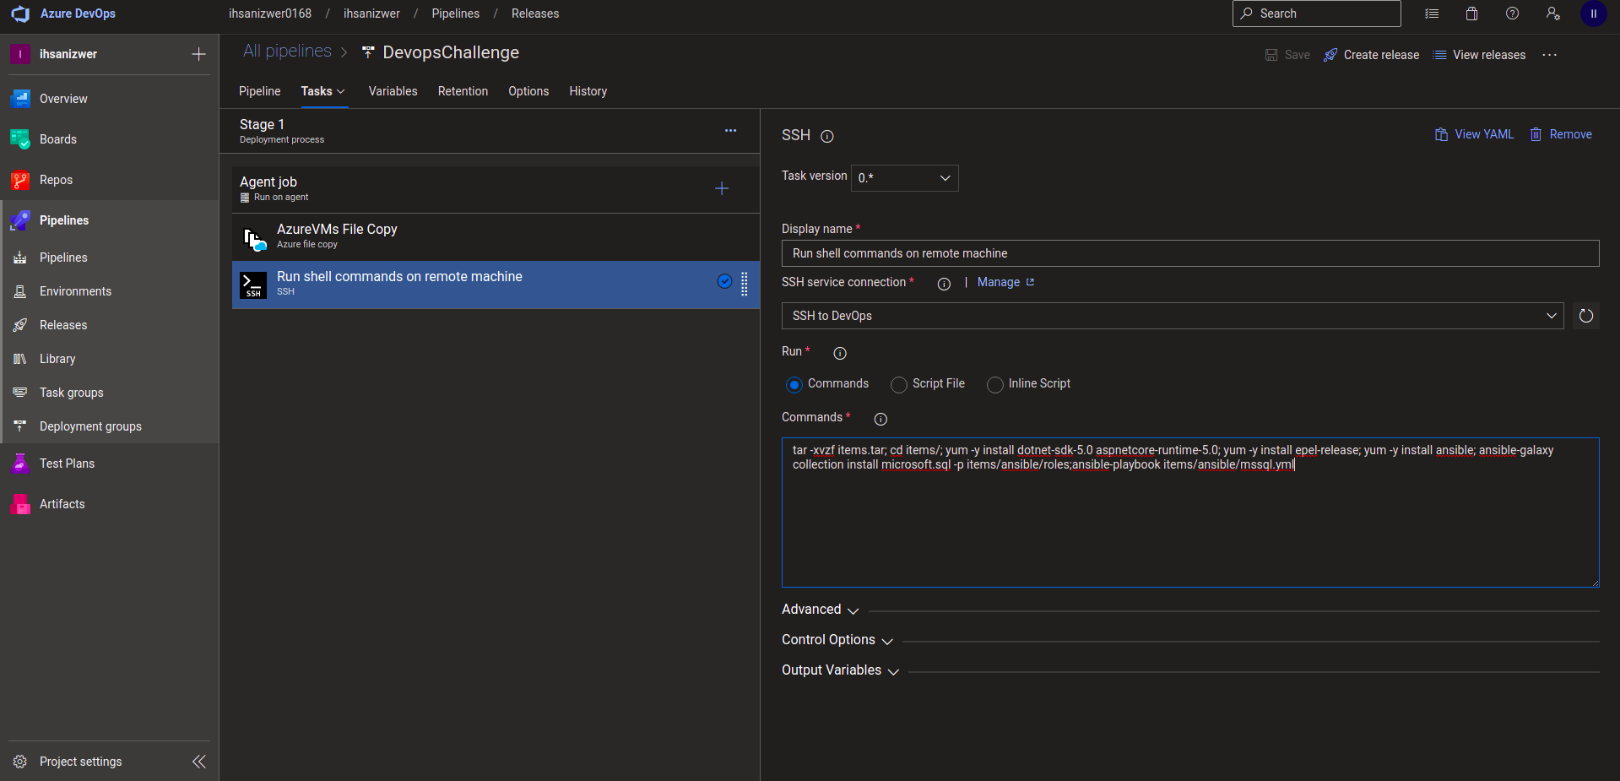
Following are the commands. That needs to be run after.

