**Data Visualization with Tableau**

**Sales Analysis of a Website with Tableau**

**Overview:**

Visual analysis is a non-linear process. For example, a user might start with an initial task or question in mind, find relevant data, and prepare it for analysis. During analysis, she/he realizes that she/he needs additional data, so she/he goes back a couple of steps to get more data, choose a new visual mapping, and develop new insight. This example can be repeated for any of the other steps of the cycle of visual analysis.

Görsel analiz doğrusal olmayan bir süreçtir. Örneğin, bir kullanıcı aklında bir ilk görev veya soru ile başlayabilir, ilgili verileri bulabilir ve analiz için hazırlayabilir. Analiz sırasında ek verilere ihtiyacı olduğunu fark eder, bu nedenle daha fazla veri elde etmek, yeni bir görsel haritalama seçmek ve yeni içgörü geliştirmek için birkaç adım geriye gider. Bu örnek, görsel analiz döngüsünün diğer adımlarından herhangi biri için tekrar edilebilir.

The flow of analysis is difficult or impossible to achieve in traditional BI. Instead of exploiting the power of visual cues and iteration, it is heavily milestone-driven. Requirements gathering leads to development, then to testing, and eventually to launch. With visual analysis, the steps become more fluid as the answer to one question often leads to other questions, and new insights are uncovered.

Geleneksel BI'da analiz akışını elde etmek zor veya imkansızdır. Görsel ipuçlarının ve yinelemenin gücünden yararlanmak yerine, büyük ölçüde dönüm noktası odaklıdır. Gereksinimlerin toplanması, geliştirmeye, ardından test etmeye ve sonunda başlatmaya yol açar. Görsel analizle, bir sorunun yanıtı genellikle diğer sorulara yol açtığından ve yeni içgörüler ortaya çıkarıldığından adımlar daha akıcı hale gelir.

**Instructions**

In this project, you will be working on the Sales Analysis of a Website project using Tableau.

**Data Preparation**

* Import sales.csv data set. You will study the whole dataset. First, go with Live connection and observe the performance. Then, switch your connection to Extract.
* Examine the data set. Tableau displays the first 1000 rows by default in the data grid. Get a general understanding of what the dataset is about.
* Understand what a row-level record represents.
* Change the workbook locale to the United States. (Go to your workspace and come back to Data Source Page)
* Identify the data types of all columns and change any if needed. Additional Data: currency_rates.csv You can use currency_rates.csv when you need. You will relate to the other dataset. Be careful with duplications. You may need to establish relationships in more than one area.

**Data Exploration**

In this part, you will create 17 worksheets. You will search for answers to the following questions. The number at the beginning of each item below represents the sheet number. You must put that number before each sheet name. Choose any sheet name you want. For instance, a sheet name for the first item below may be **1-Number of Records**

* 1 - Go to Sheet 1 (your workspace) and find how many records the data set has.
* 2 - Find the total number of sellers.
* 3 - What is the total value of sales in EUR?
* 4 - Which brand has the highest number of purchases during the period? Create a horizontal bar chart display. Observe that there are null values. Think about how to deal with the null values. Create a new field named Brand-Updated. Replace null values with **Unknown**. Change the old Brand field with Brand-Updated.
* 5 - How many items in the “Jewellery” category have no brand associated with them?
* 6 - How many brands have between 35 and 55 transactions (inclusive)? (Suggested Chart Type: Horizontal Bar Chart)
* 7 - How many pairs of shoes were purchased by Australian (AU) buyers?
* 8 - Which brand has the highest average transaction value? Bring all values in Euros. (Suggested Chart Type: Horizontal Bar Chart)
* 9 - What is the total value of items purchased by GB buyers from GB sellers?
* 10 - What percentage of US sellers' transactions were purchased by US buyers?
* 11 - Which country made the highest percentage of international purchases?
* 12 - Which day has the highest value of purchases?
* 13 - Which category has 2,324 transactions on 7 August?
* 14 - What percentage of global sales value on 4 August came from US sellers?
* 15 - How many sellers in the US has more than 75 sales?
* 16 - Which seller in the US sold the most in terms of value?
* 17 - Which brand had the largest absolute € difference in average transaction value between domestic and international?

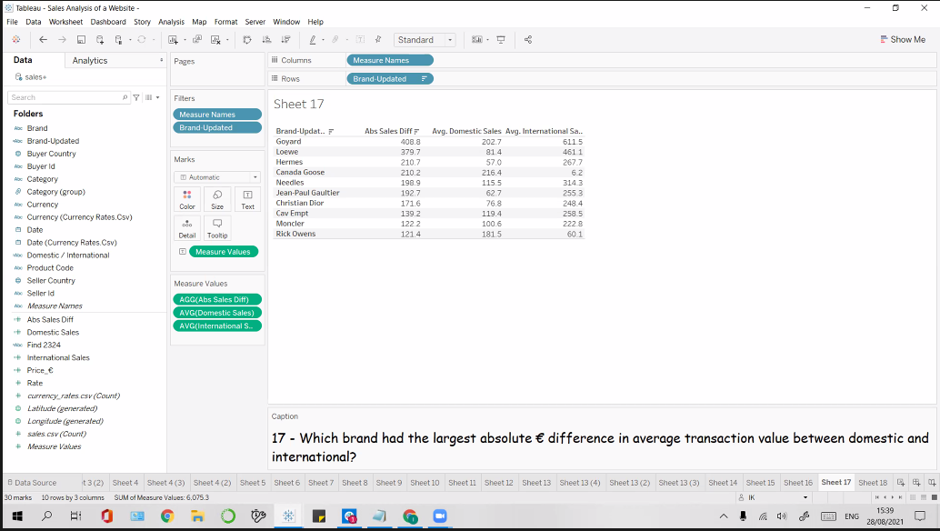

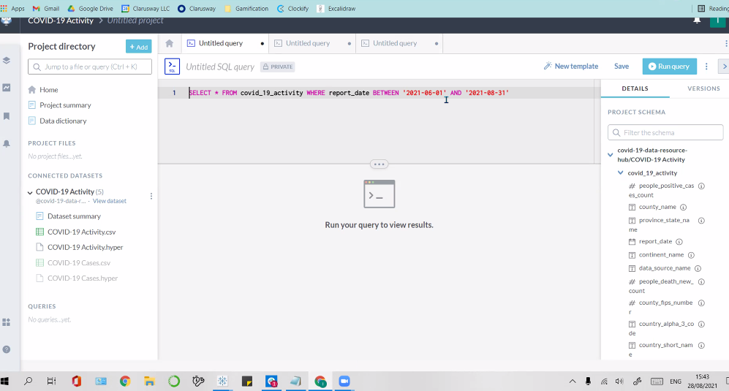

**SELECT * FROM covid_19_activity WHERE report_date BETWEEN '2021-06-01' AND '2021-08-31'**

Brandon Hocam & Isaac Hocam, çok güzel bir ders oldu. Çok teşekkür ederiz. Ağzınıza sağlık. Herkese güzel bir hafta sonu diliyorum. Beklediğimiz ne ise kavuşacağımız gün bugün olsun inş.