1.Tcps.c
#include<stdio.h>
#include<netdb.h>
#include<netinet/in.h>
#include<stdlib.h>
#include<string.h>
#include<sys/socket.h>
#include<sys/types.h>
#include<unistd.h> //read(),write(),close()
#define MAX 80
#define PORT 8080
#define SA struct sockaddr
//define designed for chat between client and server.
void func(int connfd)
{
char buff[MAX];
int n;
//infinite loop for chat
for(;;)
{
bzero(buff,MAX);
//read the message from client and copy it in buffer
read(connfd,buff,sizeof(buff));
//print the buffer which contains the client contents
printf("from client : %s\t to client : ",buff);
bzero(buff,MAX);
n=0;
//copy server message in the buffer
while((buff[n++]=getchar())!='\n')
;
//and sent buffer to client
write(connfd,buff,sizeof(buff));
//if msg contains "Exit "then server exit and chat ended
if(strncmp("exit",buff,4)==0)
{
printf("Server Exit....\n");
break;
}
}
}
//driver function
int main()
{
int sockfd,connfd,len;
struct sockaddr_in servaddr,cli;
//socket create and verification
sockfd=socket(AF_INET,SOCK_STREAM,0);
if(sockfd==-1)
{
printf("socket creation failed ....\n");
exit(0);
}
else
{
printf("socket successfully created...\n");
}
bzero(&servaddr,sizeof(servaddr));
//assign IP,PORT
servaddr.sin_family=AF_INET;
servaddr.sin_addr.s_addr=htonl(INADDR_ANY);
servaddr.sin_port=htons(PORT);
//binding newly created socket to given ip and verification
if((bind(sockfd,(SA*)&servaddr,sizeof(servaddr)))!=0)
{
printf("socket bind failed....\n");
exit(0);
}
else
printf("socket successfully binded...\n");
//now server is ready to listen and verification
if((listen(sockfd,5))!=0)
{
printf("listen failed ...\n");
exit(0);
}
else
printf("server listening...\n");
len=sizeof(cli);
//accept the data packet from client and verification
connfd=accept(sockfd,(SA*)&cli,&len);
if(connfd<0)
{
printf("server accept failed ...\n");
exit(0);
}
else
printf("server accept the client ...\n");
//function for chatting between client and server
func(connfd);
//after chatting close the socket
close(sockfd);
}

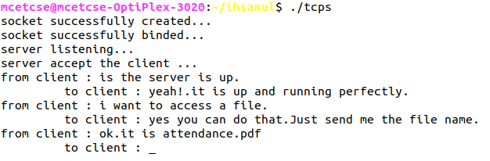
output – tcps.png
tcpc.c
#include<arpa/inet.h>//inet_addr()
#include<stdio.h>
#include<netdb.h>
#include<strings.h>//bzero()
#include<stdlib.h>
#include<string.h>
#include<sys/socket.h>
#include<unistd.h> //read(),write(),close()
#define MAX 80
#define PORT 8080
#define SA struct sockaddr
void func(int sockfd)
{
char buff[MAX];
int n;
for(;;)
{
bzero(buff,sizeof(buff));
printf("Enter the string : ");
n=0;
while((buff[n++]=getchar())!='\n')
;
write(sockfd,buff,sizeof(buff));
bzero(buff,sizeof(buff));
read(sockfd,buff,sizeof(buff));
printf("from server : %s",buff);
if((strncmp(buff,"exit",4))==0)
{
printf("client Exit...\n");
break;
}
}
}
int main()
{
int sockfd,connfd;
struct sockaddr_in servaddr,cli;
//socket create & verification
sockfd=socket(AF_INET,SOCK_STREAM,0);
if(sockfd==-1)
{
printf("socket successfully created ...\n");
exit(0);
}
else
printf("socket successfully created ..\n");
bzero(&servaddr,sizeof(servaddr));
//assign IP,PORT
servaddr.sin_family=AF_INET;
servaddr.sin_addr.s_addr=inet_addr("127.0.0.1");
servaddr.sin_port=htons(PORT);
//connect the client socket to server socket
if(connect(sockfd,(SA*)&servaddr,sizeof(servaddr))!=0)
{
printf("connection with the server failed ...\n");
exit(0);
}
else
printf("connected to the server ...\n");
//function for chat
func(sockfd);
//close the socket
close(sockfd);
}

output- tcpc.c
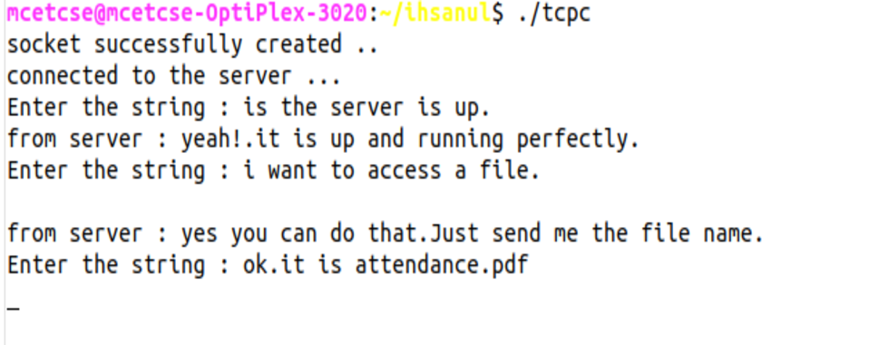
2.multis.c
#include <netinet/in.h>
#include <stdio.h>
#include <stdlib.h>
#include <sys/socket.h>
#include <string.h>
#include <unistd.h>
#include <asm-generic/socket.h>
#define PORT 8080

int main(int argc, char const* argv[])
{
int server_fd, new_socket, valread;
struct sockaddr_in address;
int opt = 1;
int addrlen = sizeof(address);
char buffer[1024] = {0};
char hello[1024];
pid_t childpid;

// Create socket
if ((server_fd = socket(AF_INET, SOCK_STREAM, 0)) == 0)
{
perror("socket failed.");
exit(EXIT_FAILURE);
}

// Set socket options
if (setsockopt(server_fd, SOL_SOCKET, SO_REUSEADDR | SO_REUSEPORT, &opt, sizeof(opt)))
{
perror("setsockopt");
exit(EXIT_FAILURE);
}

// Configure server address
address.sin_family = AF_INET;
address.sin_addr.s_addr = INADDR_ANY;
address.sin_port = htons(PORT);

// Bind socket to address
if (bind(server_fd, (struct sockaddr*)&address, sizeof(address)) < 0)
{
perror("bind failed");
exit(EXIT_FAILURE);
}
// Listen for connections
if (listen(server_fd, 3) < 0)
{
perror("listen");
exit(EXIT_FAILURE);
}
// Accept connections
for (;;)
{
if ((new_socket = accept(server_fd, (struct sockaddr*)&address, (socklen_t*)&addrlen)) < 0)
{
perror("accept");
exit(EXIT_FAILURE);
}
// Fork a child process
if ((childpid = fork()) == 0)
{
close(server_fd); // Child doesn't need the listener
// Handle client communication
while ((valread = read(new_socket, buffer, 1024)) > 0)
{
printf("Client: %s\n", buffer);
printf("Msg to client: ");
scanf("%s", hello);
send(new_socket, hello, strlen(hello), 0);
memset(buffer, 0, sizeof(buffer)); // Clear buffer
}
if (valread == 0)
{
printf("Client disconnected.\n");
}
else
{
perror("read");
}
close(new_socket);
exit(EXIT_SUCCESS); // Exit child process
}
close(new_socket); // Parent closes client socket
}
return 0;
}

output-multis.png

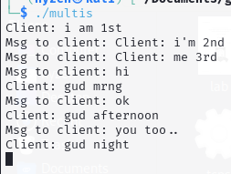
multic.c

#include <arpa/inet.h>
#include <stdio.h>
#include <stdlib.h>
#include <string.h>
#include <sys/socket.h>
#include <unistd.h>
#define PORT 8080

int main(int argc, char const* argv[]) {
int sock = 0, valread;
struct sockaddr_in serv_addr;
char hello[1024] = {0};
char buffer[1024] = {0};

// Create socket
if ((sock = socket(AF_INET, SOCK_STREAM, 0)) < 0) {
printf("\nSocket creation error\n");
return -1;
}

// Configure server address
serv_addr.sin_family = AF_INET;
serv_addr.sin_port = htons(PORT);

// Convert IP address from text to binary
if (inet_pton(AF_INET, "127.0.0.1", &serv_addr.sin_addr) <= 0) {
printf("\nInvalid address / Address not supported.\n");
return -1;
}

// Connect to server
if (connect(sock, (struct sockaddr*)&serv_addr, sizeof(serv_addr)) < 0) {
printf("\nConnection failed\n");
return -1;
}

// Send and receive messages
while (1) {
printf("from client(type your msg): ");
fgets(hello, 1024, stdin);
hello[strcspn(hello, "\n")] = '\0'; // Remove newline character

// Exit if user types "exit"
if (strcmp(hello, "exit") == 0) {
printf("Exiting...\n");
break;
}

// Send message to server
if (send(sock, hello, strlen(hello), 0) < 0) {
perror("send failed");
break;
}

// Receive response from server
valread = read(sock, buffer, 1024);
if (valread < 0) {
perror("read failed");
break;
} else if (valread == 0) {
printf("Server disconnected.\n");
break;
}

// Print server's response
buffer[valread] = '\0'; // Null-terminate the buffer
printf("Server: %s\n", buffer);
}

close(sock);
return 0;
}

output-multic1.png
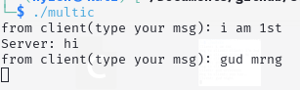
multic2.png
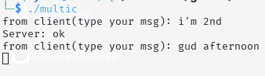
multic3.png
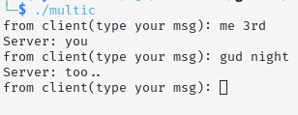
3.upds.c
#include<stdio.h>
#include<string.h>
#include<unistd.h>
#include<sys/socket.h>
#include<arpa/inet.h>
int main(void)
{
int socket_desc;
struct sockaddr_in server_addr,client_addr;
char server_message[2000],client_message[2000];
int client_struct_length=sizeof(client_addr);
//clean buffers
memset(server_message,'\0',sizeof(server_message));
memset(client_message,'\0',sizeof(client_message));
//create udp socket
socket_desc=socket(AF_INET,SOCK_DGRAM,IPPROTO_UDP);
if(socket_desc<0)
{
printf("Error while creating socket\n");
return -1;
}
printf("socket created successfully\n");
//set port and ip
server_addr.sin_family=AF_INET;
server_addr.sin_port=htons(4000);
server_addr.sin_addr.s_addr=inet_addr("127.0.0.1");
//bind to the set port and ip
if(bind(socket_desc,(struct sockaddr*)&server_addr,sizeof(server_addr))<0)
{
printf("couldn't bind to the port\n");
return -1;
}
printf("Done with binding\n");
printf("Listening for incoming message...\n\n");

while(1)
{
//Receive client's message
if(recvfrom(socket_desc,client_message,sizeof(client_message),0,(struct sockaddr*)&client_addr,&client_struct_length)<0)
{
printf("couldn't receive \n");
return -1;
}
printf("Received message from IP: %s and port :%i\n",inet_ntoa(client_addr.sin_addr), ntohs(client_addr.sin_port));
printf("Msg from clients: %s\n",client_message);
//respond to client:
strcpy(server_message,client_message);
if(sendto(socket_desc,server_message,strlen(server_message),0,(struct sockaddr*)&client_addr,client_struct_length)<0)
{
printf("can't send\n");
return -1;
}
}
//close the socket:
close(socket_desc);
return 0;
}

output-udps.png
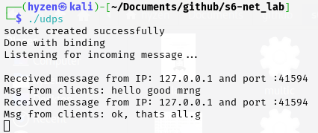

udpc.c
#include<stdio.h>
#include<unistd.h>
#include<string.h>
#include<sys/socket.h>
#include<arpa/inet.h>
int main(void)
{
int socket_desc;
struct sockaddr_in server_addr;
char server_message[2000],client_message[2000];
int server_struct_length=sizeof(server_addr);

//clean buffers:
memset(server_message,'\0',sizeof(server_message));
memset(client_message,'\0',sizeof(client_message));

//create socket:
socket_desc=socket(AF_INET,SOCK_DGRAM,IPPROTO_UDP);

if(socket_desc<0)
{
printf("Error while creating socket\n");
return -1;
}
printf("socket created successfully\n");

//set port and ip:
server_addr.sin_family=AF_INET;
server_addr.sin_port=htons(4000);
server_addr.sin_addr.s_addr=inet_addr("127.0.0.1");

while(1)
{
//get input from the user:
printf("Enter the message : ");
fgets(client_message, sizeof(client_message), stdin);
client_message[strcspn(client_message,"\n")]='\0';

//send the message to server:
if(sendto(socket_desc,client_message,strlen(client_message),0,(struct sockaddr*)&server_addr,server_struct_length)<0)
{
printf("unable to send message\n");
return -1;
}

//receive the server's response:
if(recvfrom(socket_desc,server_message,sizeof(server_message),0,(struct sockaddr*)&server_addr,&server_struct_length)<0)
{
printf("Error while receiving server's msg\n");
return -1;
}
printf("server's response : %s\n",server_message);
}

//close the socket:
close(socket_desc);

return 0;
}

output-udpc.png
