**Topic : Camera-Based Occupancy Sensing Using AI for Smart Home Applications**

**Aim(s) :**

This project aims to develop and implement a camera-based occupancy sensing system using Artificial Intelligence (AI) to enhance the functionality and efficiency of smart home applications. This system will leverage advanced computer vision techniques to accurately detect and recognize human presence in real-time, optimising energy usage, improving home security, and enhancing user comfort within a smart home environment. The project will utilise Python for simulation and model development, focusing on creating a robust and scalable solution that can be integrated into modern smart home systems.

**The objective (tasks) of the project :**

(i) The architecture for the occupancy sensing system will be designed.

(ii) The data (e.g., resizing, normalisation) for training AI models will be collected & preprocessed.

(iii) Object detection python-based models for identifying human presence will be implemented.

(iv) Python and relevant libraries to develop and simulate the models will be used.

(v) Python-based features for detecting unauthorised access and alerting homeowners will be developed.

(vi) Finally, It will enhance smart home interactions by recognizing user presence and preferences.

# **A details description of the way intended to carry out**

# Demo Project Plan Step by step

# 

# Step 1 - Data Collection & Data Preprocessing

# Step 2 - Design & Development

# (i) Object Detection Model Development

# (ii) Pose Estimation Model Development

# 

# Step 3 - Simulate System Performance using Python

# Step 4 - Prepare for deployment in a smart home environment (conceptual theoretical)

# Step 5 - Document Design & Validation Result Analysis

# Step 6 - Analysis of occupancy detection

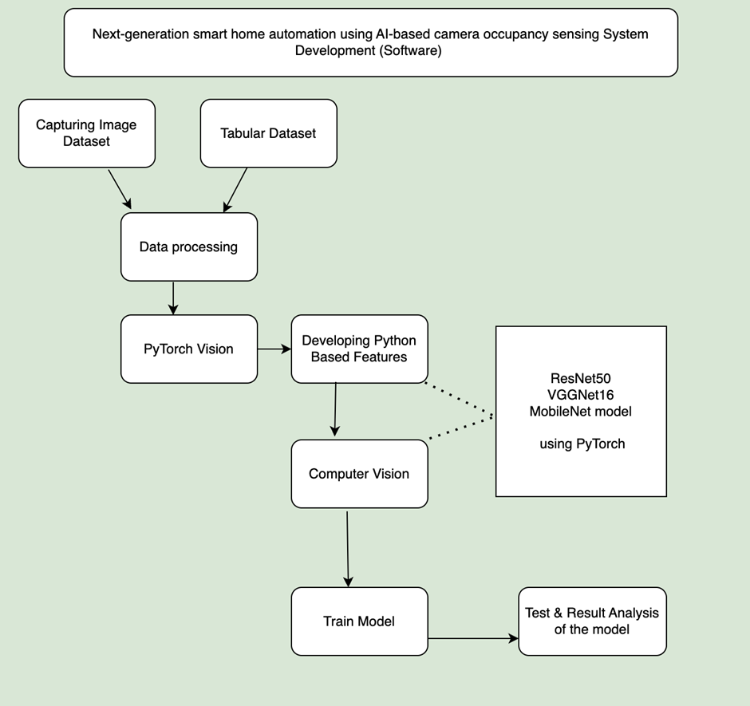

# 

# 

# **Risk Assessment of the project**

This is a demo risk assessment

We have 6 objective on this project but only offered 2 SR risk assessment .But the main thing is each objective should be SR

2 types of risk

(i) Generic Risk &

(ii) Specific Risk

| Risk No. | Description of the risk | Probability of the risk | Effect on the project | Contingencies  To mitigate the risk |
| --- | --- | --- | --- | --- |
| GR | Technical Risks: | MEDIUM TO HIGH | Technical challenges could cause project delays and jeopardise the functionality or trustworthiness of the power system protection transmission. | Execute a thorough risk evaluation throughout the project planning period to identify any potential technical issues. |
| GR | Resource Risks: | MEDIUM | Resource risks could lead to delays in project execution, budget overruns, or compromised project quality due to resource constraints. | Conduct a thorough resource assessment to identify skill gaps and resource requirements. |
| GR | Schedule Risks: | MEDIUM | Schedule risks could lead to delays in project delivery, missed deadlines, and potential financial penalties. | Identify critical path activities and allocate resources accordingly to minimise schedule impacts. |
| … | … | … | … | … |
| SR | Algorithm Complexity Risk: | HIGH | Inaccurate fault detection and clearance, leading to compromised system performance and reliability. | Break down complex algorithms into smaller, manageable modules for easier debugging and testing. |
| SR | Testing and Validation Risk: | MEDIUM | Limited testing may result in undetected flaws or mistakes in performance evaluation, putting real-world deployments at risk. | Develop a comprehensive test plan that addresses all aspects of system functionality, including problem detection, resolution, and communication. |

**Try to maintain this sequence**

# **Chapter 2**

## 2.1 Introduction

# **Chapter 3**

## 3.1 Resource List

Write it in a table format

## 3.2 Specifications of Software Block Diagram using ML (Python Programming Language)

& Explain the block diagram in details

# **Chapter 4**

## 3.1 Resource List

# 

# 

# **Chapter 5**

## 5.1 Data Sources: Writings are necessary in this field . Write in details for easy understanding so that a non technical guy may understand.

## 5.2 Data Annotation: label the data for training machine learning models.Writings are necessary in this field . Write in details for easy understanding so that a non technical guy may understand.

## 5.3 Data Preprocessing :Writings are necessary in this field . Write in details for easy understanding so that a non technical guy may understand.

# **Chapter 6**

# Design & Development

## Writing is necessary in this field . Write in details for easy understanding so that a non technical guy may understand.

Give Picture diagram charts in this area

# **Chapter 7**

# Testing

With software testing part Writings are necessary in this field . Write in details for easy understanding so that a non technical guy may understand.

# **Chapter 8**

# Analysis

## Writing is necessary in this field . Write in details for easy understanding so that a non technical guy may understand.

## 8.1 Validation Result Analysis : validate the model’s accuracy and reliability.

## 8.2 Benchmarking: Compare the simulation results with existing solution

## 8.3 Analysis of Camera-Based Occupancy Sensing Using AI for Smart Home Applications efficiency in industry.

## 8.4 Reduction in Contamination: evaluate how improved sorting reduces contamination in recycling streams for the industry.

## 8.5 Consumer Benefits: analyse the overall benefits of Camera-Based Occupancy Sensing Using AI for Smart Home Applications

## **Chapter 9**

## Writing is necessary in this field . Write in details for easy understanding so that a non technical guy may understand.

## 9.1 Monitoring Procedures for the model

## 9.2 Risk Assessment of the model

# **Chapter 10**

## Writing is necessary in this field . Write in details for easy understanding so that a non technical guy may understand.

## 10.1 The work carried out to date

## 10.2 Conclusion

# **Chapter 11**

## Keep Blank

Give Some Diagrams Pie or Bar charts Table where necessary for better understanding Also level it.

Written report should be 9k words to maintain the points which are mentioned above and also relate to the project work and title area .

Please Do Not write in general concepts , relate it with the project workflow .Do Not copy paste from Chat Gpt . Use chat Gpt as a calculator .Paraphrase it, humanise it then write it according to the project concept.

Robotic writings easily can be detected so please avoid direct copy paste from chat gpt or others AI

Give a turnitin report

Provide 4 or 5 slide

give the speech of the slide in a different doc or word file

Give Python files in Colab format

Writings report in word or doc format

Do Not work on Keep blank areas

In each sector on the software part make sure that the 6 objectives may satisfy the simulation .

Dataset is all yours

Mail it : likabishop@gmail.com

Deadline : 25 august 2024