CSCI222 Assignment 1 Report

Team Number : <A-1>

 | Student Number | Name | Email Address
1 | 5920590 | (Team Leader)  Loh Hao Yi | Tel : 9771 0059  Email : lohhaoyi@gmail.com
2 | 5920632 | Ong Chung Ling Joshua | Joshuaong94@gmail.com
3 | 5921405 | Desmond Wee Choon Leon | desmondweee@gmail.com
4 | 5922136 | Lee Wei Rong | Lee_wei_rong@yahoo.com.sg
5 | 5922811 | Tan Yong Jie Cleman | clemantan11@gmail.com
6 | 5841574 | Tan Chee Ann | Tancheeann1993@gmail.com

Table of Contents

- Project Overview
- Risk and Analysis
- Gantt Chart(Project Plan)
- UML Artefacts (Domain Modeling)
5. Report Compilation
6. VCS Screenshots
7. References

Project Overview

A brief overview of the project based on information in this assignment specification and details of the actual application.

This overview should not be created by simply cutting and pasting text supplied. It should be written by the members of the group and provide a retrospective view of the project on its completion.

It should be “complete” in the sense that it explains the project to an external assessor who has not seen any of the assignment details.

Examples of relevant information includes:

- "Vision"

- To develop a Facilities Booking System written in C++ , allowing members to login and easy access. The system should be able to view their information and make facilities based on privilege . The manager of the facility should also be able to change any bookings, add remove and update facilities and the charging rate.

Initial Use-Case Model

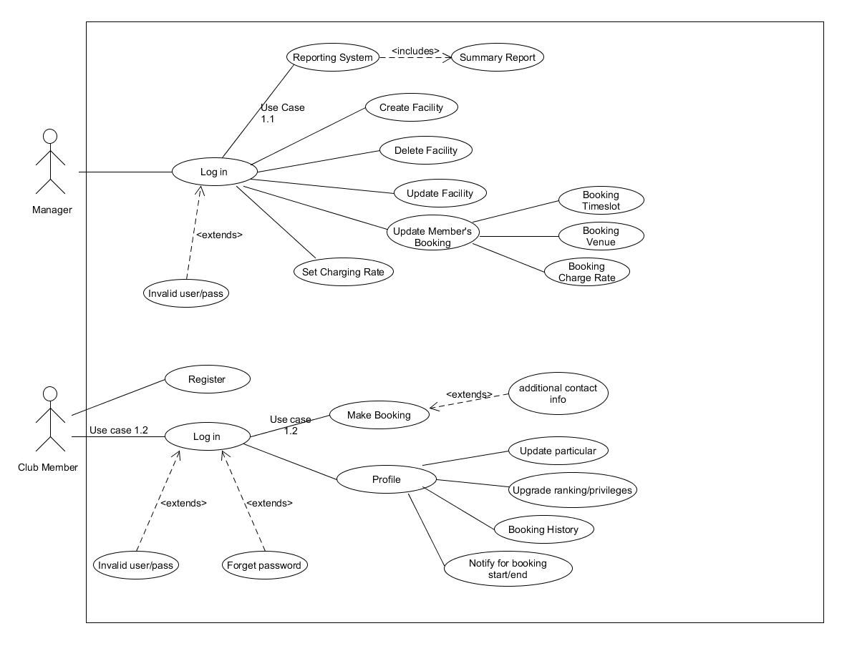

Project Plan
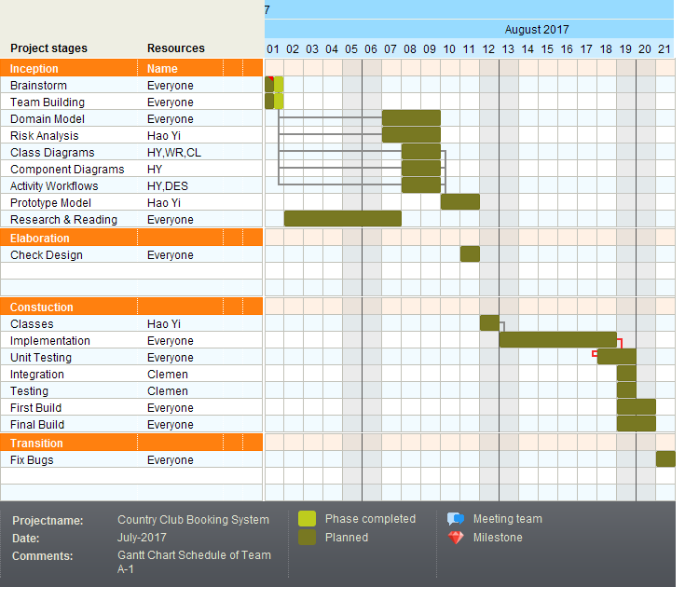

Roles and Responsibility

A tabular summary of the group structure identifying group members, the roles that they filled, the artefacts that they successfully delivered.

The main roles could be found in Assn 1 Qn Paper, Appendix B, bullet point 6. It is possible to use different roles not found in the Qn Paper, e.g. "Database Implementer", "GUI Designer", etc.

Artefacts refers to any intermediate or final work products which are produced and used during your RUP development activities. Examples could be any program source codes (*.h, *.cpp), documentations (test plan / cases, design diagrams), etc.

Note: this section can span as many pages as necessary

Team Number : <A-1>

 | Student Name | Role | Artefacts
1 | Loh Hao Yi | Project Manager | Class Diagram v1,v2,vF  WorkFlow diagram v1 – client  Sequence diagram  SRS  Component diagram  Object diagram
2 | Lee Wei Rong | GUI Designer | Class Diagram v1,Detailed Use case 1.1 ,1.2
3 | Cleman Tan | Program Tester  & Intergration | Pptx,Class Diagram v1,v2,
4 | Desmond wee | Program Analyst | WorkFlow diagram v1,v2,vF -client and manager
5 | Tan Chee An | Implementor | Use case v1,v2,vF
6 | Joshua Ong | Documentation | Use case v1,v2  SRS

Risk Analysis and Counter Measures

For this section, you are to identify relevant risks and classify them in a table format as shown below. A sample (example) is shown in the first 2 rows.

Column Impact Type -
What is the type of impact affected by the risk?
E.g. Deadline/Budget/Successful Task Completion/etc.

Column Risk Seriousness (%) - how serious the risk affects the project

Column Likelihood of Occurrence (%) - how likely is the risk to happen

Column WBS (affected work/task) - the work/task id(s) in WBS affected by the risk

Column Risk Description - what is nature of the risk

 | Impact Type | Risk Seriousness (%) | Likelihood of Occurrence (%) | WBS  (affected work / task ) | Risk Description
1 | Scope Creep | 90% | 25% | ALL and creates new tasks | New Features are continuously added without regard to the project plan. Undermining the success rate to deliver the project as planned and scoped initially.
2 | Deadline | 90% | 10% | 4.5, 2.1 | Key members resign in the middle of the project.
3 | Communication Overhead | 50% | 80% | ALL | In trying to communicate each other’s vision of the domain and how to handle low level implementations, we might expend more time than needed before agreeing on one unified way.
4 | Requirements and developed functions do not match | 100% | 20% | ALL

Based on the list of risks identified in above table, you are to outline a contingency plan of action to mitigate or eliminate the damage/impact caused by the risk

Column Risk Description - what is nature of the risk

Column Proposed Mgmt Plan - what is your plan(s) to reduce / eliminate the risk

Column (Possible) Reduction in Risk Seriousness (%) -
what is the possible reduction in risk’s impact, if the management plan is carried out?

 | Risk Description | Proposed Mgmt Plan | (Possible) Reduction in Risk Seriousness (%)
1 | Scope expands as the project is elongated to meet standards /members are too enthusiastic about adding features to product | Controlled Environment / Limitations to only Determined important scope | -50%
2 | Missing Key Members | Asking for extension/Working longer | .-25%
3 | Communication taking too much time and being ineffective | Disciplined Meetings/Self Responsibility/Dedicated Timer | -35%
4 | Missing what the customer wanted to develop/Miscommunication to get the requirements | Dedicated person to manage client relations/Clear documentation about what is being and not being developed/Try to have the client take a look when a milestone is complete to ensure project is on the right track | -50%

Design Artefacts - Use Cases (Iteration 1)

You may use any diagramming tool to develop your use case diagrams for the entire system.

Iteration 1 is based on your team's "INITIAL" understanding of the system.

Note 1 : Your diagram should be developed using standard UML symbols and notations for use case diagrams!

Note 2 : this section can span as many pages as necessary

Note 3 : If you are pasting screen-shots (from your adopted diagramming tool) into this sub- section, please ensure the wordings / text are clearly visible
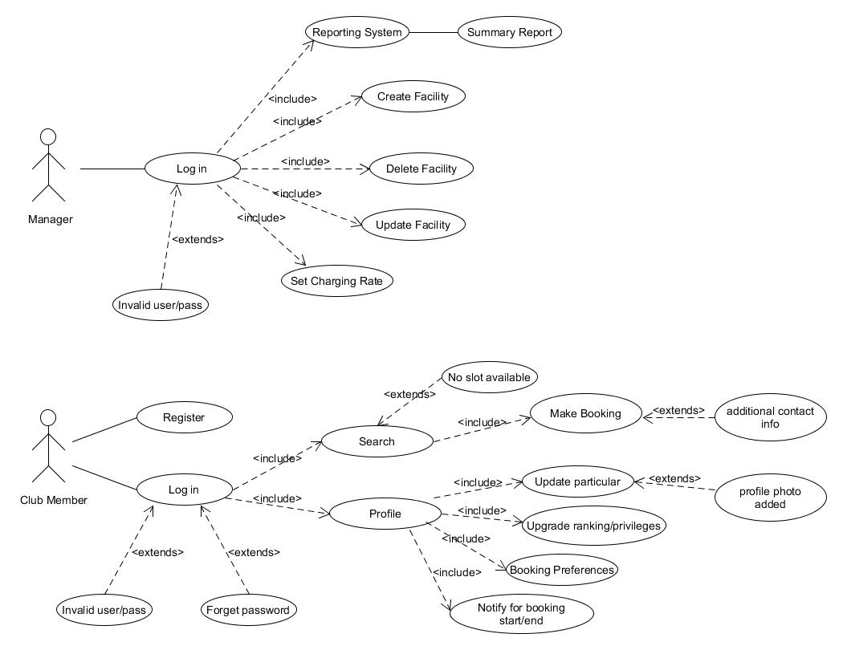

Design Artefacts - Use Cases (Iteration 2)

You may use any diagramming tool to develop your use case diagrams for the entire system.

Iteration 2 is based on your team's "LATEST" understanding of the system.

In general, the diagrams in later iterations should be more refined, more evolved, capture more details than diagrams developed in earlier iterations

Note 1 : Your diagram should be developed using standard UML symbols and notations for use case diagrams!

Note 2 : this section can span as many pages as necessary

Note 3 : If you are pasting screen-shots (from your adopted diagramming tool) into this sub- section, please ensure the wordings / text are clearly visible

Design Artefacts - Activity Workflows (Iteration 1)

You may use any diagramming tool to develop your activity diagrams for the entire system.

Iteration 1 is based on your team's "INITIAL" understanding of the system.

Note 1 : Your diagram should be developed using standard UML symbols and notations for activity diagrams!

Note 2 : this section can span as many pages as necessary

Note 3 : If you are pasting screen-shots (from your adopted diagramming tool) into this sub- section, please ensure the wordings / text are clearly visible
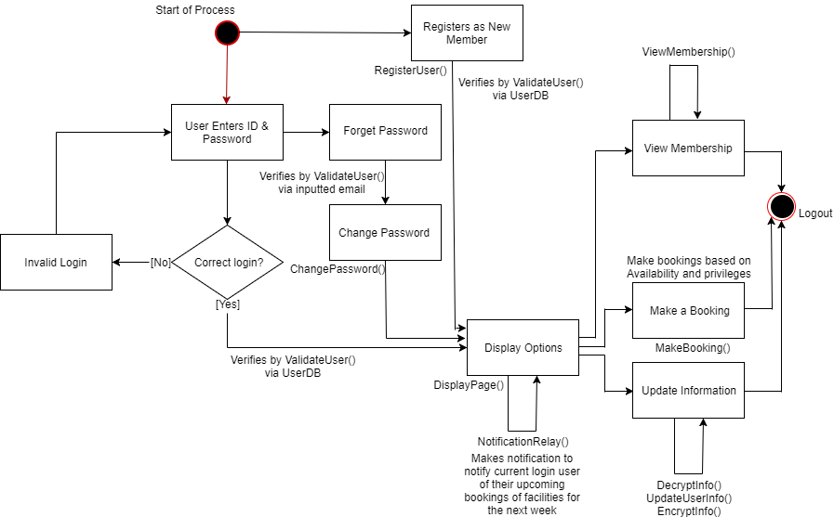

Design Artefacts - Activity Workflows (Iteration 2)

You may use any diagramming tool to develop your activity diagrams for the entire system.

Iteration 2 is based on your team's "LATEST" understanding of the system.

In general, the diagrams in later iterations should be more refined, more evolved, capture more details than diagrams developed in earlier iterations

Note 1 : Your diagram should be developed using standard UML symbols and notations for activity diagrams!

Note 2 : this section can span as many pages as necessary

Note 3 : If you are pasting screen-shots (from your adopted diagramming tool) into this sub- section, please ensure the wordings / text are clearly visible

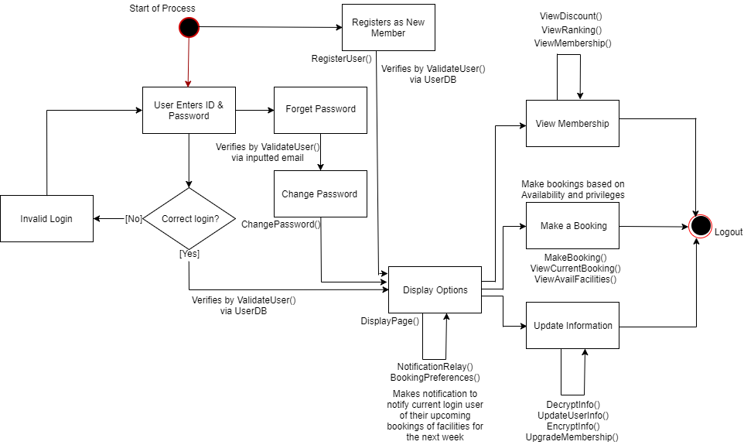
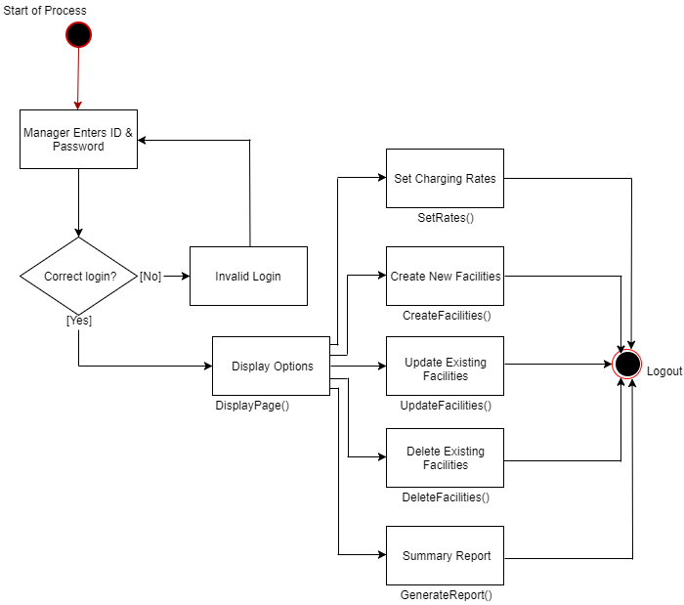

Design Artefacts - Component Diagrams (Iteration 1)

You may use any diagramming tool to develop your component diagrams for the entire system.

Iteration 1 is based on your team's "INITIAL" understanding of the system.

Note 1 : Your diagram should be developed using standard UML symbols and notations for component diagrams!

Note 2 : this section can span as many pages as necessary

Note 3 : If you are pasting screen-shots (from your adopted diagramming tool) into this sub- section, please ensure the wordings / text are clearly visible

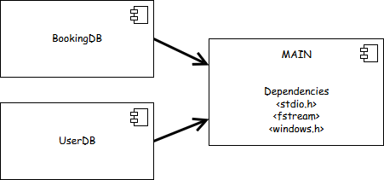

Design Artefacts - Component Diagrams (Iteration 2)

You may use any diagramming tool to develop your component diagrams for the entire system.

Iteration 2 is based on your team's "LATEST" understanding of the system.

In general, the diagrams in later iterations should be more refined, more evolved, capture more details than diagrams developed in earlier iterations

Note 1 : Your diagram should be developed using standard UML symbols and notations for component diagrams!

Note 2 : this section can span as many pages as necessary

Note 3 : If you are pasting screen-shots (from your adopted diagramming tool) into this sub- section, please ensure the wordings / text are clearly visible

Design Artefacts - Class Diagrams (Iteration 1)

You may use any diagramming tool to develop your class diagrams for the entire system.

Iteration 1 is based on your team's "INITIAL" understanding of the system.

Note 1 : Your diagram should be developed using standard UML symbols and notations for class diagrams!

Note 2 : this section can span as many pages as necessary

Note 3 : If you are pasting screen-shots (from your adopted diagramming tool) into this sub- section, please ensure the wordings / text are clearly visible
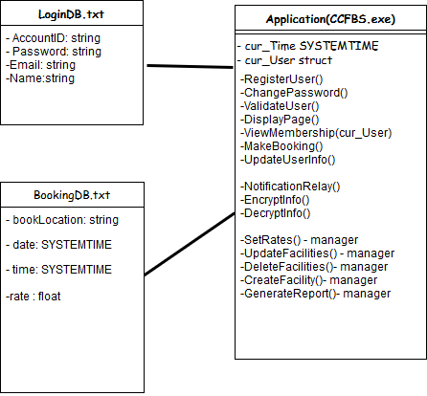

Design Artefacts - Class Diagrams (Iteration 2)

You may use any diagramming tool to develop your class diagrams for the entire system.

Iteration 2 is based on your team's "LATEST" understanding of the system.

In general, the diagrams in later iterations should be more refined, more evolved, capture more details than diagrams developed in earlier iterations

Note 1 : Your diagram should be developed using standard UML symbols and notations for class diagrams!

Note 2 : this section can span as many pages as necessary

Note 3 : If you are pasting screen-shots (from your adopted diagramming tool) into this sub- section, please ensure the wordings / text are clearly visible

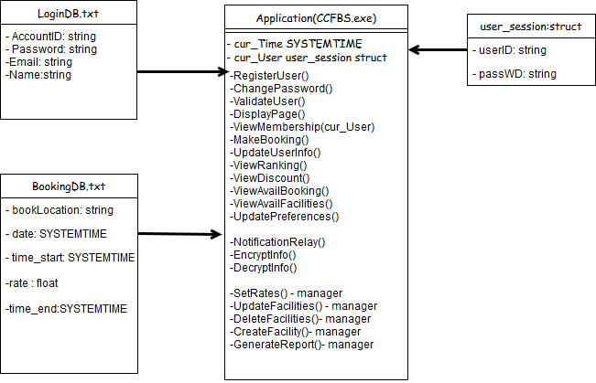

Design Artefacts - <Any other diagrams> (Iteration 1)

Depending on your system's software architecture, there may be many other diagrams (e.g. ER-Model, State / Interaction / Activity Diagrams, etc) which are applicable and should be reflected in your Design Artefacts section of your report.

Please "reuse the same structure" you see for the earlier sections on Use Case / Class / Component diagrams, together with 2 iterations version, for your diagrams in this section.

You may use any diagramming tool to develop your diagrams.

Iteration 1 is based on your team's "INITIAL" understanding of the system.

Note 1 : Your diagram should be developed using standard UML symbols and notations that is relevant for that particular type of diagram!

Note 2 : this section can span as many pages as necessary

Note 3 : If you are pasting screen-shots (from your adopted diagramming tool) into this sub- section, please ensure all the wordings / text are clearly visible
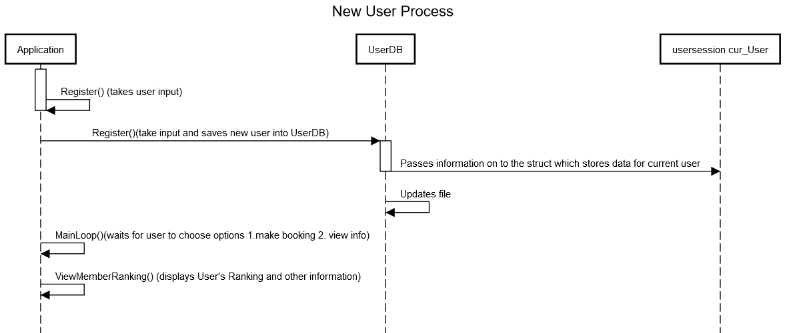

Design Artefacts - <Any other diagrams> (Iteration 2)

Depending on your system's software architecture, there may be many other diagrams (e.g. ER-Model, State / Interaction / Activity Diagrams, etc) which are applicable and should be reflected in your Design Artefacts section of your report.

Please "reuse the same structure" you see for the earlier sections on Use Case / Class / Component diagrams, together with 2 iterations version, for your diagrams in this section.

You may use any diagramming tool to develop your diagrams.

Iteration 2 is based on your team's "LATEST" understanding of the system.

In general, the diagrams in later iterations should be more refined, more evolved, capture more details than diagrams developed in earlier iterations

Note 1 : Your diagram should be developed using standard UML symbols and notations that is relevant for that particular type of diagram!

Note 2 : this section can span as many pages as necessary

Note 3 : If you are pasting screen-shots (from your adopted diagramming tool) into this sub- section, please ensure all the wordings / text are clearly visible

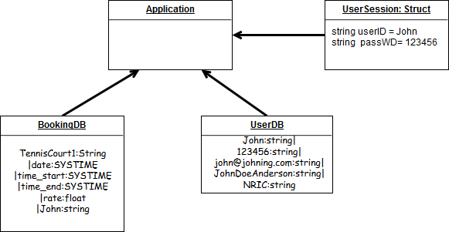

Appendix A - Formal Meeting Records

Inception Phase - Iteration 1

Elaboration Phase - Iteration 1

Elaboration Phase - Iteration 2

Appendix B - Individual Work Diaries

Team Member 1 : Loh Hao Yi

Inception Phase - Iteration 1

Elaboration Phase - Iteration 1

Elaboration Phase - Iteration 2

Team Member 'N' : Xxxx Xxxx

Inception Phase - Iteration 1

- Copy and Paste your formal meeting minutes for Inception Phase, iteration 1 here.
- You can refer to Assn 1 Qn Paper, Appendix B, bullet point 5 for a summary of contents to be included.
- Note: this section can span as many pages as necessary

Elaboration Phase - Iteration 1

- Copy and Paste your formal meeting minutes for Elaboration Phase, iteration 1 here.
- You can refer to Assn 1 Qn Paper, Appendix B, bullet point 5 for a summary of contents to be included.
- Note: this section can span as many pages as necessary
Elaboration Phase - Iteration 2

- Copy and Paste your formal meeting minutes for Inception Phase, iteration 2 here.
- You can refer to Assn 1 Qn Paper, Appendix B, bullet point 5 for a summary of contents to be included.
- Note: this section can span as many pages as necessary

Appendix C - Evidence of using VCS (Version Control Software)

Version Control Software used : GitHub

Screenshot #1 - Contents in the VCS's Root Folder containing all Repository Project Files

Screenshot #2 - VCS's listing of all the latest source files currently being managed

Screenshot #5 - Example using VCS's to display the change history / log (it may be necessary to do >1 screen capture, depending on the software used)

