Blog Management System API
Entity Relationship Diagram Documentation

Author: Md Ismile Hosen Siam
Version: 1.0
Database: MongoDB

Date: 21 September, 2026
Contents
Introduction 1
Database Overview 1
Entity Relationship Diagram 2
Entity Summary 2
Entity Details 3
User Entity 3
Session Entity 3
OTP Entity 4
PasswordResetToken Entity 4
Category Entity 5
Article Entity 5
Comment Entity 6
SystemInfo Entity 6
Entity Relationships 7

Introduction
This Entity Relationship Diagram (ERD) Documentation explains the database structure of the Blog Management System API. It describes all database entities, their attributes, relationships, and constraints.
The Blog Management System API is a backend REST API that allows users to register, verify their email, log in, and manage blog content. It supports two user roles — registered users, who create, update, and delete their own articles, comment on articles, and reply to comments; and administrators, who manage users, categories, and system-wide content. Public visitors can browse published articles and active categories without an account.
This document helps developers, database designers, testers, and other team members understand how the database is designed and how different entities are connected. It can also be used as a reference for system development, testing, and future maintenance.

Database Overview
The Blog Management System database is designed to support the system's five functional modules: authentication and session management, user management, article management, category management, and comment management. It stores and manages data for user accounts, device sessions, one-time passcodes, password-reset tokens, categories, articles, comments and system-level setup state.
The database is implemented on MongoDB, a document-oriented, NoSQL database. This documentation nonetheless presents a logical/conceptual entity model — entities, keys, cardinalities, and constraints — because a technology-neutral logical model is the correct basis for schema design regardless of the underlying engine. Each logical entity below corresponds to one MongoDB collection, and every primary key is uniformly named id, mirroring MongoDB's own native _id primary-key field. The SystemInfo collection is the exception. Its id is a fixed string key, since it holds a single settings document. Foreign keys are implemented as ObjectId references rather than embedded sub-documents, since several entities must be independently paginated, filtered, and administered.
The database uses constraints such as unique keys, indexes, and enums to improve data integrity and performance. There are no soft-delete fields in this design — deletions in the system are hard deletes — with the sole exception that Category records are never deleted at all, only toggled between active and unavailable status.
In the current design, status and account-state changes are not individually attributed or timestamped at the schema level. Auditing needs are currently met through infrastructure-level application/API logs (Winston + ELK) rather than persisted per-record history
This database design provides a clear and structured way to manage blog content and account data, and supports the main workflows of the Blog Management System API.

Entity Relationship Diagram
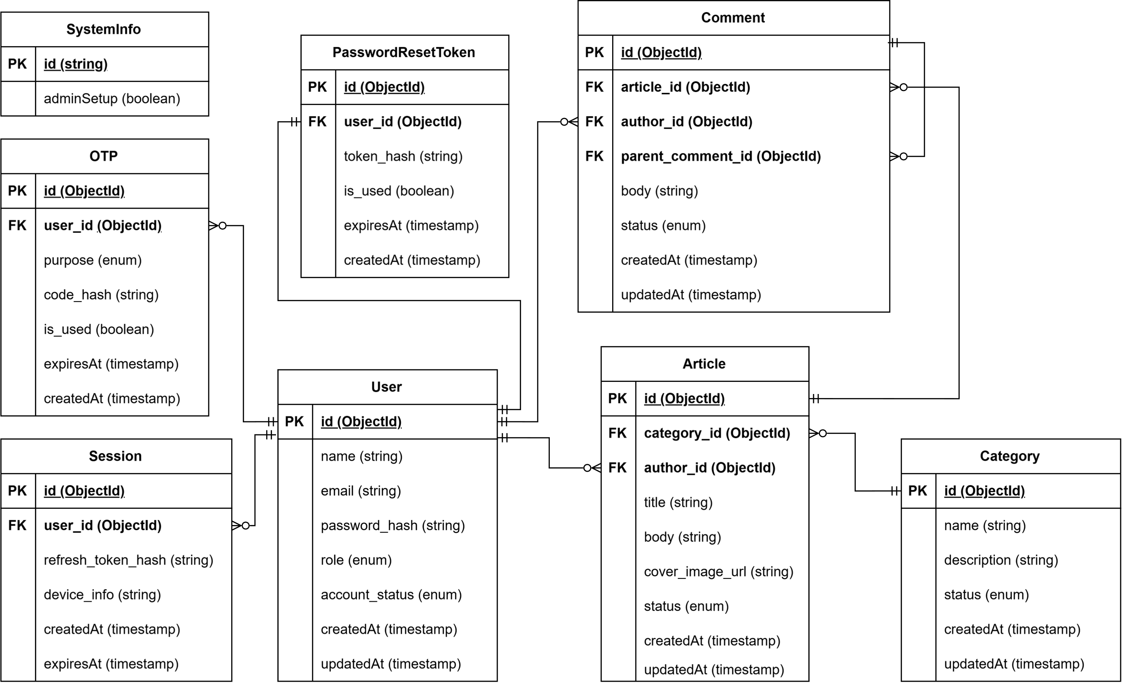

Entity Summary
The Blog Management System database contains 8 entities. Each entity stores data for a specific part of the system.
Entity | Purpose
User | Stores account, credential, role, and account status for every registered user and administrator.
Session | Stores one authenticated device/browser login, supporting multi-device sign-in and per-device logout.
OTP | Stores one-time passcodes used for both email verification and password-reset-request verification.
PasswordResetToken | Stores the short-lived, single-use credential issued after OTP verification and required to reset a password.
Category | Stores article categories used for classification, filtering, search, and sort on article listings.
Article | Stores blog articles authored by a user or admin.
Comment | Stores comments and threaded replies on articles.
SystemInfo | Stores system-level state, such as whether the initial administrator setup is complete.

Entity Details

User Entity
Purpose
The User entity represents an account holder — either a standard user or an administrator. It stores personal details, login credentials, role, verification state, and account status.
Attributes
Field | Type | FK | Required | Default | Description
id | ObjectId | — | Yes | auto() | Unique identifier for the user.
name | STRING | — | Yes | — | User's display name.
email | STRING | — | Yes | — | User's login email address.
password_hash | STRING | — | Yes | — | bcrypt hash of the password.
role | ENUM | — | Yes | user | User's role in the system.
account_status | ENUM | — | Yes | pending | Current account status.
createdAt | TIMESTAMP | — | Yes | now() | Record creation time.
updatedAt | TIMESTAMP | — | Yes | now() | Last update time.
role: user, admin
account_status: pending, active, blocked
Unique Constraints: email
Indexes: email, role, account_status

Session Entity
Purpose
The Session entity represents one authenticated device/browser login. It backs the system's multi-device session model, enabling logout from the current device, logout from all devices, logout from a specific device, and listing of active sessions.
Attributes
Field | Type | FK | Required | Default | Description
id | ObjectId | — | Yes | auto() | Identifies a session/device
user_id | ObjectId | User.id | Yes | — | Reference of user.
refresh_token_hash | STRING | — | Yes | — | Hashed refresh token.
device_info | STRING | — | Yes | — | Device information.
createdAt | TIMESTAMP | — | Yes | now() | Session issue time.
expiresAt | TIMESTAMP | — | Yes | — | Valid for 30 days.
Unique Constraints: refresh_token_hash
Indexes: user_id

OTP Entity
Purpose
The OTP entity stores a single, purpose-tagged one-time passcode used for both email verification and password-reset-request verification.
Attributes
Field | Type | FK | Required | Default | Description
id | ObjectId | — | Yes | auto() | Unique identifier of the OTP.
user_id | ObjectId | User.id | Yes | — | The account the OTP was issued for.
purpose | ENUM | — | Yes | — | Distinguishes the email-verification and password-reset flows.
code_hash | STRING | — | Yes | — | Hashed OTP code.
is_used | BOOLEAN | — | Yes | false | Indicates whether the OTP has already been consumed.
expiresAt | TIMESTAMP | — | Yes | — | Valid for 5 minutes.
createdAt | TIMESTAMP | — | Yes | now() | Issue time.
purpose: email_verification, password_reset
Unique Constraints: (user_id, purpose)
Indexes: (user_id, purpose)

PasswordResetToken Entity
Purpose
The PasswordResetToken entity stores the short-lived credential issued after OTP verification and required to actually change the password.
Attributes
Field | Type | FK | Required | Default | Description
id | ObjectId | — | Yes | auto() | Unique identifier of the reset token.
user_id | ObjectId | User.id | Yes | — | The account the token authorizes a reset for.
token_hash | STRING | — | Yes | — | Hashed representation of the token.
is_used | BOOLEAN | — | Yes | false | Indicates single-use consumption of the token.
expiresAt | TIMESTAMP | — | Yes | — | Valid for 5 minutes.
createdAt | TIMESTAMP | — | Yes | now() | Issue time.
Unique Constraints: token_hash
Indexes: user_id

Category Entity
Purpose
The Category entity represents an article category, managed by administrators, and used for classification, filtering, search, and sort on article listings.
Attributes
Field | Type | FK | Required | Default | Description
id | ObjectId | — | Yes | auto() | Unique identifier of the category.
name | STRING | — | Yes | — | Name of the category.
description | STRING | — | No | NULL | Description of the category.
status | ENUM | — | Yes | active | Current status of the category.
createdAt | TIMESTAMP | — | Yes | now() | Record creation time.
updatedAt | TIMESTAMP | — | Yes | now() | Last update time.
status: active, unavailable
Unique Constraints: name
Indexes: status, name

Article Entity
Purpose
The Article entity is the core content entity — a blog post authored by a user, optionally moderated into a published state by an administrator.
Attributes
Field | Type | FK | Required | Default | Description
id | ObjectId | — | Yes | auto() | Unique identifier of the article.
category_id | ObjectId | Category.id | Yes | — | Reference to the article's category.
author_id | ObjectId | User.id | Yes | — | Reference to the authoring user.
title | STRING | — | Yes | — | Title of the article.
body | STRING | — | Yes | — | Body of the article.
cover_image_url | STRING | — | Yes | — | URL of the cover image.
status | ENUM | — | Yes | published | Current status.
createdAt | TIMESTAMP | — | Yes | now() | Record creation time.
updatedAt | TIMESTAMP | — | Yes | now() | Last update time.
status: draft, published
Unique Constraints: none
Indexes: category_id, author_id, status, createdAt, title

Comment Entity
Purpose
The Comment entity stores a comment or threaded reply on an article. Top-level comments and replies are represented by the same entity, distinguished by a self-referencing parent link — a reply is simply a comment whose parent_comment_id is not null. When a comment is deleted, all of its direct and nested replies must also be deleted.
Attributes
Field | Type | FK | Required | Default | Description
id | ObjectId | — | Yes | auto() | Unique identifier of the comment.
article_id | ObjectId | Article.id | Yes | — | Reference of the article.
author_id | ObjectId | User.id | Yes | — | Reference of the owner.
parent_comment_id | ObjectId | Comment.id | No | NULL | Reference to the parent comment.
body | STRING | — | Yes | — | Comment text.
status | ENUM | — | Yes | public | Current status
createdAt | TIMESTAMP | — | Yes | now() | Record creation time.
updatedAt | TIMESTAMP | — | Yes | now() | Last update time.
status: public, hidden
Unique Constraints: none
Indexes: article_id, author_id, parent_comment_id, status

SystemInfo Entity
Purpose
The SystemInfo entity stores global system state that doesn't belong to any user or content record. It currently tracks whether the initial administrator setup has been completed.
Attributes
Field | Type | FK | Required | Default | Description
id | STRING | — | Yes | — | Fixed identifier of the system-info document.
adminSetup | BOOLEAN | — | Yes | false | Indicates whether the initial admin account has been set up.
Unique Constraints: none
Indexes: none

Entity Relationships
Parent Entity | Child Entity | Relationship | Foreign Key
User | Session | One-to-Many (1: N) | Session.user_id
User | OTP | One-to-Many (1: N) | OTP.user_id
User | PasswordResetToken | One-to-One (1: 1) | PasswordResetToken.user_id
User | Article | One-to-Many (1: N) | Article.author_id
User | Comment | One-to-Many (1: N) | Comment.author_id
Category | Article | One-to-Many (1: N) | Article.category_id
Article | Comment | One-to-Many (1: N) | Comment.article_id
Comment | Comment | One-to-Many (1: N) | Comment.parent_comment_id

