## Federal Reserve Economic Data and S&P Sectors Dashboard

Project Description: This project focuses on four key time series economic datasets maintained by the Federal Reserve (FRED) compared with the performance of the S&P 500 (eleven individual sectors and the sector considered as a whole) beginning with year 2000.

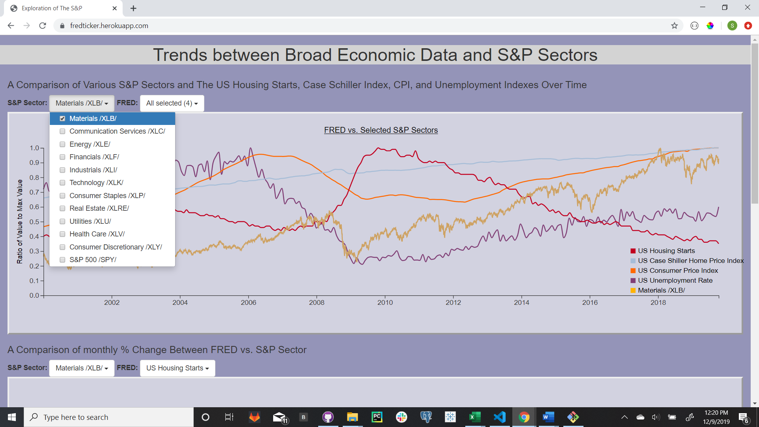

Data: The two datasets to create the visuals came from https://fred.stlouisfed.org/fred-addin/ for the Federal Reserve portion and https://finance.yahoo.com/ for the S&P sector portion. This data was housed in SQLite.

Dashboard Visuals: The visuals were created using d3 & JavaScript including the jQuery library.

Webpage Access: [**https://fredticker.herokuapp.com**](https://fredticker.herokuapp.com/)