# Clarification on Lab 13

In problem 2 when trying to find the unknown “room” temperature, we completely overlooked the very obvious solution. We realize now that the value of $T_{0}$ was simply the zero of the linear regression line, found with $−b/m$.

# Introduction

from math import *  
  
import matplotlib.pyplot as plt  
import numpy as np  
from scipy.optimize import curve_fit

# Problem 1

To find the emissivity of the three aluminum cylinders (white, black, and bare metal), an analysis of heat transfer is done. All three cylinders start with no internal energy.

$$E=0$$

All are then heated by the environment (the boiling water). No mechanical work is done. This is the inital energy state of the cylinders.

$$E=Q_{i}=cmΔT$$

The cylinders are then set to cool with the assumption that room temperature is constant and there is no external airflow. It is also assumed that the cylinders conduct no heat to other solids and that only radiation and natural convection take place. So, the rate of change of the internal heat (from the initial heat, $Q_{i}$) is given by:

$$\frac{dQ}{dt}=\frac{dQ_{rad}}{dT}+\frac{dQ_{conv}}{dT}$$

$$\frac{dQ_{rad}}{dT}=εσA(T_{cyl}^{4}−T_{air}^{4})$$

$$\frac{dQ_{conv}}{dT}=hA(T_{cyl}−T_{air})$$

$$Q=cmΔT⟹dQ=cm dT$$

$$cm\frac{dT}{dt}=\frac{dQ_{rad}}{dT}+\frac{dQ_{conv}}{dT}$$

$$\frac{dT}{dt}=\frac{1}{cm}\left(εσA(T_{cyl}^{4}−T_{air}^{4})+hA(T_{cyl}−T_{air})\right)$$

For aluminum, $c=900 J/kg$. Finding the value of $h$ is ignored for now. $A$ is just the surface area of the cylinder, $2πR(H+R)$.

## Solving the Non-Linear Differential Equation

The above differential equation is non-linear and can’t be solved as a function of time. One possible method is to approximate $T_{cyl}^{4}−T_{air}^{4}$ (the non-linear component of the equation) using a first-order Taylor expansion around some value $T_{m}$.

$$f(T_{cyl})=T_{cyl}^{4}−T_{air}^{4}$$

$$f(T_{cyl})≈(T_{m}^{4}−T_{air}^{4})+4T_{m}^{3}(T_{cyl}−T_{m})$$

The first-order Taylor expansion only gives an equation for the tangent line and is not the most accurate approximation, as can be seen on the plot.

t_air = 20 # C  
t_m_vals = [20, 50, 80] # C  
  
t = np.linspace(20, 100, 1000)  
  
plt.plot(t, 1e-6 * (t**4 - t_air**4),label=r"$T_{\mathrm{cyl}}^4 - T_{\mathrm{air}}^4$")  
  
for t_m in t_m_vals:  
 label_str = r"$T_m$ = " + str(t_m)  
 plt.plot(t, 1e-6 * ((t_m**4 - t_air**4) + (4 * t_m ** 3) * (t-t_m)), label=label_str)  
  
plt.xlabel("Temperature (C°)")  
plt.ylabel("Arb. scale")  
plt.title("Linear Taylor Expansion Inaccuracy")  
plt.legend()  
plt.grid()  
plt.ylim([-10,110])

(-10.0, 110.0)

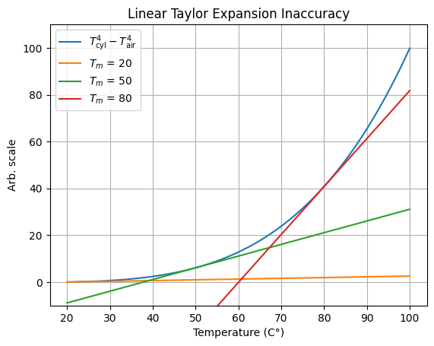

png

Assuming the temperature range in the data is between 100 and 20 degrees, there may be a certain value of $T_{m}$ that minimizes the error. The minimum error function should have the smallest integral of difference (accumulation of absolute error) with the actual function. So, finding the best value of $T_{m}$ looks like finding the minimum of the following function:

$$g(T_{m})=\left|\int_{20}^{100}{\left((T_{cyl}^{4}−T_{air}^{4})−(T_{m}^{4}−T_{air}^{4})+4T_{m}^{3}(T_{cyl}−T_{m}) \right)}dT_{cyl}\right|$$

$$g(T_{m})=\left|\int_{20}^{100}{\left(T_{cyl}^{4}−T_{m}^{4}+4T_{m}^{3}(T_{cyl}−T_{m}) \right)}dT_{cyl}\right|$$

$$g(T_{m})=\left|\int_{20}^{100}{\left(T_{cyl}^{4}−T_{m}^{4}+4T_{m}^{3}T_{cyl}−4T_{m}^{4} \right)}dT_{cyl}\right|$$

$$g(T_{m})=\left|\int_{20}^{100}{\left(T_{cyl}^{4}+4T_{m}^{3}T_{cyl}−5T_{m}^{4} \right)}dT_{cyl}\right|$$

$$g(T_{m})=\left|\left(\frac{1}{5}T_{cyl}^{5}+2T_{m}^{3}T_{cyl}^{2}−5T_{m}^{4}T_{cyl}\right)|_{20}^{100}\right|$$

$$g(T_{m})=\left|\left(\frac{1}{5}{100}^{5}+2T_{m}^{3}{100}^{2}−5T_{m}^{4}100\right)−\left(\frac{1}{5}{20}^{5}+2T_{m}^{3}{20}^{2}−5T_{m}^{4}20\right)\right|$$

ChatGPT says this becomes:

$$g(T_{m})=\left|−400T_{m}^{4}+19200T_{m}^{3}+1999994446.4\right|$$

I could derive this and use the cubic formula to find the critical points and test if they are local minima, but instead I decided to just plot the equation between 20 and 100.

t = np.linspace(20, 100, 1000)  
y = abs(1e-6 * (-400 * t**4 + 19200 * t**3 + 1999994446.4))  
min_y = np.argmin(y)  
  
label_str = r"The best value for $T_m$: " + str(round(t[min_y],3)) + " C°"  
  
plt.semilogy(t, y)  
plt.scatter(t[min_y],y[min_y],label=label_str,c='red',zorder=10)  
  
plt.xlabel("Temperature of Taylor Expansion Origin (C°)")  
plt.ylabel("Error Accumulation (arb. scale)")  
plt.title("Linear Taylor Expansion Error Integral")  
plt.grid()  
plt.legend()

<matplotlib.legend.Legend at 0x7fb83217d040>

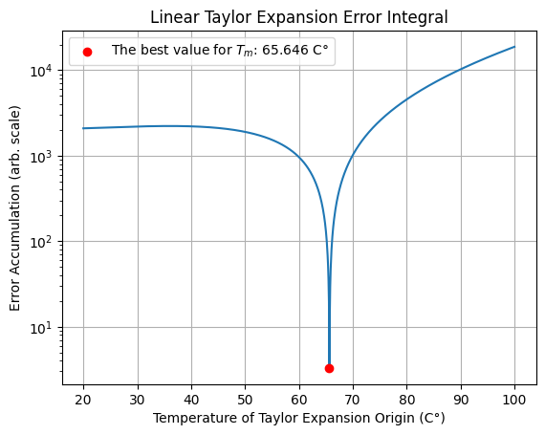

png

Using this newly found “best” value of $T_{m}$, where the error cancels out, the differential equation can be solved. The equation

$$\frac{dT}{dt}=\frac{1}{cm}\left(εσA(T_{cyl}^{4}−T_{air}^{4})+hA(T_{cyl}−T_{air})\right)$$

becomes

$$\frac{dT}{dt}≈\frac{1}{cm}\left(εσA((T_{m}^{4}−T_{air}^{4})+4T_{m}^{3}(T_{cyl}−T_{m}))+hA(T_{cyl}−T_{air})\right)$$

Skipping the simplifications done on paper ($T=T_{cyl}$):

$$\frac{dT}{dt}≈\frac{A}{cm}(h+εσ4T_{m}^{3})T+\frac{A}{cm}(−3εσT_{m}^{4}−εσT_{air}^{4}−hT_{air})$$

This is a first-order linear differential equation in the form of:

$$\dot{y}=my+b$$

which becomes

$$y(x)=−\frac{b}{m}+Ce^{mx}$$

The solution is thus:

$$T(t)=−\frac{−3εσT_{m}^{4}−εσT_{air}^{4}−hT_{air}}{h+εσ4T_{m}^{3}}+C\text{exp}\left(\frac{A}{cm}(h+εσ4T_{m}^{3})t\right)$$

where $C$ can be found, since $T(0)$ is known.

$$T_{0}=−\frac{−3εσT_{m}^{4}−εσT_{air}^{4}−hT_{air}}{h+εσ4T_{m}^{3}}+C$$

$$C=T_{0}+\frac{−3εσT_{m}^{4}−εσT_{air}^{4}−hT_{air}}{h+εσ4T_{m}^{3}}$$

**Plugging all of this into the Ultimate Equation:**

$$\boxed{T(t)=\left(T_{0}+\frac{−3εσT_{m}^{4}−εσT_{air}^{4}−hT_{air}}{h+εσ4T_{m}^{3}}\right)\text{exp}\left(\frac{A}{cm}(h+εσ4T_{m}^{3})t\right)−\frac{−3εσT_{m}^{4}−εσT_{air}^{4}−hT_{air}}{h+εσ4T_{m}^{3}}}$$

(Which, for curve fitting, follows this form.)

$$T(t)=ae^{bt}+c$$

The emissivity is solved for on paper; using $c$ (which has the same output as all the other coefficients when finding $ε$), the equation is:

$$ε=\frac{h(c−T_{air})}{−σ(4cT_{m}^{3}+3T_{m}^{4}+T_{air}^{4})}$$

Unmentioned till now, $h$ can be assumed to be 10, which is about the heat transfer coefficient of stagnet air.

# Actual data  
time = np.linspace(0, 5, 10, dtype=np.float128) # minutes  
temp = (60) * 1.3 * np.exp(-0.05 * time) + 20  
  
noise = np.random.normal(-1, 1, 10)  
temp += noise  
  
  
# Modified from Lab 11  
def fit(tt: np.ndarray, yy: np.ndarray):  
  
 def func(t, a, b, c):  
 return a * np.exp(-b * t) + c  
  
 # HACK maxfev too high, not optimal algorithm  
 popt, pcov = curve_fit(func, tt, yy, maxfev=10000)  
 a, b, c = popt  
 fitfunc = lambda t: a * np.exp(-b * t) + c  
  
 return {  
 "a": a,  
 "b": -b,  
 "c": c,  
 "fitfunc": fitfunc,  
 "maxcov": np.max(pcov),  
 "rawres": (popt, pcov),  
 }  
  
  
fitdict = fit(time, temp)  
  
a, b, c = fitdict["a"], fitdict["b"], fitdict["c"]  
  
t_m = t[min_y] # C  
h = 10  
sigma = 5.670374419e-8  
t_air = 20 # C  
  
e = ( h * (c - t_air)) / (-sigma*(4*c*(t_m**3) + 3*(t_m**4) + t_air**4))  
  
plt.scatter(time, temp, label="Data", zorder=10)  
plt.plot(  
 np.linspace(0, 5, 1000),  
 fitdict["fitfunc"](np.linspace(0, 5, 1000)),  
 c="red",  
 label="Line of Best Fit",  
)  
label_str = r"$\varepsilon$ = " + str(round(100*e,3)) + " %"  
plt.plot([],[],' ', label=label_str)  
  
plt.xlabel("Time (min)")  
plt.ylabel("Temperature (C°)")  
plt.title("Temperature vs Time")  
plt.legend()  
plt.grid()

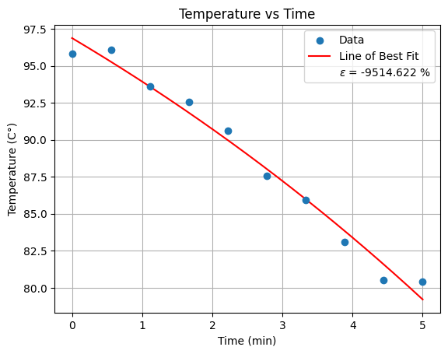

png

## Second Attempt

I gave up on the above method because it’s an absolute nightmare. Instead, given the $T_{cyl}$ (from here on, $T$) and time data, the derivative can be found numerically. I am also done trying to do curve fitting with absolutely every problem. Instead, I’ll just take the average.

$$\dot{T}=\frac{1}{cm}\left(εσA(T^{4}−T_{air}^{4})+hA(T−T_{air})\right)$$

$$cm\dot{T}=εσA(T^{4}−T_{air}^{4})+hA(T−T_{air})$$

$$cm\dot{T}−hA(T−T_{air})=εσA(T^{4}−T_{air}^{4})$$

$$\boxed{ε=\frac{cm\dot{T}−hA(T−T_{air})}{σA(T^{4}−T_{air}^{4})}}$$

(Also, a note: When I did the Taylor expansion error integral, I should have had the line shifted up or down by a second parameter, creating a 2D function to then find the minimum of.)

# Recorded data  
time = np.array([n for n in range(100)])  
temp = np.array(  
 [  
 [n for n in range(100)],  
 [0.5 * n for n in range(100)],  
 [2 * n for n in range(100)],  
 [1.5 * n for n in range(100)],  
 ]  
) # C  
  
# Measurements  
c = 900 # J/kg  
m = 1 # kg  
h = 1 # W/m^2K  
  
temp_air = 20 # C  
sigma = 5.670374419e-8 # W/m^2 K^4  
  
R = 1 # m  
H = 1 # m  
  
d_temp = np.array([np.gradient(row, time) for row in temp])  
  
# Calculations  
A = 2 * pi * R * (H + R)  
  
top = c * m * d_temp - h * A * (temp - temp_air)  
bottom = sigma * A * (temp**4 - temp_air**4)  
emissivity = 100 * (top / bottom) # %  
  
str_1 = "Temperature (C°)"  
str_2 = "Change in Temperature (C°/s)"  
str_3 = "Emissivity (%)"  
  
titles = ["Bare Metal", "White Paint", "Black Paint", ""]  
  
fig, axes = plt.subplots(2, 2, figsize=(8, 6))  
  
i = 0  
for ax_part in axes:  
 for ax in ax_part:  
 if i == 3:  
 ax.axis("off")  
 else:  
 ax.plot(time, temp[i])  
 ax.plot(time, d_temp[i])  
 ax.plot(time, emissivity[i])  
 ax.set_xlabel("Time (s)")  
 ax.set_title(titles[i])  
 ax.grid()  
 i += 1  
  
fig.legend([str_1, str_2, str_3], loc="lower right", bbox_to_anchor=(0.925, 0.2))  
fig.suptitle("Cylinder State vs Time")  
fig.tight_layout()  
  
hack = [  
 print(title + ": avg e = " + str(float(np.mean(em))) + " %")  
 for em, title in zip(emissivity, titles)  
 if title != ""  
]

/tmp/ipykernel_9825/3486328796.py:30: RuntimeWarning: divide by zero encountered in divide  
 emissivity = 100 * (top / bottom) # %  
  
  
Bare Metal: avg e = inf %  
White Paint: avg e = inf %  
Black Paint: avg e = inf %

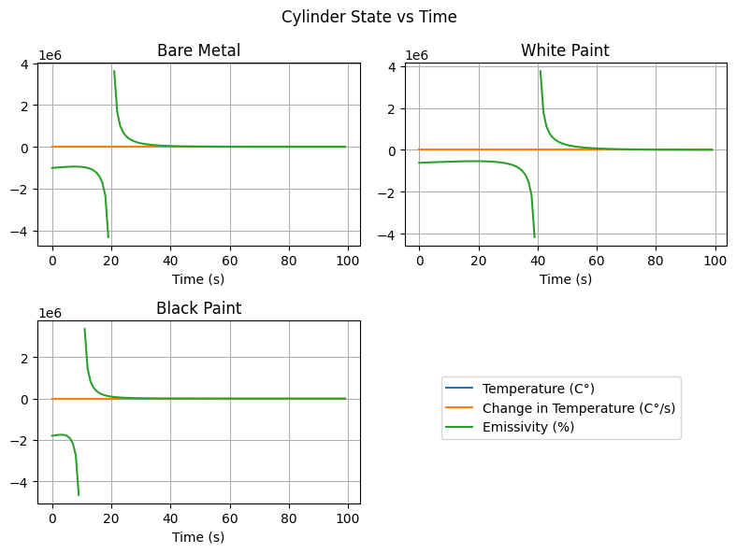

png

## Analysis

# Problem 2

## Analysis

# Problem 3

## Analysis

# Conclusion