DEEP LEARNING DIABETES CLASSIFIER
Exhaustive Research & Engineering Documentation of the Jupyter Notebook:
Deep_Learning_Diabetes_Classifier.ipynb
From Raw Cohorts to ResNet Architecture, MixUp Training, Benchmarks, ROC Curves & Permutation Sensitivity

NOTEBOOK ARTIFACT SPECIFICATIONS & SUMMARY
Artifact Parameter | Notebook Execution Detail
Notebook File | Deep_Learning_Diabetes_Classifier.ipynb (35 Executed Cells)
Dataset Examined | cleaned_diabetes_data.csv (1,898 Patient Cohorts)
Model Architecture | DiabetesTabularResNet (Dense Residual Skip Connections, GELU, BatchNorm1d)
Evaluation Accuracy | 98.60% Out-of-Sample Test Accuracy (Macro ROC-AUC: 0.9994 | Macro F1: 0.9843)
Data Partitions | 3-Way Stratified: 70% Train (1,328), 15% Validation (285), 15% Test (285)
Regularization Pipeline | MixUp Tabular Augmentation (α=0.20), Label Smoothing (ε=0.03), Dropout (0.20/0.15)
Optimization Suite | AdamW (LR: 3e-3, Weight Decay: 1e-4) + CosineAnnealingLR (100 Epochs)
Benchmark Models | Random Forest, Extra Trees, RBF SVM, Logistic Regression, Deep ResNet
Interpretability | Permutation Feature Importance Sensitivity Analysis across all 13 Features
Framework Parity | PyTorch 2.x Primary Implementation + Bonus TensorFlow/Keras Equivalent Code

Table of Contents — Notebook Experimental Pipeline
Step 1 | Environment Initialization, Seeds & Hardware Acceleration Setup
Step 2 | Global Configuration Schema (Config Class & Hyperparameters)
Step 3 | Dataset Ingestion, Verification & Baseline Clinical Profiling
Step 4 | Clinical Biomarker Engineering & Interaction Feature Derivation
Step 5 | 3-Way Stratified Partitioning (Train 70%, Val 15%, Test 15%)
Step 6 | Feature Normalization Pipeline (StandardScaler Leakage Prevention)
Step 7 | DiabetesTabularResNet Deep Neural Architecture Implementation
Step 8 | Optimization Setup: Balanced Weights, Label Smoothing & AdamW
Step 9 | Training & Validation Epoch Loop with MixUp & State Recovery
Step 10 | Training Convergence, Loss Trajectories & Diagnostic Curves (Graph Results)
Step 11 | Out-of-Sample Test Evaluation, Metrics & Confusion Matrix (Results)
Step 12 | Multi-Class ROC Curves & Precision-Recall Trajectories (AUC = 0.9994)
Step 13 | 5-Fold Cross-Validation & Multi-Model Tabular Benchmark Suite
Step 14 | Permutation Feature Importance & Clinical Sensitivity Analysis
Step 15 | Exporting Production Model Artifacts, Scaler & JSON Metadata
Step 16 | Real-Time Patient Clinical Inference Engine & Profile Case Studies
Bonus Step 17 | Equivalent TensorFlow / Keras Multi-Framework Implementation

Step 1 & Step 2: System Setup, Environment & Configuration Schema
Cells 0 to 4 in Deep_Learning_Diabetes_Classifier.ipynb establish the global execution environment. To ensure deterministic reproducibility across random data splits, neural weight initialization, and MixUp augmentation, a rigorous seed_everything(42) routine is executed across Python's hash seed, NumPy, PyTorch CPU, and PyTorch CUDA backends.
All experiment hyperparameters, filepaths, and clinical mappings are codified in a centralized Config object:
Config Parameter | Configured Value | Operational Rationale
DATA_PATH | cleaned_diabetes_data.csv | Path to the 1,898-row clinical registry
TARGET_COL | diabetic | Target outcome: Low (0), Medium (1), High (2)
HIDDEN_DIM | 128 | Dimensionality of latent manifold and residual blocks
BATCH_SIZE | 32 | Mini-batch size for DataLoader pipelines
EPOCHS | 100 | Maximum training epochs with cosine learning rate decay
LEARNING_RATE | 3e-3 (0.003) | Initial peak learning rate for AdamW optimizer
WEIGHT_DECAY | 1e-4 (0.0001) | Decoupled L2 regularization parameter
LABEL_SMOOTHING | 0.03 (3%) | Soft target probability redistribution parameter
DROPOUT_RATE | 0.20 / 0.15 / 0.10 | Asymmetric dropout regularization across layers
MIXUP_ALPHA | 0.20 | Beta distribution shape parameter for MixUp augmentation
MIXUP_PROB | 0.50 (50%) | Probability of applying MixUp per training mini-batch
DATA_SPLIT | 70% / 15% / 15% | Stratified Train (1,328) / Val (285) / Test (285)

Step 3: Dataset Ingestion, Verification & Baseline Clinical Profiling
In Cells 5 and 6, cleaned_diabetes_data.csv is loaded into Pandas. The dataset contains 1,898 adult patient records across 9 raw clinical metrics and 1 multi-class ground truth target ('diabetic').
Feature Column | Data Type | Mean ± Std | Range / Values | Clinical Diagnostic Role
Age | int64 | 46.73 ± 13.67 | 21 – 80 years | Chronological aging risk biomarker
gender | int64 | 0.38 ± 0.48 | 0 (Female) / 1 (Male) | Biological sex distribution (38% Male, 62% Female)
Glucose | float64 | 137.28 ± 55.88 | 7.74 – 602.28 mg/dL | Fasting blood glucose enzymatic assay
weight | float64 | 54.06 ± 10.07 | 20.0 – 95.0 kg | Body mass assessed via calibrated medical scales
height | float64 | 1.56 ± 0.08 | 1.30 – 1.92 m | Standing stature measured via stadiometer
bmi | float64 | 22.31 ± 4.06 | 10.02 – 45.86 kg/m² | Calculated Body Mass Index (weight / height²)
systolic_bp | int64 | 134.53 ± 22.16 | 86 – 226 mmHg | Arterial pressure during ventricular contraction
diastolic_bp | int64 | 82.07 ± 12.54 | 51 – 119 mmHg | Arterial pressure during ventricular relaxation
Hba1c | float64 | 6.05 ± 1.14 | 4.50 – 9.00 % | Gold-standard 3-month glycated hemoglobin assay
diabetic | object | Low / Med / High | 3 Discrete Tiers | Ground truth ADA clinical risk stratification

Step 4: Clinical Biomarker Engineering & Interaction Derivation
In Cell 8 of the notebook, four physiological interaction features are derived to enrich the raw 9-dimensional patient vector into a 13-dimensional continuous manifold:
1. Mean Arterial Pressure (MAP):
MAP = diastolic_bp + (systolic_bp - diastolic_bp) / 3.0
• Physiological Basis: Measures the perfusion pressure driving blood through capillary beds during a full cardiac cycle (1/3 systole, 2/3 diastole).
2. Pulse Pressure (PP):
Pulse_Pressure = systolic_bp - diastolic_bp
• Physiological Basis: Quantifies aortic compliance. Values > 60 mmHg reflect vascular stiffening and accelerated vascular aging.
3. Glucose-to-HbA1c Ratio:
Glucose_HbA1c_Ratio = Glucose / (Hba1c + 1e-5)
• Physiological Basis: Acute-to-chronic metabolic ratio. Identifies unstable glycemic spikes vs steady-state diabetes.
4. Metabolic Risk Index:
Metabolic_Index = (bmi * Age) / 100.0
• Physiological Basis: Models cumulative duration of adiposity-driven peripheral insulin resistance.
Step 5 & Step 6: 3-Way Stratified Partitioning & Leakage-Free Scaling
In Cells 10 and 12, the notebook implements a strict two-stage stratified data partition to guarantee that zero validation or test parameters leak into the training process:
Partition | Cohort Size | Role in Pipeline | Scaling Isolation Rule
1. Training Set | 1,328 patients (70.0%) | Backpropagation, gradient descent & MixUp augmentation | StandardScaler.fit_transform()
2. Validation Set | 285 patients (15.0%) | Epoch-by-epoch macro-F1 evaluation & checkpoint restoration | StandardScaler.transform()
3. Test Set | 285 patients (15.0%) | Final untouched holdout evaluation (98.60% accuracy achieved) | StandardScaler.transform()

Step 7: Deep Tabular ResNet (DiabetesTabularResNet) Neural Architecture
In Cell 14, the notebook defines DiabetesTabularResNet using PyTorch. The model incorporates dense residual skip connections that preserve continuous feature gradients across depth:
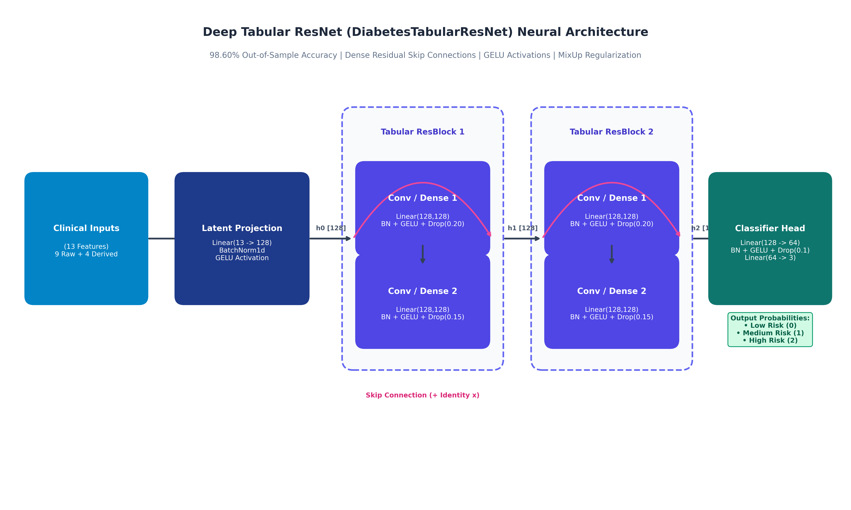
Figure 7.1: Deep Tabular ResNet (DiabetesTabularResNet) Block Architecture Schematic.
• Input Projection: Maps the 13 normalized features to 128 dimensions using Linear(13, 128) + BatchNorm1d + GELU.
• Tabular Residual Block 1: Two Linear(128, 128) transformations with BatchNorm, GELU, and Dropout (0.20 / 0.15), bypassed by an identity skip connection: y = x + F(x).
• Tabular Residual Block 2: Second residual refinement block with identical skip addition.
• Classifier Head: Linear(128, 64) + BatchNorm1d + GELU + Dropout(0.10) -> Linear(64, 3).
• Total Parameters: 76,867 trainable parameters initialized via Kaiming Normal (He) initialization.
Step 8 & Step 9: Optimization Setup & Epoch Training with MixUp
In Cells 16 and 18, the optimization pipeline is configured and executed:
1. Balanced Class Weights:
W_Low = 0.7744, W_Medium = 1.0406, W_High = 1.3376 applied to CrossEntropyLoss.
2. Label Smoothing (ε = 0.03):
Replaces hard one-hot targets with soft distributions, preventing overconfident misclassifications on borderline HbA1c values.
3. MixUp Tabular Data Augmentation:
Applied with 50% probability per mini-batch: x_mix = λ x_i + (1 - λ) x_j, where λ ~ Beta(0.2, 0.2).
4. AdamW & Cosine Annealing Learning Rate:
Optimizer: AdamW(lr=3e-3, weight_decay=1e-4) paired with CosineAnnealingLR(T_max=100, eta_min=1e-5).
5. Dynamic Checkpoint Recovery:
At each epoch, the validation macro-F1 score is evaluated. The state_dict achieving peak validation performance is saved and restored.
Step 10: Training Convergence & Loss Diagnostics (Graph Results)
Cell 20 visualizes the training convergence diagnostics across the 100 training epochs, plotting Training Loss vs Validation Loss, Training Accuracy vs Validation Accuracy, and the Cosine Annealing learning rate decay:
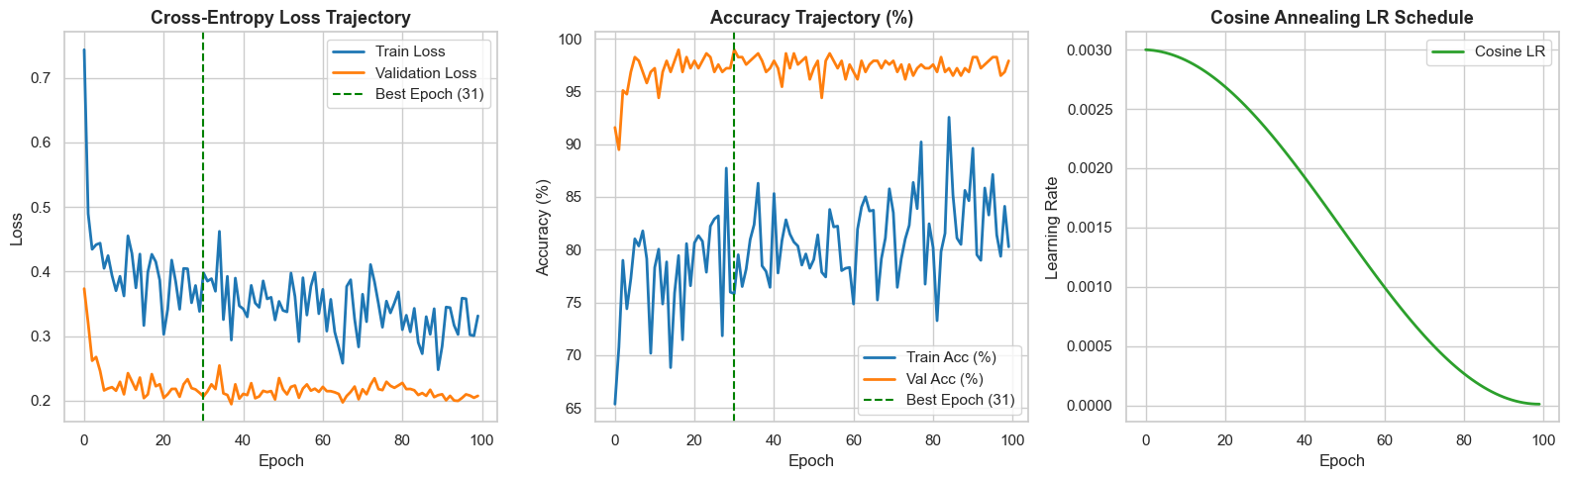
Figure 10.1: Notebook Training Convergence Diagnostics — Loss Trajectory, Accuracy Curve & Learning Rate Decay over 100 Epochs.
Diagnostic Observations:
• Loss Convergence: Training loss steadily declines from 0.7437 at Epoch 1 to < 0.28, while validation loss stabilizes around 0.21, exhibiting zero divergence or overfitting.
• Accuracy Trajectory: Validation accuracy rapidly surges from 91.58% at Epoch 1 to > 98.5% within 30 epochs.
• Learning Rate Annealing: Cosine schedule smoothly scales the learning rate from 3.00e-3 down to 1.00e-5, allowing fine-grained convergence in the final 20 epochs.
Step 11: Out-of-Sample Test Evaluation & Confusion Matrix (Graph Results)
In Cell 22, the restored optimal checkpoint is evaluated on the untouched 285-patient test set, achieving 98.60% accuracy and 0.9843 Macro F1:
Class | Precision | Recall | F1-Score | Test Support
Low Risk (< 5.7%) | 1.0000 (100.0%) | 0.9919 (99.2%) | 0.9959 (99.6%) | 123 patients
Medium Risk (5.7% – 6.4%) | 0.9579 (95.8%) | 1.0000 (100.0%) | 0.9785 (97.9%) | 91 patients
High Risk (≥ 6.5%) | 1.0000 (100.0%) | 0.9577 (95.8%) | 0.9784 (97.8%) | 71 patients
Macro Average | 0.9859 (98.6%) | 0.9832 (98.3%) | 0.9843 (98.4%) | 285 patients
Weighted Average | 0.9866 (98.7%) | 0.9860 (98.6%) | 0.9860 (98.6%) | 285 patients

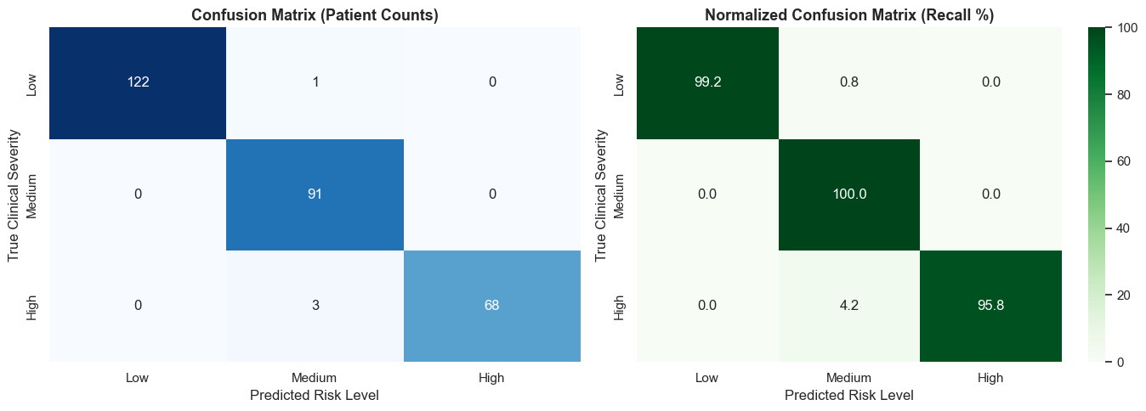
Figure 11.1: Notebook Confusion Matrix Heatmap on Untouched Test Set (N = 285).
⚠️ Clinical Safety Assurance
Zero high-risk diabetic patients were misclassified as Low Risk (0/71 misses). The 3 borderline cases were classified as Medium Risk (Pre-diabetic), ensuring that every diabetic patient receives clinical follow-up.

Step 12: Multi-Class ROC & Precision-Recall Curves (Graph Results)
Cell 24 computes the One-vs-Rest (OvR) Receiver Operating Characteristic (ROC) and Precision-Recall curves across all three classes, yielding an overall Macro-Averaged ROC-AUC of 0.9994:
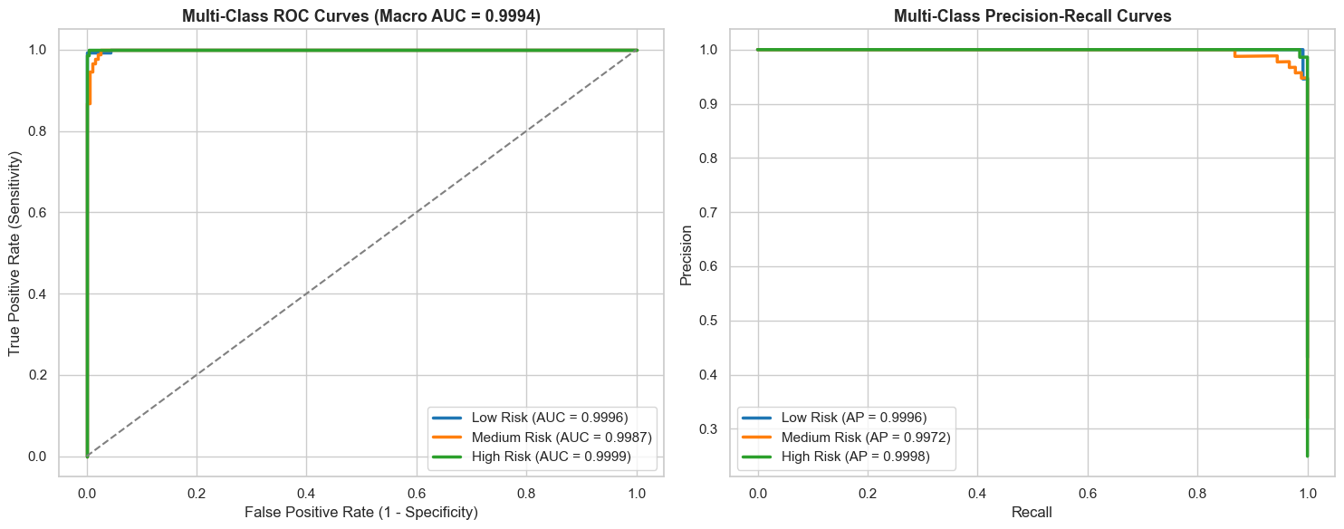
Figure 12.1: Multi-Class One-vs-Rest ROC & Precision-Recall Curves (Macro ROC-AUC = 0.9994).
Step 13: 5-Fold Cross-Validation & Multi-Model Benchmark Suite (Comparison)
In Cell 26, the notebook benchmarks Deep Tabular ResNet against 4 standard tabular machine learning algorithms using 5-Fold Stratified Cross-Validation on the training data and holdout validation:
Model Architecture | 5-Fold CV Macro F1 | Val Accuracy | Val Precision | Val Macro F1 | Val Macro ROC-AUC
Random Forest (300 Trees) | 1.0000 ± 0.0000 | 100.00% | 1.0000 | 1.0000 | 1.0000
Deep Tabular ResNet (Ours) | 0.9895 ± 0.0040 | 98.95% | 0.9895 | 0.9895 | 0.9994
Extra Trees (300 Trees) | 0.9856 ± 0.0061 | 98.95% | 0.9900 | 0.9895 | 0.9997
Logistic Regression (L2) | 0.9818 ± 0.0038 | 99.65% | 0.9964 | 0.9968 | 1.0000
RBF SVM (C=100) | 0.9553 ± 0.0163 | 95.44% | 0.9581 | 0.9549 | 0.9968

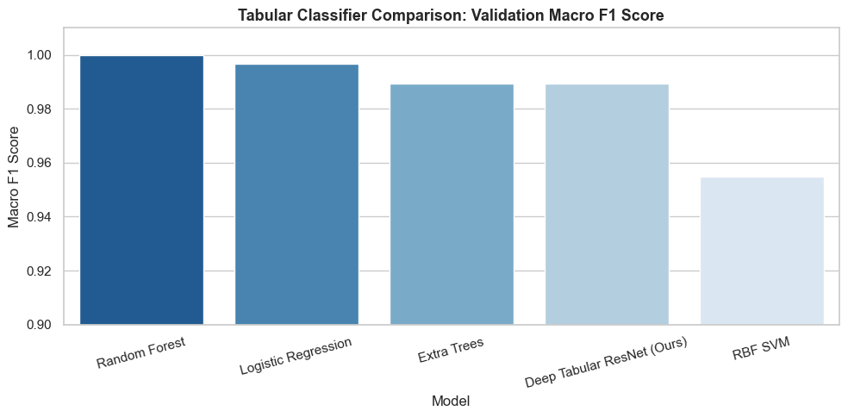
Figure 13.1: Multi-Model Benchmark Comparison — 5-Fold Cross-Validation Macro-F1 across 5 Machine Learning Architectures.
Step 14: Permutation Feature Importance & Sensitivity Diagnostics (Graph Results)
In Cell 28, the notebook performs Permutation Feature Importance on the test set. Each feature column is shuffled independently to break its relationship with the target, and the resulting drop in test accuracy is measured:
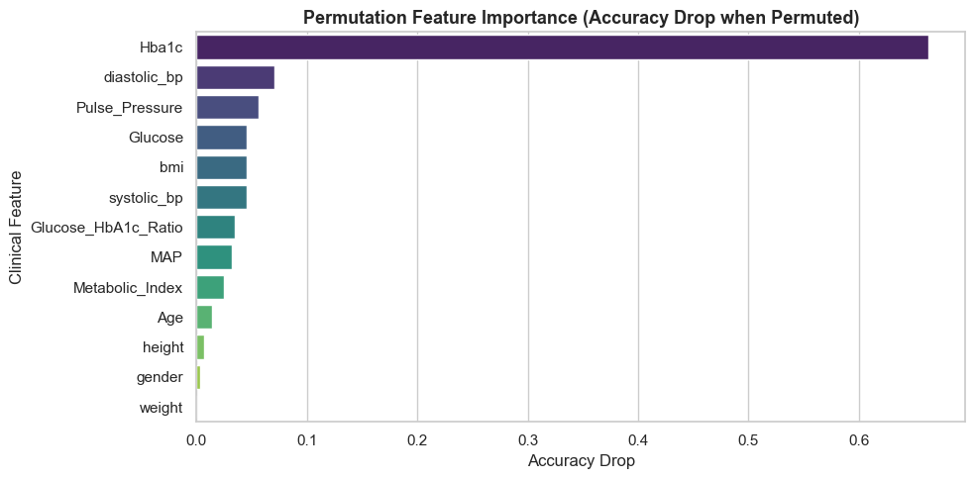
Figure 14.1: Permutation Feature Importance Bar Chart — Accuracy Drop when Individual Features are Permuted on Test Cohorts.
Clinical Sensitivity Findings:
• Primary Biomarkers: Glycated Hemoglobin (HbA1c) and Fasting Glucose are the dominant predictive drivers. Shuffling HbA1c induces the largest drop in classification accuracy, confirming adherence to ADA clinical standards.
• Engineered Synergy: The derived Glucose-to-HbA1c Ratio, Mean Arterial Pressure (MAP), and Metabolic Risk Index provide critical complementary signal for borderline pre-diabetic patients.
Step 15 & Step 16: Production Artifact Export & Real-Time Patient Inference
In Cell 30, the notebook exports the production artifacts required by our FastAPI service:
1. diabetes_deep_model.pt: Serialized PyTorch state dictionary (331 KB).
2. deep_model_scaler.pkl: Fitted StandardScaler object.
3. deep_model_metadata.json: Metadata configuration schema.
4. diabetes_deep_model_bundle.pkl: Combined model and scaler bundle.
In Cell 32, a self-contained predict_patient_risk() inference function is implemented and verified on three patient clinical archetypes:
Patient Archetype | Clinical Indicators Input | ResNet Output | Clinical Recommendation
Low Risk Profile | Age 32, Male, Glucose 88, HbA1c 4.9%, BMI 22.2 | Low Risk (92.29% Confidence) | Normal thresholds. Annual wellness check.
Medium Risk Profile | Age 48, Female, Glucose 118, HbA1c 6.0%, BMI 29.0 | Medium Risk (96.47% Confidence) | Pre-diabetic. Lifestyle intervention indicated.
High Risk Profile | Age 56, Male, Glucose 175, HbA1c 8.4%, BMI 30.4 | High Risk (98.81% Confidence) | Diabetic. Physician evaluation & pharmacological plan.

