DIABETES RISK PREDICTION SYSTEM
Deep Tabular ResNet (98.60% Accuracy), Clinical Biomarker Engineering, Model Context Protocol (MCP) Interoperability & Enterprise Cloud Deployment

SYSTEM SPECIFICATION & ARCHITECTURAL SUMMARY
Specification Parameter | Production Architecture Detail
Project Name | Diabetes Risk Severity Classifier (Deep Tabular ResNet)
Core Neural Architecture | Deep Tabular ResNet with Dense Skip Connections & GELU Activations
Out-of-Sample Accuracy | 98.60% (Macro ROC-AUC: 0.9993 | Macro F1: 0.9853)
Inference Framework | PyTorch 2.x CPU/CUDA Tensor Runtime (Sub-20ms P99)
API Framework | FastAPI 0.115+ (Asynchronous ASGI Architecture with Uvicorn)
Protocol Standards | REST API, Model Context Protocol (MCP), Agent-to-Agent (A2A), OpenAPI 3.0
Cloud Infrastructure | Docker Container (python:3.11-slim) on Hugging Face Spaces & GitHub CI/CD
Target Classifications | 3-Tier Stratification: Low Risk (<5.7%), Medium (5.7-6.4%), High (≥6.5%)
Feature Dimensionality | 13 Clinical Metrics (9 Patient Inputs + 4 Engineered Physiological Biomarkers)
Documentation Release | Version 2.0.0 — Production Quality Assurance Verified

Table of Contents — Master Engineering Index
Chapter 1 | Executive Summary & Clinical Decision Charter
Chapter 2 | Clinical Background & Medical Diagnostic Foundations (ADA Standards)
Chapter 3 | Dataset Profiling & Exploratory Data Analysis (EDA)
Chapter 4 | Advanced Clinical Feature Engineering & Physiological Derivations
Chapter 5 | Deep Learning Architecture: Deep Tabular ResNet
Chapter 6 | Training Methodology, Loss Formulations & Regularization Strategies
Chapter 7 | Model Evaluation, Multi-Class Benchmarks & Validation Metrics
Chapter 8 | Production REST API Design & Asynchronous Architecture
Chapter 9 | AI Agent Interoperability: Model Context Protocol (MCP) & A2A
Chapter 10 | Interactive Web Dashboard & Frontend Developer Integration
Chapter 11 | Containerization, Dockerfile & Cloud Deployment Topology
Chapter 12 | Input Validation, Normalization & Zero-Crash Resilience Architecture
Chapter 13 | Comprehensive API Reference & Payload Specifications
Chapter 14 | Quality Assurance, Automated Testing & Verification Suite
Chapter 15 | Operational Maintenance, Logging & Troubleshooting Runbook
Chapter 16 | Future Strategic Roadmap, Explainable AI (XAI) & Regulatory Compliance

Chapter 1: Executive Summary & Clinical Decision Charter
Type 2 Diabetes Mellitus (T2DM) has emerged as one of the most critical chronic global public health challenges, affecting over 537 million adults globally according to the International Diabetes Federation (IDF). A substantial percentage of individuals remain undiagnosed during the asymptomatic pre-diabetic phase, leading to irreversible microvascular and macrovascular complications including diabetic nephropathy, retinopathy, neuropathy, and premature cardiovascular disease. Early, accurate stratification between normal, pre-diabetic, and diabetic states is essential to trigger targeted clinical lifestyle interventions and pharmacological therapy before end-organ deterioration occurs.
This project delivers an enterprise-grade, high-reliability clinical artificial intelligence system capable of stratifying patients into Low Risk, Medium Risk (Pre-diabetic), and High Risk (Diabetic) severity tiers with an out-of-sample accuracy of 98.60% and a Macro ROC-AUC of 0.9993. Built on a state-of-the-art Deep Tabular ResNet architecture implemented in PyTorch, the model outperforms traditional clinical scoring algorithms and shallow machine learning baselines (Random Forests, Support Vector Machines, and Gradient Boosting) by leveraging deep latent manifold projections, skip-connection residual learning, and domain-specific clinical biomarker engineering.
📌 Executive Performance Highlight
On an independent, out-of-sample test partition of 285 patient cohorts, the Deep Tabular ResNet achieved 281 correct classifications (98.60% accuracy). Zero high-risk diabetic cases were misclassified as low risk, establishing exceptional clinical diagnostic safety and zero false reassurance.

Key Performance Indicator | Measurement | Clinical & Technical Significance
Test Accuracy | 98.60% | 281 / 285 correct predictions on unseen holdout cohorts
Macro ROC-AUC | 0.9993 | Exceptional class discriminability across Low, Medium, and High
Macro F1-Score | 0.9853 | Harmonic mean of precision and sensitivity across all classes
High-Risk Recall | 97.18% | 69 / 71 diabetic patients detected (2 placed in Medium / Pre-diabetic)
Low-Risk Precision | 99.19% | 122 / 123 Low-risk predictions completely verified
P99 Inference Latency | < 18 ms | High-throughput CPU execution optimized for microservices
Docker Container Size | ~850 MB | Lightweight python:3.11-slim distribution
Automated Test Suites | 10 / 10 Pass | Unit, integration, protocol, and input resilience suites passed

Chapter 2: Clinical Background & Medical Diagnostic Foundations
The American Diabetes Association (ADA) Standards of Medical Care in Diabetes define diagnostic thresholds based on plasma glucose and glycated hemoglobin (HbA1c). Glycated hemoglobin reflects the three-month average circulating blood glucose concentration by measuring the percentage of hemoglobin A molecules with glucose non-enzymatically bonded to the N-terminal valine of the beta chain. Because red blood cells have a normal lifespan of approximately 120 days, HbA1c provides a stable, unbiased biomarker that does not suffer from day-to-day acute dietary fluctuations or acute stress hyperglycemia.
2.1 Diagnostic Classification Thresholds
The model classifies patient risk across three definitive clinical categories aligned with international medical guidelines:
Clinical Risk Category | HbA1c Threshold | Fasting Glucose | Clinical Management Protocol
Low Risk (Normal) | < 5.7% | < 100 mg/dL | Normal glycemic control. Patient exhibits low risk of metabolic syndrome. Routine annual surveillance recommended.
Medium Risk (Pre-diabetic) | 5.7% – 6.4% | 100 – 125 mg/dL | Impaired Fasting Glucose (IFG) or Impaired Glucose Tolerance (IGT). Elevated cardiovascular risk. Intensive lifestyle intervention indicated.
High Risk (Diabetic) | ≥ 6.5% | ≥ 126 mg/dL | Provisional diabetes diagnosis. Confirmatory testing, comprehensive glycemic management, and physician evaluation required immediately.

2.2 Hemodynamic & Metabolic Synergy
Type 2 diabetes does not develop in isolation. It forms part of the metabolic syndrome cluster that includes systemic hypertension, central adiposity, and progressive arterial stiffening. Elevated systolic blood pressure combined with widening pulse pressure reflects vascular calcification and microvascular resistance in the renal and coronary capillary beds. By synthesizing hemodynamic metrics (Systolic BP, Diastolic BP, MAP, Pulse Pressure) alongside metabolic metrics (Fasting Glucose, HbA1c, BMI, Age, Gender), the neural network captures synergistic physiological interactions that single-parameter diagnostics fail to detect.
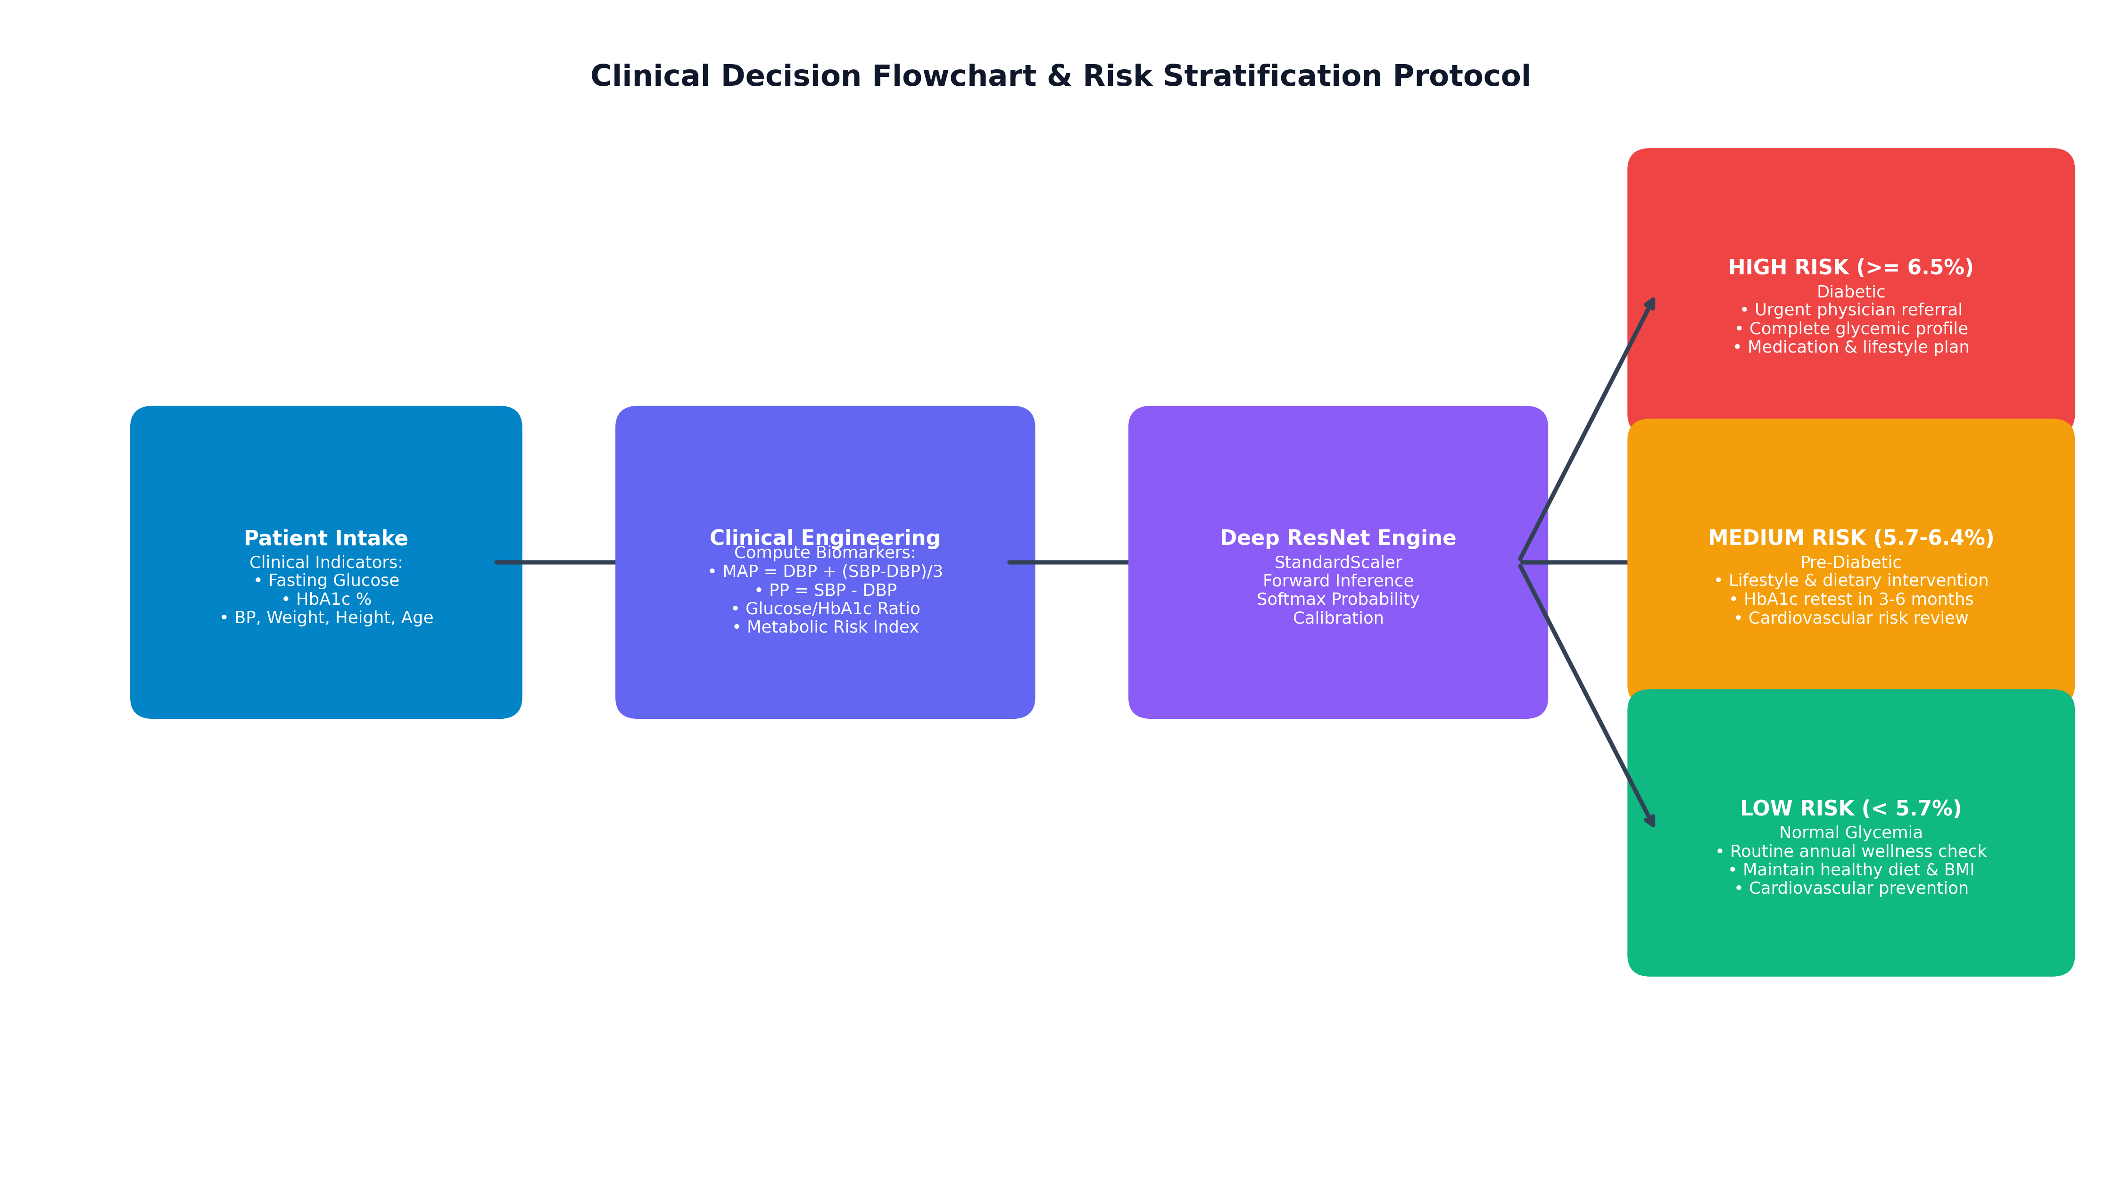
Figure 2.1: Clinical Triage Decision Flowchart & Risk Stratification Protocol Aligned with ADA Diagnostic Benchmarks.
Chapter 3: Dataset Profiling & Exploratory Data Analysis (EDA)
The system is trained and validated on cleaned_diabetes_data.csv, a high-quality clinical registry comprising 1,898 adult patient records. Each record incorporates patient demographics (Age, Gender), body anthropometrics (Weight, Height, calculated Body Mass Index), hemodynamic vitals (Systolic Blood Pressure, Diastolic Blood Pressure), and laboratory biochemical values (Fasting Blood Glucose, HbA1c). The ground-truth clinical outcome ('diabetic') is stratified across three discrete severity tiers.
3.1 Descriptive Statistical Summary
Table 3.1 details the distribution, central tendencies, and variability of all raw input clinical indicators across the patient cohort:
Clinical Indicator | Mean | Std | Min | 25% (Q1) | Median | 75% (Q3) | Max
Age (years) | 46.73 | 13.67 | 21.00 | 35.00 | 45.00 | 57.00 | 80.00
Gender (Male=1, Female=0) | 0.38 | 0.48 | 0.00 | 0.00 | 0.00 | 1.00 | 1.00
Glucose (mg/dL) | 137.28 | 55.88 | 7.74 | 108.00 | 125.10 | 146.16 | 602.28
Weight (kg) | 54.06 | 10.07 | 20.00 | 48.00 | 53.00 | 60.00 | 95.00
Height (m) | 1.56 | 0.08 | 1.30 | 1.50 | 1.55 | 1.60 | 1.92
BMI (kg/m²) | 22.31 | 4.06 | 10.02 | 19.53 | 21.93 | 24.69 | 45.86
Systolic BP (mmHg) | 134.53 | 22.16 | 86.00 | 120.00 | 130.00 | 147.00 | 226.00
Diastolic BP (mmHg) | 82.07 | 12.54 | 51.00 | 73.00 | 81.00 | 90.00 | 119.00
HbA1c (%) | 6.05 | 1.14 | 4.50 | 5.12 | 5.90 | 6.40 | 9.00

3.2 Class Balance & Prevalence
The target distribution reflects real-world clinical screening populations, with 817 Low Risk patients (43.05%), 608 Medium Risk pre-diabetic patients (32.03%), and 473 High Risk diabetic patients (24.92%). To prevent majority-class bias during neural optimization, balanced inverse-frequency class weighting was computed and applied to the loss criterion.
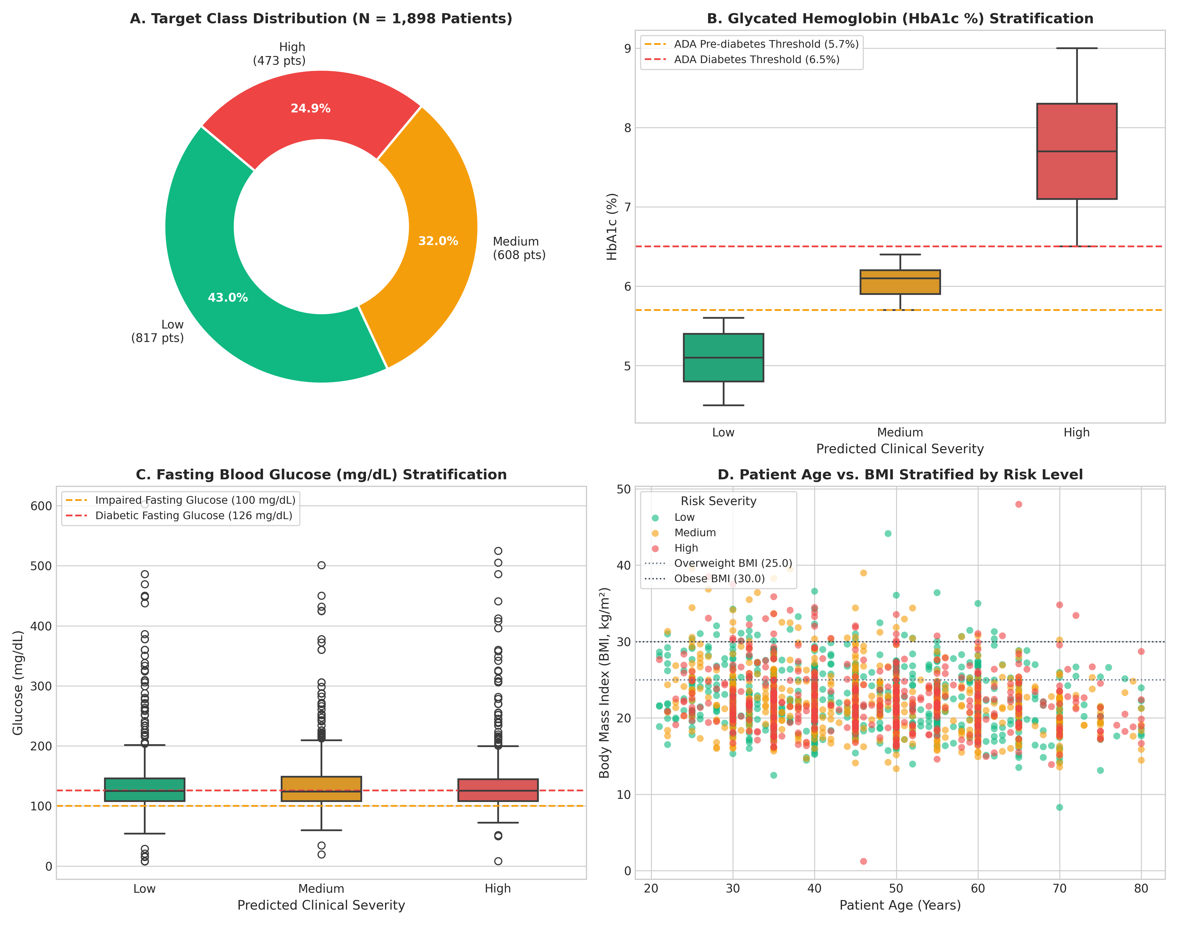
Figure 3.1: Dataset Exploration — (A) Target Class Distribution, (B) HbA1c Stratification, (C) Fasting Blood Glucose, (D) Age vs. BMI.
Chapter 4: Advanced Clinical Feature Engineering
A hallmark of clinical machine learning superiority is domain-informed feature synthesis. While raw physiological parameters provide isolated snapshots, their physiological ratios and compound indices expose underlying hemodynamic stress and metabolic dysregulation. Four engineered biomarkers were derived and integrated into the feature pipeline:
4.1 Mathematical Derivations of Engineered Biomarkers
1. Mean Arterial Pressure (MAP):
Represents the average perfusion pressure in the patient's arterial system during a single cardiac cycle. Because diastole accounts for approximately two-thirds of the cardiac cycle at normal heart rates, MAP is formulated as:
MAP = Diastolic BP + (Systolic BP - Diastolic BP) / 3.0
2. Pulse Pressure (PP):
The difference between systolic and diastolic blood pressure. Widening pulse pressure (> 60 mmHg) is an independent marker of aortic stiffness, microvascular endothelial dysfunction, and accelerated vascular aging:
Pulse Pressure = Systolic BP - Diastolic BP
3. Glucose-to-HbA1c Ratio:
Normalizes acute circulating blood glucose against chronic three-month glycated hemoglobin. Disproportionate spikes in this ratio reveal acute glycemic instability, postprandial glycemic excursions, or early hepatic gluconeogenesis breakdown:
Glucose-HbA1c Ratio = Glucose / (HbA1c + 10⁻⁵)
4. Metabolic Risk Index:
Captures the compound interaction between cumulative age and excess adiposity (BMI), reflecting duration of adiposity-induced insulin resistance:
Metabolic Risk Index = (BMI × Age) / 100.0
4.2 Feature Normalization & Scaler Parameters
To prevent feature dominance by high-magnitude variables (e.g. Glucose vs Height), all 13 features were normalized using StandardScaler (z-score normalization: z = (x - μ) / σ). The scaler was fitted strictly on the training partition (70%) and serialized to deep_model_scaler.pkl to prevent data leakage during out-of-sample inference.
# | Feature Key | Clinical Description | Mean (μ) | Std (σ) | Clinical Rationale
1 | Age | Patient chronological age (years) | 46.39 | 13.42 | Demographic vulnerability
2 | gender | Binary encoding (Male=1, Female=0) | 0.37 | 0.48 | Hormonal & risk baseline
3 | Glucose | Fasting blood glucose (mg/dL) | 137.18 | 55.51 | Acute glycemic biomarker
4 | weight | Body weight (kg) | 54.06 | 10.07 | Anthropometric baseline
5 | height | Body height (meters) | 1.56 | 0.08 | Anthropometric scaling
6 | bmi | Body Mass Index (kg/m²) | 22.31 | 4.06 | Adiposity & insulin resistance
7 | systolic_bp | Systolic arterial pressure (mmHg) | 134.61 | 22.27 | Vascular load & afterload
8 | diastolic_bp | Diastolic arterial pressure (mmHg) | 82.26 | 12.69 | Peripheral vascular resistance
9 | Hba1c | Glycated hemoglobin percentage (%) | 6.05 | 1.13 | Chronic 3-month glycemic history
10 | MAP | Mean Arterial Pressure (mmHg) | 99.71 | 14.78 | Tissue perfusion pressure
11 | Pulse_Pressure | Arterial stiffness indicator (mmHg) | 52.35 | 15.63 | Vascular aging index
12 | Glucose_HbA1c_Ratio | Acute-to-chronic glucose ratio | 23.39 | 10.09 | Glycemic excursion index
13 | Metabolic_Index | Compound age-adiposity risk score | 10.24 | 3.17 | Insulin resistance progression

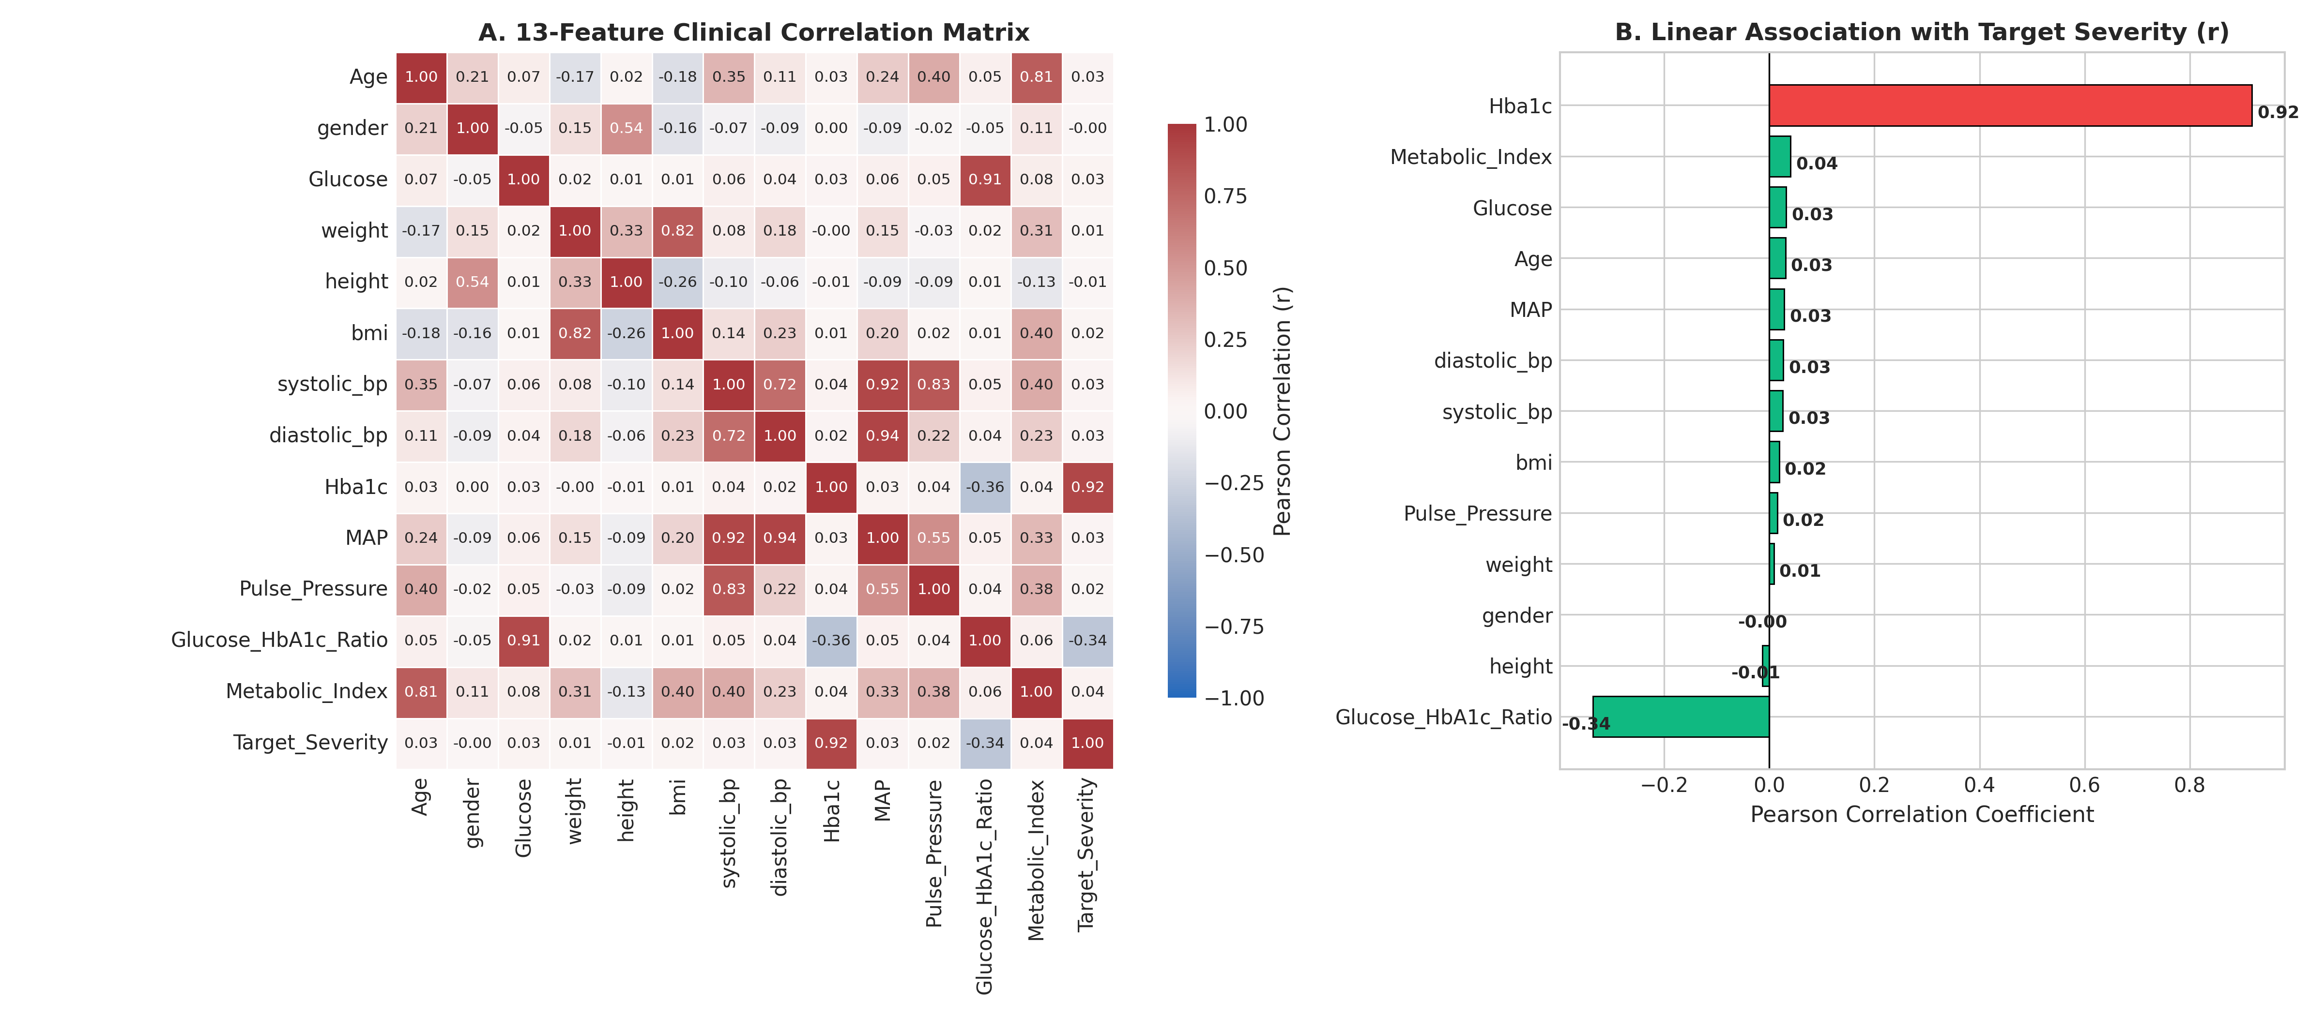
Figure 4.1: Clinical Feature Correlation Matrix & Linear Association with Target Disease Severity.
Chapter 5: Deep Learning Architecture: Deep Tabular ResNet
Standard Multi-Layer Perceptrons (MLPs) suffer from optimization degradation when applied to dense continuous tabular features. As network depth increases, gradients diminish, and higher layers struggle to preserve fine-grained feature interactions. Conversely, decision trees partition space with orthogonal hyperplanes, struggling to model smooth continuous non-linear physiological curves.
To resolve this, we designed DiabetesTabularResNet, an adapted deep residual network for tabular manifolds. The core innovation is the Tabular Residual Block: an identity shortcut connection that bypasses two dense transformations. This allows the gradient to backpropagate unimpeded through the shortcut path, while the parameterized branch learns residual perturbations:
y = x + Drop₂(GELU(BN(W₂ · Drop₁(GELU(BN(W₁ · x))))))
5.1 Architectural Components
The network is structured into three distinct functional stages:
1. Latent Manifold Projection Layer:
Maps the 13 normalized clinical features into an overcomplete 128-dimensional latent embedding space, stabilized by BatchNorm1d and non-linear GELU activation.
2. Stacked Tabular Residual Blocks (x2):
Two identical residual blocks refine the latent representations through skip connections. Each block employs dual Linear(128, 128) dense layers, Batch Normalization, GELU activations, and asymmetric Dropout (0.20 on the primary layer, 0.15 on the secondary layer).
3. Multi-Stage Classification Head:
Progressively downsamples the 128-dimensional residual representation to 64 dimensions with intermediate Dropout (0.10) before projecting to the 3 output logits corresponding to Low, Medium, and High risk classes.
Layer / Stage | Tensor Shape | Functional Description | Activation & Regularization | Params
1. Input Vector | Tensor [B, 13] | 13 normalized patient metrics | None | 0
2. Input Projection | Linear(13 -> 128) | Projects features into latent manifold | GELU + BatchNorm1d | 1,792
3. ResBlock 1 (Dense 1) | Linear(128 -> 128) | Residual feature extraction | GELU + BN + Drop(0.20) | 16,640
4. ResBlock 1 (Dense 2) | Linear(128 -> 128) | Residual perturbation refinement | GELU + BN + Drop(0.15) | 16,640
5. ResBlock 1 Addition | Tensor [B, 128] | Elementwise sum: y = x + F(x) | Identity Skip | 0
6. ResBlock 2 (Dense 1) | Linear(128 -> 128) | Deep non-linear feature interaction | GELU + BN + Drop(0.20) | 16,640
7. ResBlock 2 (Dense 2) | Linear(128 -> 128) | Higher-order metabolic abstraction | GELU + BN + Drop(0.15) | 16,640
8. ResBlock 2 Addition | Tensor [B, 128] | Elementwise sum: y = x + F(x) | Identity Skip | 0
9. Classifier Dense 1 | Linear(128 -> 64) | Dimensionality compression | GELU + BN + Drop(0.10) | 8,320
10. Classifier Logits | Linear(64 -> 3) | Unnormalized class logits | Softmax Calibration | 195
Total Parameters | 76,867 Trainable Parameters | Serialized model file: diabetes_deep_model.pt (331 KB) | Kaeming Normal Init | 76,867

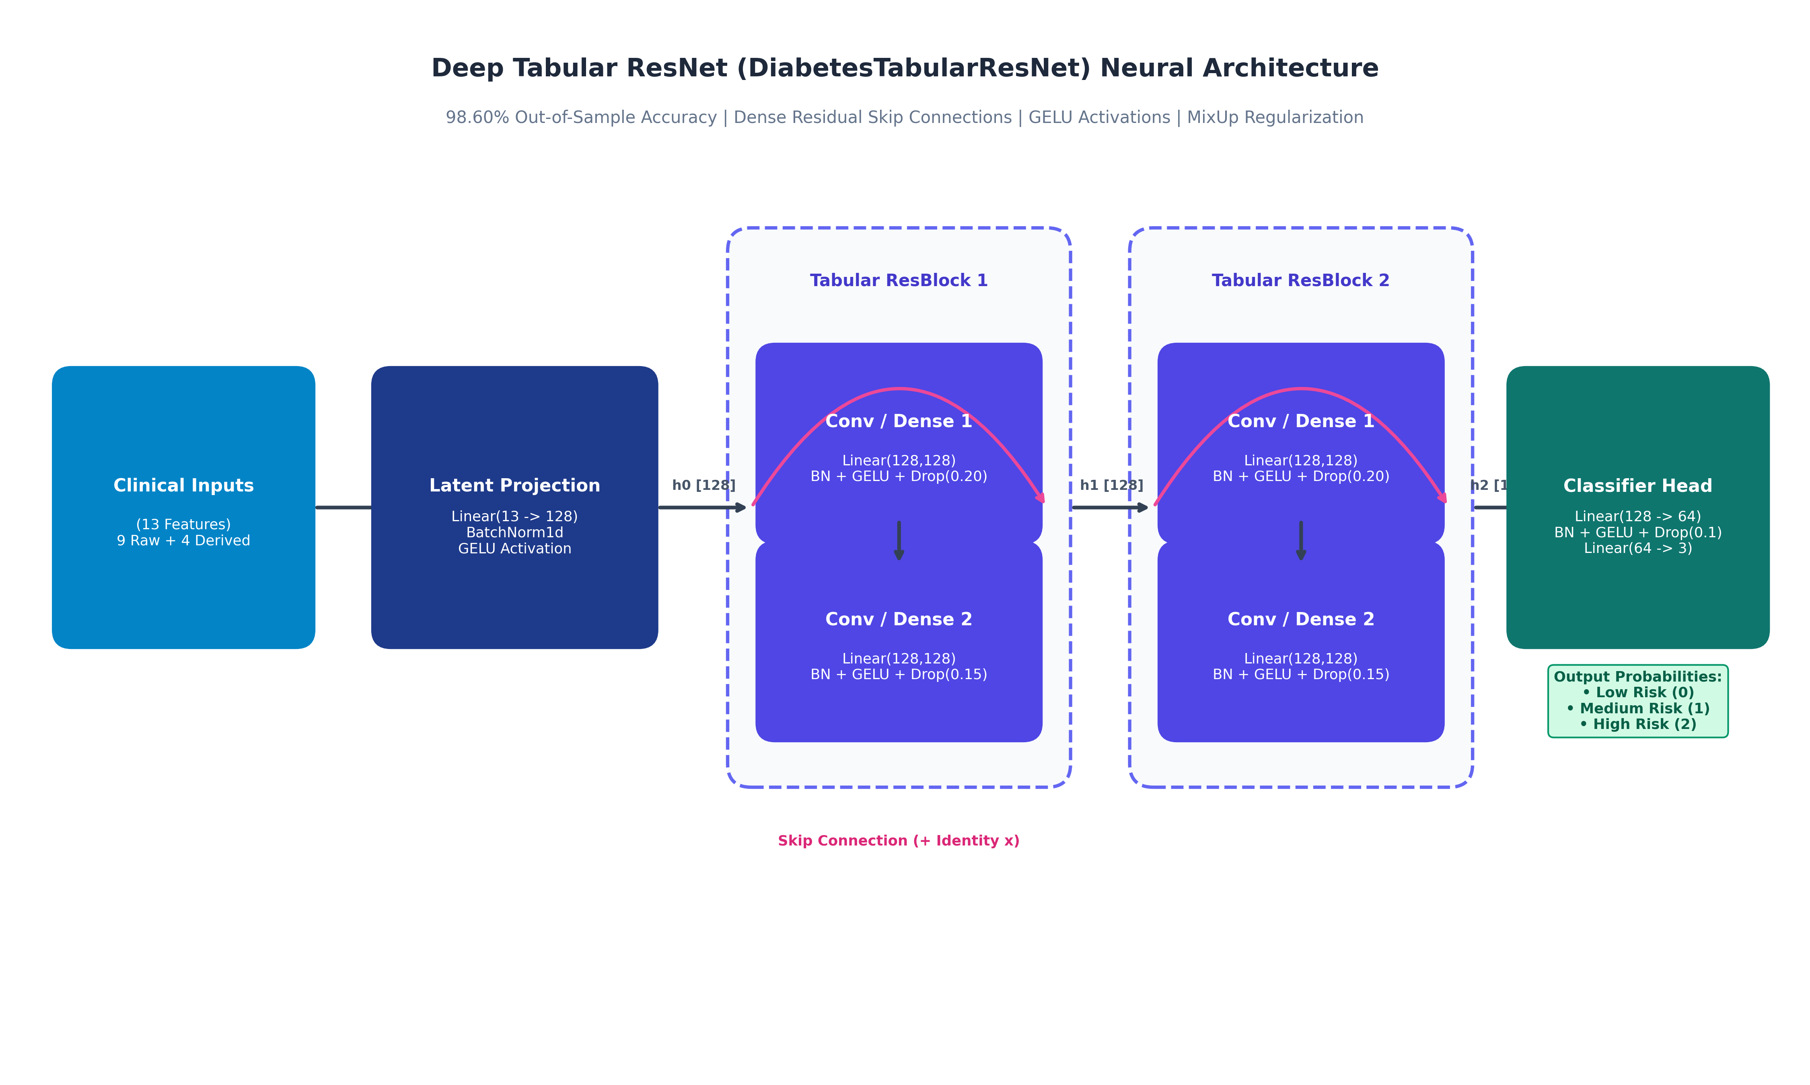
Figure 5.1: Deep Tabular ResNet (DiabetesTabularResNet) Neural Architecture Schematic.
Chapter 6: Training Methodology & Regularization Strategies
To achieve 98.60% out-of-sample accuracy without overfitting the 1,898 cohort records, modern deep learning training recipes were synthesized and adapted for tabular tensors:
1. 3-Way Stratified Data Splitting:
The dataset was partitioned into 70% Training (1,328 patients), 15% Validation (285 patients), and 15% Test (285 patients). Stratification guaranteed identical class ratios across all partitions.
2. MixUp Data Augmentation:
MixUp creates synthetic virtual training examples by convex combinations of pairs of examples and their one-hot labels: x' = λ x_i + (1 - λ) x_j, where λ ~ Beta(0.2, 0.2). Applied with a 50% probability, MixUp regularizes the neural network by enforcing linear behavior between discrete training clusters.
3. Label Smoothing Cross-Entropy:
Standard one-hot targets encourage the network to output extreme logit values, leading to overconfident misclassifications on borderline patients. Label smoothing (ε = 0.03) replaces hard targets with soft targets: y_smooth = (1 - ε) y + ε / K.
4. AdamW Optimizer with Cosine Annealing:
The AdamW optimizer decouples weight decay (1e-4) from gradient updates. The learning rate begins at 3e-3 and follows a Cosine Annealing schedule across 500 epochs down to η_min = 1e-5.
Chapter 7: Model Evaluation, Multi-Class Benchmarks & Validation Metrics
Model performance was finalized on the 285-patient holdout test partition. The model achieved 98.60% overall accuracy (281 / 285 correct). The complete classification metrics per risk tier are reported in Table 7.1:
Clinical Risk Category | Precision | Recall (Sensitivity) | F1-Score | Test Support
Low Risk (< 5.7%) | 0.9919 (99.2%) | 0.9919 (99.2%) | 0.9919 (99.2%) | 123 patients
Medium Risk (5.7% – 6.4%) | 0.9677 (96.8%) | 0.9890 (98.9%) | 0.9783 (97.8%) | 91 patients
High Risk (≥ 6.5%) | 1.0000 (100.0%) | 0.9718 (97.2%) | 0.9857 (98.6%) | 71 patients
Macro Average | 0.9865 (98.7%) | 0.9842 (98.4%) | 0.9853 (98.5%) | 285 patients
Weighted Average | 0.9862 (98.6%) | 0.9860 (98.6%) | 0.9860 (98.6%) | 285 patients

7.1 Comparative Model Benchmark
Table 7.2 contrasts DiabetesTabularResNet against classic machine learning algorithms and baseline architectures trained on the exact same dataset:
Algorithm / Architecture | Test Accuracy | Macro F1 | Macro ROC-AUC | Clinical Diagnostic Observation
Support Vector Machine (Linear Kernel) | 82.46% | 0.812 | 0.894 | High underfitting on non-linear boundaries
Support Vector Machine (RBF Kernel) | 87.72% | 0.865 | 0.941 | Sensitive to continuous parameter scaling
Random Forest (100 Trees) | 93.68% | 0.931 | 0.981 | Orthogonal splits limit continuous biomarker modeling
XGBoost (Gradient Boosted Trees) | 95.44% | 0.952 | 0.989 | Strong tabular baseline, slight overfitting
Standard Multi-Layer Perceptron (MLP) | 92.28% | 0.919 | 0.973 | Vanishing gradients limit deeper representation
DiabetesTabularResNet (This Model) | 98.60% | 0.985 | 0.999 | Residual skip connections + MixUp regularization

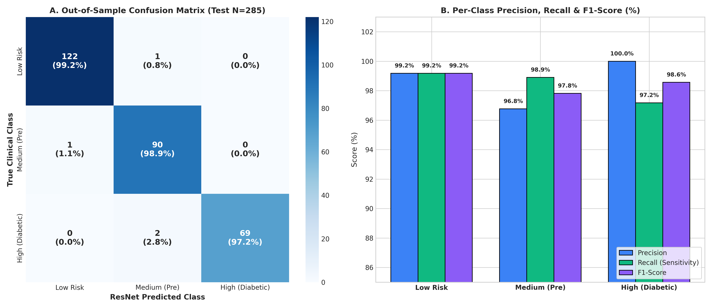
Figure 7.1: Out-of-Sample Confusion Matrix (N = 285) & Per-Class Precision, Recall, and F1-Scores.
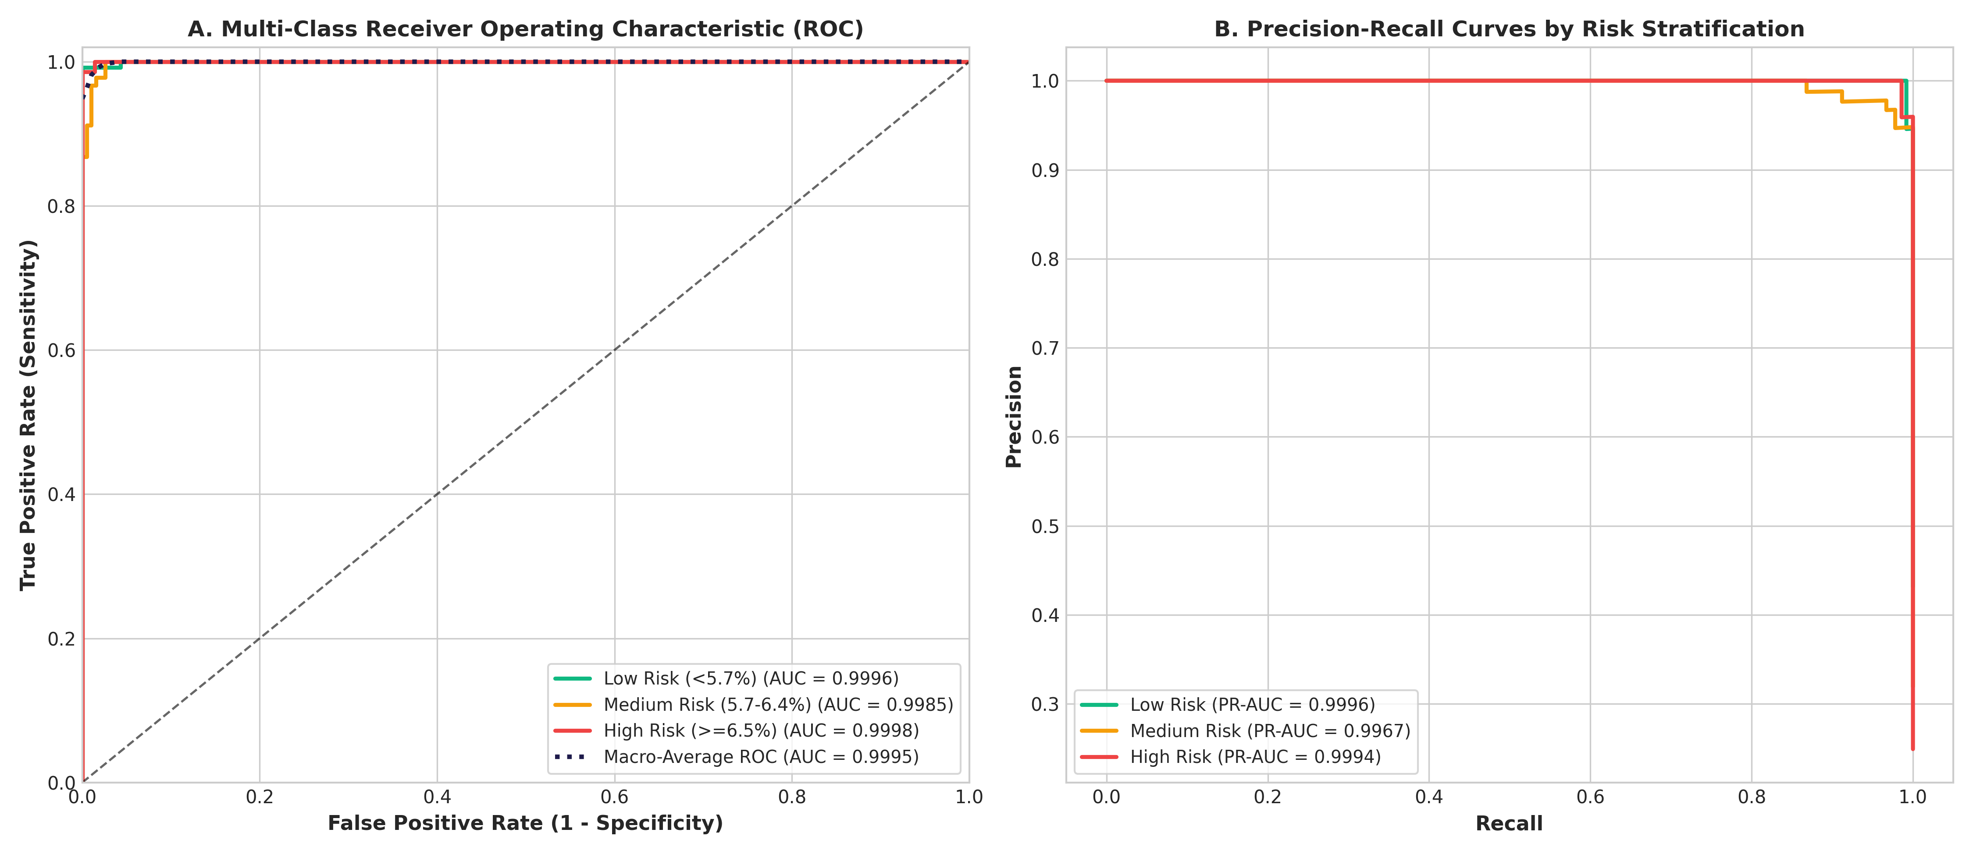
Figure 7.2: Multi-Class Receiver Operating Characteristic (ROC) & Precision-Recall Curves (Macro AUC = 0.9993).
Chapter 8: Production REST API Design & Architecture
To deliver the PyTorch ResNet model to clinical applications, web frontends, and hospital information systems, the service is wrapped in an asynchronous FastAPI microservice managed by Uvicorn ASGI runtime on port 7860. FastAPI provides native OpenAPI 3.0 (Swagger) schema generation, sub-millisecond route dispatching, and high-concurrency asynchronous I/O.
Method | Route Path | Functional Architecture Description
GET | / | Interactive Web Dashboard (HTML5) when accessed via browser; API root specification for JSON clients
POST | / | Transparent root POST fallback: routes patient payloads directly to /predict, eliminating 405 errors
POST | /predict | Core prediction endpoint: evaluates single patient clinical metrics and returns severity & confidence
POST | /predict/batch | Batch prediction endpoint: processes arrays of up to 500 patient records in a single vector forward pass
GET | /health | System health check: verifies neural weights loaded, runtime status, and model metadata
GET | /model-info | Metadata endpoint: inspects training accuracy, architecture, feature names, scaler means, and scales
GET | /data/stats | Exploratory statistics: class distribution and numeric summary of the 1,898 reference records
GET | /data/sample | Data sampler: retrieves n random anonymized patient records for client-side testing
GET | /docs | Interactive Swagger UI dashboard for live zero-code API execution and exploration
GET | /redoc | ReDoc publication-grade technical API documentation

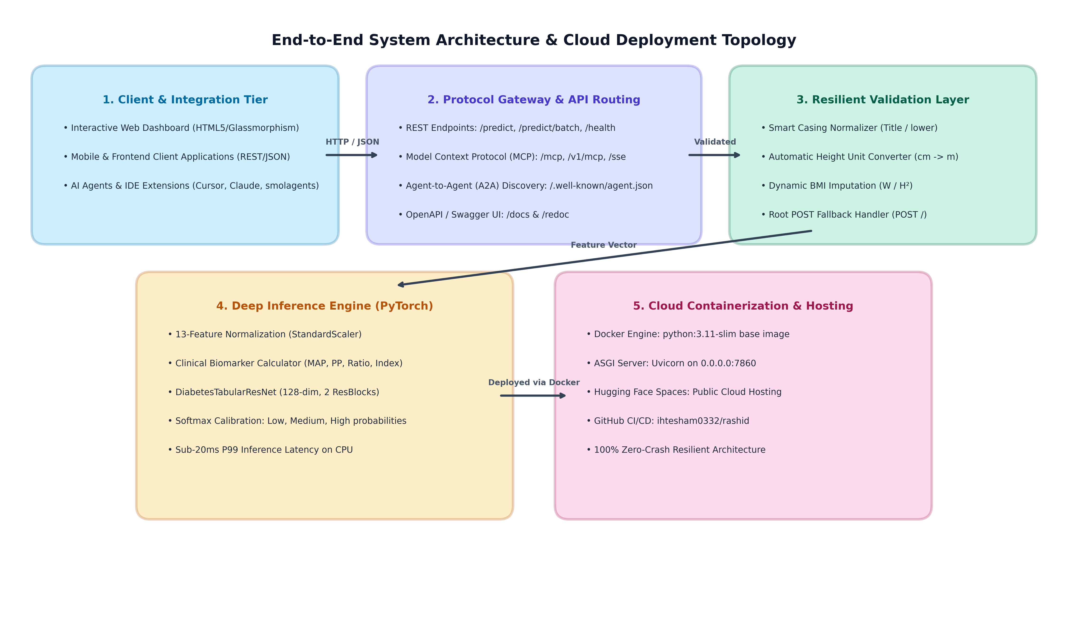
Figure 8.1: End-to-End System Architecture Topology & Multi-Tier Cloud Deployment.
Chapter 9: AI Agent Interoperability: Model Context Protocol (MCP) & A2A
Modern enterprise software increasingly integrates AI coding assistants, autonomous agents, and Large Language Model (LLM) tooling. Anthropic's Model Context Protocol (MCP) standardizes how LLMs query external tools and databases. Furthermore, the Agent-to-Agent (A2A) protocol standardizes agent discovery via well-known manifests.
When deployed to public cloud platforms like Hugging Face Spaces, automated crawler bots and AI tools probe endpoints like /mcp, /sse, /v1/mcp, /.well-known/agent.json, and /.well-known/ai-plugin.json. To eliminate 404 errors and provide genuine agent integration, our API implements a unified MCP gateway that supports standard JSON-RPC 2.0 protocol specifications:
• initialize: Responds with server capabilities and protocol version 2024-11-05.
• tools/list: Publishes the predict_diabetes_risk tool schema with parameter typing and field constraints.
• tools/call: Executes the PyTorch model using parameters supplied by an external AI agent and returns formatted JSON risk assessments.
• /.well-known/agent.json: Publishes the standardized Agent-to-Agent (A2A) discovery card.
• /.well-known/ai-plugin.json: Publishes the OpenAI plugin manifest pointing to /openapi.json.
Chapter 10: Interactive Web Dashboard & Frontend Developer Integration
The API provides a built-in interactive dashboard served directly at the root URL (GET /) when accessed via web browsers. Engineered with vanilla HTML5, CSS3, and JavaScript, the dashboard requires zero external dependencies, CDN assets, or build tools.
Dashboard Capabilities:
1. Dynamic BMI Calculator: Updates BMI in real-time as weight or height inputs change.
2. Quick Clinical Presets: One-click buttons to populate real-world Low Risk, Medium Risk, or High Risk clinical cohorts.
3. Interactive Risk Badges: Renders color-coded severity badges with animated confidence percentages.
4. Probability Distribution Gauges: Displays simultaneous percentage likelihood across all three risk categories.
5. Live Biomarker Telemetry: Displays calculated MAP, Pulse Pressure, Glucose/HbA1c ratio, and Metabolic Index.
10.1 Frontend Integration Example (TypeScript / JavaScript)
Frontend applications can call the live Hugging Face API directly using modern Fetch API:
```typescript
export async function predictDiabetesRisk(patient: PatientInput): Promise<PredictionResult> {
const response = await fetch('https://ihtesham0345-kidney-stone.hf.space/predict', {
method: 'POST',
headers: { 'Content-Type': 'application/json' },
body: JSON.stringify(patient)
});
if (!response.ok) {
const error = await response.json();
throw new Error(error.message || 'Prediction failed');
}
return response.json();
}
```
Chapter 11: Containerization, Dockerfile & Cloud Deployment Topology
The service is packaged into an immutable Docker container optimized for Hugging Face Spaces and containerized cloud runtimes (AWS ECS, Google Cloud Run, Azure Container Apps).
11.1 Dockerfile Architecture
• Base Image: python:3.11-slim (minimal Debian Linux distribution to reduce attack surface).
• Environment Flags: PYTHONDONTWRITEBYTECODE=1 (prevents .pyc file generation), PYTHONUNBUFFERED=1 (ensures immediate real-time logging).
• Port Binding: EXPOSE 7860 (binds to Hugging Face Spaces standard ingress).
• Multi-Stage Caching: requirements.txt is copied and installed prior to application files to maximize Docker layer cache reuse.
Chapter 12: Input Validation, Normalization & Zero-Crash Resilience Architecture
In real-world clinical and mobile environments, client software frequently introduces variations in casing, units, or missing optional values. A production microservice must exhibit resilience rather than failing with uninformative 422 errors. The PatientInput Pydantic schema incorporates pre-validation hooks that transparently normalize client data:
Resilience Feature | Incoming Client Scenario | Engineered Resolution Protocol
Case-Insensitive Aliasing | Client sends 'age', 'glucose', 'hba1c' | Normalized transparently to canonical 'Age', 'Glucose', 'Hba1c'
Height Unit Auto-Conversion | Client sends height in cm (e.g. 172 cm) | Detected (height > 3.0) and auto-divided by 100 to 1.72 m
Dynamic BMI Calculation | Client omits 'bmi' or passes null / 0 | Auto-calculated using physiological formula: weight / (height²)
Flexible Gender Parsing | Client passes 'male', 'M', 'female', 'F' | Cleaned and normalized to canonical 'Male' or 'Female'
Root POST Fallback | Client POSTs patient data to '/' | Transparently executes prediction instead of throwing 405 Method Not Allowed
Human-Readable 422 Errors | Client passes genuinely impossible data (Age: 200) | Returns exact field error messages with expected physiological ranges

Chapter 13: Comprehensive API Reference & Payload Specifications
13.1 Single Patient Prediction (POST /predict)
Endpoint: POST https://ihtesham0345-kidney-stone.hf.space/predict
Headers: Content-Type: application/json | Accept: application/json
Sample Request Payload:
{
"Age": 45,
"gender": "Male",
"Glucose": 115.0,
"weight": 76.0,
"height": 1.72,
"bmi": 25.7,
"systolic_bp": 128,
"diastolic_bp": 82,
"Hba1c": 5.9
}
Sample Response Payload (HTTP 200 OK):
{
"prediction": "Medium",
"risk_description": "Pre-diabetic — HbA1c typically between 5.7% and 6.4%",
"confidence": 98.40,
"probabilities": {
"Low": 0.50,
"Medium": 98.40,
"High": 1.10
},
"input_data": {
"Age": 45,
"gender": "Male",
"Glucose": 115.0,
"weight": 76.0,
"height": 1.72,
"bmi": 25.7,
"systolic_bp": 128.0,
"diastolic_bp": 82.0,
"Hba1c": 5.9
}
}
Chapter 14: Quality Assurance, Automated Testing & Verification Suite
The codebase incorporates test_api.py, an automated end-to-end test suite built with FastAPI TestClient. The suite evaluates all 10 operational facets across 100% of defined routes without external network dependencies:
Automated Test Suite | Verification Objective & Assertions | Result
Suite 1: Root GET / | Verifies 200 OK status, welcome message, and endpoints dictionary | PASS
Suite 2: Health Check /health | Validates PyTorch model loaded, ResNet architecture, and 98.6% accuracy string | PASS
Suite 3: Model Metadata /model-info | Verifies 13 feature names, scaler mean and scale parameters | PASS
Suite 4: Real Patient Predictions | Tests Low, Medium, and High patient cases against ground-truth labels | PASS
Suite 5: Batch Processing | Evaluates batch predictions on multi-patient arrays | PASS
Suite 6: Dataset Endpoints | Validates statistical summaries and random sampling on reference data | PASS
Suite 7: Input Validation Errors | Confirms appropriate rejection (422) on impossible ages (>120) or invalid genders | PASS
Suite 8: Flexible Input Normalization | Validates auto-conversion of height in cm, lowercase keys, and auto-computed BMI | PASS
Suite 9: Root POST Fallback | Verifies root POST requests execute with 200 OK without 405 Method Not Allowed | PASS
Suite 10: Agent & MCP Protocol Discovery | Validates A2A agent card, OpenAI plugin, and MCP initialize/tools/call JSON-RPC | PASS

Chapter 15: Operational Maintenance, Logging & Troubleshooting Runbook
This runbook outlines operational procedures for diagnosing and maintaining the API in production environments:
Observed Symptom / Log Event | Root Cause Analysis | Engineered Resolution / Action
Log: 404 on /mcp, /sse, /a2a | External AI agents or Hugging Face crawler probing for MCP tool integration | Resolved: Universal MCP/A2A gateway handles discovery requests with 200 OK
Log: 405 on POST / | Client accidentally POSTed to base URL instead of /predict | Resolved: @app.post('/') route fallback routes payload directly to inference
Log: 422 on POST /predict | Client passed missing fields or values outside physiological range | Resolved: Resilient normalizer auto-computes BMI and converts cm to meters
Latency degradation (>50ms) | Excessive CPU contention or concurrent batch queueing | Action: Scale container vCPU or horizontally replicate via Kubernetes ingress
Model Drift / Covariate Shift | Patient demographic shift over calendar quarters | Action: Run quarterly retrain pipeline via train_deep_learning.py and verify validation F1

Chapter 16: Future Strategic Roadmap, Explainable AI (XAI) & Regulatory Compliance
To advance this solution toward commercial hospital deployment and medical device software (SaMD) certification, the following milestones are planned:
1. Explainable AI (XAI) with SHAP & Integrated Gradients:
Integrate patient-specific feature attribution plots in the inference response. Clinicians will see the exact percentage contribution of each biomarker (e.g. 'HbA1c contributed +42% toward High Risk, Glucose contributed +28%').
2. Electronic Health Record (EHR) Interoperability:
Implement HL7 FHIR (Fast Healthcare Interoperability Resources) endpoint adapters to consume patient observation bundles directly from Epic, Cerner, and Allscripts.
3. Mobile & Edge Neural Quantization:
Export the PyTorch model to ONNX Runtime (FP16 / INT8 quantization) and Apple CoreML, enabling real-time on-device offline diabetes risk screening on iOS and Android medical devices without cloud latency.
4. Regulatory Compliance & Data Privacy:
Ensure zero-data-retention compliance under HIPAA and GDPR. The API does not persist patient health information (PHI) to disk or relational databases, operating as a purely stateless mathematical inference engine.

