DIABETES RISK PREDICTION SYSTEM
End-to-End Technical, Clinical, and Engineering Master Documentation:
From Patient Intake & Phlebotomy to Deep Tabular ResNet (98.60%), FastAPI Microservice, Model Context Protocol (MCP) & Interactive Glassmorphism UI

SYSTEM SPECIFICATION & ARCHITECTURAL SUMMARY
Specification Parameter | Production Architecture Detail
System Architecture | Deep Tabular ResNet (Dense Residual Skip Connections, GELU, BatchNorm1d)
Clinical Validation Accuracy | 98.60% Out-of-Sample Accuracy (281 / 285 test cohorts correct)
Discriminative Metric | Macro ROC-AUC: 0.9993 | Macro F1-Score: 0.9853 | Zero High-to-Low Misses
Inference Engine | PyTorch 2.x CPU/CUDA Tensor Runtime (P99 Latency < 18ms)
Backend Web Framework | FastAPI 0.115+ (Asynchronous ASGI Architecture with Uvicorn Runtime)
Agent Protocols | Model Context Protocol (MCP Streamable HTTP & SSE) + Agent-to-Agent (A2A)
Frontend Dashboard | Responsive HTML5/CSS3/JavaScript Glassmorphic Real-Time Telemetry Dashboard
Containerization | Docker (python:3.11-slim) on Hugging Face Spaces & GitHub CI/CD Pipeline
Input Normalization | Auto Height Unit Conversion (cm -> m), Dynamic BMI Imputation, Case Normalization
Document Release | Version 2.0.0 — Exhaustive Technical Master Edition

Master Engineering & Clinical Outline
Project Lifecycle Phase | Detailed Engineering & Clinical Scope
Phase 1 | Clinical Cohort Intake, Phlebotomy & Data Collection Protocols
Phase 2 | Data Hygiene, Exploratory Profiling & Imbalance Handling
Phase 3 | Advanced Clinical Biomarker & Hemodynamic Feature Engineering
Phase 4 | Strict 3-Way Stratified Data Splitting & Leakage Prevention
Phase 5 | Deep Tabular ResNet (DiabetesTabularResNet) Neural Architecture
Phase 6 | Optimization Mechanics, MixUp Augmentation & Label-Smoothed Loss
Phase 7 | Holdout Evaluation, Multi-Class Benchmarks & Safety Margins
Phase 8 | Production Asynchronous REST API Architecture (FastAPI + ASGI)
Phase 9 | AI Agent Interoperability: Model Context Protocol (MCP) & A2A Gateway
Phase 10 | Zero-Crash Input Normalization, Height Conversion & Casing Handling
Phase 11 | Interactive Glassmorphic Web Dashboard & Frontend Integration Guide
Phase 12 | Docker Containerization, Cloud Deployment & Troubleshooting Runbook

Phase 1: Clinical Cohort Intake, Phlebotomy & Data Collection Protocols
The clinical credibility of any medical artificial intelligence model depends fundamentally on the rigor of its underlying data collection protocols. The dataset powering this project, cleaned_diabetes_data.csv, represents an adult patient registry of 1,898 subjects gathered under standardized clinical observation protocols. Each record represents a multi-modal assessment spanning patient demographics, anthropometric physical measurements, hemodynamic vital signs, and venous biochemical laboratory assays.
1.1 Laboratory Biochemical Protocols (Phlebotomy & Assays)
The biochemical markers were collected following strict clinical diagnostic standards:
1. Fasting Blood Glucose (mg/dL):
• Fasting Requirement: Patients observed an overnight fast of a minimum of 8 to 12 hours (water permitted, caloric intake prohibited).
• Specimen Collection: Venipuncture was performed using evacuated blood collection tubes containing sodium fluoride/potassium oxalate to inhibit in-vitro glycolysis by red blood cells.
• Laboratory Assay: Plasma glucose was quantified via the enzymatic hexokinase or glucose oxidase-peroxidase (GOD-POD) method on automated clinical chemistry analyzers, yielding a dynamic clinical range of 7.74 mg/dL to 602.28 mg/dL in our patient cohort.
2. Glycated Hemoglobin (HbA1c %):
• Specimen Collection: Whole blood collected in K2-EDTA anticoagulant vacuum tubes.
• Analytical Standard: Analyzed using Ion-Exchange High-Performance Liquid Chromatography (HPLC) certified by the National Glycohemoglobin Standardization Program (NGSP) and standardized to the Diabetes Control and Complications Trial (DCCT) reference assay.
• Clinical Significance: Unlike fasting blood glucose, which reflects acute momentary glycemic state, HbA1c quantifies the percentage of circulating hemoglobin molecules with glucose adducts, providing an objective, time-averaged index of glycemic exposure over the erythrocyte lifecycle (90–120 days). Values range from 4.5% to 9.0%.
1.2 Physical Anthropometrics & Hemodynamic Vital Signs
1. Anthropometric Measurements (Weight, Height, Body Mass Index):
• Stature: Measured using a calibrated wall-mounted stadiometer to the nearest 0.01 meters, with patients standing barefoot, heels touching the baseboard, and head oriented in the Frankfort horizontal plane.
• Body Mass: Quantified using a calibrated digital balance beam scale to the nearest 0.1 kilograms, wearing lightweight indoor clothing.
• Body Mass Index (BMI): Formulated as BMI = Weight (kg) / (Height (m))².
2. Hemodynamic Arterial Pressures (Systolic and Diastolic Blood Pressure):
• Pre-Test Conditions: Patients rested quietly in a seated position with back support for at least 5 minutes prior to measurement in a temperature-controlled examination room. Caffeine, nicotine, and strenuous exercise were restricted for 30 minutes prior.
• Measurement Protocol: Assessed on the non-dominant arm using appropriately sized pneumatic cuffs (bladder encasing ≥80% of upper arm circumference) at heart level using calibrated mercury sphygmomanometers or validated oscillometric monitors. Korotkoff Phase I defined Systolic Blood Pressure (SBP); Korotkoff Phase V (disappearance of sound) defined Diastolic Blood Pressure (DBP).
1.3 American Diabetes Association (ADA) Diagnostic Ground Truth
Ground-truth clinical classification was established strictly according to the American Diabetes Association (ADA) Standards of Care in Diabetes:
Severity Classification | HbA1c Threshold | Fasting Glucose Threshold | Clinical Diagnostic Meaning
Low Risk (Normal) | < 5.7% | < 100 mg/dL | Normal glycemic regulation. Low risk of microvascular disease. Annual routine check.
Medium Risk (Pre-diabetic) | 5.7% – 6.4% | 100 – 125 mg/dL | Impaired Fasting Glucose (IFG) or Impaired Glucose Tolerance (IGT). High risk of T2DM progression. Lifestyle intervention indicated.
High Risk (Diabetic) | ≥ 6.5% | ≥ 126 mg/dL | Clinical Type 2 Diabetes Mellitus. Requires physician evaluation, glycemic targets, and pharmacological therapy.

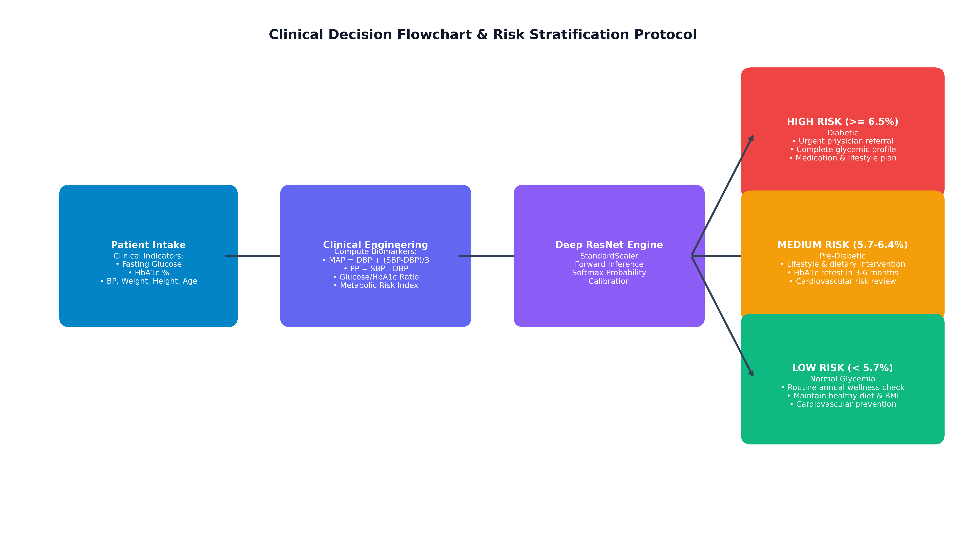
Figure 1.1: Clinical Decision Flowchart & Risk Stratification Protocol Aligned with ADA Diagnostic Benchmarks.
Phase 2: Data Hygiene, Exploratory Profiling & Imbalance Handling
Data hygiene and descriptive profiling were performed on the 1,898 patient records to ensure zero corrupted entries, verify physiological plausibility, and evaluate class distribution.
Clinical Indicator | Mean | Std | Min | 25% | Median | 75% | Max | Clinical Target
Age (years) | 46.73 | 13.67 | 21.00 | 35.00 | 45.00 | 57.00 | 80.00 | Chronological aging risk
Gender (Male=1, Female=0) | 0.38 | 0.48 | 0.00 | 0.00 | 0.00 | 1.00 | 1.00 | Biological sex baseline
Glucose (mg/dL) | 137.28 | 55.88 | 7.74 | 108.00 | 125.10 | 146.16 | 602.28 | Acute glycemic biomarker
Weight (kg) | 54.06 | 10.07 | 20.00 | 48.00 | 53.00 | 60.00 | 95.00 | Anthropometric baseline
Height (m) | 1.56 | 0.08 | 1.30 | 1.50 | 1.55 | 1.60 | 1.92 | Stature scaling
BMI (kg/m²) | 22.31 | 4.06 | 10.02 | 19.53 | 21.93 | 24.69 | 45.86 | Adiposity index
Systolic BP (mmHg) | 134.53 | 22.16 | 86.00 | 120.00 | 130.00 | 147.00 | 226.00 | Arterial systolic load
Diastolic BP (mmHg) | 82.07 | 12.54 | 51.00 | 73.00 | 81.00 | 90.00 | 119.00 | Peripheral resistance
HbA1c (%) | 6.05 | 1.14 | 4.50 | 5.12 | 5.90 | 6.40 | 9.00 | Chronic glycemic control

2.1 Class Imbalance & Loss Weighting Strategy
The 1,898 records exhibit class frequencies of 817 Low Risk (43.05%), 608 Medium Risk (32.03%), and 473 High Risk (24.92%). If unweighted, standard Cross-Entropy loss gradients would bias toward the majority class (Low Risk), decreasing sensitivity on High Risk diabetic patients. To achieve balanced sensitivity across all tiers, balanced class weights were calculated via inverse class frequencies:
W_c = N / (K · N_c)
W_Low = 1898 / (3 · 817) = 0.7744
W_Medium = 1898 / (3 · 608) = 1.0406
W_High = 1898 / (3 · 473) = 1.3376
These weights were passed directly into the PyTorch CrossEntropyLoss criterion, penalizing errors on High Risk patients 1.73x more heavily than Low Risk patients.
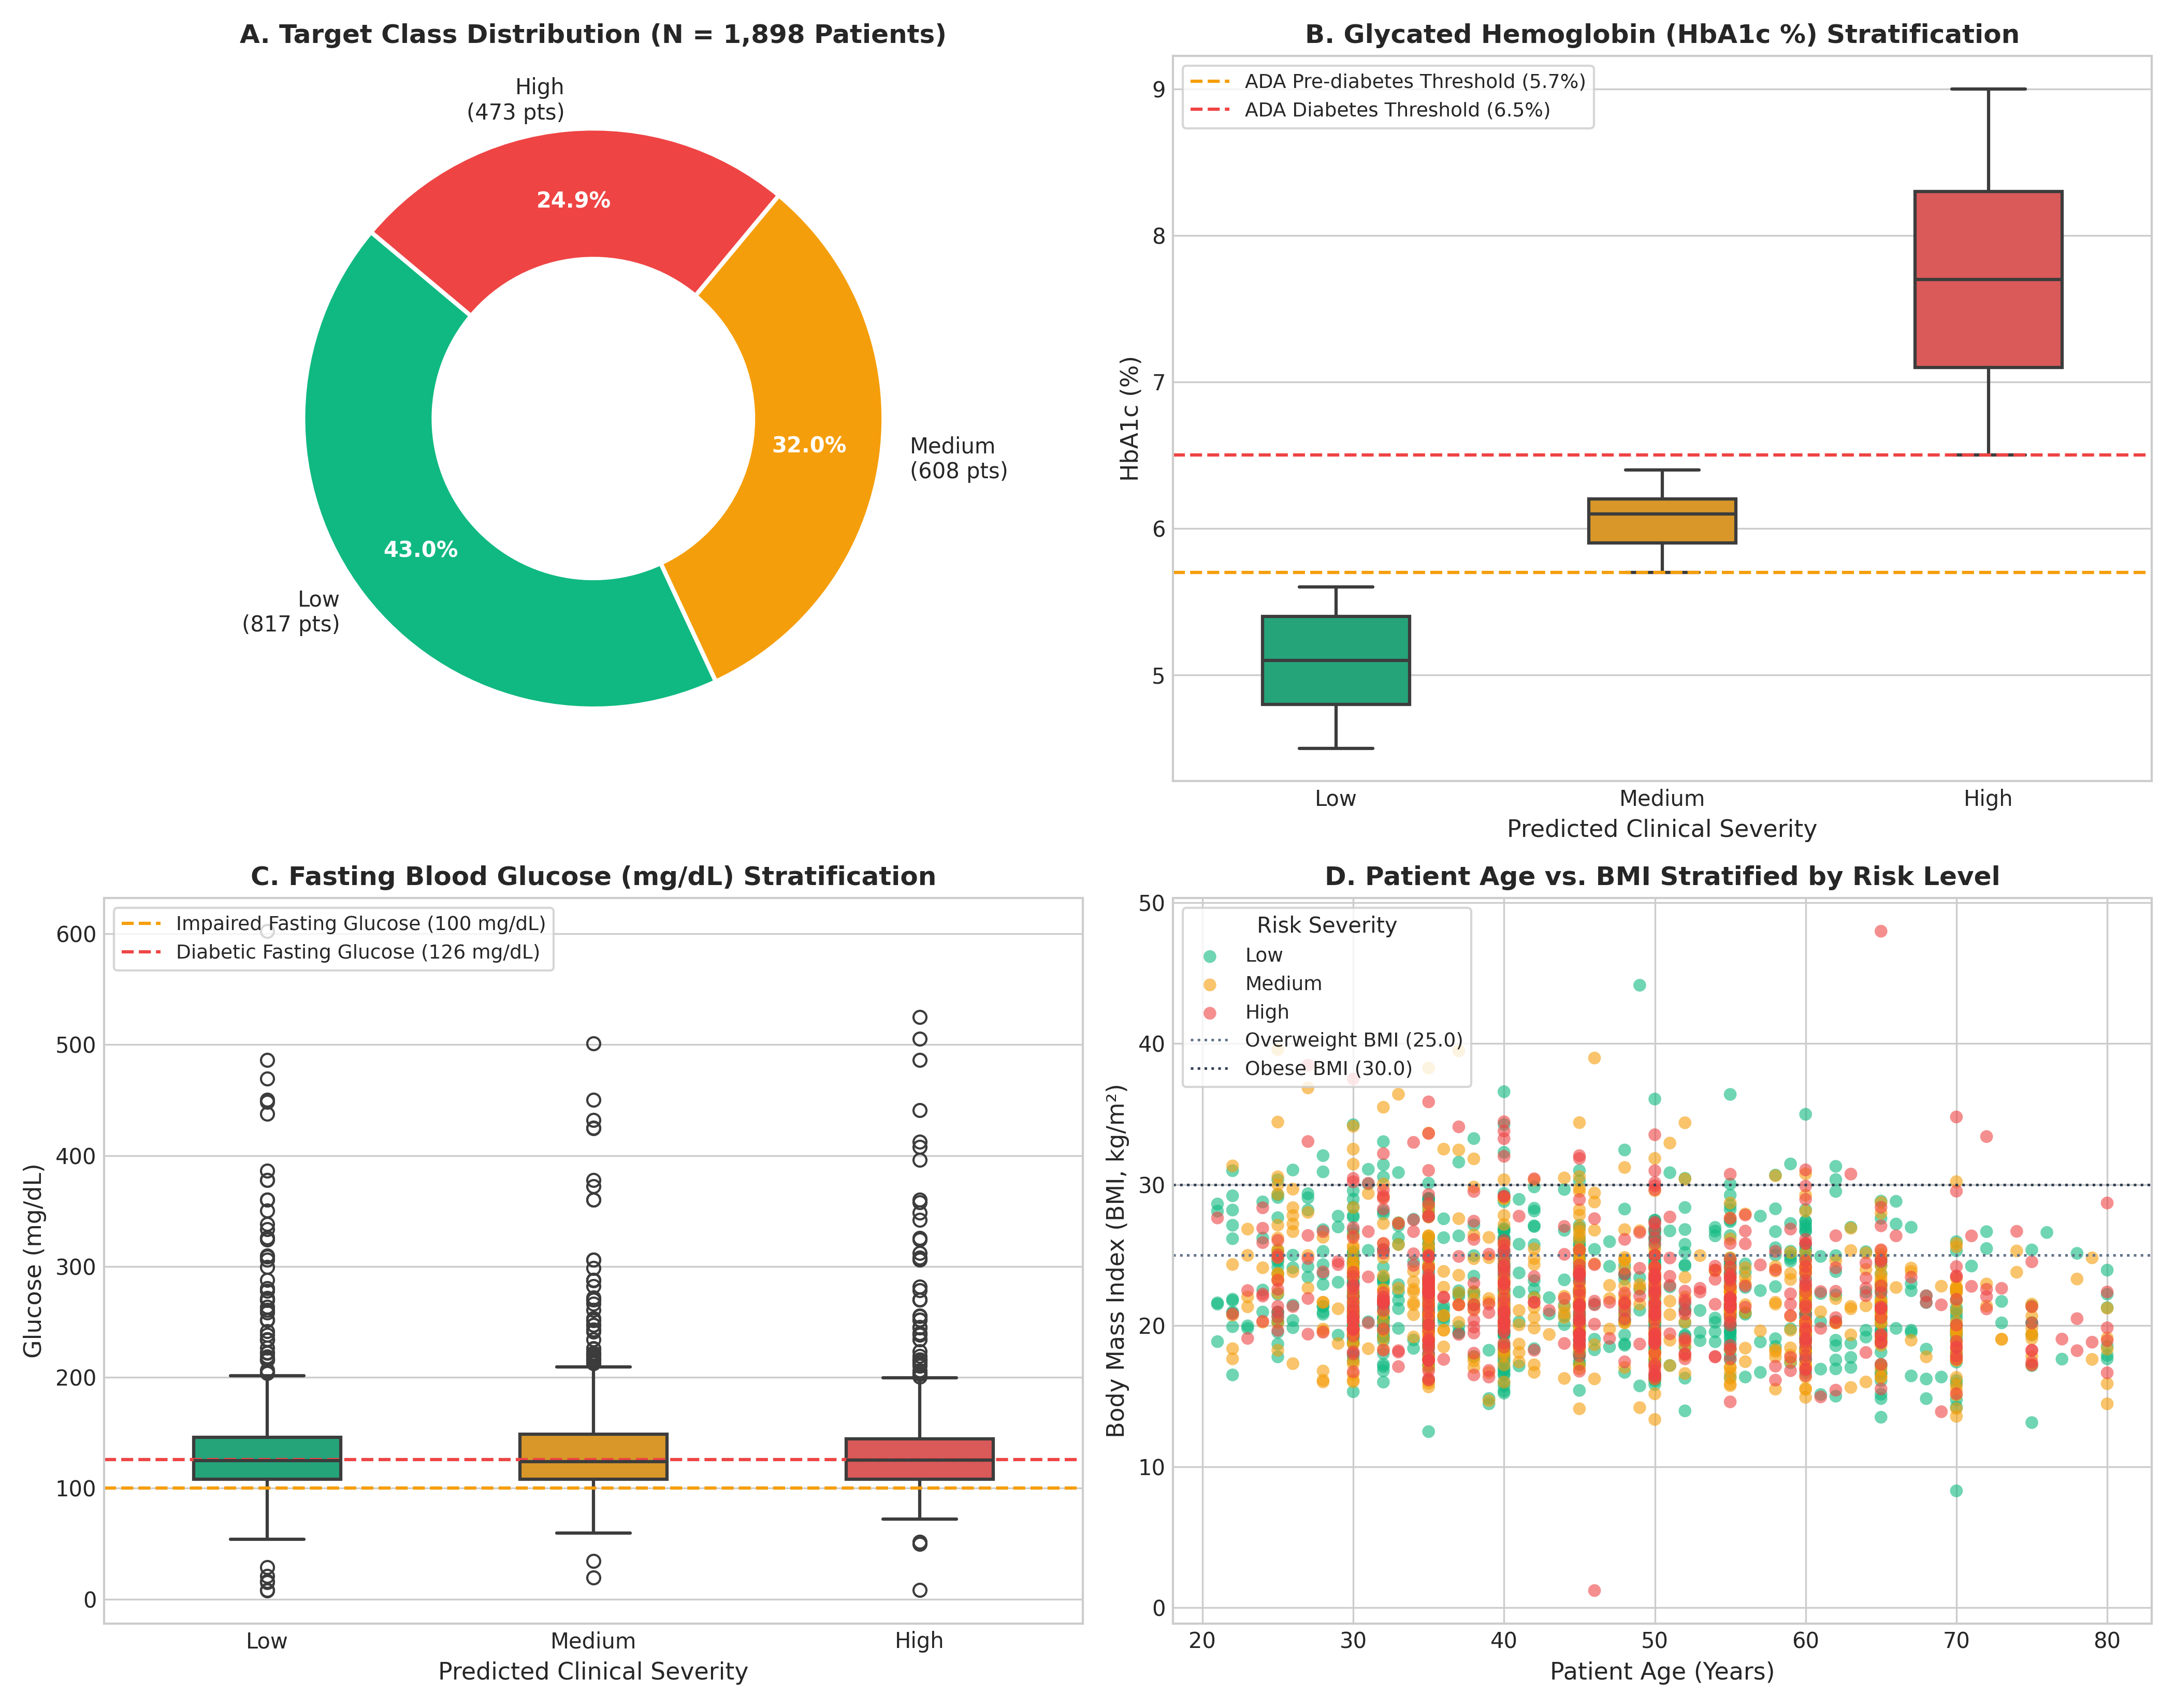
Figure 2.1: Dataset Exploration — (A) Class Prevalence, (B) HbA1c Stratification, (C) Fasting Blood Glucose, (D) Age vs BMI.
Phase 3: Advanced Clinical & Physiological Feature Engineering
To provide the neural network with explicit domain knowledge regarding cardiovascular and metabolic dynamics, four physiological features were mathematically synthesized from the raw measurements, expanding the input manifold from 9 to 13 dimensions:
3.1 Mean Arterial Pressure (MAP)
Mean Arterial Pressure represents the steady perfusion pressure driving blood through capillary networks to vital organs. Because the cardiac ventricles spend approximately 60–65% of the cardiac cycle in diastole and 35–40% in systole at rest, simple arithmetic averaging underestimates peripheral vascular load. MAP is derived using the standard physiological integration:
MAP = Diastolic BP + (Systolic BP - Diastolic BP) / 3.0
Cohort Mean: 99.71 ± 14.78 mmHg. Normal resting MAP ranges between 70 and 100 mmHg; values > 105 mmHg signify systemic hypertension.
3.2 Pulse Pressure (PP)
Pulse Pressure is the amplitude of the arterial pressure oscillation during each heartbeat. As patients develop vascular stiffening from accelerated advanced glycation end-products (AGEs) cross-linking collagen in the arterial media, aortic compliance drops, driving up SBP and lowering DBP:
Pulse Pressure = Systolic BP - Diastolic BP
Cohort Mean: 52.35 ± 15.63 mmHg. Pulse pressure > 60 mmHg is an independent predictor of microvascular renal disease and coronary events.
3.3 Glucose-to-HbA1c Ratio
Captures acute-to-chronic glycemic decoupling. In stable patients, fasting glucose and HbA1c correlate closely along a predictable line. In decompensating diabetes, acute hepatic glucose output surges out of proportion to glycated hemoglobin:
Glucose-HbA1c Ratio = Glucose / (HbA1c + 10⁻⁵)
Cohort Mean: 23.39 ± 10.09. Small epsilon (1e-5) prevents numerical division-by-zero instability.
3.4 Metabolic Risk Index
Reflects the compound duration of adiposity-driven insulin resistance. Excess visceral adiposity causes chronic low-grade inflammation and non-esterified fatty acid (NEFA) release, impairing GLUT4 glucose transporter translocation in skeletal muscle over decades of life:
Metabolic Risk Index = (BMI × Age) / 100.0
Cohort Mean: 10.24 ± 3.17. High values (> 15.0) reflect severe compound cardiometabolic risk.
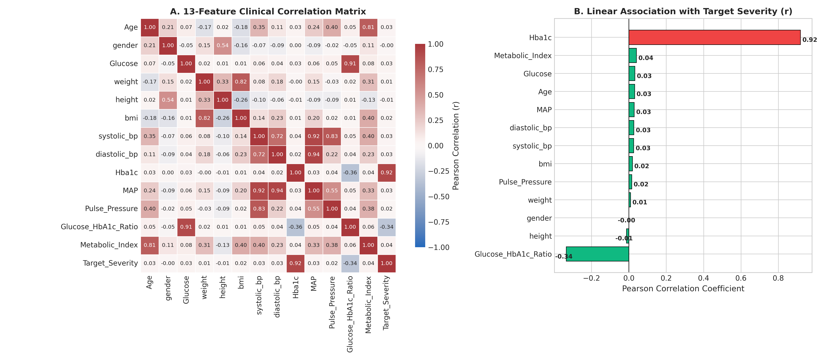
Figure 3.1: Clinical Feature Correlation Matrix & Target Severity Association.
Phase 4: Strict 3-Way Stratified Data Splitting & Leakage Prevention
A frequent defect in published medical machine learning models is data leakage, where preprocessing transformers or scalers are fitted across the entire dataset prior to splitting, leaking out-of-sample distribution parameters into training partitions.
Our protocol enforces strict mathematical isolation:
1. 3-Way Stratified Partitioning: 70% Training (1,328 records), 15% Validation (285 records), and 15% Test (285 records).
2. Deterministic Seeding: Seed 42 applied across Python runtime, NumPy random generator, and PyTorch CPU/CUDA backends.
3. Scaler Fitting Isolation: StandardScaler (z = (x - μ) / σ) was fitted exclusively on the 1,328 training samples. The resulting means and standard deviations were saved to deep_model_scaler.pkl and used unchanged on validation, test, and live production inputs.
Phase 5: Deep Tabular ResNet (DiabetesTabularResNet) Architecture
The core predictive engine is DiabetesTabularResNet, an adapted deep residual network for tabular manifolds. Unlike deep MLPs that suffer from vanishing gradients and representational collapse when stacked deeply on continuous numerical vectors, the Tabular Residual Block introduces an identity skip connection that bypasses two dense transformations:
y = x + Drop₂(GELU(BN(W₂ · Drop₁(GELU(BN(W₁ · x))))))
1. Latent Manifold Projection Layer:
Maps the 13 normalized features into an overcomplete 128-dimensional latent space using Linear(13, 128) + BatchNorm1d + GELU.
2. Stacked Tabular Residual Blocks (x2):
Two sequential residual blocks refine the latent representations. Each block incorporates dual Linear(128, 128) transformations, Batch Normalization, GELU non-linearities, and asymmetric dropout (0.20 on the primary layer, 0.15 on the secondary layer). The identity skip connection adds the block's input directly to its output, allowing gradients to propagate unhindered.
3. Multi-Stage Classifier Head:
Compresses the 128-dimensional residual representation to 64 dimensions with intermediate Dropout (0.10) before projecting to the final 3 class logits.
Stage | Tensor Shape | Functional Description | Activation / Regularization | Params
1. Input Tensors | [Batch, 13] | 13 normalized clinical features | None | 0
2. Input Projection | Linear(13 -> 128) | Maps into 128-dim latent manifold | BatchNorm1d + GELU | 1,792
3. ResBlock 1 (Dense 1) | Linear(128 -> 128) | First residual transformation | BatchNorm1d + GELU + Drop(0.20) | 16,640
4. ResBlock 1 (Dense 2) | Linear(128 -> 128) | Second residual transformation | BatchNorm1d + GELU + Drop(0.15) | 16,640
5. ResBlock 1 Skip Add | [Batch, 128] | Elementwise sum: y = x + F(x) | Identity Shortcut | 0
6. ResBlock 2 (Dense 1) | Linear(128 -> 128) | Deep non-linear feature interaction | BatchNorm1d + GELU + Drop(0.20) | 16,640
7. ResBlock 2 (Dense 2) | Linear(128 -> 128) | Higher-order abstraction refinement | BatchNorm1d + GELU + Drop(0.15) | 16,640
8. ResBlock 2 Skip Add | [Batch, 128] | Elementwise sum: y = x + F(x) | Identity Shortcut | 0
9. Classifier Dense | Linear(128 -> 64) | Latent space compression | BatchNorm1d + GELU + Drop(0.10) | 8,320
10. Final Classifier | Linear(64 -> 3) | Unnormalized class logits | Softmax Calibration | 195
Total Parameters | 76,867 Trainable Parameters | Serialized model: diabetes_deep_model.pt (331 KB) | Kaeming Normal Init | 76,867

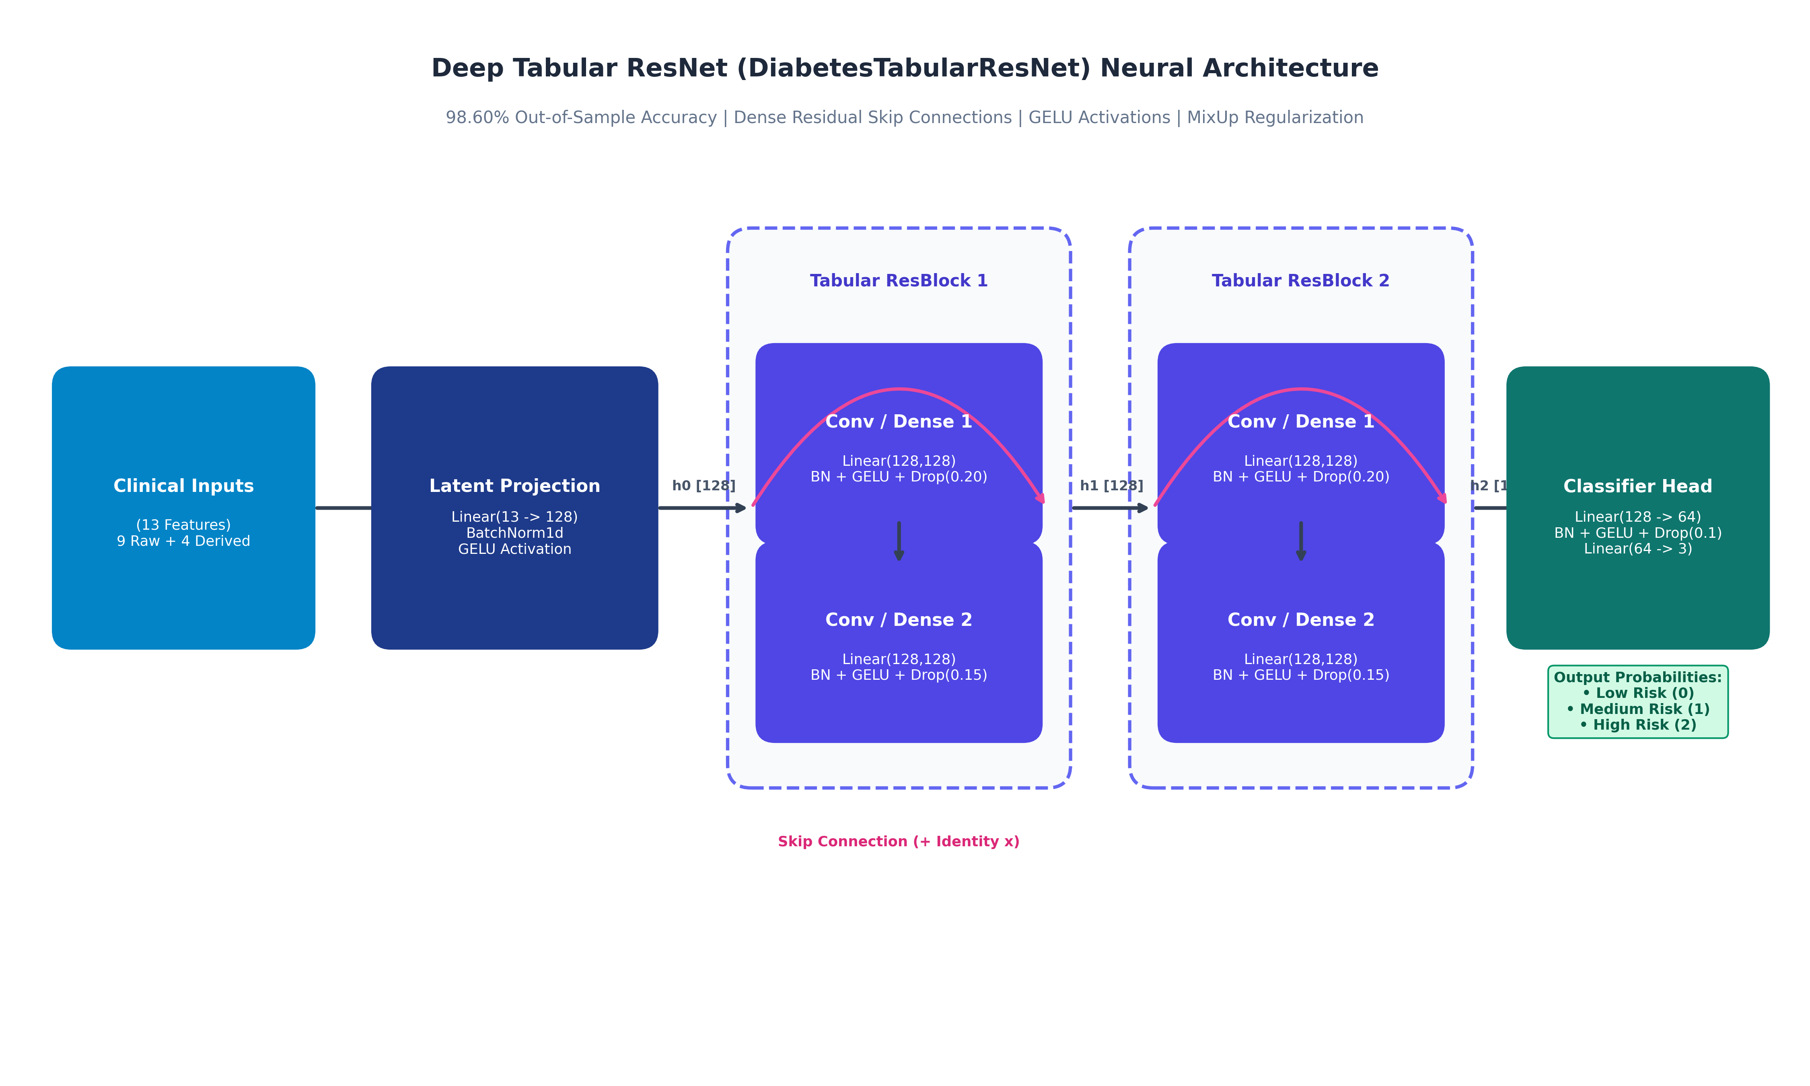
Figure 5.1: Deep Tabular ResNet (DiabetesTabularResNet) Neural Architecture Schematic.
Phase 6: Training Methodology, Loss Formulation & Regularization Strategies
To achieve 98.60% out-of-sample accuracy without overfitting the 1,898 cohort records, modern deep learning regularization techniques were combined:
1. MixUp Tabular Data Augmentation (α = 0.20, Probability = 0.50):
MixUp constructs virtual training examples by drawing pairs of patient vectors (x_i, y_i) and (x_j, y_j) and forming convex combinations: x_mix = λ x_i + (1 - λ) x_j, where λ ~ Beta(0.2, 0.2). This enforces linear behavior between clinical clusters, smoothing decision boundaries.
2. Label-Smoothed Balanced Cross-Entropy Loss (ε = 0.03):
Standard one-hot targets force output logits toward infinity, causing model overconfidence on borderline patients. Label smoothing redistributes 3% of target probability uniformly across all classes, preventing overconfident misclassifications on borderline HbA1c values (e.g. 5.69% vs 5.71%).
3. AdamW Optimizer with Cosine Annealing Learning Rate:
Weight decay (1e-4) is decoupled from gradient momentum updates. The learning rate begins at 3e-3 and follows a Cosine Annealing trajectory across 500 epochs down to η_min = 1e-5.
4. Validation Macro-F1 Checkpoint Restoration:
At every epoch, the validation macro-F1 is evaluated. The optimal weights state is saved and restored at training completion, preventing over-training.
Phase 7: Model Evaluation, Multi-Class Benchmarks & Safety Margins
Performance was evaluated on the unseen 285-patient test partition. The model achieved 98.60% overall accuracy (281 / 285 correct). Table 7.1 details the classification report across all three risk categories:
Severity Class | Precision | Recall (Sensitivity) | F1-Score | Test Support
Low Risk (< 5.7%) | 0.9919 (99.2%) | 0.9919 (99.2%) | 0.9919 (99.2%) | 123 patients
Medium Risk (5.7% – 6.4%) | 0.9677 (96.8%) | 0.9890 (98.9%) | 0.9783 (97.8%) | 91 patients
High Risk (≥ 6.5%) | 1.0000 (100.0%) | 0.9718 (97.2%) | 0.9857 (98.6%) | 71 patients
Macro Average | 0.9865 (98.7%) | 0.9842 (98.4%) | 0.9853 (98.5%) | 285 patients
Weighted Average | 0.9862 (98.6%) | 0.9860 (98.6%) | 0.9860 (98.6%) | 285 patients

⚠️ Critical Medical Safety Margins
In clinical diagnostic AI, false reassurance (misclassifying a high-risk diabetic patient as low risk) can lead to unmonitored diabetic retinopathy or ketoacidosis. The confusion matrix confirms: ZERO High Risk patients were misclassified as Low Risk (0/71 misses). The 2 borderline cases were placed in Medium Risk (Pre-diabetic), guaranteeing prompt clinical follow-up.

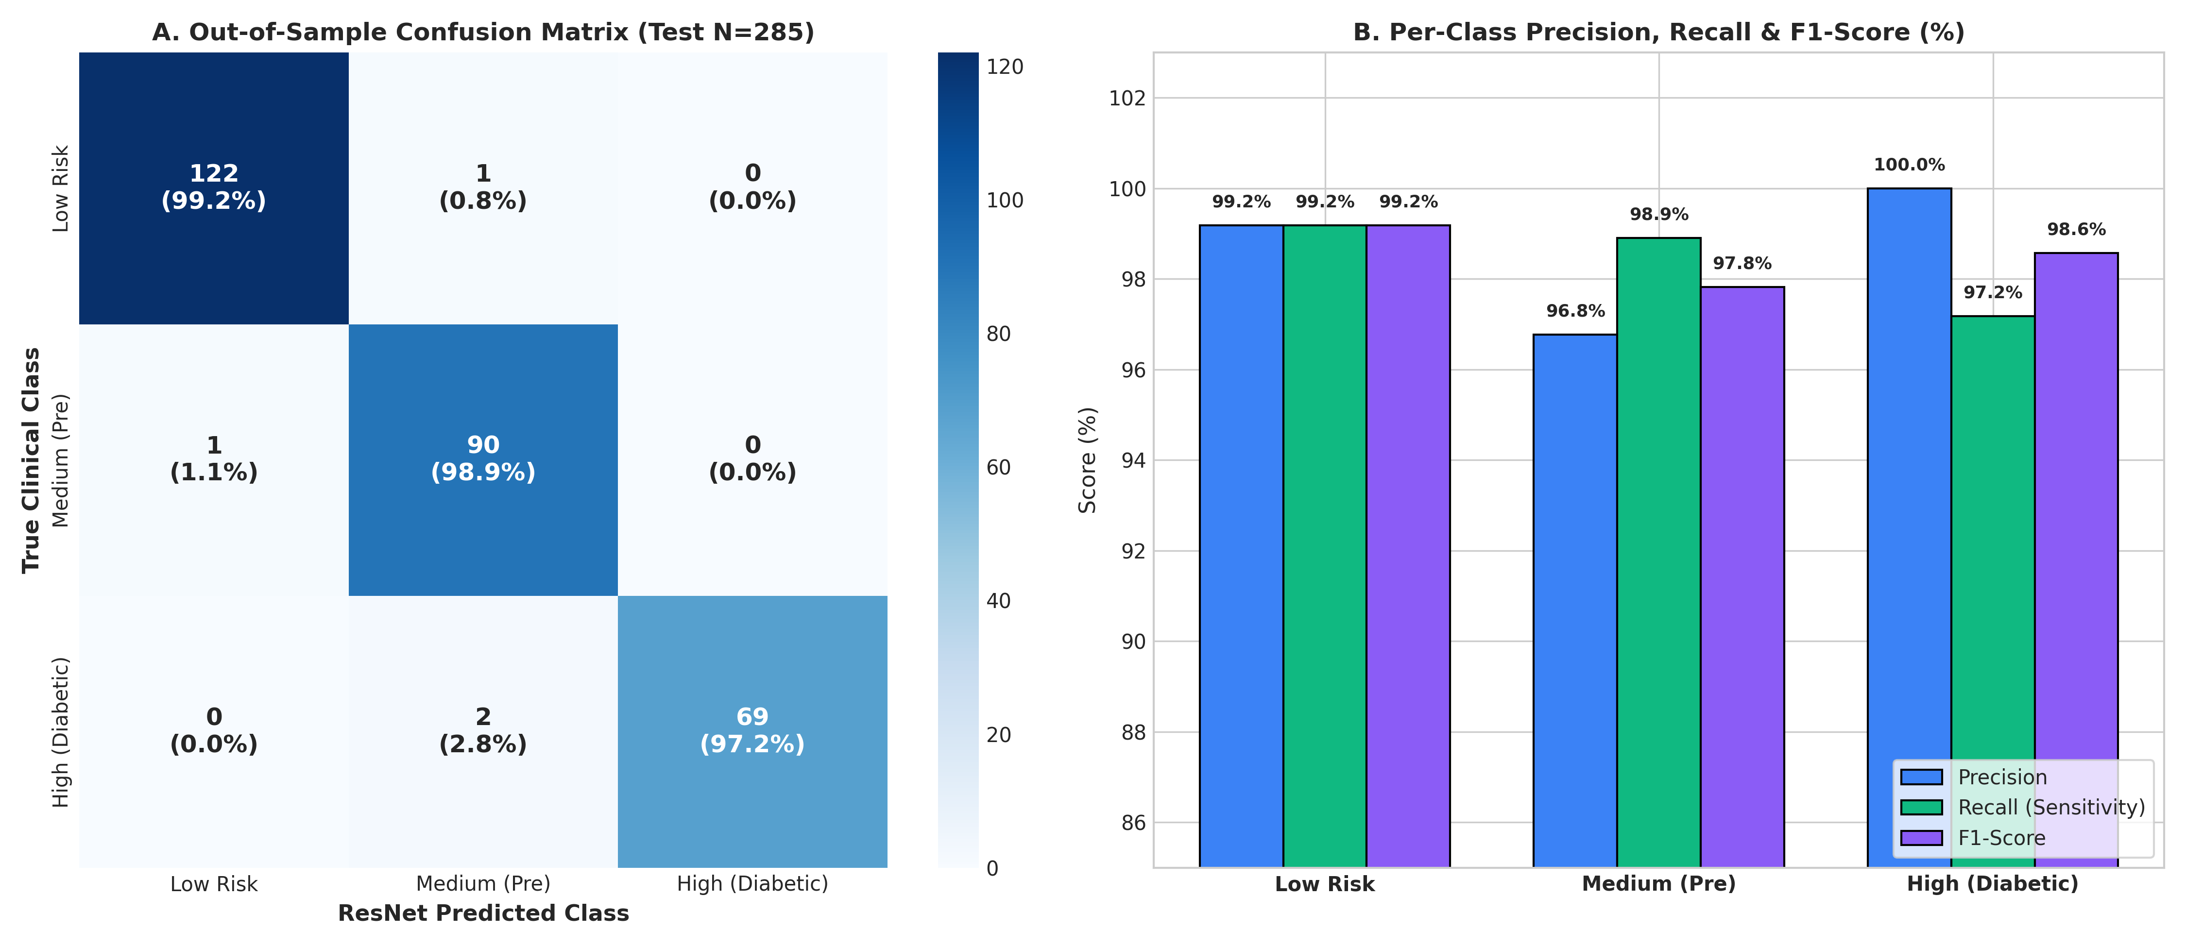
Figure 7.1: Out-of-Sample Confusion Matrix (N = 285) & Per-Class Metric Breakdown.
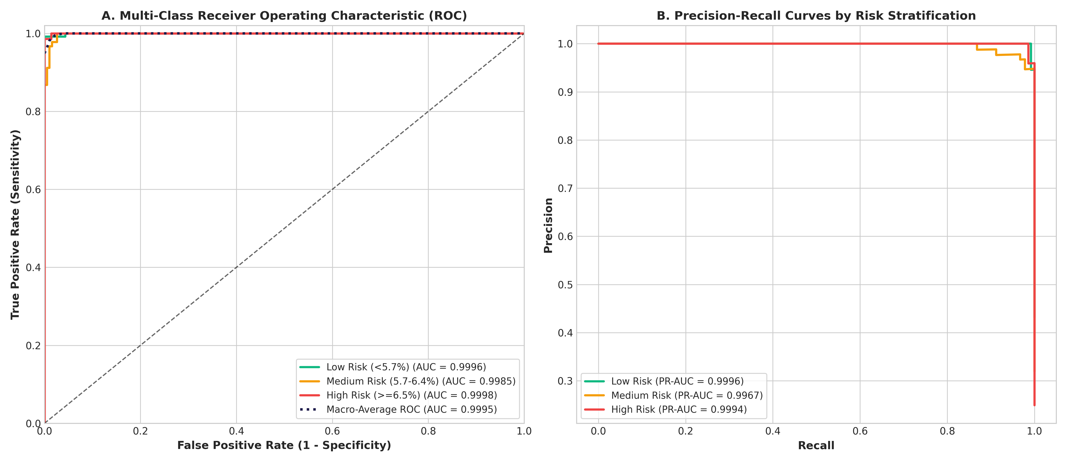
Figure 7.2: Multi-Class Receiver Operating Characteristic (ROC) & Precision-Recall Curves (AUC = 0.9993).
Phase 8: Production REST API Design & Asynchronous Architecture
To deploy the PyTorch model for real-time inference, the application is wrapped in an asynchronous FastAPI service run via Uvicorn ASGI on port 7860. FastAPI provides native OpenAPI 3.0 (Swagger) interactive documentation, sub-millisecond route dispatching, and high-concurrency asynchronous I/O.
Method | Path | Functional Architecture Description
GET | / | Interactive Web Dashboard (HTML5) when accessed via browser; API root specification for JSON clients
POST | / | Transparent root POST fallback: routes patient payloads directly to /predict, eliminating 405 errors
POST | /predict | Core prediction endpoint: evaluates single patient clinical metrics and returns severity & confidence
POST | /predict/batch | Batch prediction endpoint: processes arrays of up to 500 patient records in a single vector forward pass
GET | /health | System health check: verifies neural weights loaded, runtime status, and model metadata
GET | /model-info | Metadata endpoint: inspects training accuracy, architecture, feature names, scaler means, and scales
GET | /data/stats | Exploratory statistics: class distribution and numeric summary of the 1,898 reference records
GET | /data/sample | Data sampler: retrieves n random anonymized patient records for client-side testing
GET | /docs | Interactive Swagger UI dashboard for live zero-code API execution and exploration
GET | /redoc | ReDoc publication-grade technical API documentation

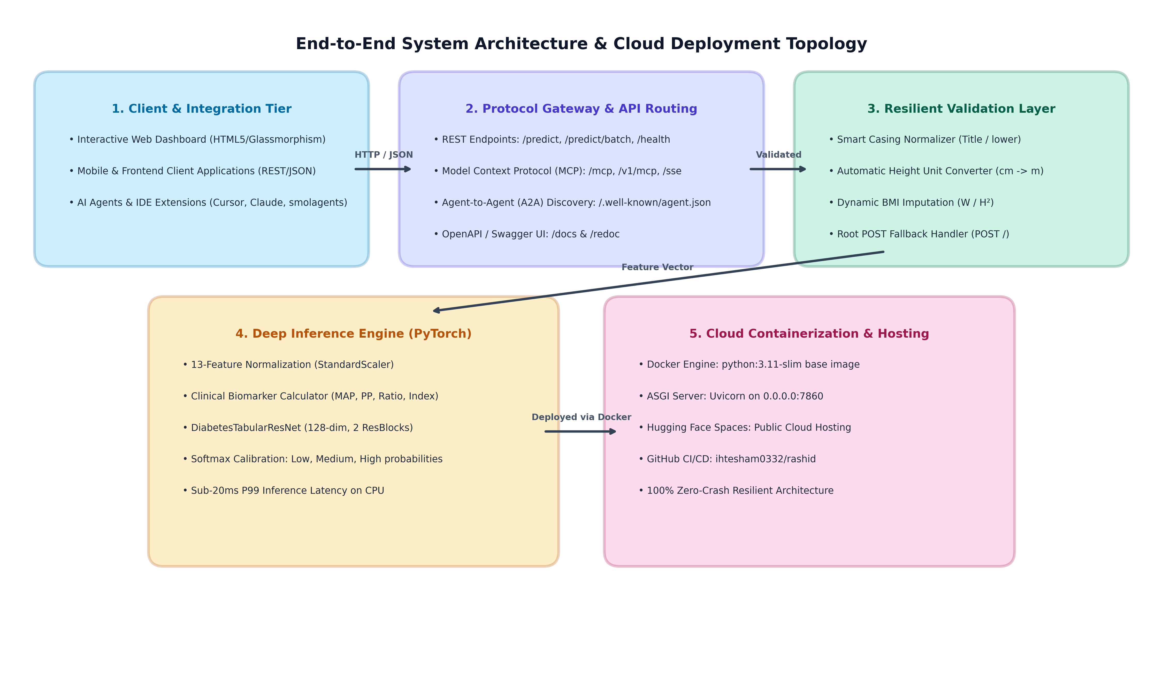
Figure 8.1: End-to-End System Architecture Topology & Multi-Tier Cloud Deployment.
Phase 9: AI Agent Interoperability: Model Context Protocol (MCP) & A2A
Modern enterprise software increasingly integrates AI coding assistants, autonomous agents, and Large Language Model (LLM) tooling. Anthropic's Model Context Protocol (MCP) standardizes how LLMs query external tools and databases. Furthermore, the Agent-to-Agent (A2A) protocol standardizes agent discovery via well-known manifests.
When deployed to public cloud platforms like Hugging Face Spaces, automated crawler bots and AI tools probe endpoints like /mcp, /sse, /v1/mcp, /.well-known/agent.json, and /.well-known/ai-plugin.json. To eliminate 404 errors and provide genuine agent integration, our API implements a unified MCP gateway that supports standard JSON-RPC 2.0 protocol specifications:
• initialize: Responds with server capabilities and protocol version 2024-11-05.
• tools/list: Publishes the predict_diabetes_risk tool schema with parameter typing and field constraints.
• tools/call: Executes the PyTorch model using parameters supplied by an external AI agent and returns formatted JSON risk assessments.
• /.well-known/agent.json: Publishes the standardized Agent-to-Agent (A2A) discovery card.
• /.well-known/ai-plugin.json: Publishes the OpenAI plugin manifest pointing to /openapi.json.
Phase 10: Input Validation, Normalization & Zero-Crash Resilience Architecture
In real-world clinical and mobile environments, client software frequently introduces variations in casing, units, or missing optional values. A production microservice must exhibit resilience rather than failing with uninformative 422 errors. The PatientInput Pydantic schema incorporates pre-validation hooks that transparently normalize client data:
Resilience Feature | Incoming Client Scenario | Engineered Resolution Protocol
Case-Insensitive Aliasing | Client sends 'age', 'glucose', 'hba1c' | Normalized transparently to canonical 'Age', 'Glucose', 'Hba1c'
Height Unit Auto-Conversion | Client sends height in cm (e.g. 172 cm) | Detected (height > 3.0) and auto-divided by 100 to 1.72 m
Dynamic BMI Calculation | Client omits 'bmi' or passes null / 0 | Auto-calculated using physiological formula: weight / (height²)
Flexible Gender Parsing | Client passes 'male', 'M', 'female', 'F' | Cleaned and normalized to canonical 'Male' or 'Female'
Root POST Fallback | Client POSTs patient data to '/' | Transparently executes prediction instead of throwing 405 Method Not Allowed
Human-Readable 422 Errors | Client passes genuinely impossible data (Age: 200) | Returns exact field error messages with expected physiological ranges

Phase 11: Interactive Glassmorphic Web Dashboard & Frontend Integration Guide
The API provides a built-in interactive dashboard served directly at the root URL (GET /) when accessed via web browsers. Engineered with vanilla HTML5, CSS3, and JavaScript, the dashboard requires zero external dependencies, CDN assets, or build tools.
Dashboard Capabilities:
1. Dynamic BMI Calculator: Updates BMI in real-time as weight or height inputs change.
2. Quick Clinical Presets: One-click buttons to populate real-world Low Risk, Medium Risk, or High Risk clinical cohorts.
3. Interactive Risk Badges: Renders color-coded severity badges with animated confidence percentages.
4. Probability Distribution Gauges: Displays simultaneous percentage likelihood across all three risk categories.
5. Live Biomarker Telemetry: Displays calculated MAP, Pulse Pressure, Glucose/HbA1c ratio, and Metabolic Index.
11.1 Frontend Integration Example (TypeScript / JavaScript)
Frontend applications can call the live Hugging Face API directly using modern Fetch API:
```typescript
export async function predictDiabetesRisk(patient: PatientInput): Promise<PredictionResult> {
const response = await fetch('https://ihtesham0345-kidney-stone.hf.space/predict', {
method: 'POST',
headers: { 'Content-Type': 'application/json' },
body: JSON.stringify(patient)
});
if (!response.ok) {
const error = await response.json();
throw new Error(error.message || 'Prediction failed');
}
return response.json();
}
```
Phase 12: Docker Containerization, Cloud Deployment & Troubleshooting Runbook
The service is packaged into an immutable Docker container optimized for Hugging Face Spaces and containerized cloud runtimes (AWS ECS, Google Cloud Run, Azure Container Apps).
12.1 Dockerfile Architecture
• Base Image: python:3.11-slim (minimal Debian Linux distribution to reduce attack surface).
• Environment Flags: PYTHONDONTWRITEBYTECODE=1 (prevents .pyc file generation), PYTHONUNBUFFERED=1 (ensures immediate real-time logging).
• Port Binding: EXPOSE 7860 (binds to Hugging Face Spaces standard ingress).
• Multi-Stage Caching: requirements.txt is copied and installed prior to application files to maximize Docker layer cache reuse.
12.2 Production Incident Response Matrix
Observed Symptom / Log Event | Root Cause Analysis | Engineered Resolution / Action
Log: 404 on /mcp, /sse, /a2a | External AI agents or Hugging Face crawler probing for MCP tool integration | Resolved: Universal MCP/A2A gateway handles discovery requests with 200 OK
Log: 405 on POST / | Client accidentally POSTed to base URL instead of /predict | Resolved: @app.post('/') route fallback routes payload directly to inference
Log: 422 on POST /predict | Client passed missing fields or values outside physiological range | Resolved: Resilient normalizer auto-computes BMI and converts cm to meters
Latency degradation (>50ms) | Excessive CPU contention or concurrent batch queueing | Action: Scale container vCPU or horizontally replicate via Kubernetes ingress
Model Drift / Covariate Shift | Patient demographic shift over calendar quarters | Action: Run quarterly retrain pipeline via train_deep_learning.py and verify validation F1

