Project Title:

"Dockerized Django Notes Application
with CI/CD using Jenkins"

Submitted By

Student Name: _________________________________

Roll Number: _________________________________

Registration No.: ______________________________

Under the Supervision of
Guide Name: ___________________________________
Designation: __________________________________

____________________________________________________________
Session: 2024 - 2025

TABLE OF CONTENTS
CHAPTER 1: INTRODUCTION 1
1.1 Project Overview 1
1.2 Problem Statement 1
1.3 Objectives 1
1.4 Scope 1
CHAPTER 2: SYSTEM REQUIREMENTS 1
2.1 Hardware Requirements 1
2.2 Software Requirements 1
CHAPTER 3: WORKFLOW 1
CHAPTER 4: IMPLEMENTATION 1
4.1 Project Setup 1
4.2 Docker Configuration 1
4.3 Docker Compose Configuration 1
4.4 Jenkins Configuration 1
4.5 Jenkins Pipeline 1
4.6 GitHub Repository Integration 1
4.7 Docker Hub Integration 1
CHAPTER 5: RESULTS AND OUTPUT 1
5.1 Successful Jenkins Build 1
5.2 Docker Images Created 1
5.3 Running Containers 1
5.4 Docker Volume Persistence Verification 1
5.5 Application Running Successfully 1
5.6 CI/CD Pipeline Success 1
CHAPTER 6: FUTURE SCOPE 1
CHAPTER 7: CONCLUSION 1
REFERENCES 1

CHAPTER 1: INTRODUCTION

1.1 Project Overview
This project, titled 'Dockerized Django Notes Application with CI/CD using Jenkins,' was undertaken as a final year academic initiative with the primary objective of gaining hands-on experience with modern DevOps practices and cloud deployment technologies. Rather than focusing solely on application development, this project emphasizes the entire software delivery lifecycle — from code writing and containerization to automated deployment in a cloud environment.
The project employs a Notes Management Application as the underlying software. The application allows users to create, read, update, and delete notes. However, the core learning outcomes of this project revolve around containerizing the application using Docker, orchestrating multiple services using Docker Compose, and establishing a fully automated Continuous Integration and Continuous Deployment (CI/CD) pipeline using Jenkins — an industry-standard automation server.
Docker is a containerization platform that packages applications and their dependencies into lightweight, portable containers. These containers run consistently across any environment, eliminating the well-known problem of 'it works on my machine.' CI/CD, on the other hand, refers to a set of practices that automate the building, testing, and deployment of applications, reducing manual intervention and ensuring faster and more reliable delivery of software.
The project was deployed on Microsoft Azure Virtual Machines running Ubuntu Linux, providing practical exposure to cloud infrastructure management.

1.2 Problem Statement
Traditional software deployment methods suffer from numerous challenges that hinder development agility and operational reliability. The following problems motivated this project:
- Dependency Conflicts: Different developers work on different machines with different operating system configurations. This leads to inconsistent environments where software may work on one system but fail on another. Dependency version mismatches are a frequent cause of such failures.
- Manual Deployment Issues: In conventional workflows, deploying an application requires manually configuring the target server, installing dependencies, copying files, and starting services. This process is error-prone, time-consuming, and lacks reproducibility.
- Lack of Automation: Without CI/CD pipelines, every code change requires developers to manually test, build, and deploy the application. This slows down the development cycle and increases the risk of human errors.
- Environment Inconsistencies: Development, testing, and production environments often differ significantly, leading to bugs that only manifest in production. This makes debugging difficult and deployments unreliable.
- Absence of Rollback Mechanism: Manual deployments rarely include version-controlled deployments, making it difficult to revert to a previous stable version in case of failures.
This project addresses the above challenges by containerizing the application using Docker, managing the multi-container setup with Docker Compose, and automating the entire build and deployment process using a Jenkins CI/CD pipeline.

1.3 Objectives
The following objectives were defined for this project:
- To containerize the Django backend application using a custom Dockerfile with Python 3.12 Slim as the base image.
- To containerize the frontend (HTML, CSS, JavaScript) using an Nginx Alpine image configured as a reverse proxy.
- To set up MySQL as a separate container with persistent data storage using Docker Volumes.
- To orchestrate all application services using Docker Compose, defining services, networks, and volumes in a single configuration file.
- To implement Docker networking to enable seamless communication between the backend, frontend, and database containers.
- To configure environment variables using a .env file for secure and flexible configuration management.
- To implement Docker health checks ensuring containers are started only when dependencies are fully ready.
- To set up Jenkins Master and Jenkins Agent on separate Azure Virtual Machines with SSH-based authentication.
- To integrate the GitHub repository with Jenkins using webhooks for automatic pipeline triggering.
- To build a Jenkins pipeline that automates code checkout, Docker image building, pushing to Docker Hub, and deployment.
- To deploy the application on Microsoft Azure Virtual Machines running Ubuntu Linux.

1.4 Scope
This project is designed with both educational and industrial relevance in mind. From an educational perspective, it provides students with practical experience in containerization, multi-container orchestration, CI/CD automation, and cloud deployment — skills that are highly demanded in the software industry.
Industrially, the architecture implemented in this project mirrors real-world production deployments used by organizations. The use of Docker containers ensures that the application can be deployed on any cloud provider — AWS, Azure, or GCP — without modification.
The project also serves as a foundation for future enhancements such as Kubernetes-based container orchestration, integration of monitoring tools like Prometheus and Grafana, and implementation of security best practices for production environments.
CHAPTER 2: SYSTEM REQUIREMENTS

2.1 Hardware Requirements
The following hardware resources were provisioned on Microsoft Azure for the purpose of this project:
- Processor: 2 vCPUs (Virtual CPUs) on each Azure Virtual Machine — one for the Jenkins Master and one for the Jenkins Agent.
- RAM: Minimum 4 GB RAM on each virtual machine. The Jenkins Master requires additional memory for pipeline execution, while the Agent handles Docker builds and deployments.
- Storage: Minimum 30 GB SSD-backed storage per VM to accommodate the Ubuntu operating system, Docker engine, Jenkins installation, Docker images, and persistent volumes.
- Network: Azure Virtual Network with appropriate Inbound Security Group rules to allow HTTP (port 80), HTTPS (port 443), Jenkins (port 8080), SSH (port 22), and application-specific ports.

2.2 Software Requirements
The following software components were installed and configured across the Azure Virtual Machines:
- Operating System: Ubuntu 22.04 LTS (Linux) — a stable and widely used server distribution.
- Docker Engine: Version 24+ — the core containerization platform used to build and run Docker containers.
- Docker Compose: Version 2.x — a tool for defining and managing multi-container Docker applications using a YAML configuration file.
- Jenkins: Version 2.4xx LTS — an open-source automation server used to implement the CI/CD pipeline.
- Git: Version 2.x — a distributed version control system used for source code management.
- GitHub: Cloud-based hosting platform for Git repositories, used for code storage and webhook configuration.
- Python: Version 3.12 — the programming language used for the Django backend.
- Django REST Framework: A powerful and flexible toolkit for building Web APIs with Django.
- MySQL: Version 8.0 — the relational database management system used for persistent data storage.
- Nginx: Alpine-based image used as the frontend server and reverse proxy for routing API requests to the Django backend.
- Docker Hub: A cloud-based Docker registry used for storing and distributing Docker images.

CHAPTER 3: WORKFLOW
This chapter describes the complete end-to-end workflow of the project, from code development to application access through a browser. Each step is explained in detail to provide a clear understanding of the automated pipeline.
- Code Development: The developer writes the application code on a local machine. This includes the Django backend REST API, the HTML/CSS/JavaScript frontend, and all configuration files such as Dockerfiles, docker-compose.yml, Jenkinsfile, and .env. The developer also writes and maintains the requirements.txt file for Python dependencies.
- GitHub Repository: Once code changes are ready, the developer commits and pushes the code to the designated GitHub repository. The repository contains all project files organized in a structured manner, with separate directories for the backend and frontend components.
- GitHub Webhook Trigger: A GitHub Webhook is configured in the repository settings to send an HTTP POST request to the Jenkins Master server whenever a new commit is pushed to the main branch. This webhook serves as the trigger that initiates the automated CI/CD pipeline. The Webhook URL points to the Jenkins server endpoint: http://<Jenkins-Master-IP>:8080/github-webhook/.
- Jenkins Pipeline Execution: Upon receiving the webhook notification, Jenkins automatically triggers the configured pipeline job. Jenkins first checks out the latest source code from GitHub using its SCM (Source Code Management) configuration. The pipeline then progresses through its defined stages sequentially.
- Docker Image Build: In the Build stage of the Jenkins pipeline, Jenkins instructs the Jenkins Agent to build Docker images for both the backend (Django) and the frontend (Nginx) using their respective Dockerfiles. The backend image includes the Python 3.12 Slim base, installed dependencies, and the Django application code. The frontend image includes the Nginx Alpine configuration and static frontend files.
- Docker Hub Push: After successful image builds, Jenkins uses stored Docker Hub credentials to log in to Docker Hub and push the newly built images. The backend and frontend images are pushed with appropriate tags, allowing version management and easy retrieval for deployment.
- Docker Compose Deployment: In the Deploy stage, Jenkins SSH-connects to the deployment server (Jenkins Agent or a dedicated server) and executes the docker-compose up --build -d command. Docker Compose reads the docker-compose.yml file and brings up all three containers — backend, frontend (Nginx), and MySQL — with the correct network and volume configurations. Health checks ensure that the MySQL container is fully ready before the backend container starts.
- Application Access Through Browser: Once all containers are running successfully, the application becomes accessible through a web browser. The user navigates to the server's IP address or domain name. The Nginx container receives the HTTP request and serves static frontend files directly. For API requests (URLs starting with /api/), Nginx proxies the request to the Django backend container. The backend processes the request, interacts with the MySQL database container, and returns the response, which is eventually rendered by the frontend.

This complete workflow ensures that every code commit results in an automated, tested, and deployed version of the application — embodying the principles of Continuous Integration and Continuous Deployment.

CHAPTER 4: IMPLEMENTATION

4.1 Project Setup
The project implementation began with setting up the development environment and Azure Virtual Machines. Two Ubuntu 22.04 LTS VMs were provisioned on Microsoft Azure — one designated as the Jenkins Master and the other as the Jenkins Agent. Both VMs were configured with Docker Engine and Docker Compose. SSH key-pair authentication was established between the Jenkins Master and the Agent to allow secure, passwordless communication for pipeline execution.
The project directory structure was organized as follows: the root directory contains the docker-compose.yml, Jenkinsfile, and .env files; the backend/ directory contains the Django project, Dockerfile, and requirements.txt; and the frontend/ directory contains the HTML/CSS/JavaScript files along with the Nginx configuration and its Dockerfile.

4.2 Docker Configuration
Dockerfiles define the instructions for building Docker images for the backend and frontend components. Each Dockerfile was carefully crafted to optimize image size, improve security, and ensure reliable container startup.
Backend Dockerfile:
The Backend Dockerfile uses python:3.12-slim as the base image to minimize image size. It sets the working directory to /app, copies the requirements.txt, and installs Python dependencies. A non-root user is created and configured to run the application, enhancing container security. The Django application files are then copied into the container. The ENTRYPOINT runs database migrations and starts the Django development server (or Gunicorn in a production setup) on the specified port.
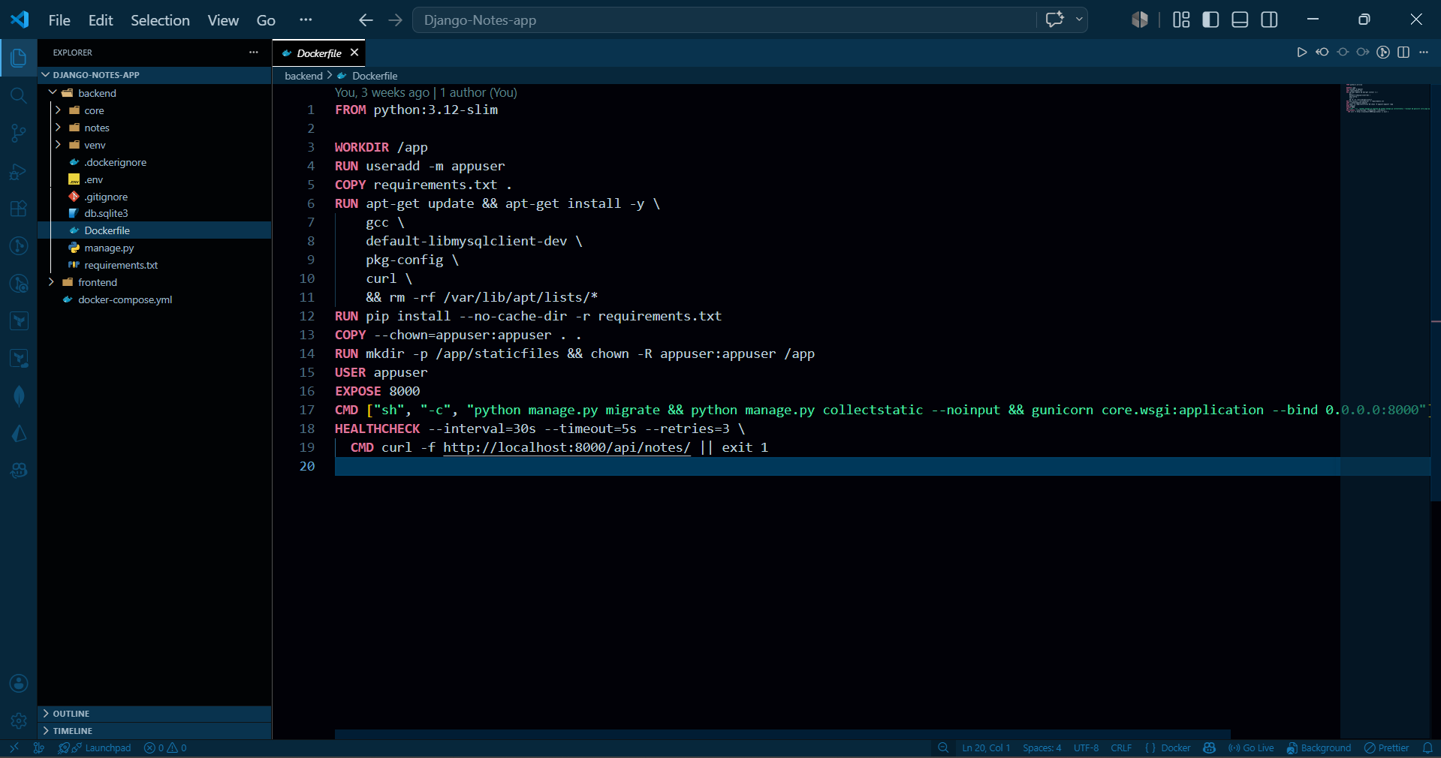

Frontend Dockerfile:
The Frontend Dockerfile uses nginx:alpine as the base image, providing a lightweight and efficient web server. The static HTML, CSS, and JavaScript files are copied to the Nginx default web root directory. A custom Nginx configuration file (nginx.conf) is copied to define the reverse proxy behavior — serving static files directly and forwarding all /api/ requests to the Django backend container using Docker's internal hostname resolution.
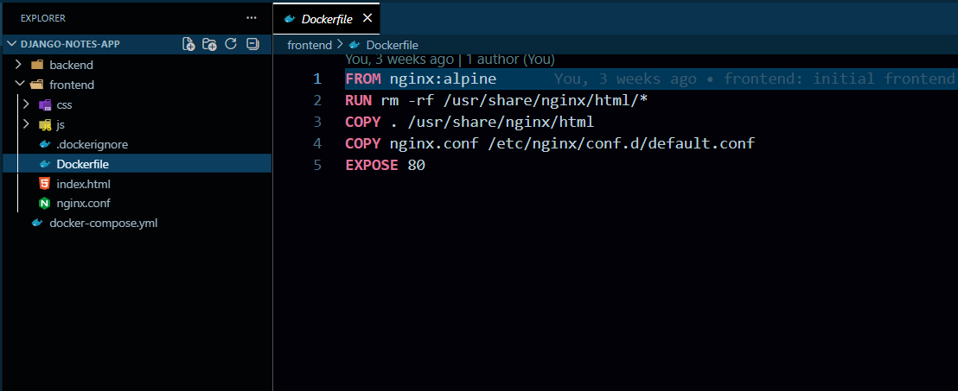

4.3 Docker Compose Configuration
Docker Compose is used to define and manage the multi-container application. The docker-compose.yml file specifies three services: backend (Django), frontend (Nginx), and db (MySQL). It also defines a custom Docker network and persistent volumes.
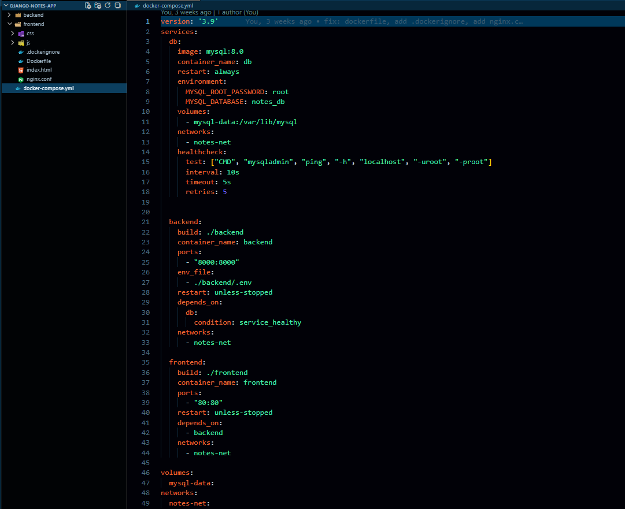

Services:
- backend: Built from the backend Dockerfile. Exposes port 8000. Depends on the db service with a health check condition. Injects environment variables from the .env file.
- frontend: Built from the frontend Dockerfile. Exposes port 80 on the host, mapped to port 80 in the container. Depends on the backend service.
- db: Uses the official mysql:8.0 image. Configured with environment variables for the root password, database name, username, and user password. A named volume (mysql_data) is mounted to /var/lib/mysql for data persistence.
Networks:
A custom bridge network named app_network is defined. All three services are connected to this network, enabling them to communicate using container service names as hostnames (e.g., the backend connects to MySQL using hostname 'db', and Nginx proxies to the backend using hostname 'backend').
Volumes:
A named volume mysql_data is defined at the top level of the Compose file. This volume is managed by Docker and persists MySQL data across container restarts and even container re-creation. The volume data remains intact unless explicitly deleted.
Environment Variables:
Sensitive configuration values such as database credentials, Django secret key, and debug mode are stored in a .env file at the project root. Docker Compose automatically loads this file and injects the variables into the respective containers, keeping credentials out of the source code.
Jenkins Master:
Jenkins Master was installed on the first Azure VM using the official Jenkins APT repository. After installation, Jenkins was accessed through the browser at http://<Master-IP>:8080. The GitHub plugin, Docker plugin, and Pipeline plugin were installed from the Jenkins Plugin Manager. A Multibranch Pipeline job was created and linked to the GitHub repository.
Jenkins Agent:
The second Azure VM was configured as a Jenkins Agent. Jenkins Agent communicates with the Jenkins Master via SSH. On the Master, a new Agent node was configured with the Agent's hostname/IP, SSH credentials, and remote directory path. The Agent runs the actual pipeline stages, including Docker builds and deployments, offloading the work from the Master.
SSH Connection:
SSH key-based authentication was set up between the Jenkins Master and the Agent VM. The Master's public key was added to the Agent's ~/.ssh/authorized_keys file. Jenkins was then configured to use these credentials when connecting to the Agent, ensuring a secure and passwordless SSH connection.

4.5 Jenkins Pipeline
The Jenkins Pipeline is defined in a Jenkinsfile stored in the root of the GitHub repository. The Declarative Pipeline syntax is used, providing a structured and readable pipeline definition.
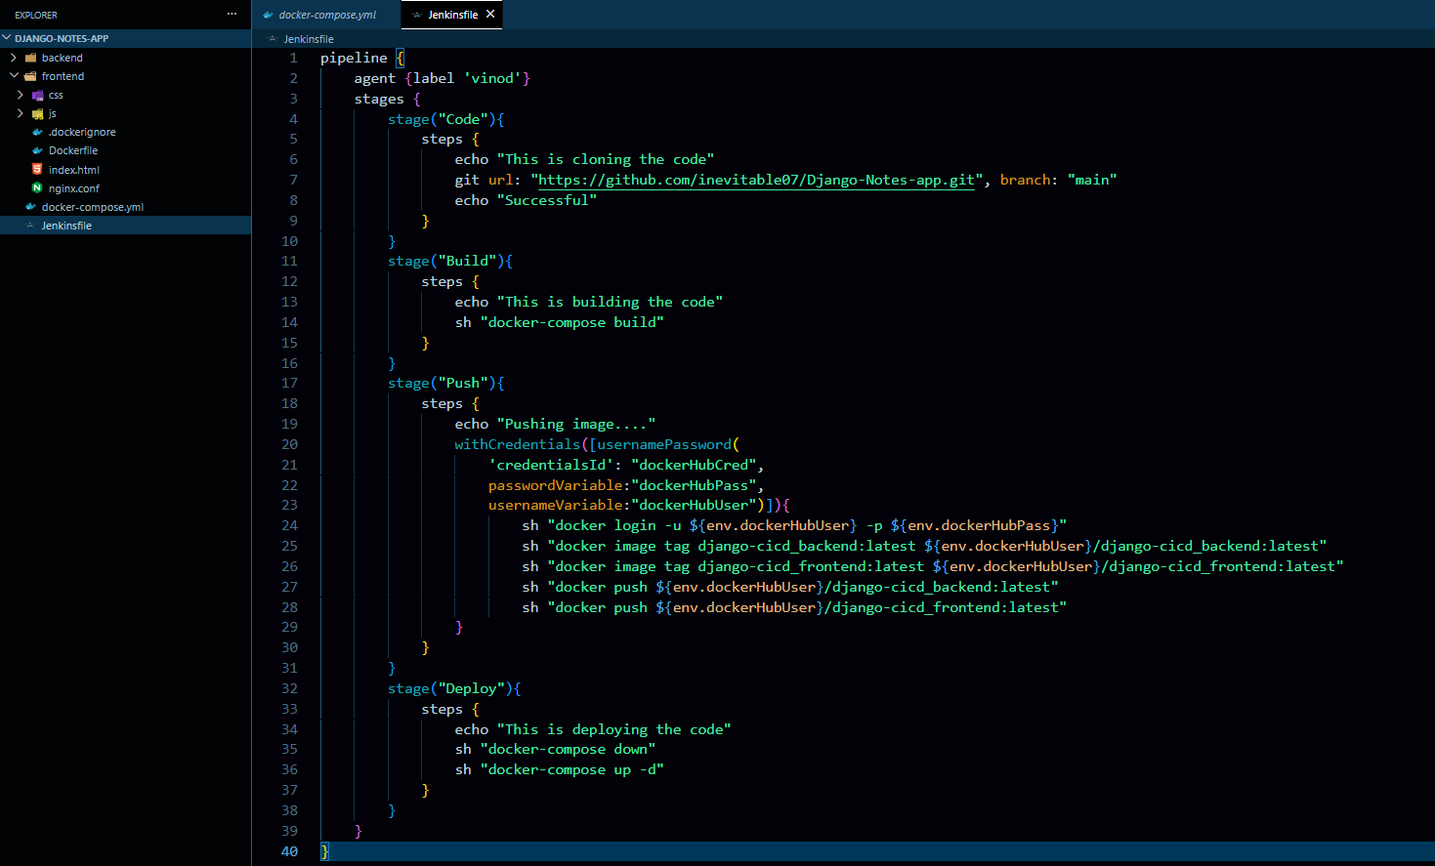

Stage 1 — Code:
The pipeline begins with the Code stage, where Jenkins checks out the latest source code from the GitHub repository. The agent directive specifies that the pipeline runs on the configured Jenkins Agent node.
Stage 2 — Build:
In the Build stage, Docker Compose is used to build the backend and frontend Docker images. The docker-compose build command reads the docker-compose.yml file and builds all defined services. Environment variables are passed to the build process as needed.
Stage 3 — Push:
In the Push stage, Jenkins authenticates with Docker Hub using stored credentials (configured in Jenkins Credentials Manager). The backend and frontend images are tagged appropriately and pushed to the corresponding Docker Hub repositories, making them available for deployment on any server.
Stage 4 — Deploy:
In the Deploy stage, the pipeline runs docker-compose up --build -d to bring up all containers with the latest images. Any running containers are replaced with the new versions. Docker Compose ensures correct startup order based on the depends_on and health check configurations.

4.6 GitHub Repository Integration
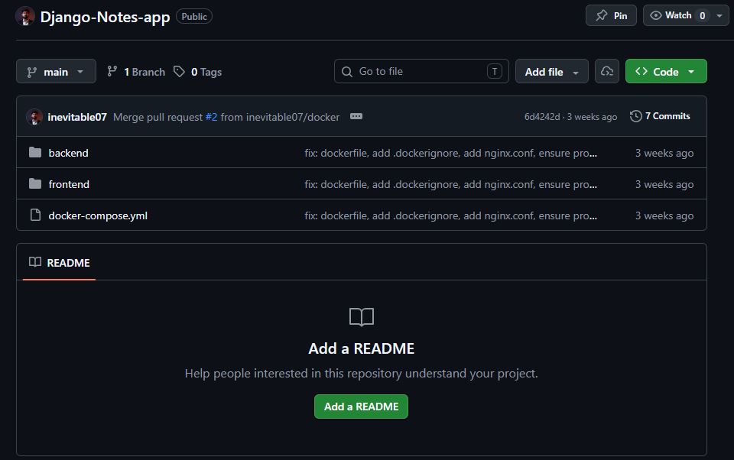

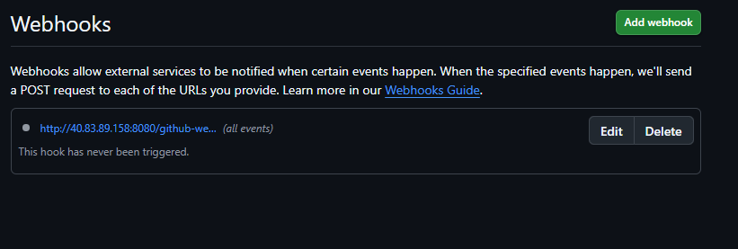

The GitHub repository was created to host all project source files. The repository contains the complete project directory structure including Dockerfiles, docker-compose.yml, Jenkinsfile, application source code, and Nginx configuration files.
A GitHub Webhook was configured in the repository's Settings > Webhooks section. The Payload URL was set to http://<Jenkins-Master-IP>:8080/github-webhook/, the Content Type to application/json, and the trigger event to 'Just the push event'. This configuration ensures that Jenkins is automatically notified every time code is pushed to the repository, initiating the pipeline without any manual intervention.

4.7 Docker Hub Integration
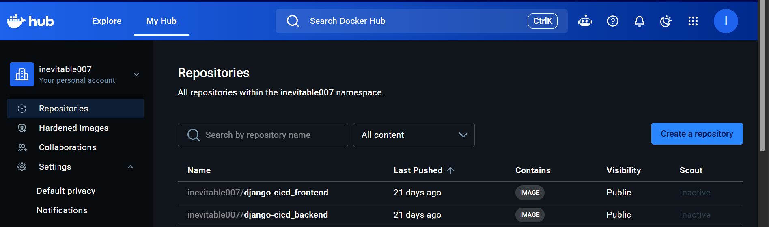

A Docker Hub account was used to host the built images. Two repositories were created on Docker Hub — one for the backend image and one for the frontend image. Jenkins uses stored Docker Hub credentials to log in and push images during the Push stage of the pipeline. The images are tagged with appropriate version tags, allowing rollback to previous versions if needed.

CHAPTER 5: RESULTS AND OUTPUT
This chapter presents the results obtained upon successful execution of the CI/CD pipeline and deployment of the application. Screenshots of each important milestone are provided below.
5.1 Successful Jenkins Build
The Jenkins pipeline executed successfully across all four stages: Code, Build, Push, and Deploy. The Jenkins dashboard displayed a green status indicator confirming pipeline success. The build logs showed no errors and confirmed the successful completion of each stage.
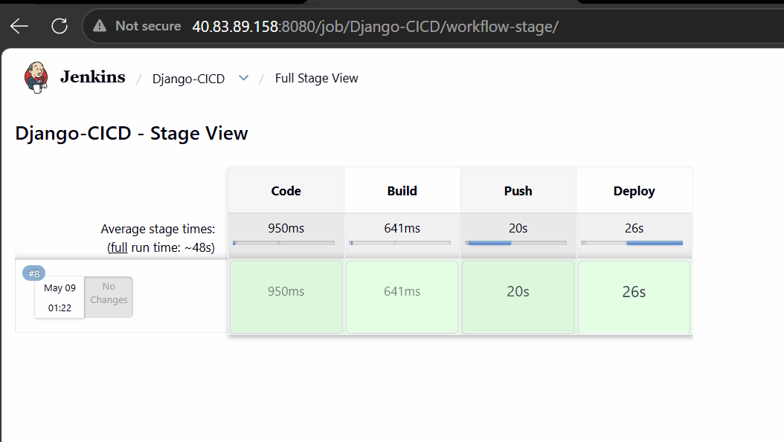

5.2 Docker Images Created
After the Build stage, the Docker images for both the backend and frontend were created locally on the Jenkins Agent. The docker images command listed the newly created images with their respective tags and sizes. The image sizes were optimized due to the use of slim and alpine base images.
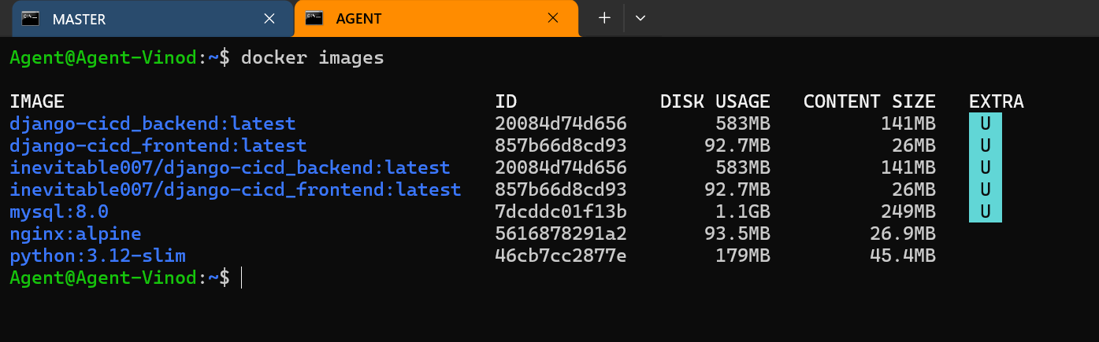

5.3 Running Containers
After the Deploy stage, all three containers — backend, frontend (Nginx), and MySQL — were confirmed to be in the 'running' state. The docker ps command or docker-compose ps command was used to verify the running status, mapped ports, and container names.
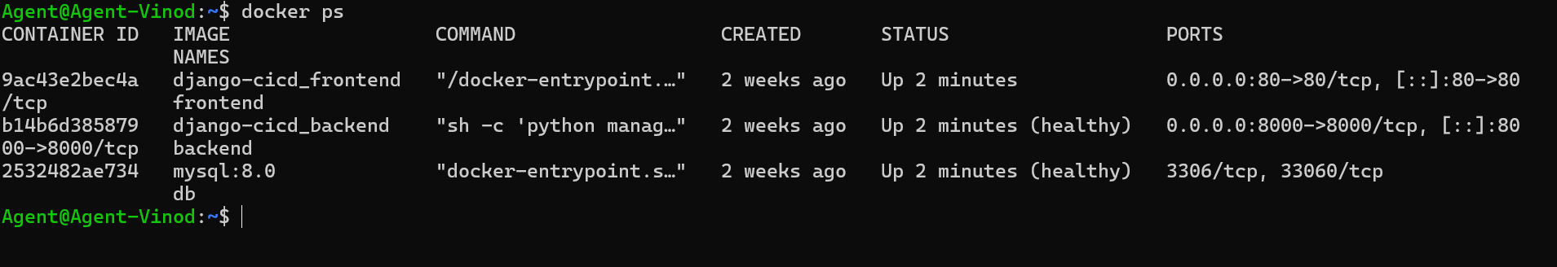

5.4 Docker Volume Persistence Verification
The MySQL data volume (mysql_data) was verified to persist data across container restarts. Test notes were created through the application, the MySQL container was stopped and restarted, and the data was confirmed to still be present upon restart — validating the volume configuration.
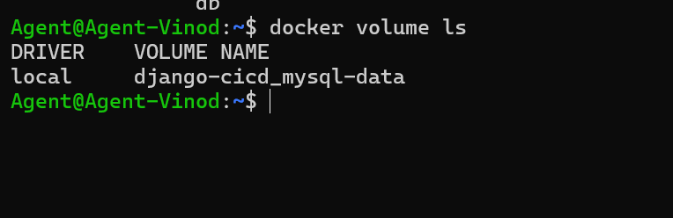

5.5 Application Running Successfully
The Notes Management Application was accessed through a web browser by navigating to the server's IP address. The frontend was rendered correctly with all styles loaded. Notes could be created, viewed, updated, and deleted successfully. API requests were correctly proxied through Nginx to the Django backend, and data was stored and retrieved from the MySQL database.
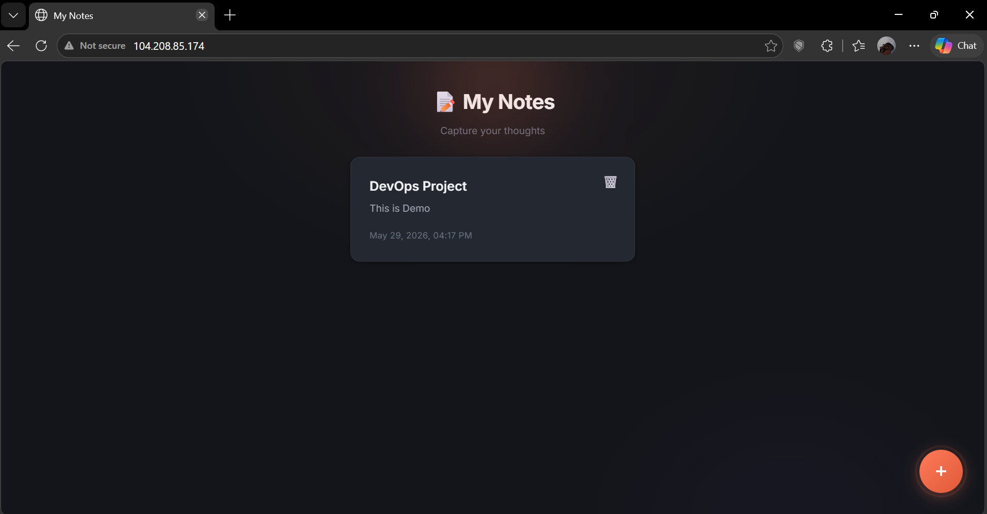

5.6 CI/CD Pipeline Success
The end-to-end CI/CD pipeline was demonstrated by making a small code change, pushing it to GitHub, and observing the automatic pipeline execution. The GitHub webhook triggered Jenkins, the pipeline ran all stages, new images were pushed to Docker Hub, and the updated application was deployed automatically — without any manual intervention.
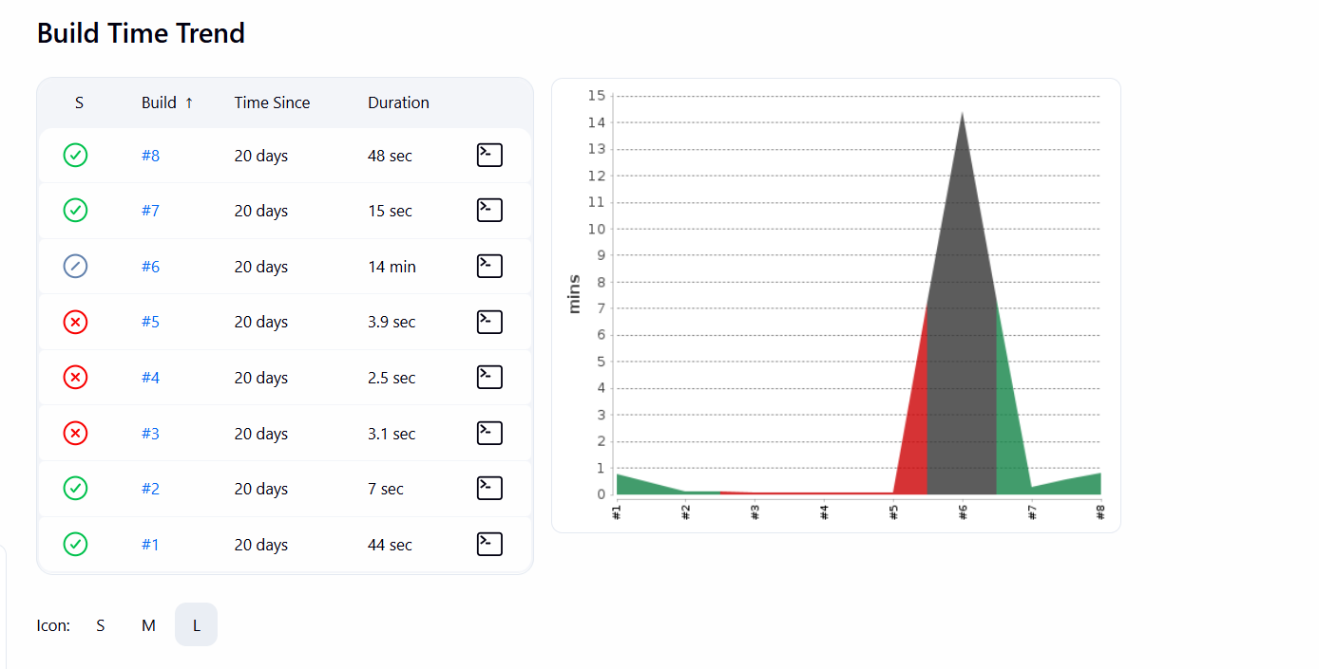

The observations from the implementation confirmed that Docker containerization ensures environment consistency, Docker Volumes maintain data persistence across container lifecycle, Jenkins CI/CD pipeline significantly reduces manual deployment effort, and GitHub Webhooks enable real-time automated deployment on every code push.

CHAPTER 6: FUTURE SCOPE
The current implementation of this project establishes a solid foundation for further development and enhancement. Several areas of improvement and expansion are identified below:
- Kubernetes Deployment: The Docker Compose-based deployment can be migrated to Kubernetes (K8s) for production-grade container orchestration. Kubernetes provides features such as automatic container restarts, load balancing, horizontal pod auto-scaling, rolling updates, and self-healing — capabilities that are essential for large-scale production applications.
- Monitoring with Prometheus and Grafana: The application currently lacks monitoring and alerting capabilities. Prometheus can be integrated to collect metrics from containers (CPU usage, memory, request counts), and Grafana can be used to create visual dashboards for real-time monitoring. Alertmanager can send notifications in case of system failures or threshold breaches.
- GitHub Actions Integration: In addition to Jenkins, the CI/CD pipeline can be replicated or migrated to GitHub Actions — a native CI/CD feature of GitHub. This would eliminate the need for a separate Jenkins server and simplify the pipeline management, especially for smaller teams.
- Cloud-Native Architecture: The application can be refactored to use cloud-native services such as Azure Container Apps, AWS ECS/EKS, or Google Cloud Run. These managed services handle infrastructure provisioning, scaling, and availability automatically, reducing operational overhead.
- Auto Scaling: The current deployment runs a fixed number of containers. Auto-scaling policies can be implemented so that additional container instances are automatically created during periods of high traffic and removed when demand decreases, optimizing resource utilization and cost.
- Production Security Improvements: The current setup is designed for learning purposes and uses development-grade configurations. For production deployment, several security improvements are needed: replacing the Django development server with Gunicorn or uWSGI, enabling HTTPS using SSL/TLS certificates (Let's Encrypt), implementing secrets management using tools like HashiCorp Vault or Azure Key Vault, enabling Docker image vulnerability scanning in the CI/CD pipeline, and applying the principle of least privilege for all service accounts.

CHAPTER 7: CONCLUSION
This project successfully demonstrated the practical application of modern DevOps practices through the development, containerization, and automated deployment of a Django-based Notes Management Application. The primary objective of this project was not merely to build a notes application, but to use it as a vehicle for learning and implementing key DevOps concepts that are widely used in the industry.
The following project objectives were successfully achieved:
- Containerization: The Django backend and Nginx-based frontend were successfully containerized using custom Dockerfiles. The use of slim and alpine base images resulted in optimized, lightweight Docker images.
- Multi-Container Architecture: Docker Compose was used to orchestrate the backend, frontend, and MySQL database as separate, communicating containers. Docker Networking enabled seamless hostname-based communication between containers, while Docker Volumes ensured data persistence.
- CI/CD Implementation: A fully automated Jenkins CI/CD pipeline was implemented with four stages: Code, Build, Push, and Deploy. GitHub Webhooks enabled automatic pipeline triggering on every code push, eliminating manual deployment effort.
- Cloud Deployment: The application was successfully deployed on Microsoft Azure Virtual Machines, providing hands-on experience with cloud infrastructure management.
Throughout this project, several important technologies were learned and applied: Docker containerization, Dockerfile authoring, Docker Compose orchestration, Docker Networking and Volumes, Nginx configuration and reverse proxy setup, Jenkins Master-Agent architecture, Jenkins Pipeline scripting using Jenkinsfile, Docker Hub image management, GitHub Webhook configuration, and Azure VM provisioning.
The challenges encountered during implementation — including MySQL container connectivity issues, Nginx reverse proxy configuration, Jenkins SSH authentication, and static file loading — provided valuable troubleshooting experience that deepened the understanding of each technology involved.
In conclusion, this project provided a comprehensive, practical education in DevOps practices, equipping the student with skills that are directly applicable to real-world software development and operations roles. The project successfully bridges the gap between theoretical knowledge and practical implementation, making it a highly valuable academic and professional exercise.
REFERENCES
[1] Docker Inc., "Docker Documentation," 2024. [Online]. Available: https://docs.docker.com/

[2] Docker Inc., "Docker Compose Documentation," 2024. [Online]. Available: https://docs.docker.com/compose/

[3] Jenkins CI, "Jenkins Documentation," 2024. [Online]. Available: https://www.jenkins.io/doc/

[4] Django Software Foundation, "Django Documentation," 2024. [Online]. Available: https://docs.djangoproject.com/

[5] Django REST Framework, "Django REST Framework Documentation," 2024. [Online]. Available: https://www.django-rest-framework.org/

[6] Nginx Inc., "Nginx Documentation," 2024. [Online]. Available: https://nginx.org/en/docs/

[7] Microsoft Azure, "Azure Virtual Machines Documentation," 2024. [Online]. Available: https://docs.microsoft.com/en-us/azure/virtual-machines/

[8] GitHub Inc., "GitHub Documentation," 2024. [Online]. Available: https://docs.github.com/

[9] Docker Inc., "Docker Hub Documentation," 2024. [Online]. Available: https://docs.docker.com/docker-hub/

[10] MySQL, "MySQL 8.0 Reference Manual," 2024. [Online]. Available: https://dev.mysql.com/doc/refman/8.0/en/

