Name: Isaac Hughes
Date Created: 2/11/2025

Output:
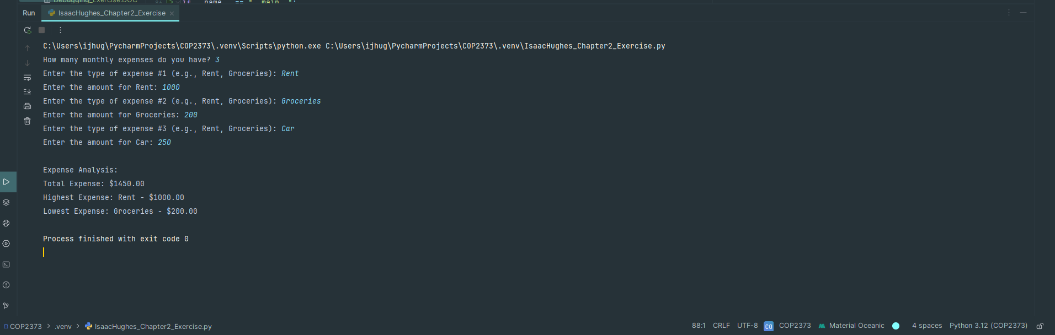

1. Function Name: get_expenses
- Description:
Prompts the user to enter their monthly expenses. The function first asks for the number of expenses, then in a loop, requests the expense type and the amount for each expense. It returns a list of expense tuples.
- Parameters:
None
- Variables:
  - num_expenses (int): The number of expenses the user will enter.
  - expense_type (str): The type or category of the expense.
  - expense_amount (float): The amount for the expense.
  - expenses (list): A list that stores each expense as a tuple in the form (expense_type, expense_amount).
- Logical Steps:
  - Prompt the user for the number of expenses.
  - For each expense:
    - Request the expense type.
    - Request the expense amount (converted to a float).
    - Append a tuple of (expense_type, expense_amount) to the list.
  - Return the complete list of expenses.
- Returns:
A list of tuples representing the expenses.

2. Function Name: analyze_expenses
- Description:
Analyzes the list of expenses using the reduce function to calculate the total expense, the highest expense, and the lowest expense.
- Parameters:
  - expenses (list): A list of expense tuples.
- Variables:
  - total (float): The sum of all expense amounts.
  - highest_expense (tuple): The expense tuple with the highest amount.
  - lowest_expense (tuple): The expense tuple with the lowest amount.
- Logical Steps:
  - Use reduce to iterate over the list and sum up the expense amounts to compute the total.
  - Use reduce with a lambda function to determine the expense with the highest amount.
  - Use reduce with a lambda function to determine the expense with the lowest amount.
  - Return the computed total, highest expense, and lowest expense.
- Returns:
A tuple in the form (total, highest_expense, lowest_expense).

3. Function Name: display_results
- Description:
Displays the analysis results. It prints the total expense, and clearly labels the highest and lowest expenses along with their corresponding types and amounts.
- Parameters:
  - total (float): The total of all expenses.
  - highest_expense (tuple): The expense tuple with the highest amount.
  - lowest_expense (tuple): The expense tuple with the lowest amount.
- Variables:
None
- Logical Steps:
  - Print the total expense.
  - Print the highest expense along with its type and amount.
  - Print the lowest expense along with its type and amount.
- Returns:
None

Logical Steps (Program Flow)
- Collect Expenses:
The get_expenses() function is called to collect the user's monthly expenses.
- Analyze Expenses:
The analyze_expenses(expenses) function processes the list of expenses to calculate the total expense, the highest expense, and the lowest expense using the reduce method.
- Display Results:
The display_results(total, highest_expense, lowest_expense) function outputs the results in a user-friendly format.

Link to Repo: https://github.com/ihugs73/COP2373

