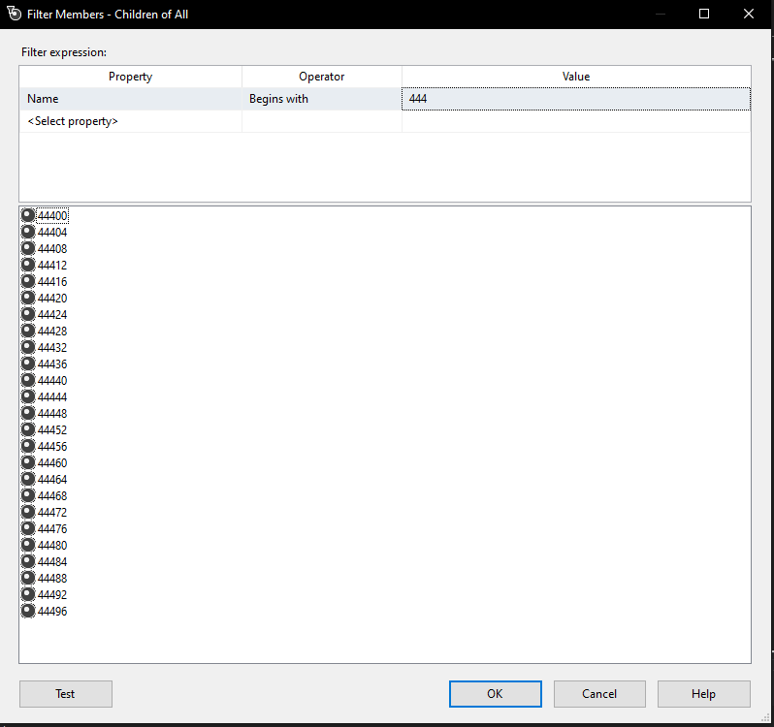

Step 19 (p.639), save a print screen of the Mining Models tab (you will need to hand in a copy of the Mining Models)

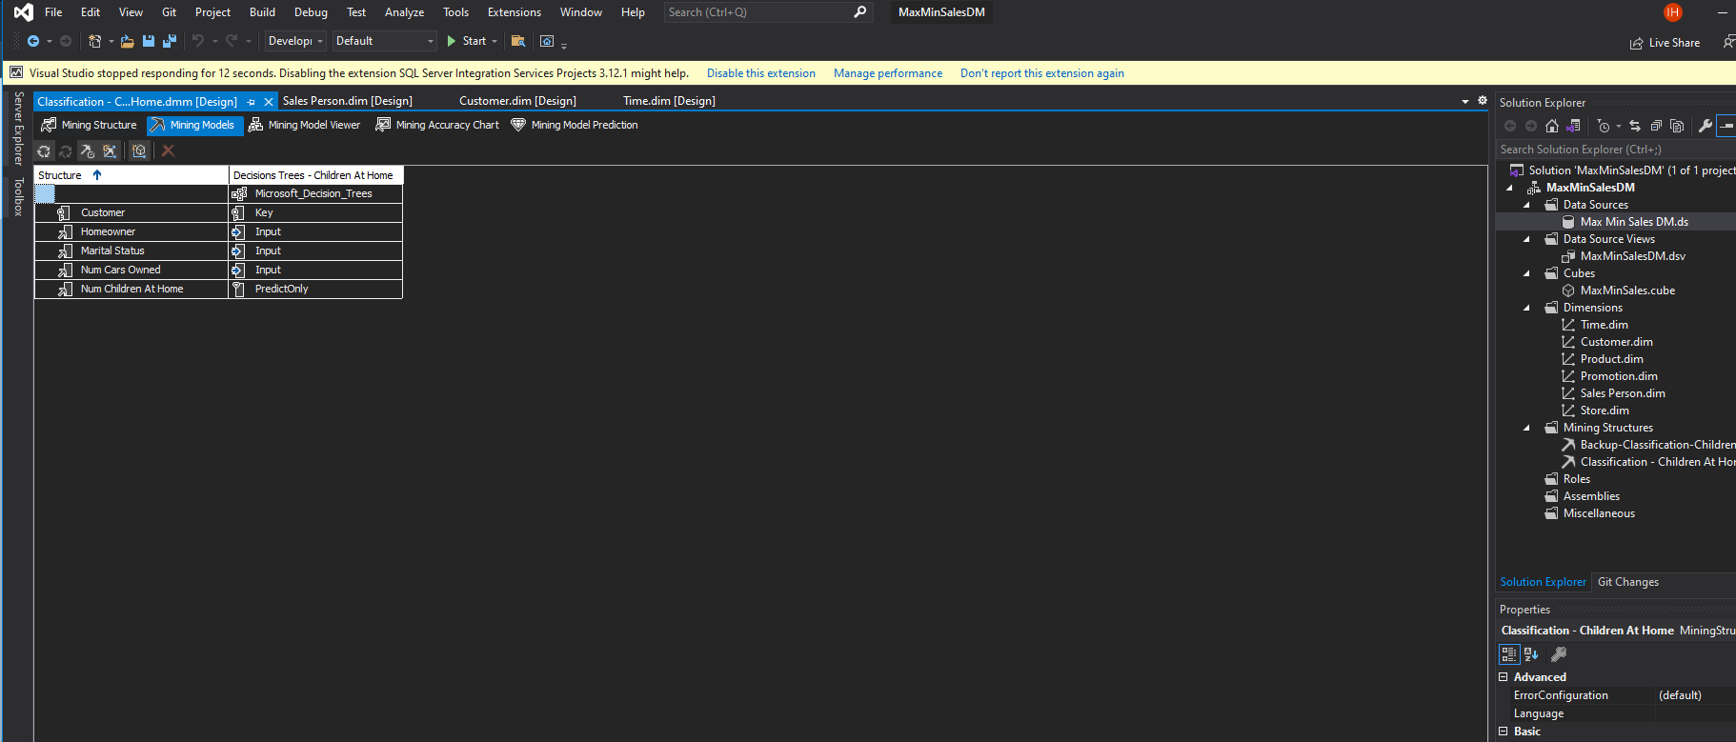

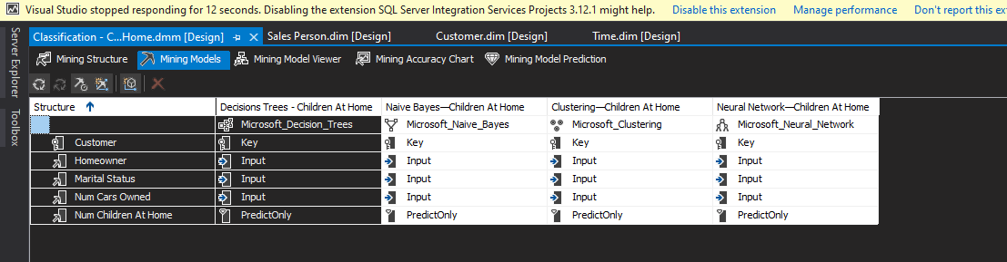

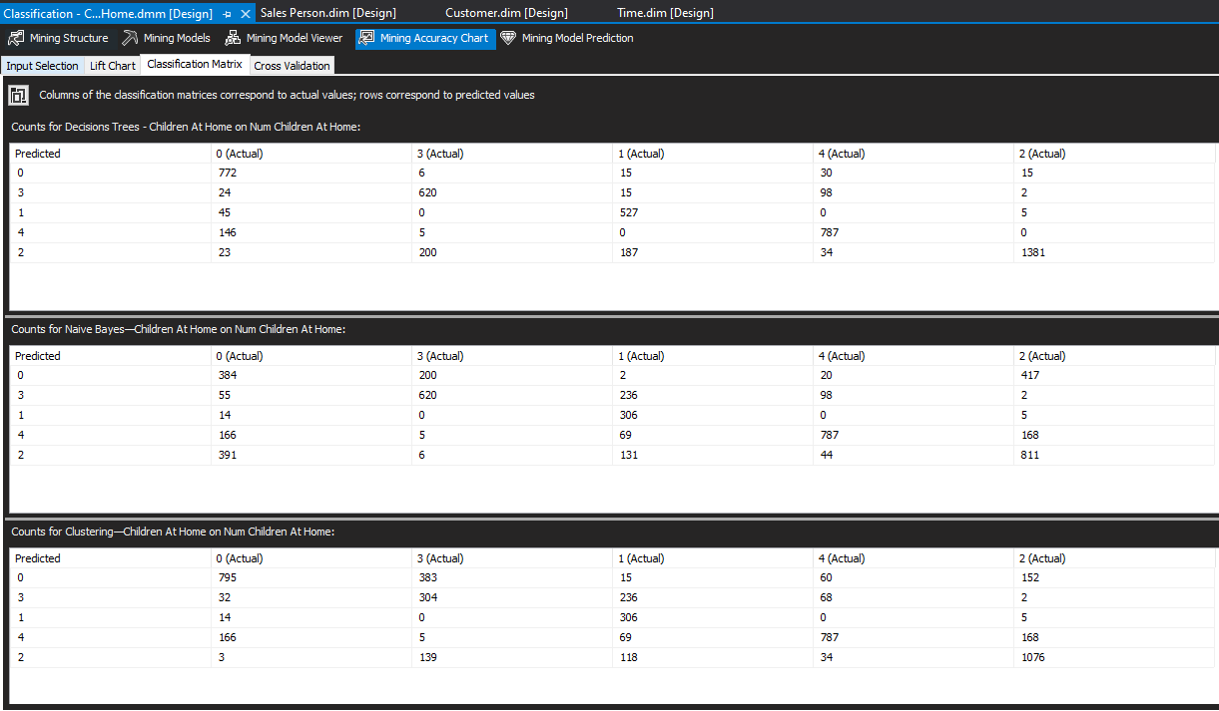

Which mining model(s) should be used? Why?