Ian Hugya

BAIS 3210

Assignment 5

1. Mining Models

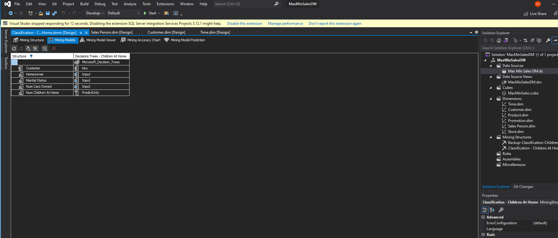

1. Classification Matrix

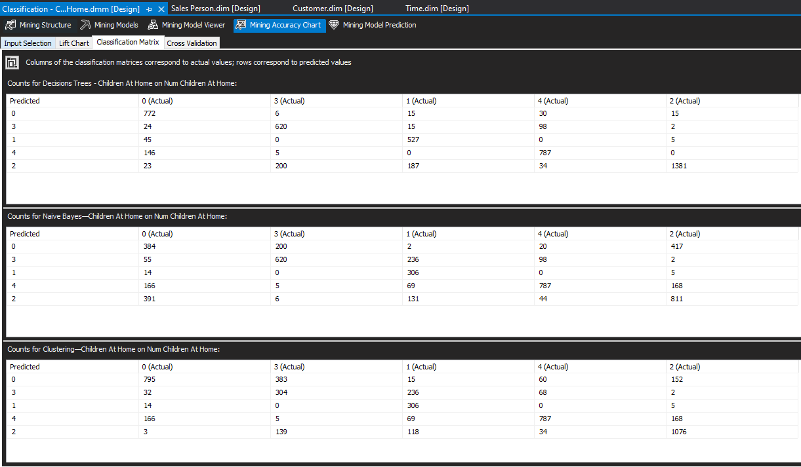

1. DMX Queries

//Step 6 (Query 1)

SELECT

[Num Children At Home]

FROM

[Decision Trees-Children At Home]

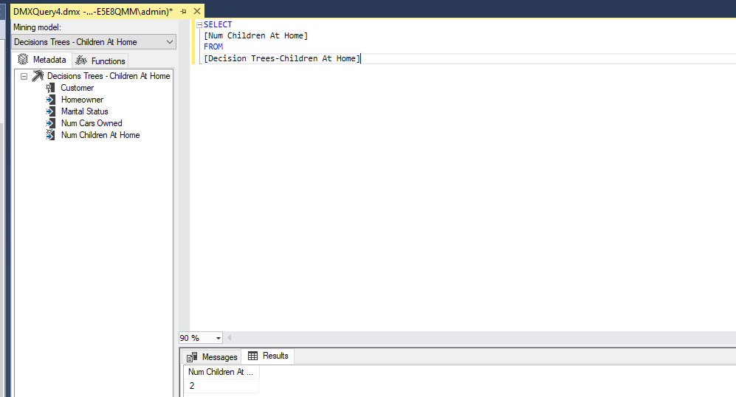

//Step 8 (Query 2)

SELECT [Decision Trees-Children At Home].[Num Children At Home]

From [Decision Trees-Children At Home]

NATURAL PREDICTION JOIN

(SELECT 'Y' AS [Homeowner], 'N' AS [Marital Status], '2' AS [Num Cars Owned]) AS t

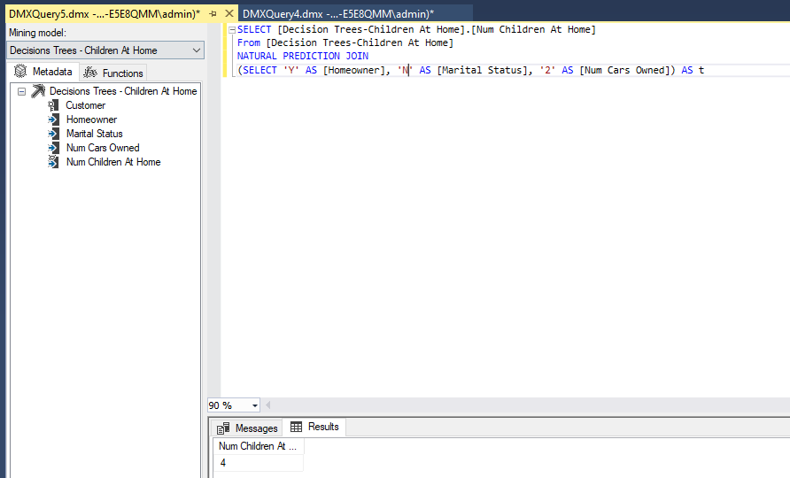

//Step 10 (Query 3)

SELECT

[Decisions Trees - Children At Home].[Num Children At Home],

('Homeowner = Y; Martial Status = N; Num Cars Owned =2') as [Input Criteria]

From

[Decisions Trees - Children At Home]

NATURAL PREDICTION JOIN

(SELECT 'Y' AS [Homeowner],

'N' AS [Marital Status],

2 AS [Num Cars Owned]) AS t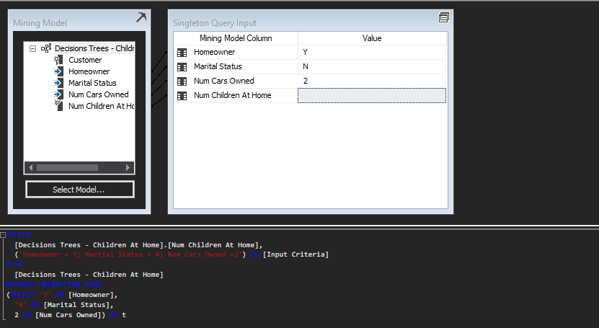

//Step 10 (Query 4)

SELECT

t.[Customer_Name],

t.[Address],

t.[City],

t.[State],

t.[ZipCode]

FROM

[Decision Trees-Children At Home]

PREDICTION JOIN

OPENQUERY([Max Min Sales DM],

'SELECT

[Customer_Name],

[Address],

[City],

[State],

[ZipCode],

[Homeowner],

[MaritalStatus],

[NumCarsOwned]

FROM

[dbo].[Customer]

') AS t

ON

[Decision Trees-Children At Home].[Homeowner] = t.[Homeowner] AND

[Decision Trees-Children At Home].[Marital Status] = t.[MaritalStatus] AND

[Decision Trees-Children At Home].[Num Cars Owned] = t.[NumCarsOwned]

WHERE

[Decision Trees-Children At Home].[Num Children At Home] = 0

