INSTALL JDK and MYSQL SERVER
ihvn@ihvn-Latitude-5400:~$ sudo apt-get update

ihvn@ihvn-Latitude-5400:~$ sudo apt-get install openjdk-8-jdk

ihvn@ihvn-Latitude-5400:~$ sudo apt-get install mysql-server
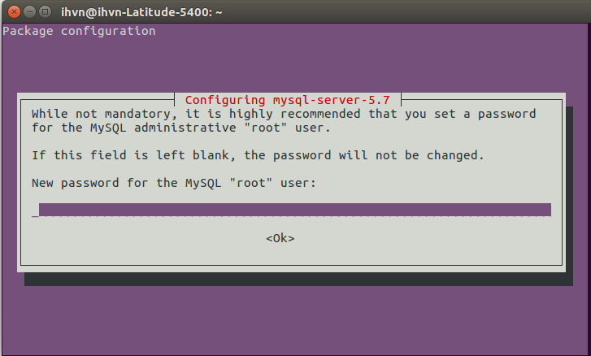

ihvn@ihvn-Latitude-5400:~$ sudo systemctl start mysql

ihvn@ihvn-Latitude-5400:~$ sudo systemctl enable mysql

ihvn@ihvn-Latitude-5400:~$ /usr/bin/mysql -u root –p // This is to start up your Mysql server

mysql> select User, Host authentication_string From mysql.user; // This should display table of users

INSTALL MYSQL WORK-BENCH

ihvn@ihvn-Latitude-5400:~$ sudo apt-get install mysql-workbench

TOMCAT INSTALLATION

root@ihvn-Latitude-5400:/tmp# sudo groupadd tomcat

root@ihvn-Latitude-5400:/tmp# useradd -s /bin/false -g tomcat -d /opt/tomcat tomcat

root@ihvn-Latitude-5400:/tmp# cd /root

root@ihvn-Latitude-5400:~# mkdir /opt/tomcat

root@ihvn-Latitude-5400:~# cd /opt/tomcat

root@ihvn-Latitude-5400:~# cd ..
root@ihvn-Latitude-5400:/opt#
// Go to Tomcat official website to copy Tomcat 9 download link
step1 : https://tomcat.apache.org/download-90.cgi
step2 : Right click on Tar.gz (under Binary Distribution - > Core)
step3: Select “ Copy Link Location” (Image below)
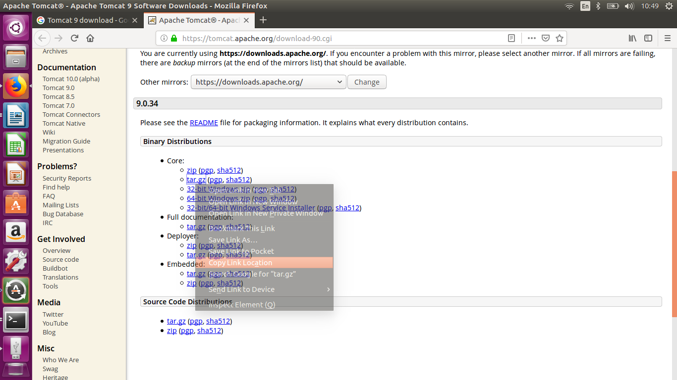
root@ihvn-Latitude-5400:/opt# wget <the link you copied from above step>

ihvn@ihvn-Latitude-5400:/opt$ ls // check files in the “/opt” folder to confirm tomcat 9 tar.gz is downloaded
apache-tomcat-9.0.34.tar.gz // this is the file you should see in your “/opt” folder

root@ihvn-Latitude-5400:/opt# sudo tar xzvf apache-tomcat-9.0.34.tar.gz -C /opt/tomcat --strip-components=1

root@ihvn-Latitude-5400:~# cd /opt/tomcat

root@ihvn-Latitude-5400:/opt/tomcat# sudo chgrp -R tomcat /opt/tomcat

root@ihvn-Latitude-5400:/opt/tomcat# sudo chmod -R g+r conf

root@ihvn-Latitude-5400:/opt/tomcat# sudo chmod g+x conf

root@ihvn-Latitude-5400:/opt/tomcat# sudo chown -R tomcat webapps/ work/ temp/ logs/

root@ihvn-Latitude-5400:/opt/tomcat# sudo update-java-alternatives –l

java-1.8.0-openjdk-amd64 1081 /usr/lib/jvm/java-1.8.0-openjdk-amd64 // this is how the output looks like, copy the Path and save somewhere.

root@ihvn-Latitude-5400:/opt/tomcat# sudo nano /etc/systemd/system/tomcat.service

<Copy the painted code below and paste in the window that pops up but change “/usr/lib/jvm/java-1.8.0-openjdk-amd64” with the Path displayed by your Machine in two steps above which you copied and saved>

[Unit]
Description=Apache Tomcat Web Application Container
After=network.target

[Service]
Type=forking

Environment=JAVA_HOME=/usr/lib/jvm/java-1.8.0-openjdk-amd64/jre
Environment=CATALINA_PID=/opt/tomcat/temp/tomcat.pid
Environment=CATALINA_HOME=/opt/tomcat
Environment=CATALINA_BASE=/opt/tomcat
Environment='CATALINA_OPTS=-Xms512M -Xmx1024M -server -XX:+UseParallelGC'
Environment='JAVA_OPTS=-Djava.awt.headless=true -Djava.security.egd=file:/dev/./urandom'

ExecStart=/opt/tomcat/bin/startup.sh
ExecStop=/opt/tomcat/bin/shutdown.sh

User=tomcat
Group=tomcat
UMask=0007
RestartSec=10
Restart=always

[Install]
WantedBy=multi-user.target

root@ihvn-Latitude-5400:/opt/tomcat# sudo systemctl daemon-reload

root@ihvn-Latitude-5400:/opt/tomcat# sudo systemctl start tomcat

root@ihvn-Latitude-5400:/opt/tomcat# sudo systemctl status tomcat

root@ihvn-Latitude-5400:/opt/tomcat# sudo systemctl enable tomcat
<At this point your Tomcat should be up http://localhost:8080/ , without any admin account created yet>

DEPLOYMENT OF OPENMRS WAR FILE

root@ihvn-Latitude-5400:/opt# apt install libgnome2-bin

root@ihvn-Latitude-5400:/opt# sudo systemctl restart tomcat

root@ihvn-Latitude-5400:/opt# gnome-open tomcat
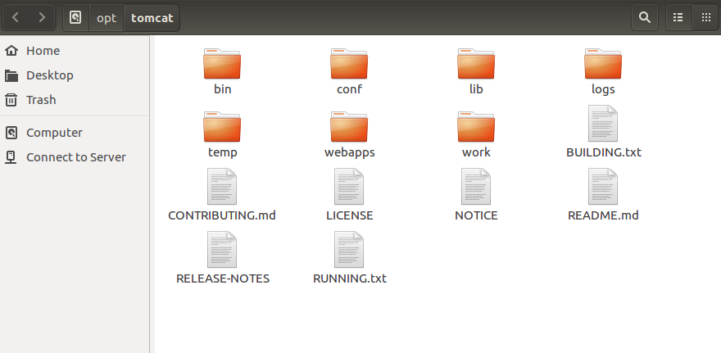

<Open the Conf Folder>
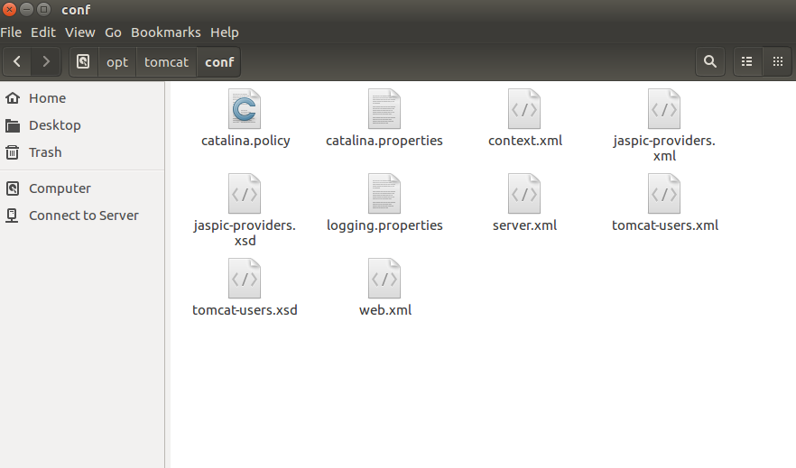

Open tomcat-users.xml and paste the roles below as shown picture below and Save
<role rolename="manager-gui"/>
<role rolename="manager-script"/>
<role rolename="manager-jmx"/>
<role rolename="manager-status"/>

<user username="admin" password="Admin123" roles="manager-script"/>
<user username="admin" password="Admin123" roles="manager-gui"/>
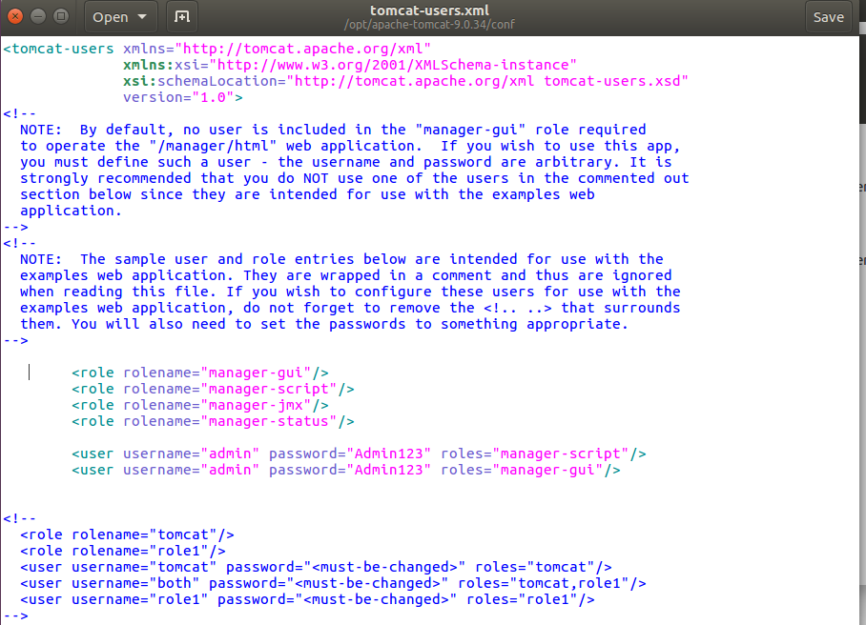
Open Server.xml and Change the Server port from 8080 to 8081 and Save
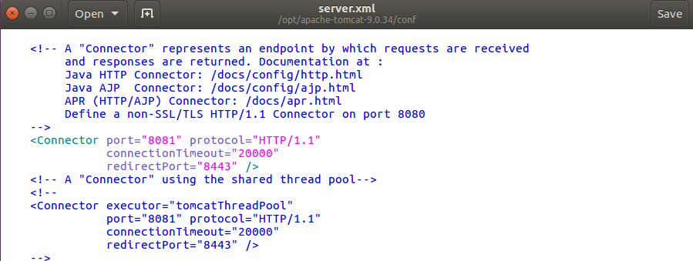
<Assign more memory to Java>
Open Tomcat folder (by clicking back arrow on the already opened folder)
open WebApp folder
manager
WEB-INF

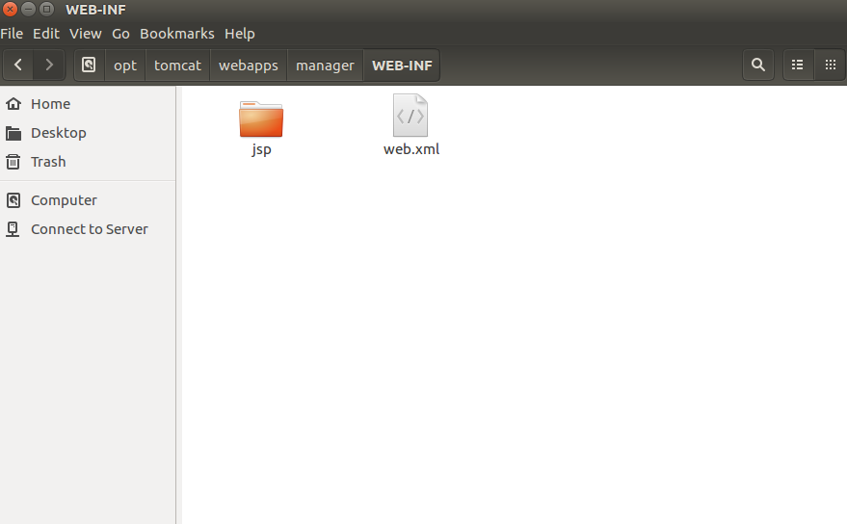

Open web.xml file in this folder (Remember this file is other folders)
Change Multipart-config from
<multipart-config>
<!-- 50MB max -->
<max-file-size>52428800</max-file-size>
<max-request-size>52428800</max-request-size>
<file-size-threshold>0</file-size-threshold>
</multipart-config>
To:
<multipart-config>
<!– 90MB max –>
<max-file-size>92428800</max-file-size>
<max-request-size>92428800</max-request-size>
<file-size-threshold>0</file-size-threshold>
</multipart-config>
Then SAVE
root@ihvn-Latitude-5400:/opt/tomcat# sudo mkdir /var/lib/OpenMRS

root@ihvn-Latitude-5400:/opt/tomcat# sudo chown -R tomcat /var/lib/OpenMRS

<Its recommended to restart the System at this point>

Upload War file for Deployment

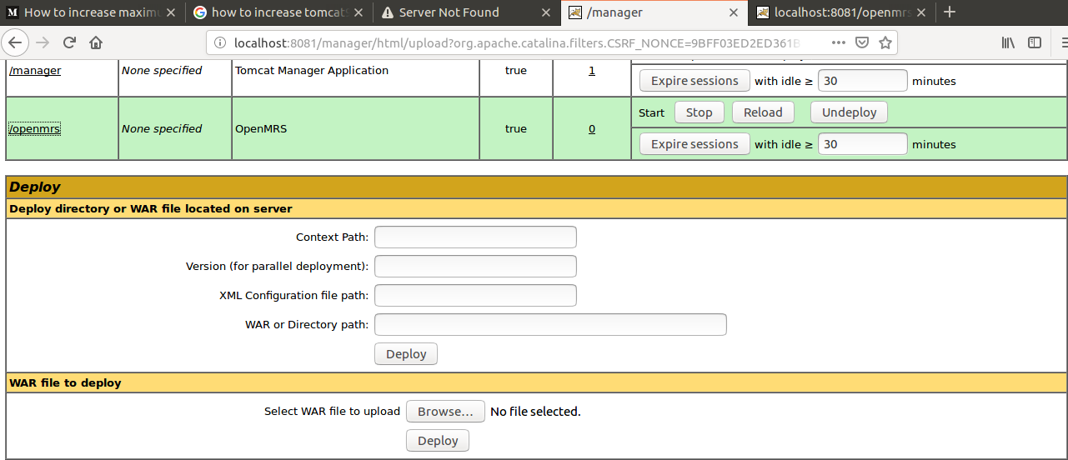
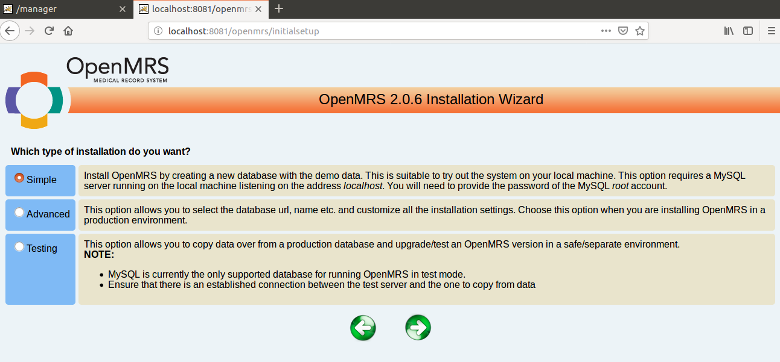

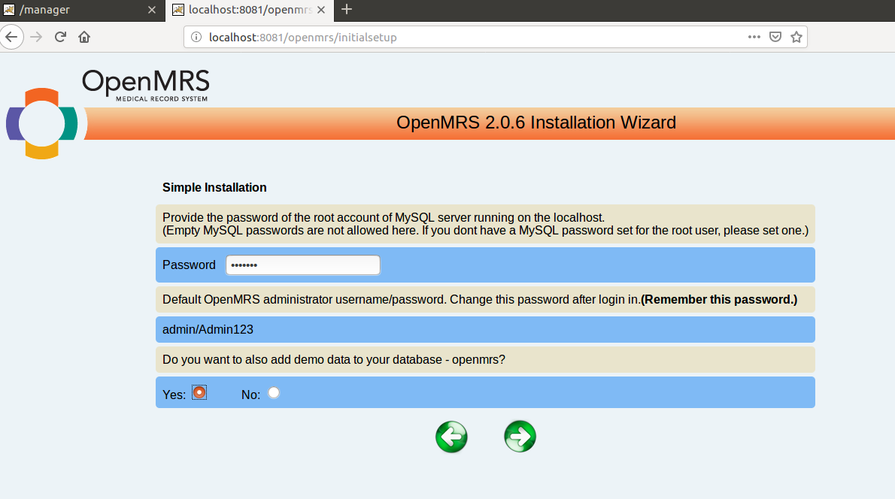

Copy and save the Installation Path “/var/lib/OpenMRS/openmrs-runtime.properties”
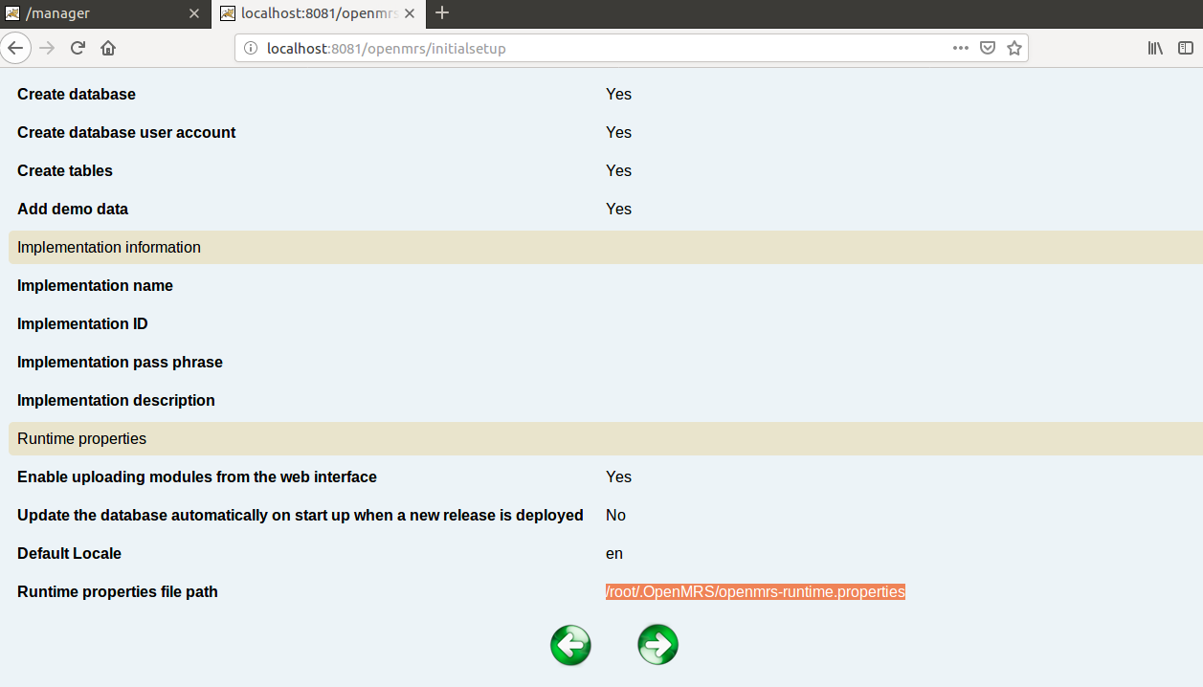

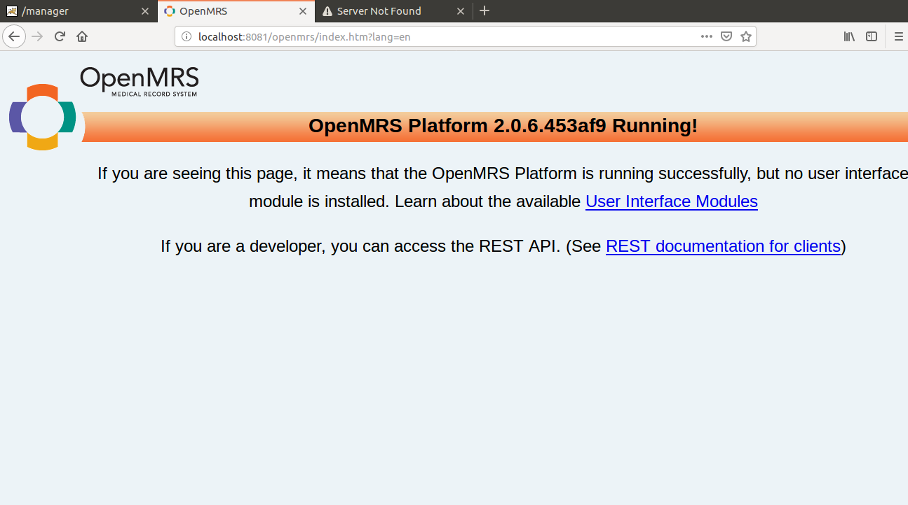
Installation completed

<Install the UI Omods>
root@ihvn-Latitude-5400:/opt/tomcat# cd /var/lib/OpenMRS

root@ihvn-Latitude-5400:/opt/tomcat# cd ..

root@ihvn-Latitude-5400:/opt# gnome-open tomcat // Open the Modules folder, copy and paste your Omods
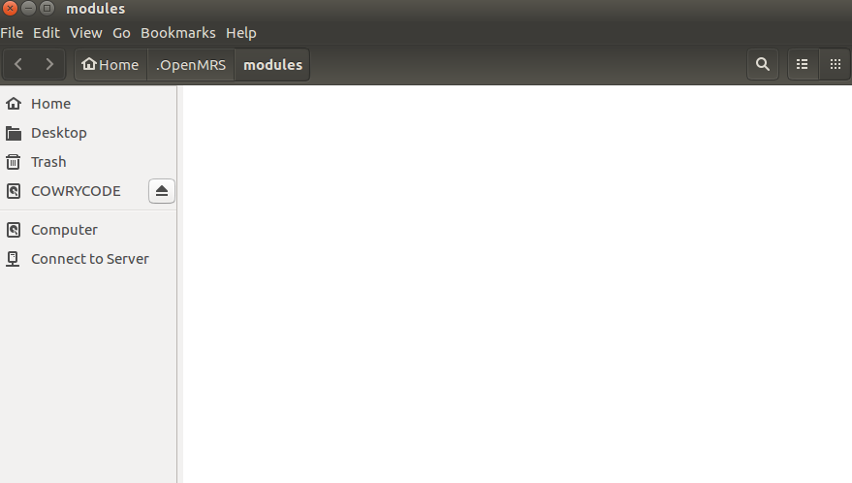

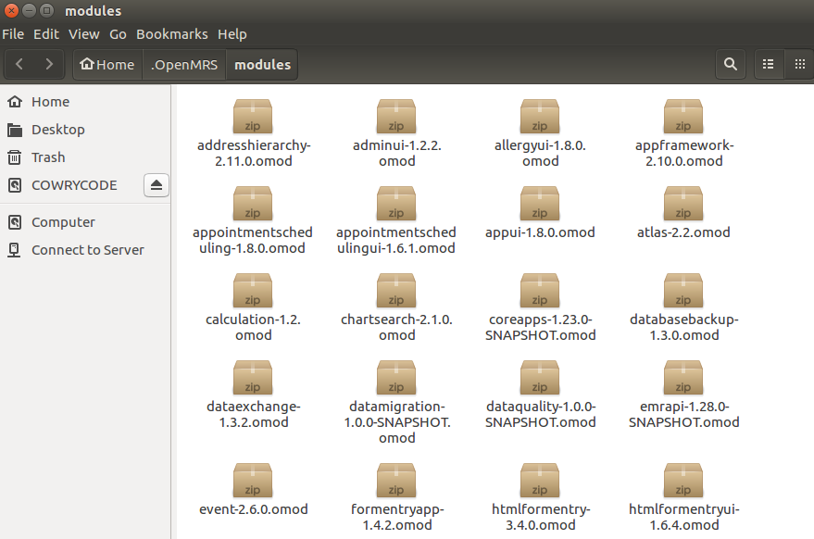
RETART THE SYSTEM

