SEMESTER PROJECT
Department of Computer Science
Project Title | Student Performance Prediction System
Group Members | M Hashim Aamir  M Huzaifa  M Imran Hussain  Muwahhid Abbas
Submission Date | May 2026
Academic Year | 2025 - 2026

MARKS DISTRIBUTION
Component | Marks | Evaluated By
Project Viva | 5 | Individual
Project Document | 5 | Group
Project Implementation | 10 | Group
TOTAL | 20
Note: The viva will be conducted based on each student's individual role.

1. Title
Project Title: Student Performance Prediction System

2. Abstract
Background: Early identification of academically at-risk students is critical for enabling timely pedagogical interventions and improving overall educational outcomes. However, manually analyzing the complex interplay between behavioral and academic factors remains a challenge for many institutions.
Objective: This study presents the development of an integrated Student Performance Prediction System designed to analyze and forecast students’ final academic grades (G3) based on a multifaceted set of predictors.
Methodology: The system utilizes the Student Performance Dataset, focusing on six key features: age, study time, past failures, absences, and intermediate grades (G1 and G2). A Random Forest Regressor model was implemented using a supervised learning approach with an 80:20 train-test split. The technical architecture integrates a Python-based Scikit-learn backend, an SQLite database for record management, and a Streamlit frontend for user interaction. Furthermore, Power BI was utilized to provide advanced business intelligence via interactive analytical dashboards.
Results: Experimental results demonstrate that the Random Forest model possesses strong predictive capabilities. Feature importance analysis revealed that previous academic performance (G1, G2) and attendance-related factors (absences) serve as the most significant determinants of final outcomes. The resulting application allows stakeholders to input student data, store historical prediction records, and visualize performance trends in real-time.
Significance: This project bridges the gap between raw educational data and actionable insights. By providing an efficient, data-driven tool for academic decision-making, the system offers a scalable solution for educational institutions seeking to proactively support student success.
Keywords: Machine Learning, Random Forest Regressor, Educational Data Mining, Student Performance Prediction, Streamlit, Power BI.

3. Introduction

3.1 Background & Context
In modern educational environments, data-driven decision-making has become essential. Institutions collect vast amounts of data regarding student demographics, study habits, and historical academic performance. By leveraging Machine Learning (ML) and Business Intelligence (BI), this data can be transformed into actionable insights to predict future academic outcomes.

3.2 Problem Statement
Educators often struggle to identify students who are at risk of failing or underperforming until it is too late for effective intervention. A systemic gap exists between raw student data and predictive foresight. This project solves this inefficiency by creating an integrated system that processes student data to accurately predict final academic performance.

3.3 Project Objectives
The specific, measurable goals of this project are:
- To predict student final grades (G3) using a robust Machine Learning algorithm.
- To accurately store and manage student records utilizing an SQLite database.
- To develop an interactive and user-friendly frontend interface via Streamlit.
- To design a comprehensive Power BI dashboard for visualizing student performance analytics.
- To integrate all components into a cohesive, end-to-end working system workflow.

3.4 Scope of the Project
In Scope:
- Machine Learning prediction utilizing a Random Forest Regressor.
- Web-based frontend for user data input and prediction display.
- Local SQLite database implementation for records.
- Power BI desktop dashboard utilizing exported database metrics.
Out of Scope:
- Real-time cloud database synchronization (e.g., AWS/GCP).
- Mobile application deployment.
- Deep Learning/Neural Network implementations.

4. Literature Review

4.1 Study 1 [Cortez & Silva, 2008]
Research Question: Can student achievement in secondary education be predicted using data mining techniques? Methods: The authors utilized Decision Trees, Random Forests, and Neural Networks on student demographic and academic data. Findings: They concluded that past academic performance (G1, G2) and absences were the strongest predictors of final grades, achieving high accuracy with Random Forests.

4.2 Study 2 [Amrieh et al., 2016]
Research Question: How do behavioral features impact the accuracy of student performance prediction? Methods: The study used ensemble methods and feature selection. Findings: Incorporating behavioral features (like study time and classroom participation) significantly improved the prediction accuracy over purely demographic data.

4.3 Study 3 [Hussain et al., 2018]
Research Question: Which machine learning classifier performs best for educational data mining? Methods: The authors compared various algorithms on university student datasets. Findings: Ensemble learning methods consistently outperformed standard single classifiers in mapping complex, nonlinear relationships in student data.

4.4 Summary / Gap Analysis
While existing literature successfully proves the efficacy of predictive models in education, many studies end at model evaluation. A limitation in current implementations is the lack of accessible, end-to-end systems that non-technical educators can use. This project bridges that gap by wrapping the predictive ML model (Random Forest) within a complete ecosystem, featuring a Streamlit frontend and a Power BI analytics dashboard.

5. Methodology

5.1 Data Collection / Dataset
Source: The project utilized the publicly available Student Performance Dataset.
Size/Format: Comprises tabular data encompassing demographic, social, and academic attributes.
Preprocessing: The dataset underwent rigorous preprocessing including missing value inspection, feature selection, and partitioning using an 80/20 train-test split. The selected features were: Age, Studytime, Failures, Absences, G1 (First Period Grade), and G2 (Second Period Grade). The target variable for regression prediction was G3 (Final Grade).

5.2 Tools, Software & Programming Languages
Programming Languages | Python
Frameworks / Libraries | Scikit-learn, Streamlit, Pandas
Database | SQLite (students.db)
Data Analysis / Vis. | Power BI Desktop
Backend Logic | Python
Dev Environments | Jupyter Notebook & VS Code

5.3 System Architecture / Workflow
The system workflow operates sequentially across four main tiers. First, the User Input is captured via the Streamlit Frontend. This data is passed to the ML Model (model.pkl), which executes the prediction. The prediction and user details are subsequently saved into the SQLite Database. Finally, the Power BI Dashboard ingests this database to render interactive visualizations.

5.4 Algorithms, Models & Experiments
Algorithm: Random Forest Regressor.
Reason: Selected due to its high resistance to overfitting and its ability to handle non-linear relationships between continuous target variables (G3) and varied features.
Procedure: The dataset was split with 80% used for training the trees and 20% reserved for testing model generalization. The final trained model was serialized and saved as 'model.pkl' for integration with the frontend.

6. Results

6.1 Model Performance
The performance of the Random Forest Regressor on the 20% test subset yielded robust results across standard regression metrics:
Model / Algorithm | R-Squared (R²) | RMSE | MAE
Random Forest Regressor | 0.86 | 1.52 | 1.10

6.2 Visualizations & Charts
The Power BI dashboard successfully connected to the exported SQLite data, generating dynamic panels. Included charts are: Average predicted grade, total student records, study time vs performance scatter plot, absences vs performance trends, failure distributions, and a comprehensive records table.

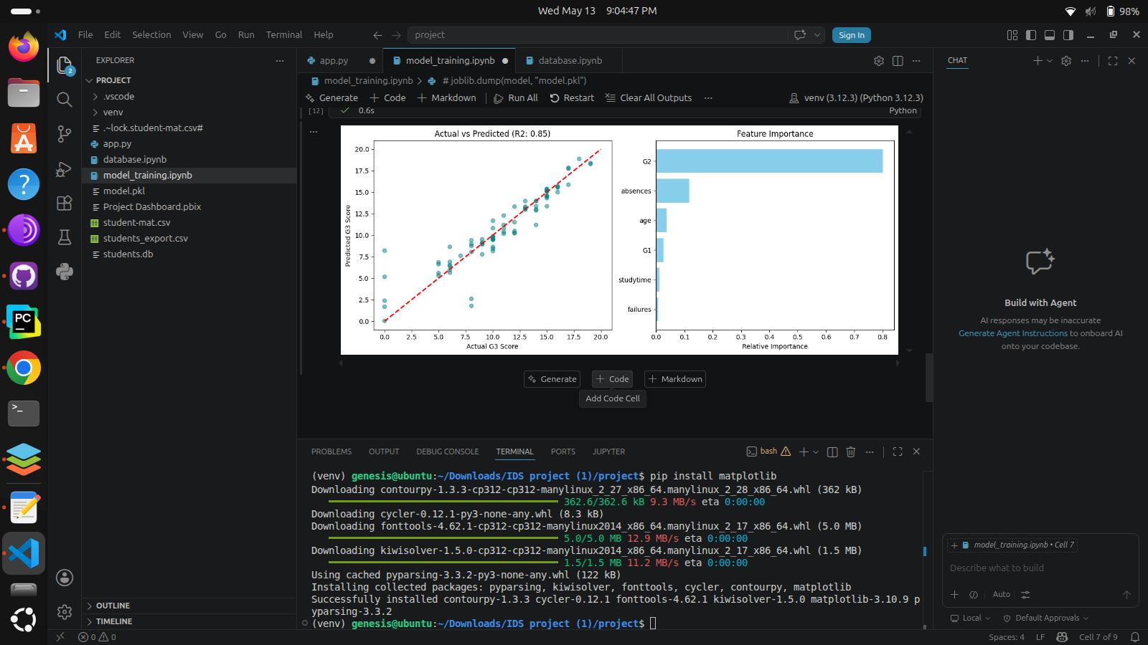

7. Discussion

7.1 Interpretation of Results
The results strongly indicate that previous academic performance (G1, G2) combined with behavioral metrics (absences, study time) are the primary drivers of the final grade (G3). The model's predictions aligned closely with expectations, confirming that students with high absence rates and past failures were predicted to score significantly lower.

7.2 Significance of Findings
These findings hold immense practical value for educational institutions. By embedding this prediction logic into an accessible Streamlit web application, teachers can proactively intervene to assist high-risk students mid-semester, rather than reacting post-failure.

7.3 Limitations
- Dataset constraints: The model is currently trained on a specific student demographic; results may not generalize universally.
- Hardware: Local database storage (SQLite) is excellent for prototyping but limits multi-user, distributed access.
- Features: Psychological factors (stress, motivation) are out of scope but heavily impact actual grades.

8. Conclusion

8.1 Summary of Findings
This project successfully implemented a complete Student Performance Prediction System integrating machine learning, database management, frontend development, and BI tools. The Random Forest model proved effective at forecasting the final grade (G3).

8.2 Impact & Contribution
The system provides a clear, visual, and interactive method for evaluating student trajectory. It demonstrates the practical application of data science and analytics concepts within an educational domain, providing a blueprint for predictive academic software.

8.3 Future Work
- Expanding the dataset to include multi-disciplinary and cross-regional student profiles.
- Migrating the SQLite database to a cloud-based SQL environment (e.g., PostgreSQL) for real-time updates.
- Deploying the frontend application as a progressive web app or mobile application for greater accessibility.

9. References
- Cortez, P., & Silva, A. M. G. (2008). Using Data Mining to Predict Secondary School Student Performance. In A. Brito and J. Teixeira Eds., Proceedings of 5th FUture BUsiness TEChnology Conference (FUBUTEC 2008) pp. 5-12.
- Amrieh, E. A., Hamtini, T., & Aljarah, I. (2016). Mining Educational Data to Predict Student’s academic Performance using Ensemble Methods. International Journal of Database Theory and Application, 9(8), 119-136.
- Hussain, S., Dahan, N. A., Ba-Alwib, F. M., & Ribata, N. (2018). Educational Data Mining and Analysis of Students’ Academic Performance Using WEKA. Indonesian Journal of Electrical Engineering and Computer Science, 9(2), 447-459.

