CSE-CIC-IDS2018 Dataset and Feature Selection
1. Dataset Overview
SentriX uses the CSE-CIC-IDS2018 dataset to train and evaluate the Isolation Forest model offline. The dataset contains both Benign Traffic and different types of cybersecurity attacks, along with information about attack timing, involved machines, and IP addresses.
The dataset is used only for model training and evaluation and is not the runtime database for SentriX incidents.
2. Attack Types
The dataset includes several attack categories, such as:
- Brute Force: Repeated attempts to gain unauthorized access.
- DoS/DDoS: Overwhelming a system or service with traffic to affect availability.
- Web Attacks: Attacks targeting web applications and services.
- Infiltration: Attempts to gain unauthorized access to a system or network.
- Botnet: Compromised devices controlled to perform malicious activities.
- SQL Injection: Exploiting application inputs to manipulate database queries.
The dataset also provides information such as Attack Date, Start Time, Finish Time, Source IP, and Destination IP, which helps describe when and where the attack activity occurred.
3. Feature Selection
SentriX uses 37 selected features to represent network traffic behavior:
- Protocol
- Flow Duration
- Total Fwd/Backward Packets
- Fwd/Bwd Packet Length statistics
- Flow Bytes/s
- Flow Packets/s
- Flow IAT Mean/Std
- Fwd/Bwd IAT Total
- Fwd/Bwd Header Length
- Fwd/Bwd Packets/s
- Packet Length Min/Max/Mean/Std/Variance
- FIN, SYN, RST, PSH, ACK, URG, and ECE Flag Count
- Down/Up Ratio
- Avg Packet Size
- Fwd Seg Size Min
4. Why These Features Were Selected
The selected features represent different characteristics of network traffic:
Feature Group | Purpose
Packet Counts | Describe the amount of network communication
Packet Lengths | Describe packet sizes
Bytes/Packets per Second | Describe traffic intensity
IAT Features | Describe packet timing
TCP Flags | Describe connection behavior
Flow Duration | Describe communication duration
Directional Features | Describe the balance and direction of traffic
Together, these features provide the Isolation Forest model with a multi-dimensional representation of network behavior, helping it identify anomalous traffic.
5. Relationship with SentriX
The CSE-CIC-IDS2018 dataset is used during the offline training phase to train the Isolation Forest model using the selected 37 features.
During runtime, SentriX receives dynamic incident data through manual input, PDF input, or simulated/server-generated data. The data is processed and mapped to the required feature representation before being analyzed by the trained Isolation Forest model.
The anomaly-detection result is then used as part of the subsequent Risk Score, Severity, Threat Analysis, AI Analysis Summary, Recommendation, Report Generation, and Organizational Security Score processes.
In summary, CSE-CIC-IDS2018 provides the training data, while the 37 selected features provide the network-traffic representation required by the Isolation Forest model to detect anomalous behavior.

Database Schema and Data Workflow
1. Database Technology
SentriX uses Supabase as the database platform. Supabase provides a PostgreSQL-based relational database that stores the operational data generated throughout the incident assessment process.
The database is responsible for storing the input incidents, AI analysis results, risk assessment results, threat analysis, recommendations, generated reports, organizational security scores, and archived reports.
The database schema is designed to separate the different stages of the SentriX workflow while maintaining relationships between them through primary and foreign keys.

2. Main Database Components
The database contains several groups of tables, where each group supports a specific part of the SentriX workflow:
User and Incident Data
users stores system users and their basic information.
incidents stores the actual security incidents received by SentriX. Incident data can come from different input methods, including manual entry, PDF input, or server-generated/simulated data.
The table stores information such as:
- Incident type
- Source and destination IP
- Description
- Asset information
- Vulnerability level
- Business impact
- Exposure
- Incident time
- Network flow features
The flow_features field can store the network features required by the Isolation Forest model.

3. AI Analysis
After an incident is submitted, the relevant data is processed and passed to the AI analysis stage.
ai_results
This table stores the output of the Isolation Forest model, including:
- anomaly_score
- is_anomaly
- model_name
- model_version
- prediction_metadata
This allows SentriX to determine whether the analyzed network behavior is considered anomalous.
If anomalous or risky behavior is identified, the incident continues to the following analysis stages.

4. Risk Assessment
risk_results
This table stores the risk assessment generated after anomaly detection.
It contains:
- Risk score
- Severity
- Risk factors
- Scoring mode
- Priority
- SLA hours
- Weights used
- Dynamic threshold
These values allow SentriX to determine how serious the incident is and how it should be prioritized.

5. Threat Analysis
threat_analysis
This table stores the security interpretation of the incident, including:
- Threat type
- Matched threat profile
- MITRE ATT&CK tactics
- MITRE ATT&CK techniques
- Confidentiality impact
- Integrity impact
- Availability impact
This information is used to represent the incident's impact on the CIA Triad and provide the threat information required by the SentriX interface and report.

6. AI Analysis Summary
ai_narratives
This table stores the textual AI analysis generated for the incident.
It contains:
- Analysis ID
- Model used
- Analysis time
- Data sources
- Analysis summary
- Key findings
- Prompt version
- Narrative source
This information provides the AI Analysis Summary displayed to the user and included in the incident report.

7. Incident Recommendations
incident_recommendations
This table stores the recommended response actions for a specific incident.
Each recommendation can be stored as an individual action with:
- Action title
- Action description
- Action scope
- Action order
- Priority
- Status
- Completion information
The recommendation is associated with the relevant Playbook through playbook_id.
playbooks
The playbooks table stores the response procedures used by SentriX for different incident types and severity levels. It contains the playbook description, actions, minimum severity, and source reference.

8. Organizational Security Score
After processing the current incident, SentriX can use the incident history together with the defined security criteria to calculate the organization's overall security score.
security_criteria
This table contains the security domains and their associated framework/control references, descriptions, and weights.
organizational_security_scores
Stores the organization's overall security score for a specific period, including:
- Overall score
- Period start/end
- Maturity level
- Incident count
- Previous score
- Calculation metadata
organizational_score_details
Stores the breakdown of the organizational score by security domain. It includes the domain, score, weight, contribution, incident hits, weakness status, improvement recommendation, and control reference.
This allows the web interface to show both the overall percentage and the score breakdown, including where weaknesses occurred and where improvement is needed.

9. Report Generation and Archiving
When the user selects Generate Report, the processed incident information can be represented as JSON and used to generate the PDF report.
incident_reports
Stores the generated report information, including:
- Incident ID
- JSON report
- PDF path
- Report version
- Generated by
- Generation time
archives
The final report is then archived together with a snapshot of the report data.
The archive stores:
- Report snapshot
- Storage path
- PDF path
- Archive period
- SHA-256 hash
- Archive timestamp
The report_snapshot preserves the report information at the time it was generated, while sha256_hash supports integrity verification.

10. DataBase Schema ERD
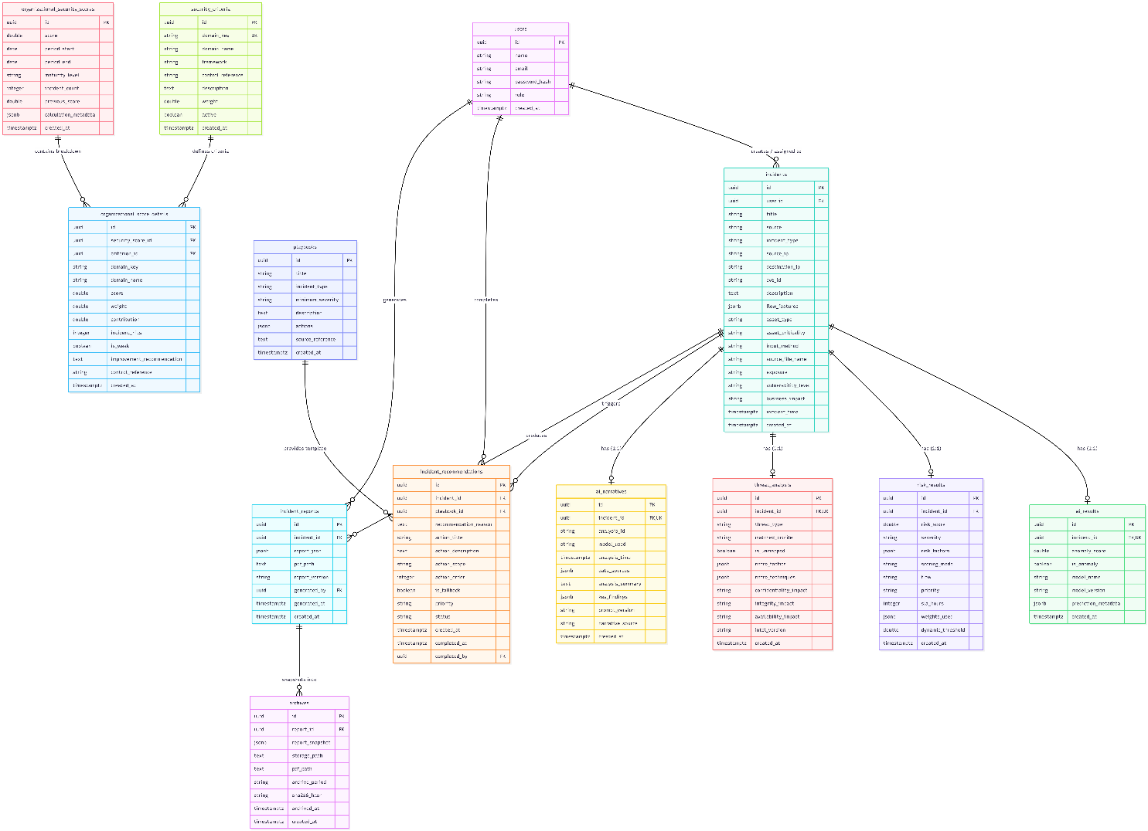

11. Complete Data Workflow in SentriX
The complete data workflow can therefore be described in the documentation as follows:
1. Data Input:
An incident enters SentriX through manual input, a PDF report, or simulated/server-generated data.
2. Incident Storage:
The incident information is stored in the incidents table.
3. Preprocessing and Feature Mapping:
If network-flow information is available, the required features are prepared in the format expected by the trained Isolation Forest model.
4. Anomaly Detection:
The processed data is analyzed by the offline-trained Isolation Forest model. Its result is stored in ai_results.
5. Risk Assessment:
If the incident requires further analysis, SentriX calculates the risk score, severity, priority, and other risk factors. These results are stored in risk_results.
6. Threat Analysis:
The system determines the threat type, MITRE ATT&CK information, and CIA impact. These results are stored in threat_analysis.
7. AI Analysis Summary:
The system generates the analysis summary and key findings, which are stored in ai_narratives.
8. Response Recommendation:
Based on the incident and its analysis, SentriX selects the relevant Playbook and stores the recommended actions in incident_recommendations.
9. Organizational Security Score:
The current incident is considered together with the organization's incident history and security criteria to calculate the organizational security score and its detailed breakdown.
10. Report Generation:
The analyzed information is assembled into a JSON representation and generated as a PDF report. The report information is stored in incident_reports.
11. Cloud Archiving:
The generated report is archived with its snapshot and SHA-256 integrity hash in archives.

Overall Concept
The role of Supabase in SentriX is therefore not to perform the AI analysis itself. Instead, it acts as the central data layer connecting the different stages of the system.
The AI/Isolation Forest performs the analysis, while Supabase stores the inputs, outputs, analysis results, recommendations, security scores, reports, and archived records needed by the web application and for later auditing.

SentriX Response Playbooks
SentriX uses predefined response playbooks to generate appropriate response recommendations after an incident has been analyzed. The playbook design separates the identification of attack types from the definition of response actions.
Attack Type Source — CSE-CIC-IDS2018
The CSE-CIC-IDS2018 dataset is used as the source for the attack scenarios covered by SentriX. The dataset defines seven main attack scenarios: Brute-force, Heartbleed, Botnet, DoS, DDoS, Web Attacks, and Infiltration of the Network from Inside. It also provides detailed information about the executed attacks, including attack names, tools, duration, attackers, and victims.
Response Action Source — NIST and CISA
The response actions used within SentriX playbooks are based on established Incident Response guidance, primarily NIST SP 800-61 and supporting CISA incident-response guidance.
NIST describes incident handling activities such as containment, eradication, and recovery, and emphasizes that containment strategies should vary according to the type of incident. (NIST Publications)
CISA's incident response playbooks also provide standardized procedures covering activities such as identification, containment, eradication, recovery, and tracking of response actions. (CISA)
Therefore, CSE-CIC-IDS2018 is not treated as the source of the response actions. It provides the attack scenarios, while NIST/CISA guidance provides the incident-response principles used to define the actions associated with those scenarios.
Role of SentriX
SentriX connects these two sources within its Decision Layer. After the AI analyzes an incident and determines the relevant threat type and severity, the Recommendation Engine selects the corresponding playbook and provides the associated response actions.
The workflow is therefore:
CSE-CIC-IDS2018 → Attack Type
NIST/CISA → Response Actions
SentriX → Playbook + Recommendation
This allows the recommendation to be linked to a recognized attack scenario while following established incident-response practices.

Playbooks Included in SentriX
Based on the seven attack scenarios defined by CSE-CIC-IDS2018, SentriX includes the following initial playbooks:
Playbook | Attack Scenario | Example Attacks / Activities
Brute Force Response Playbook | Brute-force | FTP and SSH brute-force
Heartbleed Response Playbook | Heartbleed | Heartbleed exploitation
Botnet Response Playbook | Botnet | Botnet activity and compromised hosts
DoS Response Playbook | Denial of Service | Hulk, GoldenEye, Slowloris, SlowHTTPTest
DDoS Response Playbook | Distributed Denial of Service | Distributed traffic attacks
Web Attack Response Playbook | Web Attacks | SQL Injection, Command Injection, Unrestricted File Upload
Infiltration Response Playbook | Infiltration | Internal reconnaissance, IP sweep, port scanning, service enumeration
The attack scenarios and examples above correspond to the scenarios documented by the CSE-CIC-IDS2018 dataset.

1. Brute Force Response Playbook
This playbook is used when SentriX identifies a brute-force attack. Its response actions focus on identifying the affected authentication service, investigating suspicious authentication attempts, restricting malicious sources, checking affected accounts, and monitoring for repeated attempts.
2. Heartbleed Response Playbook
This playbook is used when a Heartbleed-related incident is identified. The response focuses on identifying vulnerable systems, isolating affected systems when necessary, patching the vulnerable service, investigating possible information exposure, and verifying that the vulnerable service is no longer exposed.
3. Botnet Response Playbook
This playbook addresses incidents involving potentially compromised hosts participating in botnet activity. Actions focus on identifying and isolating affected hosts, investigating suspicious communications and malicious processes, removing malicious components, and monitoring for recurring activity.
4. DoS Response Playbook
This playbook is used for Denial-of-Service incidents. Actions focus on identifying the affected service, analyzing abnormal traffic, applying appropriate filtering or rate-limiting measures, restricting malicious sources where appropriate, and verifying service recovery.
5. DDoS Response Playbook
This playbook addresses Distributed Denial-of-Service incidents. Actions focus on identifying the affected service and distributed traffic pattern, applying appropriate traffic controls, coordinating with relevant network providers when necessary, monitoring availability, and verifying recovery.
6. Web Attack Response Playbook
This playbook is used for web application attacks. The CSE-CIC-IDS2018 scenario includes attacks against a vulnerable web application, including SQL injection, command injection, and unrestricted file upload.
The response focuses on identifying the affected application and endpoint, reviewing suspicious requests and logs, restricting malicious sources where appropriate, securing the affected functionality, checking for unauthorized changes, and monitoring for recurring activity.
7. Infiltration Response Playbook
This playbook addresses infiltration of the internal network. The CSE-CIC-IDS2018 scenario includes activities such as exploitation followed by internal reconnaissance, including IP sweep, port scanning, and service enumeration.
The response focuses on identifying and isolating the potentially compromised host, investigating suspicious communications and reconnaissance activity, reviewing the system for unauthorized access or malicious processes, removing identified malicious activity, and monitoring the network for additional compromised hosts.

Source Attribution
For traceability, each playbook in the SentriX database can reference both the attack scenario source and the response methodology source. The dataset provides the attack classification, while NIST/CISA provide the basis for the response procedures.
Primary sources:
- CSE-CIC-IDS2018: Attack scenarios and attack characteristics.
- NIST SP 800-61 Rev. 1: Archived guidance for computer security incident handling, including containment, eradication, and recovery. (NIST Publications)
- CISA Incident Response Playbooks: Standardized incident-response procedures and response activities. (CISA)
Archived NIST SP 800-61 Rev. 1
CSE-CIC-IDS2018 Official Dataset

