​
2.3.1 Gameplay:
After entering level 2, player will be spawn at the most left bottom platform. The Goal of this level is to defeat or avoid the enemy then deliver total ten present to the charismas tree then finally player can proceed to the goal zone then proceed to next level. The character can perform movement (walk, run, jump) and attack (shoot, melee, skill, ultimate). There will be multiple platform and two type of enemy which is elite and normal enemy will spawn randomly on the platform. Enemy will shoot using total ten type of gun, the gun will be drop and can be equiped by the player after defeat the enemy. After deliver all present the player will be notice to go to goal zone then enter next level.
2.3.2 Assets:

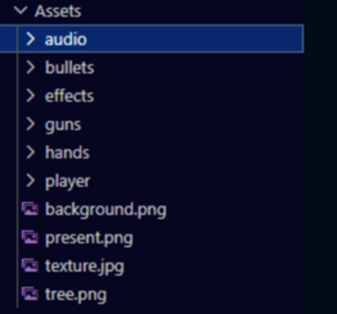
Figure 1: Asset File Structure

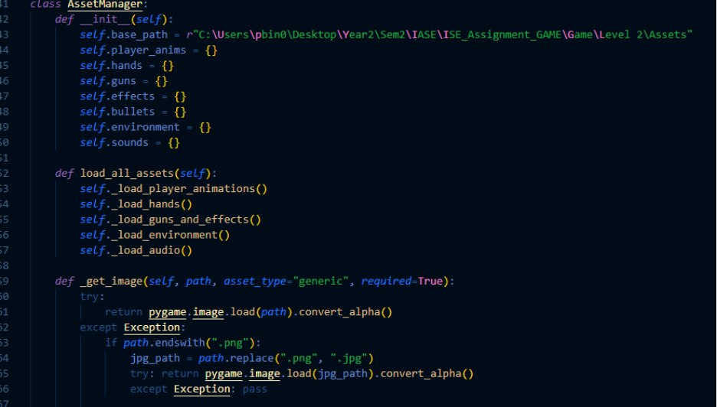
Figure 2 : AssetManager Class(1)
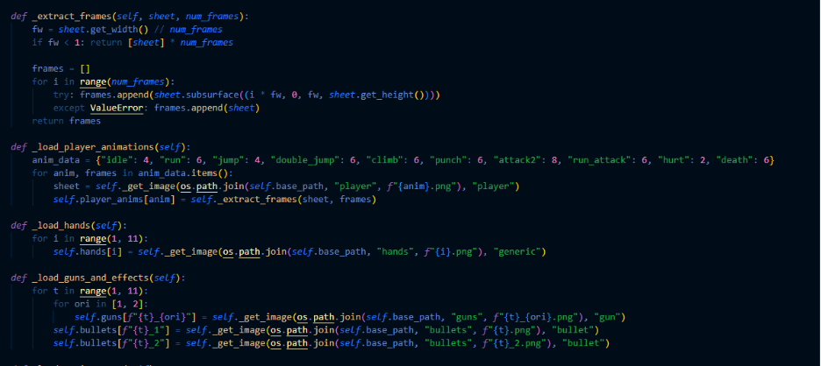
Figure 3: AssetManager Class(2)

Level three have a lot of images and seven audio file being used in program and store in directory call assets for ease of management. A class call assetmanager is created to load all the assets, assign and extract each according to each file type, content and purpose.
2.3.3 Visual effects
Visual effect methods are created as class to ease later trigger and management
1. Snow Flake
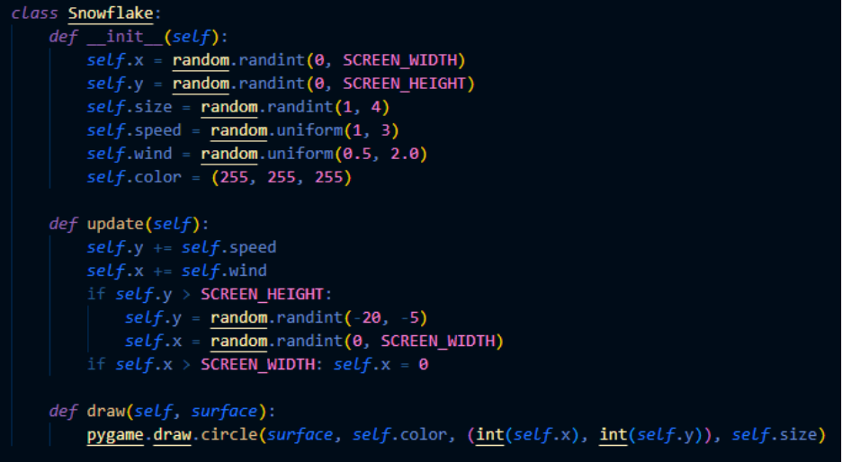
Figure 4: Snowflake Class
Snow flakes will be drawing and falling down according to random preassigned number of speed, wind and size with the given color.
2. Beam (skill)
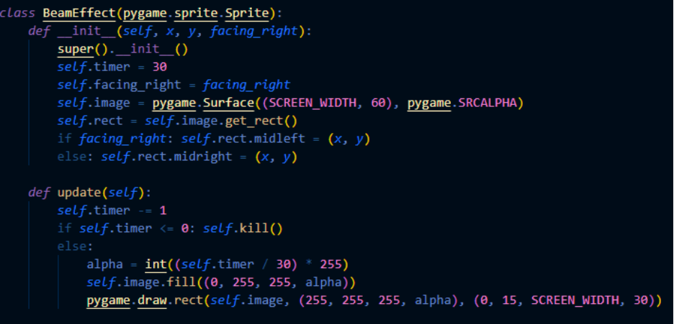
Figure 5: BeamEffect Class
A rectangle beam effect will be drawing Infront of the character after skill being trigger according to color and time predefined.
3. Blue Waves (ultimate)
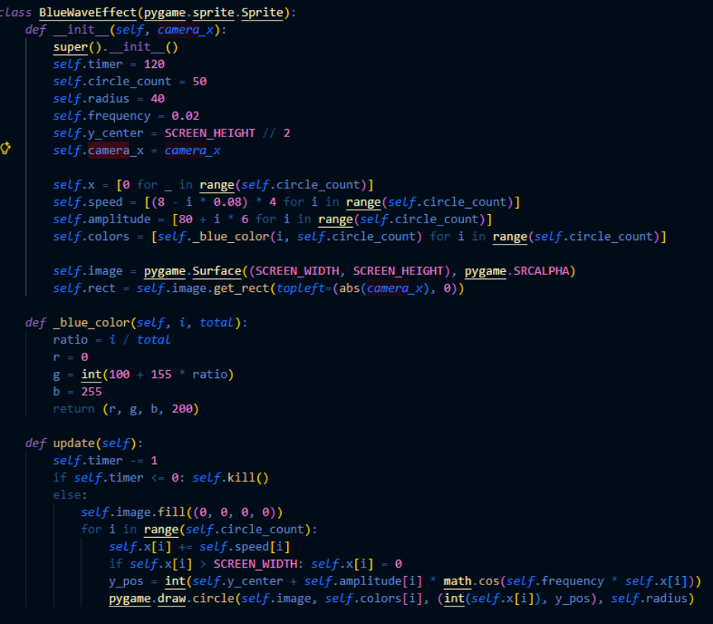
Figure 6: BlueWaveEffect Class
A blue waves which is a bunch of spinning blue circle will be drawing on the screen according to time, amount, speed and other mathematical number . It will be trigger after player use ultimate.
2.3.4 Special Effect (Sound)

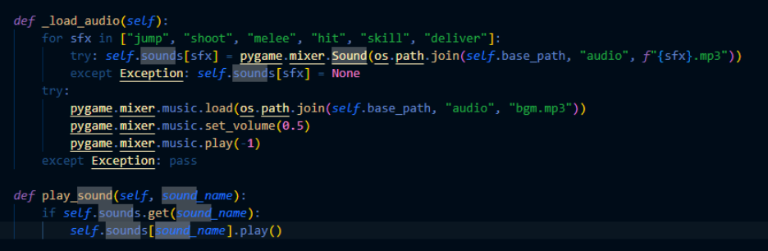
Figure 7: _load_audio and play_sound Method

Load and play sound methods is defined in asset management class.
1. Shoot
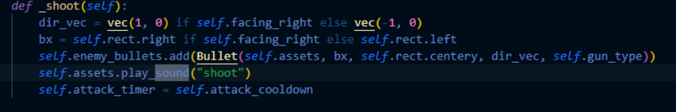
Figure 8: Enemy _shoot Method
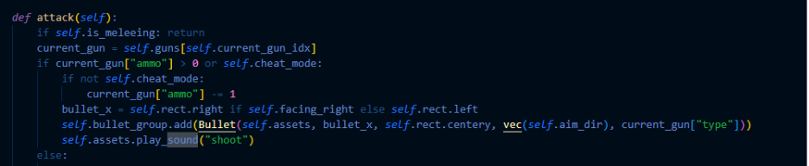
Figure 9: Player attack Method

Both enemy and player have shoot function, the shoot sound will be triggered when player or enemy shoot.
2. Jump
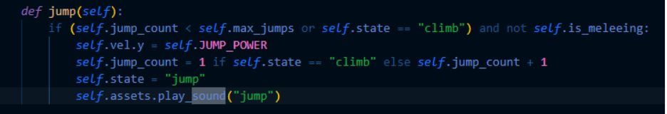
Figure 10: Player jump Method (1)
Player have jump function and jump sound will be trigger when player perform jump.
3.Melee
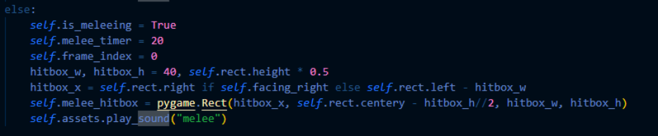
Figure 11: Player attack Method (2)

Player have attack function, it will trigger melee sound when player attack while no ammo.
4.Hit
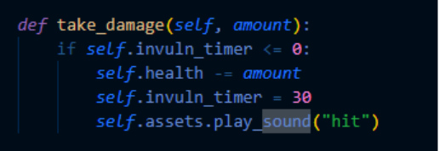
Figure 12: Player take_damage Method

Player have take damage methods which will trigger hit sound when player hitbox got hit by any damage
5.Deliver
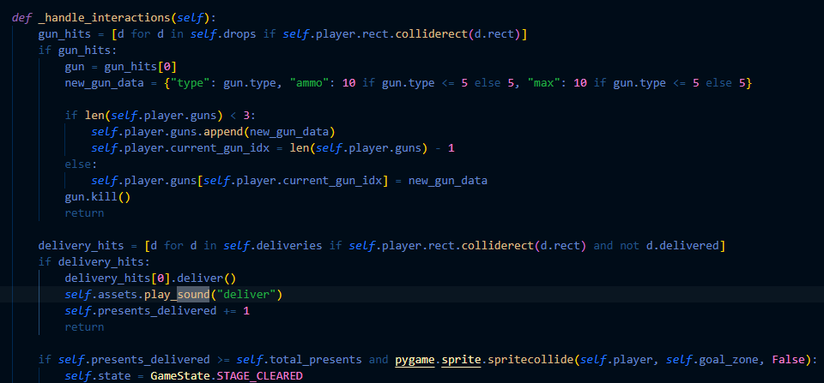
Figure 13: GameEngine _handle_interactions Methods
In Game engine class where I define the game base logic there is a handle interaction method which used to trigger method according to user input, it will play deliver sound when press ‘e’ at the Christmas tree.
6.Skill
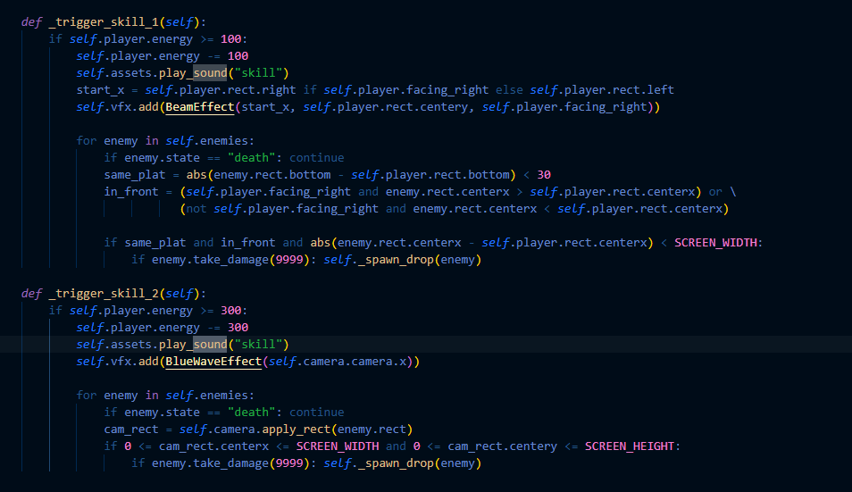
Figure 14: GameEngine _trigger_skill_1/2 Method
In game engine class there are method to trigger skill and ultimate(skill 2), it will play skill sound when player perform skill or ultimate
7.Bgm
Figure 15: load Bgm
In asset manager class load audio function it will load bgm that which will be play during the gameplay

